**ISYS3001 – Assignment 1 exercise**

Remember that this is a public repository - your changes could be seen by anyone who looks!

Add some comments about Version management outside this border, or just add some text so there is a change to this file.

Remember that your GitHub user ID must be submitted in your assignment report!

Once you’ve changed follow the next step in your assignment task.

…

This is what it looks like when you log in to GitHub. On this page we can see some of the actions related to GitHub.

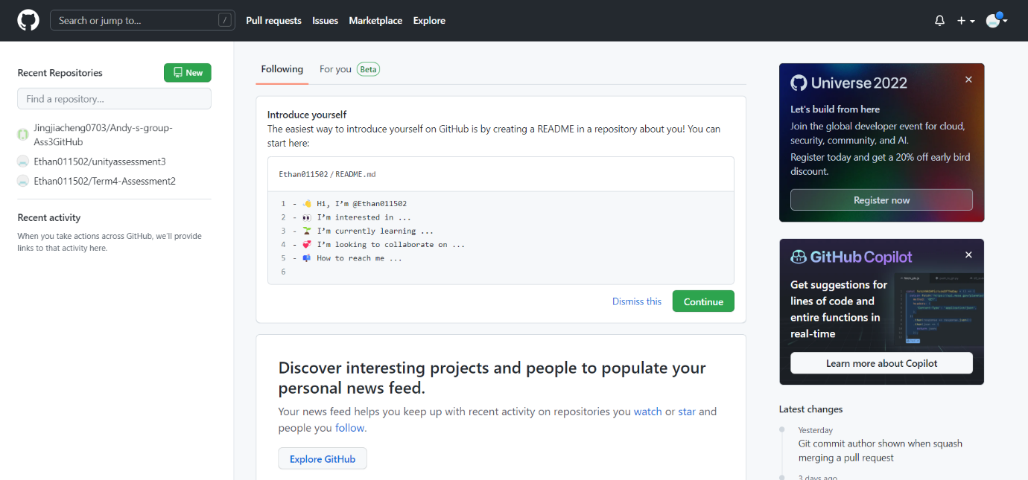

Click on the fork

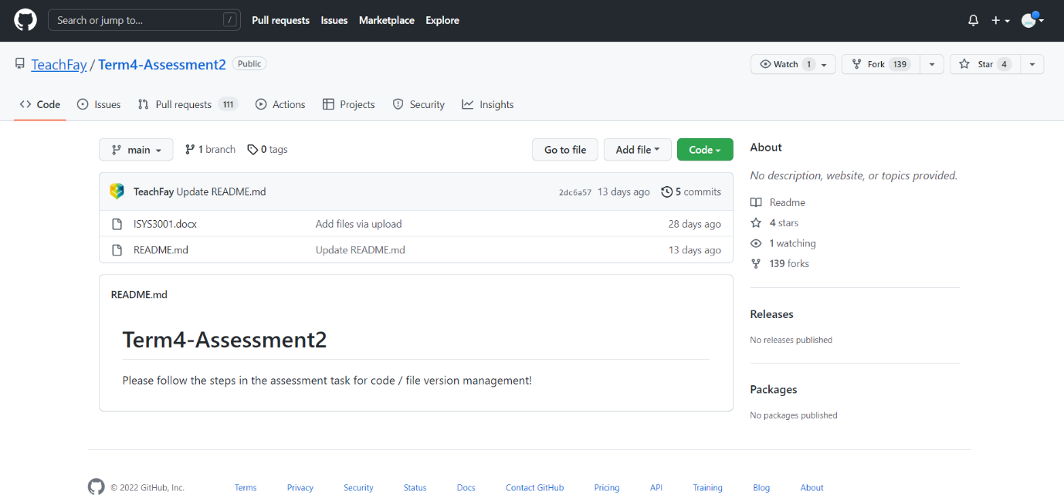



Fork this project into my public space