**Tutorial 2**

**Loading Firmware (.ace files)**

**February 2022**

In this tutorial we are going to see how to load firmware in the form of .ace files.

There is a program called AceProgrammer that allows users to load firmware in the desired module. Firmware can either be loaded from the PROM of the FPGA or from a directory in the machine.

1. **Log into sbcpix**

Ssh into the sbcpix machine of the crate corresponding to where the required module is located. For example, here we want to work with slot 7 in crate1, so

ssh sbcpix-sr1-01

(01 is the crate number. Change to 03 if modules in crate 3 are being used)

Remember to source this otherwise subsequent actions it will not work

source /tbed/user/<USERNAME>/repos/oks/setup_everything.sh

1. **Load firmware either from location in machine or PROM in FPGA**

**2.1 To load ace file stored in a location**

AceProgrammer <SLOT NUMBER> <PATH TO ACE FILE>

AceProgrammer 7 /det/pix/fw/test/ROD/Slaves/TopMerger/rodSlave_top_calibration_boot_e925784d3e12264492e6bfe9285c283291e56a7f_pixel.ace

(make sure there is “/” before location)

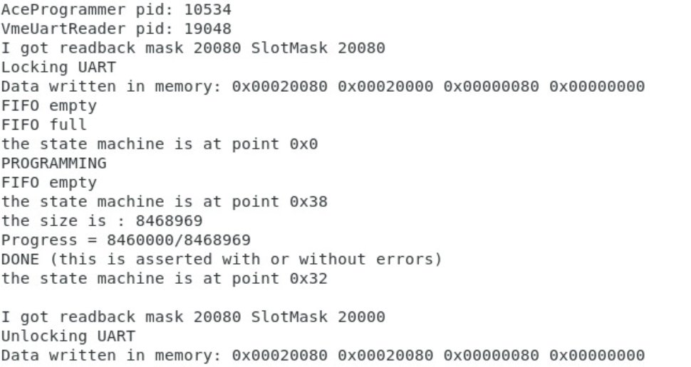

Make sure that the process has completely gone through

**2.2 Load ace file stored on PROM of FPGA**

This is the firmware version from 2018. It is stored in the FPGA PROM.

The firmware for the 2 slaves is being loaded in separate steps

S6A- Spartan 6, slave A; S6B – Spartan 6 slave B

AceProgrammer 7 /det/pix/fw/reload_from_PROM/S6B_from_PROM.ace

AceProgrammer 7 /det/pix/fw reload_from_PROM/S6A_from_PROM.ace

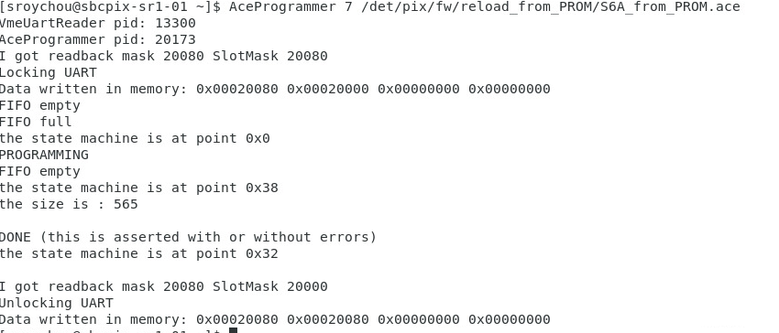

1. **Reset**

Make sure to reset before starting a run. This command resets the software in the MicroBlaze and PPC as well.

reset_ROD_FPGAs <SLOT NUMBER> all yes

reset_ROD_FPGAs 7 all yes

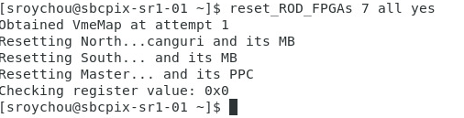

1. **Check version loaded in FPGA**

Run this command after resettling the FPGAs.

HCP_getVersionInfo --rodName <NAME>

HCP_getVersionInfo --rodName ROD_C1_S7

This gives the git hash of the firmware and software loaded into the Master, Slave and PRM of the ROD.

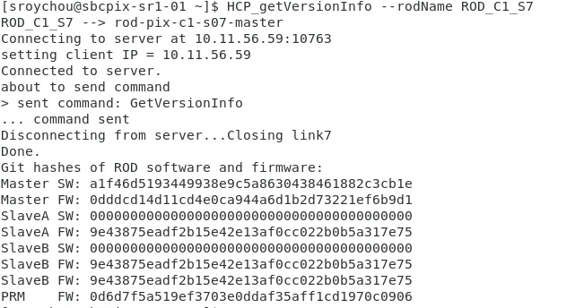

Now the loaded FW will be used when running the infrastructure.

Always ensure that the git hash is coming up correctly before starting a run. If the hash isn’t being read back, it indicates that something is wrong with the PPC or Microblaze (slave) software. It is possible that the booting hasn’t been completed, so make sure to wait for a few minutes after loading and resetting to see the correct hash.