**Tutorial 3**

**Viewing Histograms generated during Datataking**

*February 2022*

The histograms are stored in the system when a RunConfig that has Histogrammer enabled is used during datatking. Only online occupancy histograms are relevant during datataking. This is set using TagManager as seen in the introduction tutorial. Then upon doing a run using this runconfig, histograms are saved in a directory. The saved root file has to be copied into the user’s lxplus home directory in order to be viewed using Root.

1. **Enabling histogramming in runconfig**

Log into pcpix-sr1-01 (where the infrastructure is being run). Remember to run the source setup_everything.sh command as shown in the introduction tutorial before starting.

Here an existing Runconfig is being edited to include histogramming. For example, SIM_1A_READY is an existing RunConfig to which we will make changes. This command is used:

RunConfigEditor --dbPart PixelInfr_<USERNAME> --idTag SR1-22 --connTag SR1-CONN --cfgTag SR1_BOC --cfgModTag SR1_MOD --pendTag saveme --runConf SIM_1A_READY

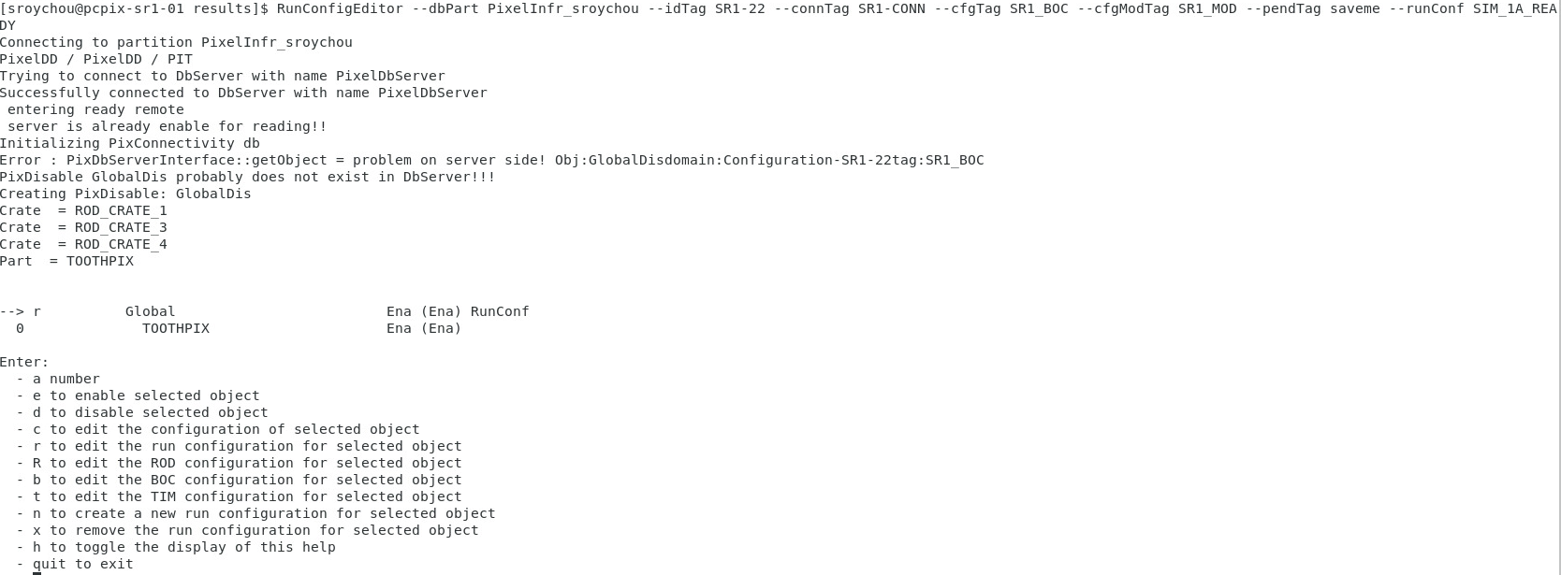

Enter r to edit the selected run configuration

We need to enable the use of historgrammer, which is line 44 here and the current value is 0. Enter 44 and then enter 1 when prompted as shown below

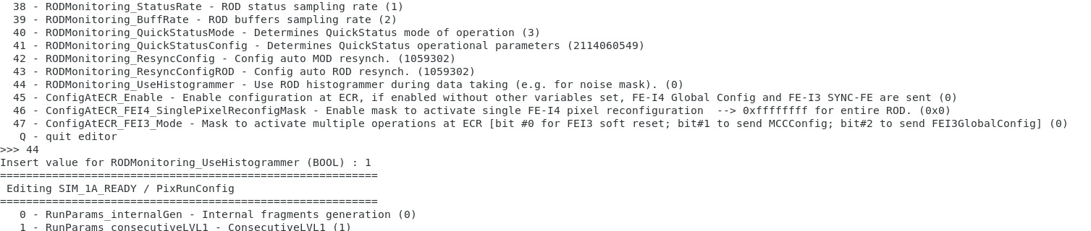

After editing it should change to 1



Enter Q to quit editor

Then enter quit to exit

When prompted to save changes enter yes, and then rename the edited run config as SIM_1A_READY_HISTO (adding HiSTO at the end is a convention followed to indicate runconfig with histo enabled)

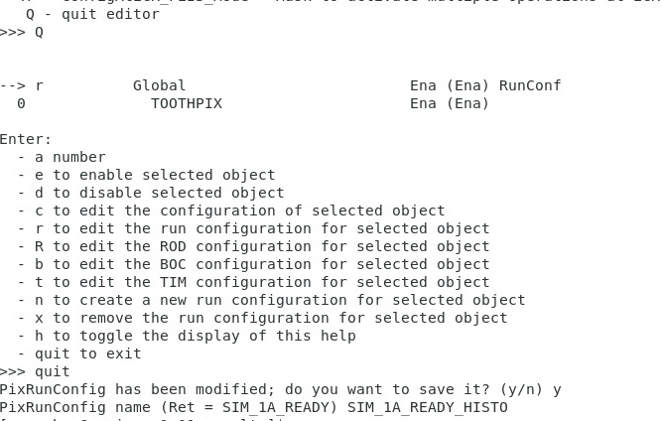

Once this step is done and the runconfig is saved and visible on TagManager, it does not have to be done again when running next time. Subsequently runs can be done on daqslice after selecting the runconfig (with _HISTO).

1. **Run on daqslice**

Select this runconfig (SIM_1A_READY_HISTO) in TagManager before starting the run.

Start and stop the run in daqslice (as shown in introduction tutorial)

Note the run number on the daqslice window.

1. **Looking at histograms**

Go to the directory that has histograms saved

Cd $PIXSCAN_STORAGE_PATH

List all the files in the directory with date and time to check which file has the run number that corresponds to your run

ls -ltr

Copy the file to home directory:

cp <RUN_NUMBER.root> ~/

for example : cp RUN_R000057820.root ~/

Go to your lxplus home and check if the file has been copied. Root is used to view the histograms. To view thr results of the corresponding run number:

root -l RUN_NUMBER.root

root -l RUN_R000057820.root

Inside the root command line type:

new TBrowser

A Root Object browser window should pop up, open the folders until histogram is listed as shown below

The number of histograms depends on how many modules are enabled in the slave modules

select colz in the draw option

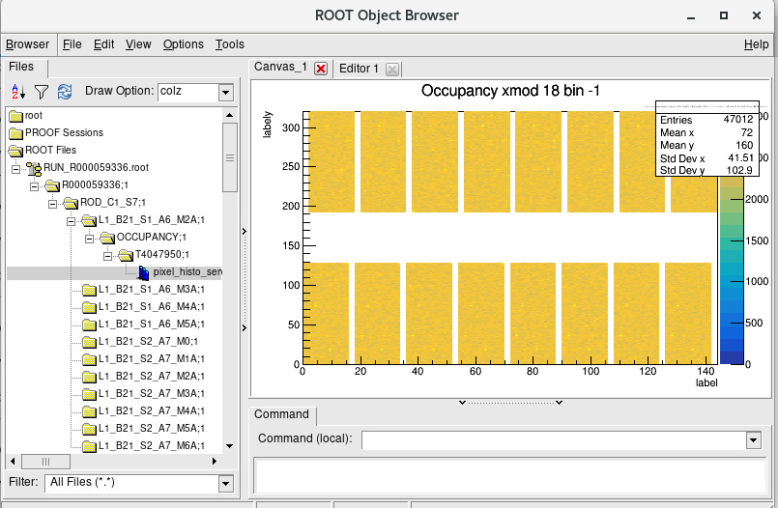

To quit root close the window and type .q in terminal.