**Tutorial 5**

**Converting .bit to .ace file**

*March 2022*

The firmware is loaded in the form of .ace files consisting of firmware for both north and south slaves. There are scripts called bit2svf and svf2ace in the Firmware repo to do this that you can get to the home directory. Or copy from here /home/okepka/fw/RodSlave/scripts/. The scripts are using Xilinx tool iMPACT for the conversion; hence a valid Xilinx setup is needed. Run these scripts from a machine that has Xilinx tools set up- for example, **pix-sr1-01**.

1. **Source Xilinx settings**

source /opt/Xilinx/14.7/ISE_DS/settings64.sh

1. **Bit2svf**

Create the SVF file using the two separate bit files (both are same here) and output filename as arguments

$SCRIPTDIR/bit2svf -3 ${NORTH_BIT} -6 ${SOUTH_BIT} -o $SVF

~/bit2svf -3 rodslave_top_calibration.bit -6 rodslave_top_calibration.bit -o rodslave_top_calibration_3_24_efb_outmem.svf

This gives rodslave_top_calibration_3_24.svf as output

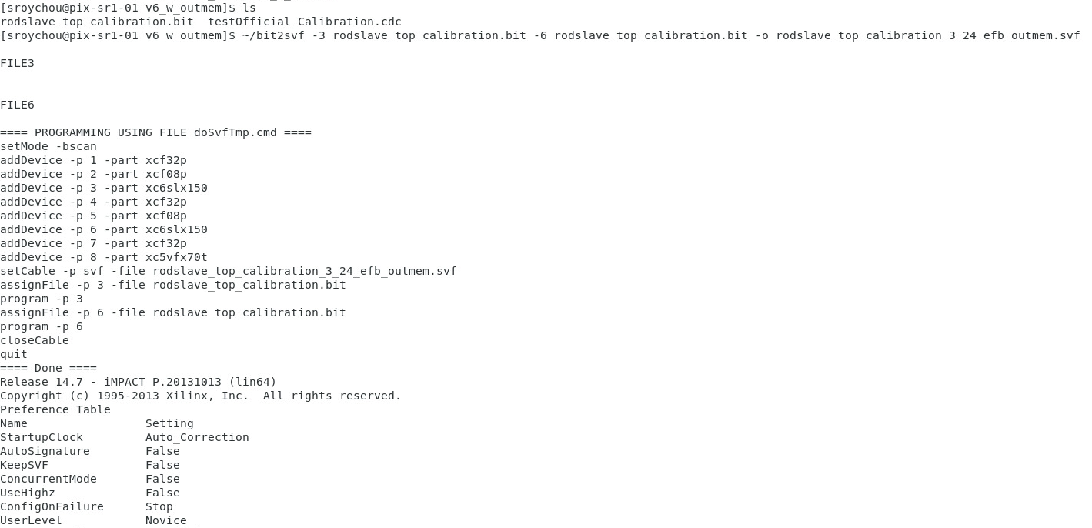

1. **Svf2ace**

Generate the ace that will come out with the same name as the svf except for the extension .ace instead of .svf

$SCRIPTDIR/svf2ace

~/svf2ace

The inputs are given here interactively

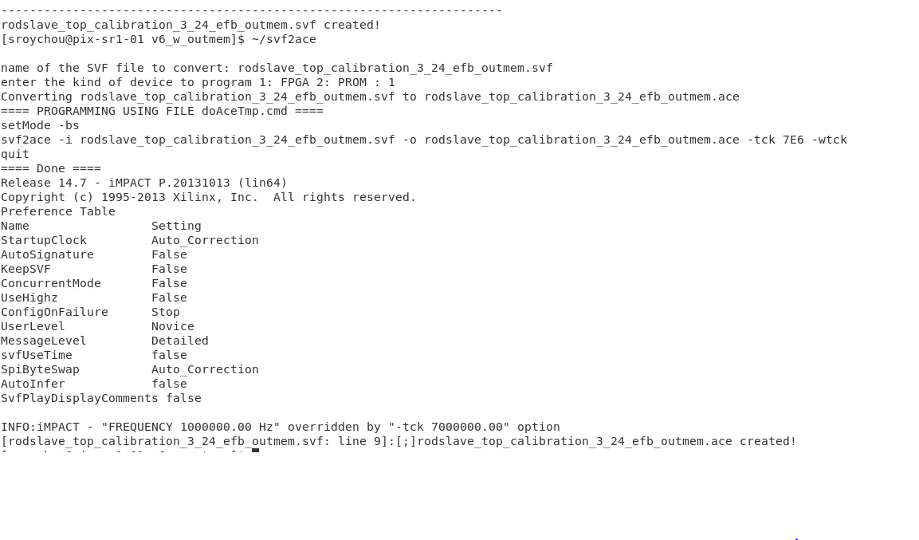

Load this ace file in FPGA according to tutorial 2

