**Tutorial 9**

**Using modules in SR1**

*November 2022*

Until now we have dealt with using an emulator (in the BOC) for the modules during datataking. However, SR1 has real modules attached to the ROD/BOC setup. It is in fact a vertical slice of the actual detector. The real modules can be controlled through a graphical interface called the FSM.

This section covers the basics of how they should be operated in this setup during both calibration and datataking. Calibration can only be done using real modules, since an emulator does not make sense there.

**Opening the FSM**

From any lxplus machine:

ssh -XY pcatlpixsr1dcs3.cern.ch

/localdisk/startPIX_SR1_FSM.bash

This is what the FSM window looks like

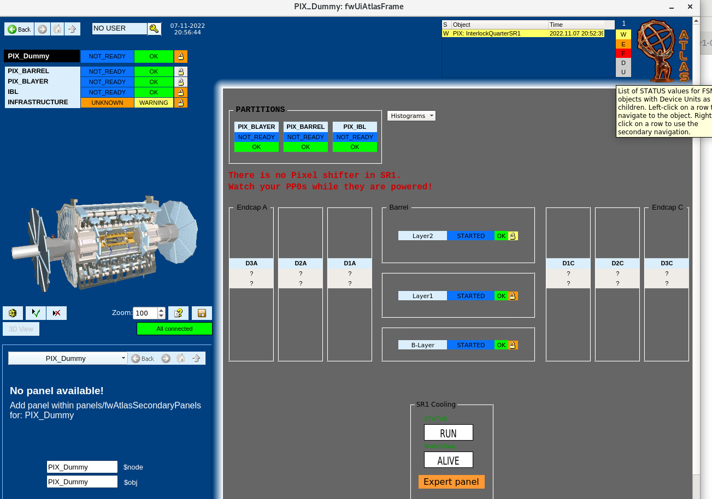

Navigate to the desired part/module. Here we will use a module attached to C1_S17, which is part of PIX_BLAYER. Double click to go further into the hierarchy.

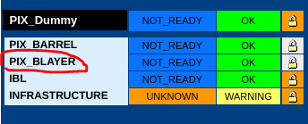

Keep navigating by clicking until you reach the desired module. Make sure to check the name of the module you would like to use on RODMON and navigate accordingly.

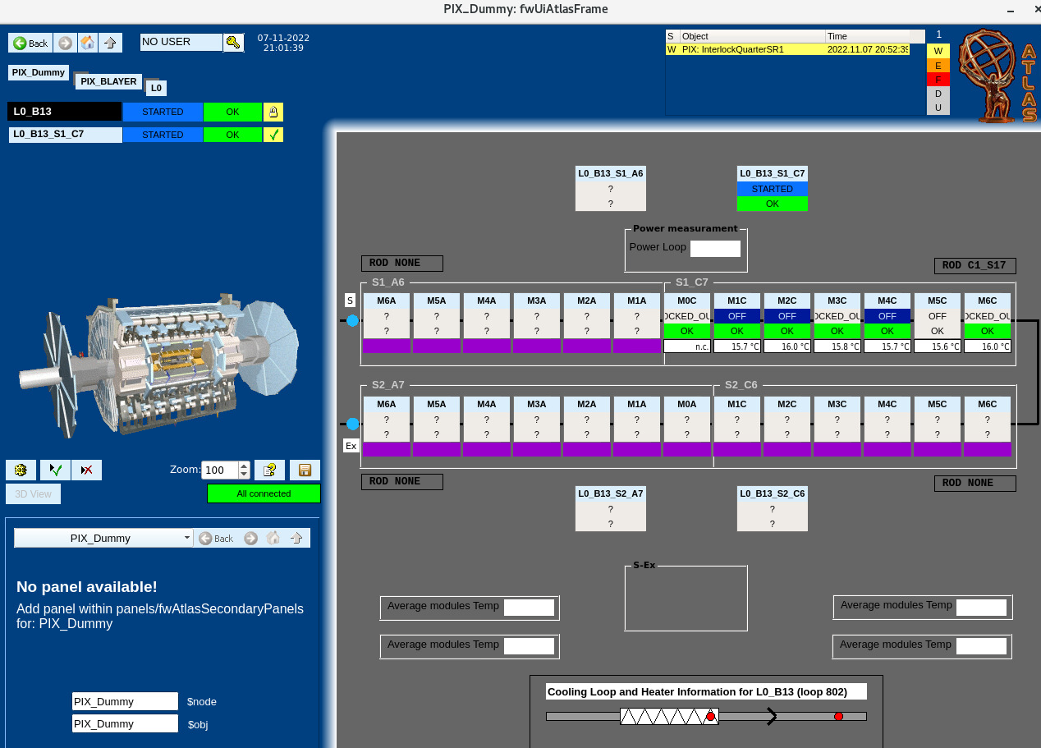

There are also useful graphics indicating which slot the module is connected to. Not all modules are filled in SR1.

This is what the window should look like before starting. Modules are usually left in the STARTED state.

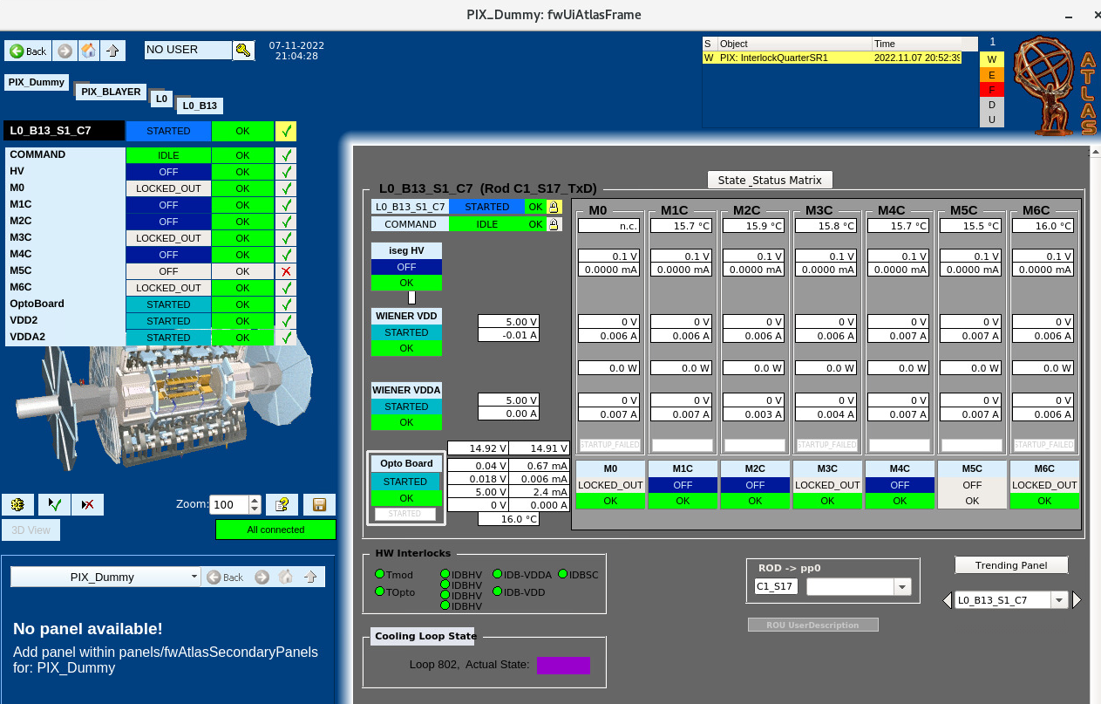

We need to switch on the modules in a particular sequence of states:

OPTO_ON->LV_ON->HV_ON -> STARTED (back to initial state)

* OPTO_ON turns on optoboard. The optoboard converts optical signals to electrical that goes into the BOC.
* LV ON turns on the low voltage of modules what is associated with turning on the module
* HV ON is a higher voltage that is responsible for biasing of the front end

More details on this can be found here

<https://gitlab.cern.ch/atlas-pixel/daq/atlaspixeldaq/-/wikis/DCS>

Click on the STARTED box to see options. Click on SWITCH_ON_OPTO, and YES when prompted again.

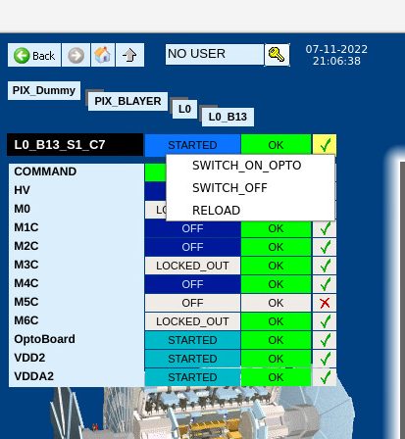

Now it should look like this

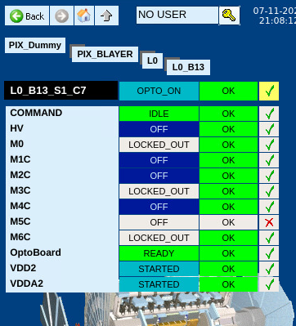

Similarly, click on OPTO_ON and SWITCH_ON_LV from the options

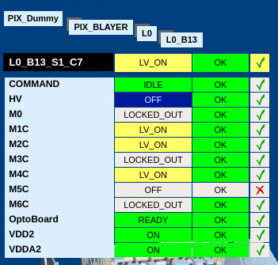

Finally switch on HV

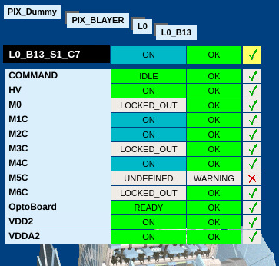

To switch off voltage or go back to the initial state navigate to the options as shown earlier and select the appropriate options. Back to started directly switches off everything in the right order to started so it can be used when you are done using the module.

**Calibration**

In pcpix start_infr as usual and then type this command to access the Console which is an application used for calibration.

ConsoleApp

A box will pop up, make sure the options selected are as below, then click OK

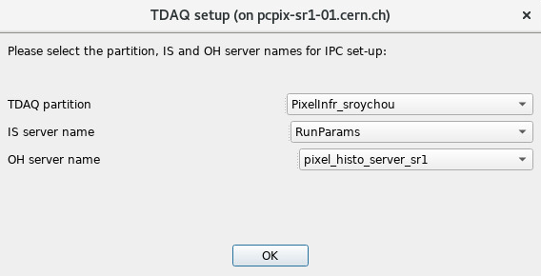

Make selections as shown below. On the third box, select only the ROD you are working with, here C1_S17 is being used. Click allocate selection, YES if prompted.

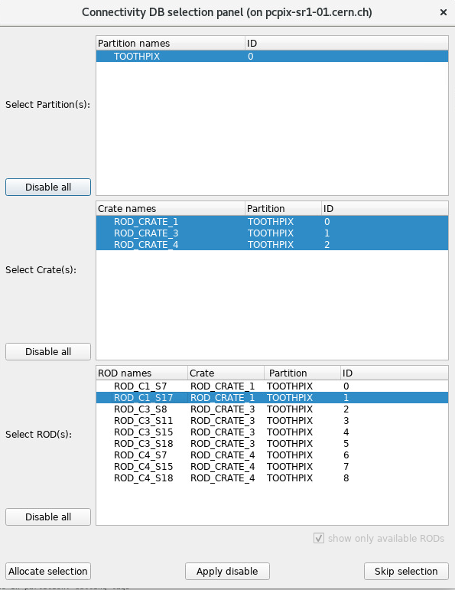

Now that the modules are switched on and allocated, they need to be configured. Navigate to the command tool tab and send the configure modules command as shown

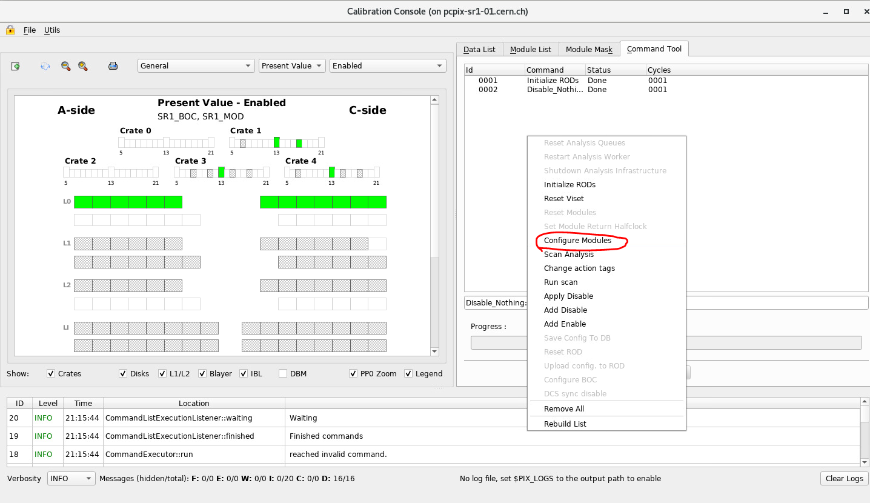

Check that the modules show READY instead of ON in the FSM window to make sure it has been configured. Monitoring scans can be done now.

Similar to sending the configure modules command, this time click Run Scans. Make sure calibration fw is loaded in the rod for running scans, otherwise the system will go into a bad state since the datataking version does not have the Microblaze that controls calibration (histogramming).

Select the correct options according to the scan to be performed. More information can be found

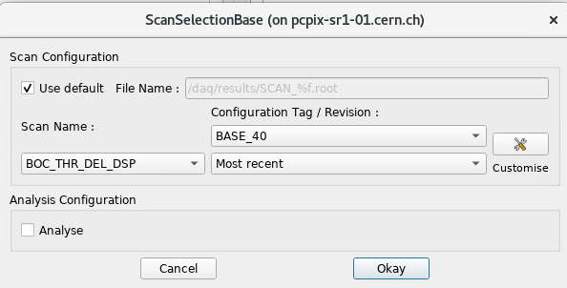

These 4 scans can be run (more information in theses and documentation)

* BOC scan – can be done with just LV ON
* Digital Scan – can be done with just LV ON
* Analog – has to be done with HV ON
* Threshold – has to be done with HV ON

For more details refer to

<https://gitlab.cern.ch/atlas-pixel/daq/atlaspixeldaq/-/wikis/Calibration-procedure#sr1>

**Datataking**

This is done similar to using the emulator, except the modules have to be turned on first as described in the first section and we need to use another runconfig and set the stable beams flag in TagManager

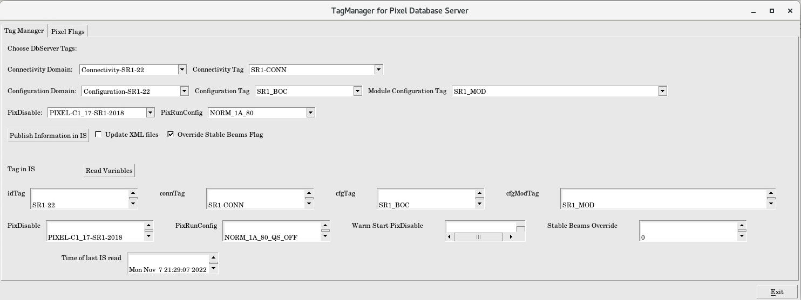

Make sure Override stable beams flag is set. This turns on the preamplifiers. The preamp amplifies the input at the front ends, so we do see some data, if it is off we cannot see any data coming in.

The correct runconfig has to be selected- currently the standard one for SR1 with real modules in NORM_1A_80. Also make sure the correct disable (specifically marked SR1 and not EMU) is selected since not all modules are working and including those in the disable can cause problems.

After this, datataking can be run in DAQSlice as usual (with correct selections in segments and resources).

**Switching off modules/closing FSM**

After you are done using modules (either datataking or calibration) navigate to the menu of state transitions (as describes during switching on) select BACK_TO STARTED.

In case there is any error or undefined state, go back to started.