Coventry University

BSc (Hons) Computing (Full-time) 2024 Intake

**Coursework Title:** **Animal The Earth**

Topic: Identify and design a mobile app for kid to know animal

Lecture: Will KWOK

Student Name: WONG Wai Chung  
 Student ID: 227108934

Module Code: VT6002CEM

Module Title: Mobile App Development

Project Title: Using Mobile Technology and augmented reality(AR) to make kid can interactive

25th December 2024

**1. Introduction 1**

1.1Aim and Objectives: 1

1.1.1 Objectives 2

1.2Idea of Mobile App 3

1.4 Comparison with Similar Apps 3

1.4.1 Animal games 3

**2. App Development Platform and Tools 4**

2.1 Key Design Considerations 5

**2.2 Development Framework 5**

2.2.1 Flutter 5

**3.1 Data storage 6**

**3.2 Hardware requirement 7**

**3.3 Software requirements 7**

**6.Conclusion 8**

**7. References 8**

# 

# 

# 1. Introduction

In recent years, animal-themed educational applications have surged in popularity, effectively engaging children by combining entertainment with learning. These apps utilize interactive elements to teach various subjects, from basic literacy to environmental awareness, leveraging children's natural curiosity about animals to enhance educational outcomes(Neeyathi-August 8, 2023 at 7:21 pm).

While there is no dearth of such apps, what is lacking is apps on real-time animal detection combined with educational content, specially designed for kids. Current apps are static information-based or simulation apps and have not been able to bring dynamism into this area as can be facilitated by using technologies like artificial intelligence (AI) and augmented reality (AR). It is, therefore, at this gap that an ingenious app needs to be constructed in order to provide education, rather than mere schooling, about the animal kingdom in a real interactive way to children.

## 1.1Aim and Objectives:

The goal of the proposed application "Detect Animal" is that children learn about different animals in a more fun, interactive way. This encourages discovery learning, a known educational approach as "learning by discovering." The plus side is that students involved in their own learning processes are more motivated and encouraged to learn. Knowledge found through discovery is more satisfying and long-lasting than knowledge merely learnt (August 05, 2024 - Kiddus Team).

The proposed app, **"Detect Animal,"** takes inspiration from the **Montessori Method** of a child-centered approach to educational training that was developed in the early 1900s by Dr. Maria Montessori. The Montessori Method puts an emphasis on activity and self-directed learning. It focuses on holistic development: social, emotional, intellectual, and physical. This application seeks to foster curiosity among children and allow them to take the lead in their learning process through the incorporation of these elements, (according to Hannah Meinke on 11/04/2019).

### 1.1.1 Objectives

1. **Provide Immersive AR Experiences:** Use AR to show the real-time 3D model of the animals in a real-world environment; let kids interact with the animals as if they were more real and fascinating.
2. **Hands-on Exploration:** Allow image recognition software to be incorporated into a child's ability to photograph or upload pictures of animals for the development of their discovery and curiosity of things that surround them.
3. **Rich in Delivering Educational Content:** Include comprehensive notes, images, and multimedia resources regarding each animal's habitat, behavior, and role within the ecosystem for a well-rounded learning experience.
4. **Encourage Curiosity Through AI Chatbot:** Provide an interactive chatbot AI that can answer questions, state fun facts, and explore animal knowledge with the children in a conversational style.
5. **Enable Worldwide Exploration through Interactive Maps:** Include an interactive world map that shows the distribution of various animal species, in which the children can relate to the concept of biodiversity and different habitats around the world.
6. **Application of Montessori Principles:**
   * Allow children to make some autonomous choices of topics and activities independently to develop a sense of autonomy and intrinsic motivation.
   * The design of the app should support self-paced learning, taking into consideration different levels of interest and comprehension.
   * Create an environment that balances fun, discovery, and structured educational outcomes.

Through its innovative coupling of discovery-based learning with a Montessori education style, **"Detect Animal"** encourages hands-on, active engagement of kids in the discovery and construction of knowledge to nurture respect for the living environment in every little child.

## 1.2Idea of Mobile App

The proposed mobile application, "Detect Animal," will be a learning platform where children can be introduced to the exciting world of animals in a very interactive and innovative manner. Combining state-of-the-art technologies such as AR and AI with principles of discovery-based learning and the Montessori Method, this app will be able to provide an unbeatable learning experience that nurtures curiosity, independence, and a deeper understanding of nature.

The whole concept of "Detect Animal" is to give the child the tools necessary for exploring and learning about the animals surrounding him, from his nearest environment to a broader scope, turning all daily experiences into moments of discovery and learning. The application is made intuitive and attractive to the eyes of young students, making education fun and interactive.

## 1.4 Comparison with Similar Apps

To compare others, you can also teach it to know more animals, there are a few apps.

| name | Animal Games | Learn animals for kids |
| --- | --- | --- |
| logo | <https://play.google.com/store/apps/details?id=com.nightboost.kids.animals.lite> | <https://play.google.com/store/apps/details?id=com.kokotots.animalkingdom> |

### 1.4.1 Animal games

|  |  |  |
| --- | --- | --- |

This app just taps the animal and shows related information. Apps like "Animal Games," which just allow users to tap on an animal and present static information, don't mesh well with the Montessori Method or discovery-based learning due to their lacking elements that would fit those approaches—interactive, self-directed, and exploratory learning.

1.4.2Learn Animals for Kids

|  |  |  |
| --- | --- | --- |

This just the vocabulary app, the information is provide by the app, is not the kid discover, ,also there are just include puzzle function apps, the kid can’t interaction, so this is not the good, app.egrate the Montessori Method and discovery-based education into "Detect Animal," the app needs to go beyond the passive interaction of simply tapping an animal to display information. Instead, it should focus on features and activities that will actively engage children in the learning process and foster a taste for inquiry, investigation, and self-discovery.

# 2. App Development Platform and Tools

This marketing researcher reports that 69.9% of users are on Android and 29.3% on iOS (November 19, 2024 - Andrew Buck). In the former case, a larger community can offer better support during development. It also means access to many open-source libraries. More people use Android than iOS users. Android platform development, however, has its challenges, for example, the security concern. Therefore, developing for both Android and iOS would be the best strategy, which would make an application available for all users on mobile platforms.

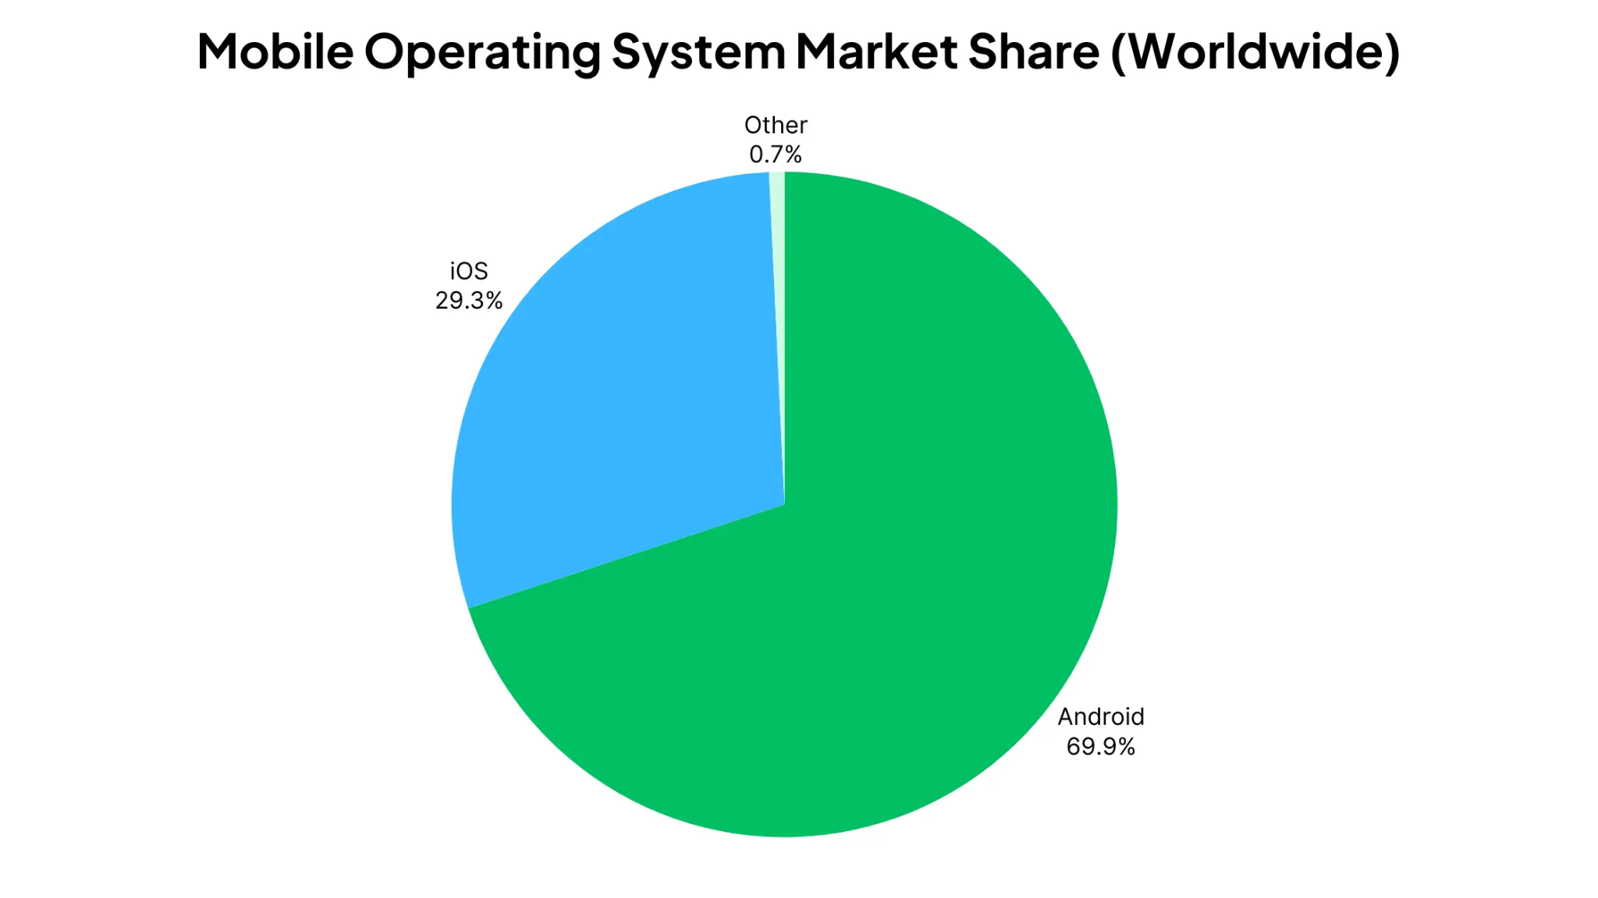

## 2.1 Key Design Considerations

* - **Data Persistence**:

Explain how user data (e.g., notes and progress) will be stored securely using local storage or cloud databases like Firebase.

* - **Sensors, Hardware, and APIs**:

Describe the use of the camera and AI APIs (e.g., TensorFlow Lite) for animal detection.

using chatGPT’s API to make the chatbot AI function.

# 2.2 Development Framework

## 2.2.1 Flutter



With Flutter, one is able to work on Android, iOS, Linux, macOS, and Windows. More information, until October 30th, 2024, Daniela Montaño. Besides that, Flutter provides developers with an extensive set of widgets, which are freely adjustable and allow designers to create remarkable and appealingly interactive user interfaces for the application. Due to the above reasons, Flutter will be the most preferred in applications that have to look good and also function well. Using Flutter allows the developer to create, with ease, outstanding and very expressive UIs that could be difficult or impossible to obtain with other frameworks. (Dan Gower, Sep 1, 2023).

# 3.1 Data storage

In market, not only Google firebase, their are other backend, such as AWS (Amazon Web Services)

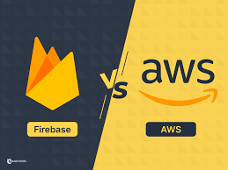

but I still to choose google

| | **Feature/Aspect** | | --- | | Firebase | | **AWS (Amazon Web Services)** | | --- | |
| --- | --- | --- | --- | --- |
| Provider | Google | Amazon |
| | **Primary Use Case** | | --- | | Backend as a Service (BaaS) for rapid development of mobile and web applications with real-time capabilities. | Infrastructure as a Service (IaaS) and Platform as a Service (PaaS) offer an extensive range of cloud services for all types of applications. |
| | **Ease of Use** | | --- | | User-friendly  interface and integration of services; good for rapid development cycles. | Full suite of services with a higher learning curve; more configuration and management are needed. |
| | **Real-Time Capabilities** | | --- | | Provides real-time data synchronization, perfect for applications that require live updates—for example, chat apps or collaboration tools. | Real-time capabilities can be implemented; some might just need some configuration and extra services. |

source:Updated on 19th Apr, 2024 -[Naman Sinha](https://www.knowledgehut.com/blog/author/naman-sinha)

Conclusion:

**Why Choose Firebase?**

* **Rapid Development: Firebase's managed services and simple interface make for a fast development and deployment time, hence a great choice for startups and projects on tight deadlines.**
* **Real-Time Data Synchronization: The real-time database capabilities of Firebase greatly help applications requiring live updates of data—for example, chat applications and collaborative tools.**
* **Integrated Services: Firebase provides an integrated suite of tools in one place for analytics, authentication, hosting, and many more.**
* **Automatic Scaling: Handles the scaling automatically, so developers can simply focus on building features rather than worrying about managing infrastructure.**

(source:Updated on 19th Apr, 2024-[Naman Sinha](https://www.knowledgehut.com/blog/author/naman-sinha))

# 3.2 Hardware requirement

⚫ Cameras

As the core AR technology, it requires a phone with a camera to display it.

⚫ Configuration

The ability to display 3d models in the program requires a high phone configuration, in the

case of the Snapdragon, at least a Snapdragon 700 or higher to ensure smooth operation.

# 

# 3.3 Software requirements

⚫ System version requirements

Due to the new technology, the user's phone system must be Android 15 or above and iOS

18 or above.

# 

# 6.Conclusion

"Detect Animal" fills a clear gap in the educational apps market by seamlessly merging real-time animal detection with the Montessori Method and discovery-based learning principles. Unlike many static, tap-to-reveal animal apps, "Detect Animal" harnesses **augmented reality (AR)** and **artificial intelligence (AI)** to provide a hands-on, exploratory experience. Children can photograph animals in their surroundings, engage with 3D models in real-world environments, and inquire about habitats, behaviors, and conservation through an AI chatbot—all of which make learning more meaningful, immersive, and self-directed.

Overall, "Detect Animal" stands poised to redefine how children explore and learn about the animal kingdom. By blending **cutting-edge technology**, **discovery-based pedagogy**, and the **Montessori ethos**, the app addresses critical educational needs and offers a scalable, modern platform for interactive, meaningful learning experiences.

# 7. References

<https://www.rasmussen.edu/degrees/education/blog/pros_cons_montessori_education/#:~:text=The%20Montessori%20Method%20was%20developed,that%20make%20it%20unique%20include>:

Exploring the Pros and Cons of Montessori Education

By [**Hannah Meinke**](https://www.rasmussen.edu/student-life/blogs/author-archives/hannah-meinke/) on 11/04/2019

<https://briebrieblooms.com/best-animal-apps-for-kids/?utm_source=chatgpt.com>

The 10 best animal apps for kids

[**Neeyathi**](http://animal/)-[August 8, 2023 at 7:21 pm](https://briebrieblooms.com/best-animal-apps-for-kids/#comment-20304)

<https://kiddus.com/blogs/blog/discovery-learning?utm_source=chatgpt.com>

Discovery learning: What it is, Examples and How to apply it

August 05, 2024-Kiddus Team

<https://www.mobiloud.com/blog/android-vs-ios-market-share>

Android vs iOS Market Share: Most Popular Mobile OS in 2024

November 19, 2024-[Andrew Buck](https://www.mobiloud.com/author/andrew-buck)

<https://waverleysoftware.com/blog/why-use-flutter-pros-and-cons/?utm_source=chatgpt.com>

WHY USE FLUTTER: PROS AND CONS OF FLUTTER APP DEVELOPMENT

Updated October 30, 2024 [Daniela Montaño](https://waverleysoftware.com/blog/author/dmontano/)

<https://designli.co/blog/flutter-application-development/?utm_source=chatgpt.com>

What is Flutter Application Development? (Pros and Cons)

[Written by Dan Gower](https://designli.co/blog/author/dan-gower), Sep 1, 2023

<https://www.knowledgehut.com/blog/cloud-computing/aws-vs-firebase?utm_source=chatgpt.com>

AWS vs Firebase: Which One to Choose in 2024?

Updated on 19th Apr, 2024-[Naman Sinha](https://www.knowledgehut.com/blog/author/naman-sinha)