ST10446731

PROG6212

POE PART 1

Contents

Introduction 2

UML Class Diagram 5

Project Plan 6

# Introduction

For Part 1 of this project, I will only be showcasing the user interface (UI) of the CMCS. This includes the design of the application's graphical components and the overall user experience, with a focus on visual appeal and logical layout. No functionality will be demonstrated in this part; it's purely a visual representation of the final product. WPF is the better option for creating applications over MVC.

The CMCS is built to be user-friendly, clear, and straightforward. It aims to provide an easy experience for all users, including independent contractors (ICs) and administrators, so tasks can be completed quickly and without confusion.

**User-Friendly Layout:** The interface will be organized and uncluttered. Key actions such as "Submit Claim" and "View Claims" will be clearly visible on a main dashboard or navigation menu.

**Simple and Clear Layout:** The system will have a clean, organized layout. Main features like "Submit Claim" and "View Claims" will be easy to find and access from a central dashboard or menu.

**Consistency:** All pages and features will follow the same design style. Navigation menus, buttons, and colours will be consistent throughout the system, helping new users learn quickly.

**Minimalist Design:** Unnecessary elements will be removed so the interface focuses on the main tasks. This makes it easier for users to complete their work without distractions.

Assumptions:

* User Skills: It is assumed that IC lecturers and administrators are familiar with basic web applications and have access to a computer with internet.
* Data Accuracy: Information provided by IC lecturers, such as claim details and supporting documents, is assumed to be correct.
* System Reliability: The system is expected to run on a secure, stable server with regular backups to prevent data loss.
* User Roles: User roles are clearly defined, with specific permissions for lecturers, programme coordinators, and academic managers, supporting a structured approval process.

**Constraints:**

* **Time and Resources:** The project must be completed within the college’s deadlines and available resources.
* **Browser Compatibility:** The system is designed for modern web browsers and may not work well on older or uncommon browsers.
* **Technology:** The project will use .NET, C#, and Microsoft SQL Server. Other technologies will not be used.

UML Class Diagram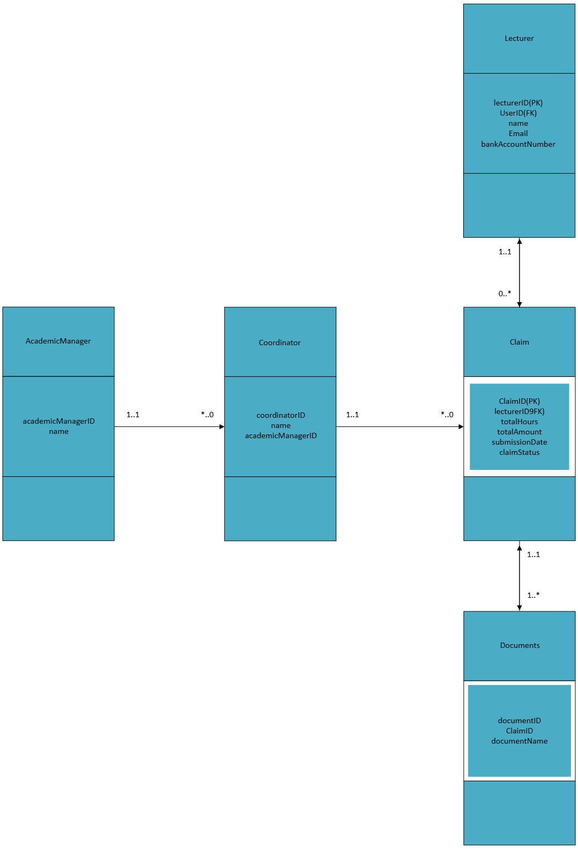

## Project Plan

|  |  |  |  |
| --- | --- | --- | --- |
| Task | Duration | Start/End Dates | Dependencies |
| Project Plan |  |  |  |
| 1. Define Project Scope & Requirements | 4 days | 2025-09-09 to 2025-09-13 | None |
| 2. Plan GUI & User Flow | 2 days | 2025-09-19 to 2025-09-22 | Task 1 |
| 3. Set up Development Environment | 5 days | 2025-09-23 to 2025-09-24 | None |
| 4. Implement Database | 10 days | 2025-09-25 to 2025-09-29 | Task 2 |
| 5. Build Claim Submission Module | 6 days | 2025-10-04 to 2025-10-10 | Task 4 |
| 6. Develop Claim Approval Workflow | 5 days | 2025-10-11 to 2025-10-16 | Task 4 |
| 7. Create Reporting & Export Features | 6 days | 2025-10-17 to 2025-10-21 | Task 4, 5, 6 |
| 8. Perform Unit & Integration Testing | 3 days | 2025-10-22 to 2025-10-26 | Tasks 5, 6, 7 |
| 9. Finalize Documentation | 10 days | 2025-10-27 to 2025-10-29 | All previous tasks |
| 10. Prepare Prototype for Presentation | 3 days | 2025-10-30 to 2025-10-31 | Task 9 |