**Does Radiation Exposure affect Body Temperature?**

***Ben Frazier, Ethan Straub, and Ronnie Delgado***

**Executive Summary and Abstract**

This study was conducted with the goal of understanding the effects of radiation on body temperature. Our population of interest is all people living on the islands of Providence, Ironbard, and Bonne Sante. We implemented a longitudinal experiment where we randomly assigned subjects to receive either the treatment (one gray of radiation) or control (no radiation). The subject's body temperature was measured before the treatment, directly after the treatment, and 3 months after the treatment. An analysis using mixed models was conducted using models with random intercepts for each person, along with covariates and possible interactions. No statistically significant evidence of an effect of radiation on body temperature was found.

**Introduction**

Humans absorb all kinds of radiation, a lot of which come from medical procedures and others from exposure to natural sources. According to the EPA, on average, humans annually absorb 620 millirems of radiation. The study’s purpose has multiple contexts in which it can fit into. It has the potential to help us understand the health related impact of people who undergo regular medical procedures, or people who live and work in close proximity to nuclear plants that emit significant amounts of radiation.

The Islands currently have only one way to administer radiation that is absorbed, with the unit Gray (Gy for short). One Gray of radiation is equivalent to 10,000 milirems, which means the 1 Gray that we expose subjects to is 16.13 times more radiation than the average person absorbs annually. We are interested in measuring both the short-term and the long-term health effects of something this extreme. In this case, we use body temperature as a proxy variable for human health, where we expect to see the most change for the islanders.

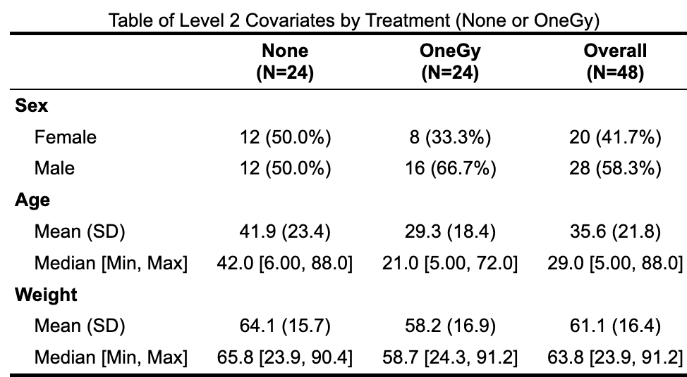

**Table 1**

The table gives the number of participants of each sex and the percentage of females and males in each treatment group,

as well as the mean, standard deviation, median, minimum, and maximum of age and weight for each treatment group.

*Note: Age is measured in years, and height is measured in kilograms

Table 1 gives summary statistics of our sample of 48 people on the islands. We will further discuss variables included in this table in the methods section. By chance, twice as many males were assigned to the OneGy group compared to females. However, sex is not likely a confounding variable because it does not appear to have a relationship with Body Temperature (Refer to Figure 2 in the Appendix).

**Methods**

An experimental longitudinal design was implemented. In each of the 4 largest cities on each of the 3 islands, 4 houses were selected, and 1 person was chosen from each house. Of the 4 people selected from each city, 2 were randomly assigned to receive no radiation, and the other 2 were assigned to receive 1 Gy of radiation. The sample function in R was used to randomly sample house numbers, and a person within each house. For each person, body temperature was measured before the treatment, right after the treatment, and 3 months after the treatment.

Data was collected for every individual’s sex, age, and weight, as well as the outside temperature. These are potentially important covariates that may explain variability in body temperature. Outside temperature was chosen as a substitute for ambient room temperature, as this was not an available measurement for the islanders. Table 2 below explains all variables that were measured for the purpose of analysis.

**Variables Table**

| **Variable** | **Description** | **Units** | **Role** |
| --- | --- | --- | --- |
| Person | A unique ID for each person | Categorical | Precision |
| Treatment | The treatment the person was assigned to | Binary ((No radiation or 1 Gy of Radiation) | Primary Explanatory Variable |
| trtTime | The time at which the body temperature was measured relative to when the treatment was given. | Used as Ternary (Before treatment, After treatment, or 3 months after treatment)  Or Continuous (1,2,3. 1 for Before treatment, 2 for After treatment, and 3 for 3 months after treatment) | Precision |
| Sex | The person’s sex | Binary (Male or Female) | Precision |
| Age | The person’s age | Years | Precision |
| Weight | The person’s weight | Kilograms | Precision |
| Outside Temp | The high temperature for the day | Celsius | Precision |
| Body Temp | The person’s body temperature | Celsius | Response |

**Table 2**

For all variables that were used in analysis this table provides

a description, units, and the variable’s role in the analysis.

4 people dropped out of the study in between the “after” and “3 months after” measurement times, so we are lacking 4 measurements for body temperature 3 months after the treatment was given. Of the 4 individuals who dropped out, 3 of them received radiation, and none of them had concerning body temperature measures directly after they were exposed to radiation (As seen in Figure 3 in the Appendix). However, we are unsure why these participants dropped out of the study and are unable to communicate with them about their health, so we cannot claim that these 4 measurements are not MNAR (Missing not at Random).

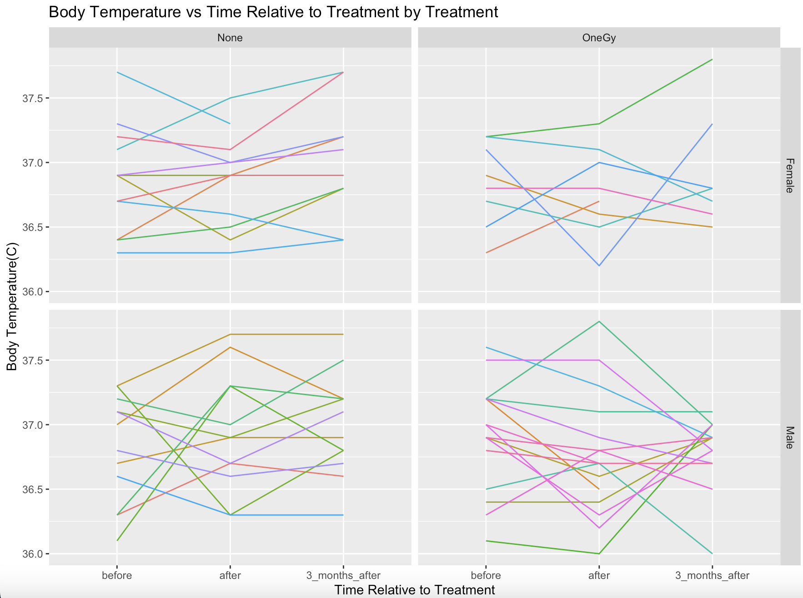

**Figure 1**

The figure shows the body temperatures for each person every time their body temperature was measured.

Plots were split by Treatment (for comparison between treatments) and Sex (for ease of viewing)

*Note: The 4 individuals who dropped out of the study are included in this figure

Looking at Figure 1, there does not appear to be a relationship between the treatment and body temperature. But it does look like there is variability in body temperature from person to person. Additionally, there is no clear trend in body temperature throughout the study for either treatment group.

**Results**

All potential models along with their coefficients are shown below in Table 4. The lmer_int_rsri and lmer_add_rsri model used trtTime as a continuous variable while all other models treat trtTime as categorical. Refer back to table 2 to see how trtTime was made continuous.

**Table of Candidate Models and their Coefficient (SE) Estimates**

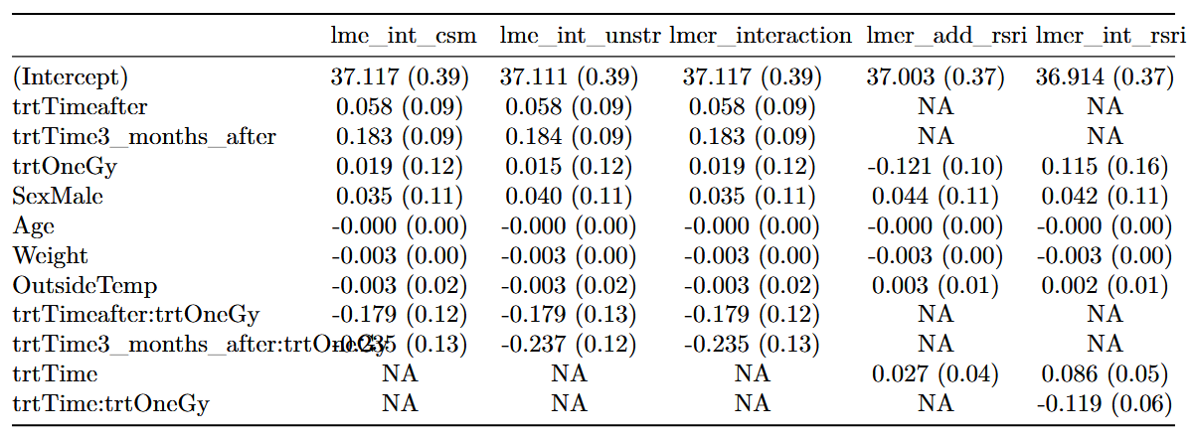**Table 4**

Coefficient table of candidate models. Each column is a candidate model and each row is a coefficient.Standard errors are within parentheses.

Not all the models had every comparable coefficient so NA’s were added where appropriate.

Fixed Effect Interaction (int), Additive (add), Random-slope Random-intercept (rsri), Random Intercept (ri), Unstructured RE covariance (unstr), Compound Symmetry(csm)

All models were fit using REML

**Table of AIC and BIC**

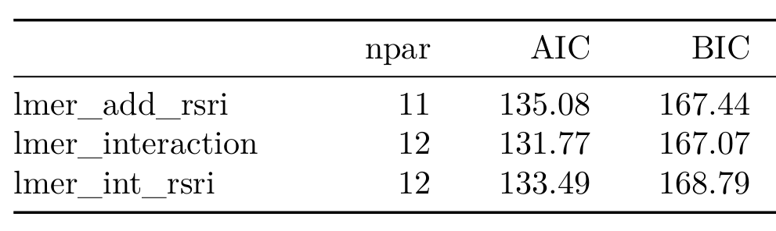**Table 5**

AIC and BIC Table of models fitted, including the number of parameters for each model.

Using table 5, the lmer_interaction model with only a random intercept was chosen since it has a similar AIC as the additive model with greater degrees of freedom and the lowest BIC of any model. An interaction makes sense for this model because the effect of radiation should depend on the time relative to exposure. Before radiation exposure, both the control and treatment groups should have similar body temperatures since neither had been exposed to radiation. And after exposure, the radiation may cause changes in body temperature for the treatment group but not the control group.

Using a parametric bootstrap with 10,000 simulations from the chosen model, we found that the interaction between treatment and treatment time is not significant (p = 0.15). Using the additive model, the treatment effect is also not significant (p = 0.257).

An “empty” model was fit using only the person random intercept to calculate a raw ICC of 0.43. This can be interpreted as 43% of the variation in the data has been accounted for by the differences between people.

The same “empty” model was also used to test the null hypothesis that the variance component of the person random effect is equal to zero for the lmer_interaction model. A likelihood ratio test was then conducted, with a likelihood ratio test statistic of 24.57 (p = 7.16e-07), meaning we reject the null hypothesis that there is no difference in body temperature between people.

**Discussion**

We were surprised to find no significant effect of radiation on body temperature. Body temperature appears to be stable across ages, weights, sexes, outside temperatures, and radiation exposure. This lack of significance supports the supposition that if radiation does have any effect on body temperature, it is a small effect.

To model a random slope random intercept model, trtTime had to be converted to numeric and due to non-standard time measurements. Any interpretations could be misleading but overall allowing the effects of a Grey exposure to vary by individual could be an area for further research.

It seems entirely possible that a sample size of 48 was too small for the model to detect the effect of radiation. And it also could be that 1 Gy of radiation is not strong enough to affect body temperature. In this study, body temperature was chosen as a proxy for overall cellular health. But there are many other potential response variables that could be used instead of body temperature in order to get a broader understanding of how radiation affects the human body. For future studies, we recommend increased sample size, and different response variables, such as measures of skin health or cancer rates.

Another potential concern for this study is the fact that the control group was not given a placebo. So if knowing whether or not you were exposed to radiation causes a change in body temperature, the results of this study could be erroneous. A future study could make every subject believe that they were exposed to radiation to eliminate any placebo effect.

**Appendix**

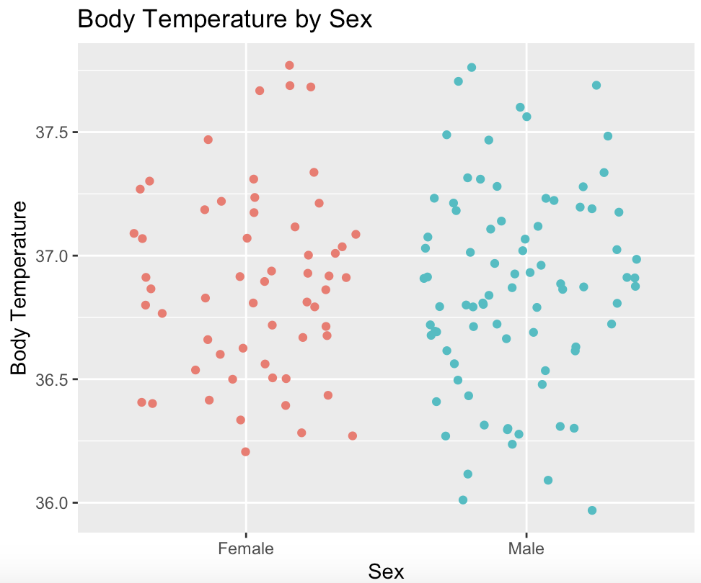

**Figure 2**

The figure shows the distribution of Body temperature for each sex in a jitter plot.

There may be more variation in male body temperature compared to females,

but there does not appear to be a large difference in the center of each distribution.

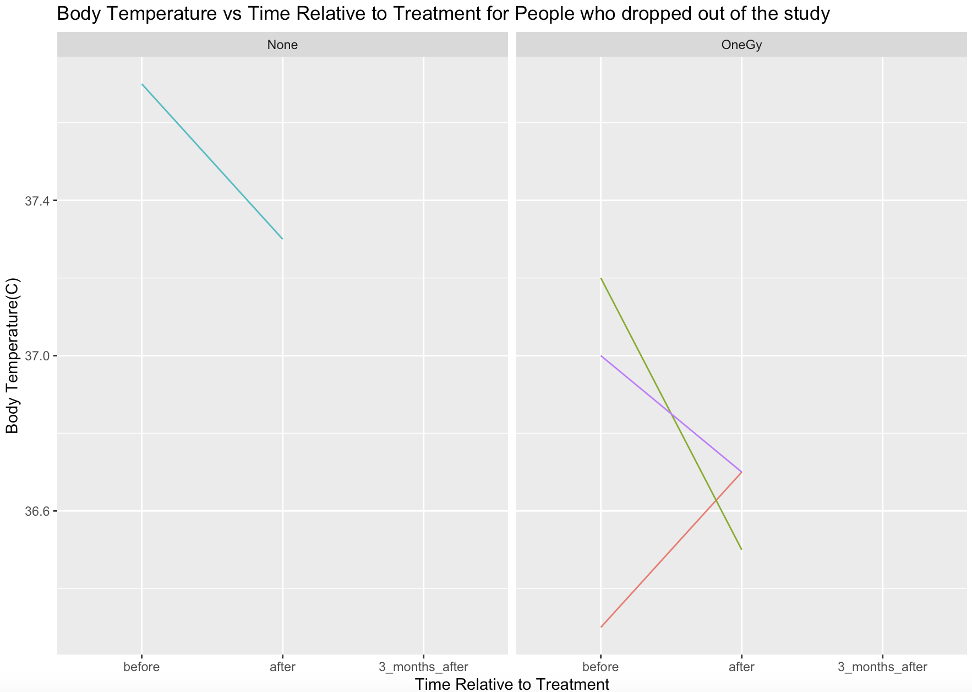

**Figure 3**

The figure shows the body temperatures for each person who dropped out

of the study, every time their body temperature was measured.

Plots were split by Treatment(for comparison between treatments.