

TRANSACTION MONITORING MODEL
BANKING
BN140 - COMMERCIAL P2P MONITORING
Prepared by: Mohamed Ssafini
Document Version: 1.0
Last Updated: March 30, 2026. [Modele_BN_140 | PDF]

MODEL OVERVIEW: BN140_COMMERCIAL P2P MONITORING
Regulatory Context
The Proceeds of Crime (Money Laundering) and Terrorist Financing Act (PCMLTFA) requires financial institutions to report suspicious transactions. Accordingly, banks must conduct ongoing monitoring of customer transactions and enhanced monitoring of entities assessed as having a high AML/ATF risk.

Business Context
Transaction monitoring enables the detection of indicators of suspicious activity. The Bank has an automated transaction monitoring system designed to identify such activities. Multiple scenarios and models have been developed within the system to cover a wide range of indicators and money laundering typologies.
A broad spectrum of indicators and typologies exists across the three stages of money laundering: placement, layering, and integration.
This model is intended to address the placement, layering, and integration stages for customers conducting P2P transactions and covers the indicators identified during the business requirements definition and model design phases, which are discussed throughout this document.
The BN140 – Commercial P2P Monitoring model is designed to detect potentially suspicious commercial P2P transactions occurring over a one-month period that may indicate money laundering or other illicit activities. This new model is an enhanced version of the existing model (SA-P2P01C – Commercial Interac P2P Monitoring). It was developed to maintain coverage of the money laundering typologies addressed by the existing model while expanding coverage to new typologies and additional types of P2P transactions.

Model Description
The BN140 – Commercial P2P Monitoring model seeks to identify customers engaging in suspicious activities involving commercial P2P transactions.
The following indicators and risk factors are considered in the unsupervised SVDD and Isolation Forest models:
- P2P transactions (incoming and outgoing), including both transaction count and volume
- P2P transactions involving round-dollar amounts (no decimal values)
- P2P transactions conducted during late-night hours (11:00 PM to 4:59 AM)
- Rapid movement of funds
- Ratio of P2P transaction amounts to total transaction amounts
- Ratio of outgoing P2P transaction amounts
- Ratio of incoming P2P transaction amounts
- Length of the customer's relationship with NBC
- Customers holding only one product with NBC ("orphan customers")
- Numbered corporations (numbered companies)

Data Used
FCT data is used for data exploration, model calibration, and performance monitoring.
Once the model is deployed to production, alerts will be generated in SAS and subsequently routed to the Actimize transaction monitoring platform.

Expected Performance
The expected performance of the new model on the new population is summarized below:
- Based on the calibration results for September 2025, the overall relevance rate of escalated alerts is expected to be approximately 50%.
- Alert volumes were estimated at approximately 93 alerts per month, taking into account the multiple-alert management process and using recent data (October 2025 to February 2026). This represents a volume comparable to that of the model currently in production, while delivering an improved relevance rate.

Performance Monitoring
Performance indicators will be monitored on a monthly basis through a dashboard produced by the MTT team. The dashboard is available through the designated monitoring platform. [Look at the link]

Model Risk Rating
The model is classified as Low Risk, with:
- Low materiality risk, and
- Medium uncertainty risk.

Table of Contents
1. Model Objective ....................................................................................................... 9
1.1 Regulatory Context ................................................................................................ 9
1.2 Business Context .................................................................................................. 9
1.3 Model Framework ................................................................................................ 9
1.4 Monitoring Scope ................................................................................................... 9
1.5 Risks, Typologies, Operational Alerts, and FINTRAC Special Bulletins ...................... 10
2. Source Data ............................................................................................................ 11
2.1.1 Data Used ....................................................................................................... 11
2.1.2 Data Quality ................................................................................................... 12
2.1.3 Limitations and Exclusions ............................................................................. 13
2.1.4 Data Analysis / Profiling ................................................................................. 13
3. Model Specifications .............................................................................................. 16
3.1 Model Description ............................................................................................. 16
3.2 Model Assumptions .......................................................................................... 16
3.3 Model Variables and Parameters ...................................................................... 16
3.4 Model Methodology and Algorithm ................................................................... 20
3.4.1 Sampling .................................................................................................... 20
3.4.2 Data Analysis ............................................................................................. 21
3.4.3 Model Algorithm ........................................................................................ 21
3.5 Results of Analyses, Testing, and Model Calibration ......................................... 24
3.5.1 Analysis Results .......................................................................................... 24
3.5.2 Testing and Calibration ............................................................................... 25
3.5.3 Final Model Definition .................................................................................. 25
3.5.4 Expected Alert Volume ................................................................................. 26
3.5.5 Expected Performance ................................................................................. 27
3.5.6 Performance Monitoring .............................................................................. 27
4. Model Risk and Materiality Level ........................................................................... 27
5. Model Review Cycle ............................................................................................... 28
6. Recommendations and Improvement Opportunities ............................................. 28
Appendix I. List of Variables Considered for Model Development .............................. 28
Appendix II. References ............................................................................................. 29

- Model Objective

  - Regulatory Context
The Proceeds of Crime (Money Laundering) and Terrorist Financing Act (PCMLTFA) requires financial institutions to report suspicious transactions. Accordingly, banks must conduct ongoing monitoring of their customers’ transactions and enhanced monitoring of entities assessed as presenting an AML/ATF risk.
The Bank has implemented rigorous procedures to actively participate in the fight against money laundering and terrorist financing without prejudice or bias. Permanent Instructions IP I515-020 and IP 011-013 describe, respectively, money laundering typologies and the Bank’s AML/ATF policy.

  - Business Context
Transaction monitoring enables the detection of indicators of suspicious activity. The Bank has tools and monitoring measures in place to identify such transactions. Several models have been developed within the SAS platform to cover key indicators and typologies using a risk-based approach.
A broad range of indicators and typologies exists to address the three stages of money laundering: placement, layering, and integration.
This model is intended to cover the placement, layering, and integration stages for customers who make suspicious use of P2P transactions. It addresses the indicators identified during workshops specifically dedicated to this topic.
Indicators derived from FINTRAC operational alerts, as well as input from financial crime experts within the Compliance sector, contributed to the development of this model.
The BN140 – Commercial P2P Monitoring model is designed to identify customers whose P2P transactions are outside normal expectations and may be associated with money laundering or other illicit activities.
In addition, this model aims to improve the effectiveness of the existing P2P01C model while reducing the volume of false positives.

  - Model Framework
Monitoring models are categorized according to business line and the nature of the products and/or services offered by the Bank.
This model falls within the monitoring framework for Category 1: Banking. The model targets commercial customers, as described in the following sections. The monitoring approach adopted for this segment is ongoing monitoring.

  - Monitoring Scope
The objective of the new model is to detect illegal activities by monitoring: P2P transaction volumes and frequencies; Rapid movement of funds; Nighttime transaction activity; Round-dollar transaction amounts; and High-risk business characteristics and industries.
The model is executed on a monthly basis and covers all primary commercial customers of NBC who have conducted at least one P2P transaction during the month.
The data used during the development and testing phases to calibrate the algorithm parameters for analyzing P2P transactions covers a six-month period, from November 1, 2024, through April 30, 2025, inclusive. The following section provides an overview of incoming and outgoing P2P transaction volumes for commercial customers during this period.
Month | Number of Clients | Avg. Incoming P2P Transactions | Max. Incoming P2P Transactions | Avg. Incoming P2P Amount | Max. Incoming P2P Amount | Avg. Outgoing P2P Transactions | Max. Outgoing P2P Transactions | Avg. Outgoing P2P Amount | Max. Outgoing P2P Amount
202411 | 44,226 | 5.1 | 1,072 | 5,541 | 1,019,619 | 3.2 | 198 | 5,596 | 278,440
202412 | 45,295 | 4.5 | 1,483 | 5,300 | 1,206,167 | 3.3 | 396 | 5,973 | 375,000
202501 | 44,305 | 4.7 | 1,472 | 4,849 | 1,169,711 | 3.0 | 752 | 5,268 | 262,684
202502 | 43,639 | 4.4 | 1,181 | 4,625 | 1,105,987 | 2.9 | 168 | 5,212 | 275,000
202503 | 45,576 | 4.8 | 1,409 | 5,100 | 1,114,121 | 3.2 | 200 | 5,531 | 323,073
202504 | 47,042 | 5.1 | 1,050 | 5,425 | 1,187,911 | 3.2 | 200 | 5,747 | 346,950

BN140 – Commercial P2P Monitoring includes expanded and updated coverage of eligible P2P transaction types compared with the legacy model currently in production. Transaction types shown in bold have been newly added to the model’s coverage. These transaction types reflect the new tags introduced as part of product enhancement initiatives.
Transaction Type | Description
VIRCR/IN/P | Interac Credit Transfer – Other Individual
VIRDT/IN/P | Interac Debit Transfer – Other Individual
MOB/VIRD/P | Interac Mobile Debit Transfer
MOB/VIRC/P | Interac Mobile Credit Transfer
MBI/VRDTI | Interac Transfer
DMD/FD/INT | Interac Fee Request
DD/FD/IAC | Interac Funds Request
SV/VIR/INT | Interac Transfer Service
VIR and Unknown Channel | Interac Transfer Service
VIRINST | Instant Interac Transfer

  - Risks, Typologies, Operational Alerts, and FINTRAC Special Bulletins

The FINTRAC website (https://fintrac-canafe.canada.ca/intel/sintel-eng) is an important source of indicators, typologies, operational alerts, and special bulletins related to AML/ATF risks.
Since 2016, FINTRAC has regularly published operational alerts developed by its experts using strategic intelligence and based on public-private partnerships aimed at combating specific financial crimes. Suspicious transaction reports associated with these initiatives are identified by a “#...” designation.
The Bank also relies on internal sources, including:
- IP515-020, which helps employees understand the primary typologies used by criminals to launder proceeds of crime. It is used within the Bank to identify potentially suspicious transactions, including through automated monitoring models.
- The Compliance SharePoint site, which serves as a reference for internal training and a source of relevant information related to AML/ATF risks.
Several risk indicators were discussed and analyzed during workshops with the sector’s AML/ATF experts. These indicators are based on contributors’ expertise in model design, FINTRAC indicators and operational alerts applicable to this type of product or customer, as well as observed or reported cases that were included within the scope of the analysis.
The main indicators identified are summarized below:
- P2P transactions (incoming and outgoing), including transaction count and volume.
- Ratio of P2P transaction amounts to total transaction amounts.
- Ratio of outgoing P2P transaction amounts.
- Ratio of incoming P2P transaction amounts.
- P2P transactions involving round-dollar amounts (without decimal values).
- Rapid movement of funds: funds that, after being received, are transferred onward (80% to 100%) within 24 hours are considered a risk indicator for fraudsters, scammers, and money mules. If a similar proportion is transferred within seven days, it may indicate money laundering activity, narcotics trafficking, or procuring-related activities.
- Transactions conducted during late-night hours (between 11:00 p.m. and 4:59 a.m.).
- Recurring transfers of round-dollar amounts within defined thresholds may help identify potential money laundering activity.
- The recency of the customer’s relationship with the Bank is also a relevant risk factor. Customers who have recently joined the Bank and who conduct substantial volumes of P2P transactions present a higher risk.
- Customer type: commercial customers.
- Orphan customers: customers who hold only a single product with NBC.
- Numbered corporations, which may be an indicator of money laundering activity.

- Source Data

2.1.1 Data Used
The FCT schema was used for model development and contains all customer data required for the design and implementation of the model.

Actimize (FCT) Tables Used During Model Development
- FCT.V_IMPL_ALERTED_SCENARIOS
- FCT.V_ACT1_V_ACM_ITEMS_ALERTS
- FCT.V_ACT1_V_ACM_RELATIONS
- FCT.V_ACT1_V_ACM_ITEMS_CASES
- FCT.V_ACT1_V_ACM_ITEM_STATUSES
- FCT.V_ACT1_V_ACM_ITEM_FORMS
- FCT.TB_UDM_ACCOUNT
- FCT.TB_UDM_PARTY_ACCOUNT_RELATION
- FCT.TB_UDM_PARTY
- BCTCIE.CLIENT
- BCTCIE.JURIDICFORM
- BCTCIE.JURIDICFORMDETAIL
Actimize Tables Used for Model Production
- FCT.TB_UDM_ACCOUNT
- FCT.TB_UDM_PARTY_ACCOUNT_RELATION
- FCT.TB_UDM_PARTY
- FCT.TB_UDM_TRANSACTIONS
¹ Analysts, advisors, and managers from the operational teams contributed to the design of the model and the identification of the key risks to be detected. Additional sources used included FINTRAC guidance and selected operational alerts applicable to this type of product and customer segment.
- BCTCIE.CLIENT
- BCTCIE.JURIDICFORM
- BCTCIE.JURIDICFORMDETAIL
Actimize (FCT) Tables Used for Multiple Alert Management
- FCT.V_ACT1_V_ACM_ITEMS_ALERTS
- FCT.V_IMPL_ALERTED_SCENARIOS
- FCT.TB_UDM_PARTY_PARTY_RELATION
- FCT.TB_BNC_ALERT
Actimize Tables Used for Alert Deployment
- FCT.TB_BNC_ALERT_PRIORISATION
- FCT.TB_SAS_ALERT
- FCT.TB_SAS_MODEL_STATSTCS

2.1.2 Data Quality
The quality of a model is highly dependent on the quality of its inputs. As noted previously, the data used by this model originates from the FCT and BCTCIE data repositories and provides a comprehensive view of customers and their banking transactions.

2.1.3 Limitations and Exclusions
Several data elements could be valuable for enhancing this model; however, they are not currently available within the FCT data environment, which limits the model's ability to detect certain typologies. Examples include IP addresses, email addresses, transaction originators and beneficiaries, security questions and answers, transaction narratives, and other similar information.
Monitoring is performed at the level of the primary account holder, and all transactions associated with the account are considered. Since it is not possible to identify which account holder initiated a transaction within jointly held accounts, the primary account holder is assumed to be responsible for the account and is therefore the individual against whom alerts are generated.

2.1.4 Data Analysis / Data Profile
The following summarizes the results of the SA-P2P01C – Commercial Interac P2P Monitoring model, which is currently in production, for fiscal year 2025 with respect to the relevance of generated alerts and cases.

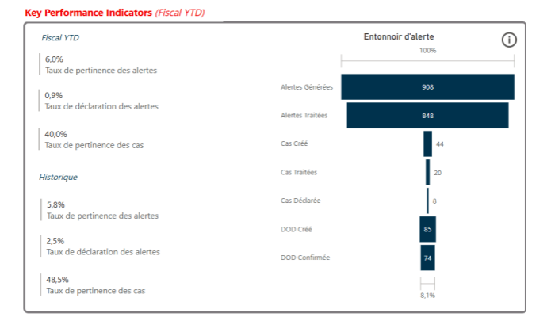
Alerts funnel
Alerts generated
STRs Confirmed
STRs Created
Cases reported
Cases reviewed
Cases created
Alerts reviewed
Historical
Alerts relevance rate
Alerts reporting rate
Case relevance rate
Case relevance rate
Alerts reporting rate
Alerts relevance rate
An analysis of reported cases demonstrated that the following observations were relevant and should be considered in the revision of the model:
- Unusual activity within high-risk industries
- Rapid movement of funds
- Customer recency (length of relationship with the Bank)
- Round-dollar transaction amounts
- Numbered corporations, which may be an indicator of money laundering activity
The following are some descriptive statistics for September 2025:

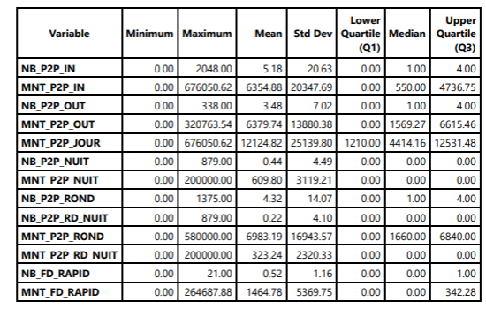
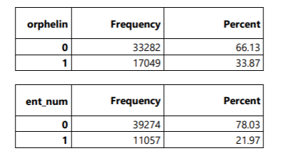
P2P Transaction Statistics
Incoming P2P Amount
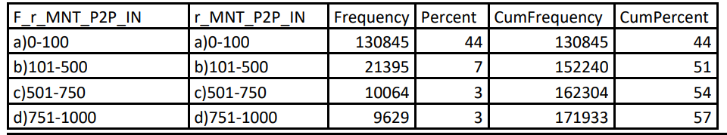
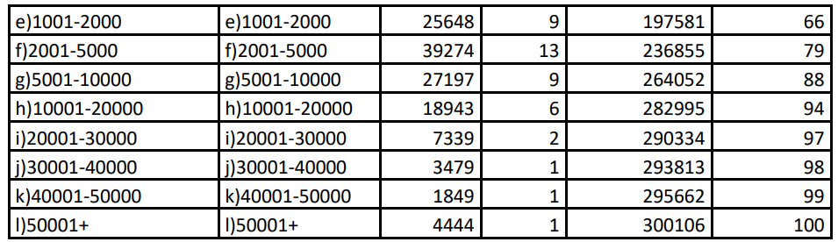

Number of Incoming P2P Transactions
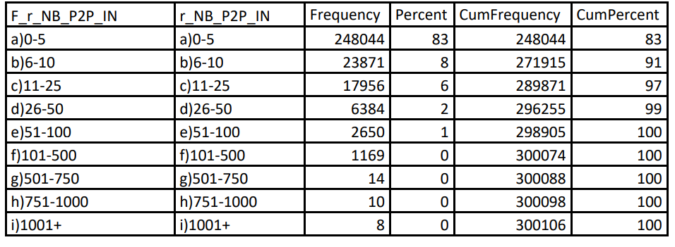

Outgoing P2P Amount
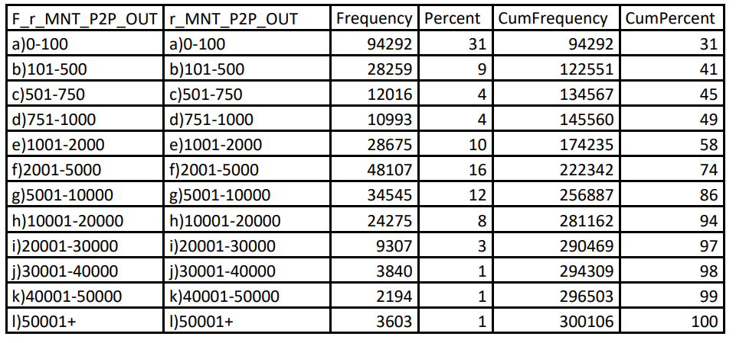
Number of Outgoing P2P Transactions
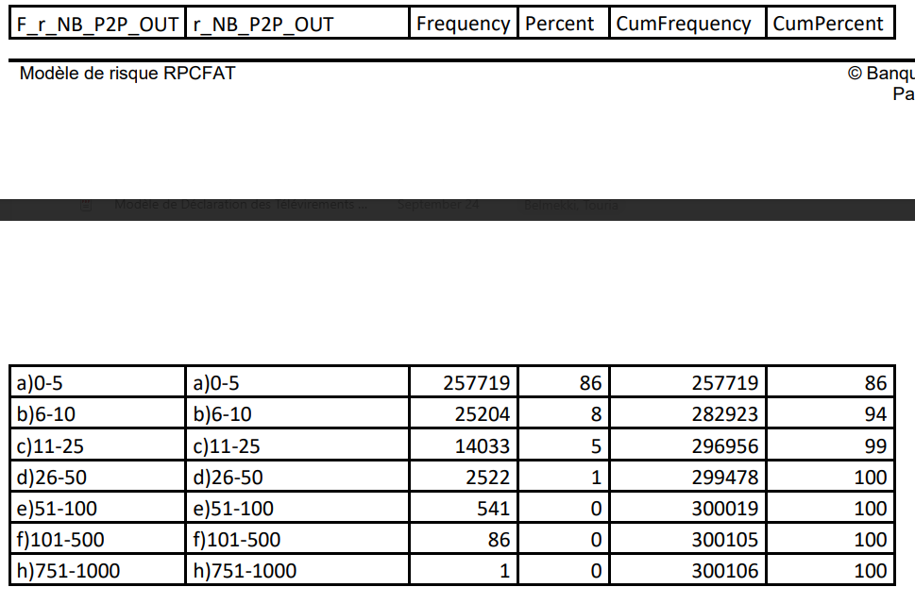

- Model Specifications

3.1 Model Description
The BN140 – Commercial P2P Monitoring model is designed to identify commercial customers who conduct unusual Interac P2P transactions or exhibit AML/ATF risk indicators deemed relevant based on the results of the analyses and calibration exercises.
The objective is to detect businesses whose transactional activity appears suspicious. Such suspicious activity may be associated with money laundering through the use of round-dollar amounts, transactions conducted during late-night or regular business hours, and other relevant indicators.
For each customer, the model ingests a set of information related to the volume and frequency of P2P transactions (both incoming and outgoing). An alert is then generated based on predefined thresholds.

3.2 Model Assumptions
This model is intended to replace the existing P2P01C – Commercial Interac P2P Monitoring model and to expand the coverage currently in place. To achieve this objective, several complementary statistical approaches were selected.
An unsupervised SVDD (Support Vector Data Description) model was developed to detect known typologies associated with commercial P2P transactions. In addition, an unsupervised Isolation Forest model is applied exclusively to industries operating in sectors considered high risk within the context of commercial P2P activity.
These models were developed in close collaboration with the AML/ATF expert team. The underlying risk criteria are based both on business expertise and FINTRAC publications, as well as on an in-depth analysis of reported cases.

  - Model Variables and Parameters
The information related to the variables used in model development, described below, is based on: Industry-recognized money laundering typologies; The expertise of the AML/ATF team; The analytical expertise of the Modeling team; and Existing monitoring models already in place.
Variable aggregates in the final dataset are calculated at the customer level on a monthly basis.

SVDD learns normal behavior from historical data and flags deviations as anomalies.
It establishes a normality boundary around the data; the farther a new event lies from this boundary, the more suspicious it is considered.
The use of soft boundaries allows the model to accommodate complex patterns rather than relying on a simple circular boundary. This is particularly useful when real-world business behavior is not perfectly uniform or regular.
The algorithm automatically calibrates the model’s scale based on the underlying data, thereby avoiding manual trial-and-error tuning. Ultimately, it produces an anomaly score that is easy to interpret, along with an adjustable threshold that can be optimized to achieve the desired balance between false positives and anomaly detection.
The indicators used in this model are presented below:

Variable | Description | Rationale for Selection
NB_P2P_IN | Number of incoming P2P transactions per month | Used to distinguish incoming and outgoing transaction amounts and volumes.
MNT_P2P_IN | Amount of incoming P2P transactions per month | Used to distinguish incoming and outgoing transaction amounts and volumes.
NB_P2P_OUT | Number of outgoing P2P transactions per month | Used to distinguish incoming and outgoing transaction amounts and volumes.
MNT_P2P_OUT | Amount of outgoing P2P transactions per month | Used to distinguish incoming and outgoing transaction amounts and volumes.
RATIO_P2P | Ratio of P2P amounts to total transaction amounts at risk: (MNT_P2P_IN + MNT_P2P_OUT) / MNT_TRN | Used to distinguish the share of P2P amounts relative to total transaction amounts, as well as the proportion of incoming and outgoing P2P activity.
RATIO_P2P_DT | Ratio of outgoing P2P amounts: MNT_P2P_OUT / MNT_TRN_DT | Used to distinguish the proportion of outgoing P2P amounts relative to total debit transaction amounts.
RATIO_P2P_CT | Ratio of incoming P2P amounts: MNT_P2P_IN / MNT_TRN_CT | Used to distinguish the proportion of incoming P2P amounts relative to total credit transaction amounts.
MNT_P2P_JOUR | Amount of daytime P2P transactions per month¹ | Used to distinguish daytime and nighttime transactions and capture potentially higher-risk typologies.
NB_P2P_NUIT | Number of nighttime P2P transactions per month¹ | Used to distinguish daytime and nighttime transactions and capture potentially higher-risk typologies.
MNT_P2P_NUIT | Amount of nighttime P2P transactions per month¹ | Used to distinguish daytime and nighttime transactions and capture potentially higher-risk typologies.
NB_P2P_ROND | Number of P2P transactions involving round-dollar amounts² | Helps identify round-dollar transactions, which may present higher risk.
NB_P2P_RD_NUIT | Number of nighttime P2P transactions involving round-dollar amounts² | Helps identify round-dollar transactions, which may present higher risk.
MNT_P2P_ROND | Total amount of round-dollar P2P transactions² per month | Helps identify round-dollar transactions, which may present higher risk.
MNT_P2P_RD_NUIT | Total amount of round-dollar P2P transactions² conducted at night per month | Helps identify round-dollar transactions, which may present higher risk.
NB_FD_RAPID | Number of rapid movement of funds transactions | Identifies rapid movement of funds and therefore potentially higher-risk activity.
MNT_FD_RAPID | Amount associated with rapid movement of funds³ per month | Identifies rapid movement of funds and therefore potentially higher-risk activity.
ORPHELIN | Customer holds only one account with NBC | Customers with only one account may be less known to the Bank and are therefore considered to present a higher risk profile.
RECENCE_INV | Inverse recency: inverse of the number of years the customer has been with National Bank of Canada | Customer relationship recency is a relevant AML/ATF risk indicator and is also used in customer risk assessments. A recently onboarded customer may pose increased risk due to limited available information.

To expand monitoring coverage, an Isolation Forest model was also implemented, focusing exclusively on high-risk sectors (see Section 3.5.3 for additional details). This model learns the predominant patterns within the data and identifies unusual observations (anomalies) without requiring labeled examples. It rapidly isolates atypical cases through a series of random data partitions; the more quickly a data point is isolated, the more suspicious it is considered. The model generates an anomaly score for each observation, along with an adjustable threshold for alert generation.

The indicators used in this model are presented below
Variable | Description | Rationale for Selection
NB_P2P_IN | Number of incoming P2P transactions per month | Used to distinguish incoming and outgoing transaction amounts and volumes.
MNT_P2P_IN | Amount of incoming P2P transactions per month | Used to distinguish incoming and outgoing transaction amounts and volumes.
NB_P2P_OUT | Number of outgoing P2P transactions per month | Used to distinguish incoming and outgoing transaction amounts and volumes.
MNT_P2P_OUT | Amount of outgoing P2P transactions per month | Used to distinguish incoming and outgoing transaction amounts and volumes.
RATIO_P2P | Ratio of P2P amounts to total transaction amounts at risk: (MNT_P2P_IN + MNT_P2P_OUT) / MNT_TRN | Used to distinguish the share of P2P amounts relative to total transaction amounts, as well as the proportion of incoming and outgoing P2P activity.
RATIO_P2P_DT | Ratio of outgoing P2P amounts: MNT_P2P_OUT / MNT_TRN_DT | Used to distinguish the proportion of outgoing P2P amounts relative to total debit transaction amounts.
RATIO_P2P_CT | Ratio of incoming P2P amounts: MNT_P2P_IN / MNT_TRN_CT | Used to distinguish the proportion of incoming P2P amounts relative to total credit transaction amounts.
MNT_P2P_JOUR | Amount of daytime P2P transactions per month¹ | Used to distinguish daytime and nighttime transactions and capture potentially higher-risk typologies.
NB_P2P_JOUR | Number of daytime P2P transactions per month¹ | Used to distinguish daytime and nighttime transactions and capture potentially higher-risk typologies.
NB_P2P_NUIT | Number of nighttime P2P transactions per month¹ | Used to distinguish daytime and nighttime transactions and capture potentially higher-risk typologies.
MNT_P2P_NUIT | Amount of nighttime P2P transactions per month¹ | Used to distinguish daytime and nighttime transactions and capture potentially higher-risk typologies.
NB_P2P_ROND | Number of P2P transactions involving round-dollar amounts² | Helps identify round-dollar transactions, which may present higher risk.
NB_P2P_RD_NUIT | Number of nighttime P2P transactions involving round-dollar amounts² | Helps identify round-dollar transactions, which may present higher risk.
MNT_P2P_ROND | Total amount of round-dollar P2P transactions² per month | Helps identify round-dollar transactions, which may present higher risk.
MNT_P2P_RD_NUIT | Total amount of round-dollar P2P transactions² conducted at night per month | Helps identify round-dollar transactions, which may present higher risk.
NB_FD_RAPID | Number of rapid movement of funds transactions | Identifies rapid movement of funds and therefore potentially higher-risk activity.
MNT_FD_RAPID | Amount associated with rapid movement of funds³ per month | Identifies rapid movement of funds and therefore potentially higher-risk activity.
ORPHELIN | Customer holds only one account with NBC | Customers with only one account may be less known to the Bank and are therefore considered to present a higher risk profile.
RECENCE | Number of years the customer has been with National Bank of Canada | Customer relationship recency is a relevant AML/ATF risk indicator and is also used in customer risk assessments. A recently established relationship may present increased risk due to limited available information.
ENT_NUM | Numbered corporation | Numbered corporations may be an indicator of money laundering activity.

A table providing additional detail on some of the definitions above is presented below:

- Normal hours are defined as 5:00 a.m. to 10:59 p.m. Late-night hours are defined as 11:00 p.m. to 4:59 a.m. These indicators enable the model to identify potentially illicit transactions conducted during late-night periods.
- A round-dollar amount refers to a transaction amount that does not contain cents (decimal values), in accordance with the definition and requirements established by AML/ATF subject matter experts (e.g., $175).
- Rapid movement of funds is identified when outgoing transactions within a given day represent between 80% and 100% of the amounts received during the same period, with a maximum observation window of seven days.
The following scenarios are considered for rapid movement of funds:
- P2P transactions to P2P transactions
- P2P transactions to other types of transfers
- Other types of transfers to P2P transactions
P2P transactions include the following transaction types: VIRCR/IN/P, VIRDT/IN/P, MOB/VIRD/P, MOB/VIRC/P, MBLVRDTIT, DMD/FD/INT, DD/FND/IAC, SV/VIR/INT, and VIR (Unknown Channel).
Other transfer types include the following transaction types: CT:CPT/DEBT, CT:DEB/PRT, CT:DEP, CT:DEP/CHQ, CT:DEP/RET, CT:PMT/DV, CT:TELE/VIR, CT:TELE/VIR/M, CT:TELE/VIR/S, DT:ACHAT, DT:C/ACHAT, DT:CHQ, DT:DTPM, DT:PC, DT:PMT/DV, DT:RETRAIT, DT:RETRAIT/DE, DT:TELE/VIR, DT:TELE/VIR/M, DT:TELE/VIR/S, and DT:VDINT.
  - Model Methodology and Algorithm

3.4.1 Sampling
P2P transactions conducted between November 1, 2024, and April 30, 2025, were used for data exploration, the development of the indicators proposed during the workshops, and the development of the model itself.
Subsequently, an initial calibration was performed using data from July 2025, while a second calibration was conducted using data from September 2025.

3.4.2 Data Analysis
The selection of data was based on industry-recognized typologies, the expert judgment of the AML/ATF Financial Crime team gathered through dedicated workshops, as well as the team's experience and knowledge of existing commercial P2P monitoring models.
Following extensive discussions and consultations with AML/ATF subject matter experts, 20 relevant variables (see Appendix I) were developed and selected for testing within the two unsupervised models (SVDD and Isolation Forest).
The SVDD algorithm is applied to the entire population, whereas the Isolation Forest algorithm is applied exclusively to data associated with high-risk industries.
During the calibration phase, the test portion of the data was used and alerts were submitted to AML/ATF experts for review using a period that had not been seen by the model during training, namely September 2025.

3.4.3 Model Algorithm
Several approaches were tested during model development, including Mahalanobis distance, clustering techniques, and random forests. Ultimately, the SVDD and Isolation Forest models were selected, a choice made possible through the capabilities of SAS Viya.
Unlike SAS 9.3, where these algorithms are not available, SAS Viya supports distributed in-memory processing through CAS (Cloud Analytic Services) and production-ready scoring. This enables greater stability in alert volumes while providing improved performance and enhanced scalability to process growing transaction volumes, all while maintaining manageable alert volumes for anomaly detection.

SVDD (Support Vector Data Description) - PROC SVDD
SVDD enables the development of an unsupervised anomaly detection model (without labeled data such as reported versus non-reported cases). Its objective is to learn the shape of behaviors considered normal within the variable space and then measure the extent to which each observation deviates from those patterns.
This approach is particularly well suited to environments where labeled data is unavailable, such as AML monitoring of commercial P2P transactions, where the primary objective is to model expected behavior and identify significant deviations.
In this context, an anomaly refers to an observation that differs substantially from the majority of behaviors. In practice, this generally involves analyzing the highest anomaly scores, calibrating alert thresholds according to the desired investigation volume, and then performing business validation.
Conceptually, the model constructs a boundary of normality around the main body of observations. In its simplest form, this boundary can be viewed as a sphere. Through the use of a kernel function, specifically an RBF (Radial Basis Function) kernel, the boundary becomes non-linear, allowing it to better capture the actual structure of the data. Observations that are located far from this boundary, or outside of it, are considered more atypical and therefore potentially more suspicious.

The primary score produced by the model is the SVDDDistance variable, which measures the distance between an observation and the learned normality region:
- A higher value indicates a more atypical observation.
- A threshold can then be defined based on the desired alert volume or available investigative capacity.
The model also identifies support vectors (SV=casuser.svdd_sv), which are the observations that help define the boundary of normal behavior. These points are particularly useful for understanding the geometry of the model and for interpreting the profiles that shape the concept of normal behavior.
For this use case, the SVDD model leverages the entire dataset to identify atypical observations through the following process:
- Uses standardized numerical variables for each customer (PARTY_KEY).
- Learns the boundary of normal behavior using SVDD with an RBF kernel.
- Saves the trained model.
- Calculates an anomaly distance (SVDDDistance) for each observation.
- Ranks observations from the most atypical to the least atypical.
- Retains the top 90 observations as priority alerts.
Key Model Parameters
- data=: training dataset
- score std: generates standard scoring outputs
- SV=: table containing support vectors
- id: business identifier
- input: input variables
- level=interval: continuous numerical variables
- kernel rbf: use of a non-linear boundary
- bw=mean2: automatically determined bandwidth parameter
- solver actset: optimization method
- stol=1e-8: convergence tolerance
- savestate rstore=: saves the trained model
- proc astore: applies the saved model
- out=: scored output table
- SVDDDistance: anomaly score
- N_TOP: number of retained alerts
For additional details, refer to: [Insert link]

Isolation Forest (PROC FOREST)
This procedure implements an unsupervised anomaly detection model. Unlike a traditional predictive model, this approach does not seek to estimate a target variable; rather, it aims to identify atypical observations (outliers) by constructing an ensemble of random trees specifically designed to isolate them efficiently.

In this analysis, the model is based on the generation of 300 isolation trees. A larger number of trees generally produces more stable and robust anomaly scores, although at the cost of increased computational time. This trade-off was deemed appropriate given the volume of data and operational constraints.

The principle behind Isolation Forest is to isolate anomalies rather than explicitly model normal behavior. Trees are constructed using entirely random partitions: at each node, both the splitting variable and the split threshold (or partitioning rule in the case of categorical variables) are selected randomly.

As a result, atypical observations tend to be isolated in fewer steps because they are generally rarer or located in less dense regions of the feature space. Consequently, they follow shorter paths through the trees, resulting in higher anomaly scores.
The primary score produced by the model is the Anomaly variable, which corresponds to a normalized measure of the average isolation path length across the forest. The closer this score is to 1, the more atypical the observation is considered and the higher its priority for investigation. This score enables observations to be ranked in descending order of anomaly to support AML alert prioritization.

In this implementation, the model is trained using historical data and combines:
- Continuous numerical variables;
- Categorical variables; and
- A business identifier that links each score to the entity being analyzed.
The scored output table contains all input variables along with the Anomaly score, facilitating interpretation of the results.
Observations are then ranked in descending order of anomaly score, and the top 20 observations are designated as priority AML alerts, with a ranking assigned to facilitate review.
Finally, the Isolation Forest model is applied exclusively to industries within high-risk sectors for P2P activity, as identified in the DODs and validated by operations experts during the workshops. The model therefore serves as an alert prioritization tool within a pre-defined high-risk population.

Model Parameters
- data=: Training dataset
- ntree=300: Number of isolation trees constructed
- isolation: Activates Isolation Forest mode (unsupervised anomaly detection)
- input ... / level=interval: Continuous numerical variables
- input ... / level=nominal: Categorical variables
- id: Business identifier
- output out=: Scored output table
- copyvars=(ALL): Copies all input variables into the scored output table
- Anomaly: Anomaly score (the closer the value is to 1, the more atypical the observation)
- proc sort by descending Anomaly: Ranks observations from the most atypical to the least atypical
- N_ALERTS: Number of alerts retained
- AML_ALERT: Alert indicator
- ALERT_RANK: Priority ranking assigned during the sorting process.

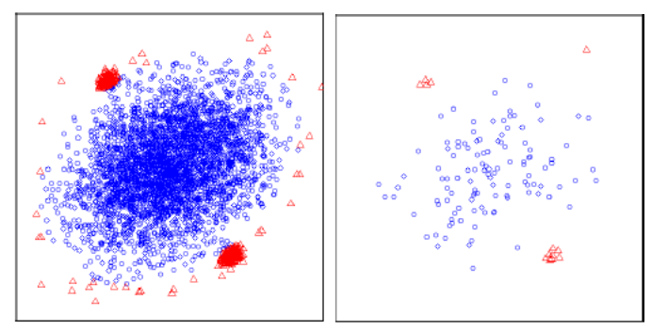
In red, the outliers detected by the Isolation Forest model are highlighted.
For additional information, please refer to the FOREST Procedure documentation and the scientific articles listed in Appendix II.

  - Results of Analyses, Testing, and Model Calibration

3.5.1 Analysis Results
During the analysis phase, several modeling approaches were tested. Ultimately, two unsupervised models were selected due to the limited number of reported cases available from the commercial P2P model currently in production.
The models ultimately retained were SVDD and Isolation Forest, based on their performance.
These models also allow for the selection of a limited number of the highest-risk alerts. Accordingly, it was decided to generate 90 alerts per month through the SVDD model and 20 alerts per month through the Isolation Forest model, which is applied only to the highest-risk sectors, for a total of 110 alerts per month.

3.5.2 Testing and Calibration
The first calibration, performed using July 2025 data, was based on the Mahalanobis Distance approach (both linear and non-linear versions). Of the 36 alerts submitted for review, 14 alerts were deemed relevant (39%), corresponding to 6 relevant customers (17%).
During the second calibration, conducted using September 2025 data, two new models were selected and delivered very strong results: SVDD and Isolation Forest.
The objective was to validate these models through a review conducted by AML subject matter experts as part of the calibration exercise. The calibration results were as follows: of the 24 alerts analyzed for September 2025, 22 customers were associated with a relevant alert, representing an overall relevance rate of 92% across the SVDD and Isolation Forest models.
These models also enabled the identification of five new relevant customers who had never previously been reviewed.
The detailed results of the calibration exercises are presented below for the Mahalanobis Distance model (first calibration) and the SVDD and Isolation Forest models (second calibration).
Model | Alert Relevance | Customer Relevance
Mahalanobis Distance | 39% (14/36 alerts) | 17% (6/36 alerts)
SVDD | 90% (20/22 alerts) | 45% (10/22 alerts)
Isolation Forest | 88% (7/8 alerts) | 62% (5/8 alerts)

Overall results for the two algorithms selected for implementation (SVDD and Isolation Forest):
Metric | Result
Alert Relevance | 22 (92%)
Customer Relevance | 12 (50%)

The calibration file exchanged with the Financial Crime Quality Management team, containing the commented model simulation cases used to assess the relevance of the submitted sample, is provided below.

3.5.3 Final Model Definition
An alert will be generated if any of the following conditions are met:
- Alert generated by the SVDD model: anomaly detection across the entire population of customer P2P transactions.
- Alert generated by the Isolation Forest model: anomaly detection applied specifically to the following high-risk industries:
  - 31-33 – Manufacturing
  - 41 – Wholesale Trade
  - 44-45 – Retail Trade
  - 48-49 – Transportation and Warehousing
  - 51 – Information and Cultural Industries
  - 52 – Finance and Insurance
  - 53 – Real Estate and Rental and Leasing
  - 54 – Professional, Scientific and Technical Services
  - 71 – Arts, Entertainment and Recreation
The model therefore seeks to isolate anomalous activities within these industry sectors, which encompass business activities considered higher risk for P2P transactions, including cryptocurrencies and digital assets, online gaming and betting, money services businesses (MSBs), cannabis-related businesses, import-export activities, and similar sectors.

3.5.4 Expected Alert Volume
The table below presents the expected alert volume for these rules based on a more recent period, assuming the models were in production today.

Period | No. of SVDD Alerts | No. of IF Alerts | Total Alerts | Alerts After Multiple Alert Management (GAM) | Estimated Cases Based on Calibration Results (Volume × Customer Relevance Rate)
202510 | 90 | 20 | 110 | 97 | 48
202511 | 90 | 20 | 110 | 95 | 47
202512 | 90 | 20 | 110 | 93 | 46
202601 | 90 | 20 | 110 | 92 | 46
202602 | 90 | 20 | 110 | 91 | 45
Average | 90 | 20 | 110 | 93 | 46

Important: At the case level, it is possible that a case has already been opened for a customer during the month under analysis. In a production environment, the high-level estimate for new cases would be closer to 25% (approximately 23 cases), compared with the 4 cases per month currently generated by the existing model.

Multiple Alert Management
A multiple alert management process has been implemented to avoid re-reviewing customers who have been investigated recently and, consequently, to limit the monthly volume requiring analysis. As such, a customer who has generated an alert during the three months preceding the monitored month will not be reviewed again, depending on the type of transactions associated with the alert.
The expected alert volume for this new model should be comparable to that of the model currently in production. However, a significant increase in alert relevance is anticipated. Although the relevance observed during calibration exercises is generally higher than what is typically observed in production, the overall volume of cases requiring review is expected to increase considerably, as this model covers a broader range of P2P transactions and additional money laundering typologies.

3.5.5 Expected Performance
Expected performance can be summarized based on the calibration results. The model is expected to achieve an alert relevance rate of approximately 50%, representing a performance level superior to that of the model currently in production.
It should be noted, however, that performance metrics are generally somewhat higher during calibration exercises and tend to decrease slightly once the model is deployed into production.

3.5.6 Performance Monitoring
Performance monitoring will be conducted through a dedicated dashboard.

4. Risk and Materiality Assessment
The BN140 – Commercial P2P Monitoring model has been assessed in accordance with the Bank’s AML/ATF model risk framework.
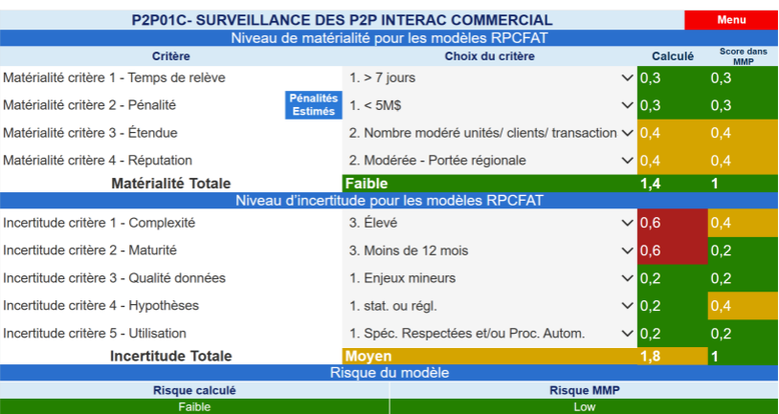
Low
Low
MRM Risk Rating
Calculated Risk Rating
Model Risk Assessment
Medium
Overall uncertainty rating
Specifications respected and/or automated process
Based on Statistical or regulatory assumptions
Minor issues
Less than 12 months
High
Criterion 5 - Usage
Criterion 4 - Assumptions
Criterion 3 – Data Quality
Criterion 2 - Maturity
Criterion 1 – Complexity
Uncertainty assessment
Materiality assessment
Low
Moderate regional impact
Moderate number of units, customers, and trans imp
Less than 5 million
Greater than 7 days

Greater than 7 days
Greater than 7 days

Criterion 1 – Lead Time
Overall Materiality Rating
Criterion 4 – Reputation

Criterion 3 – Scope

Criterion 2 – Financial Penalty Exposure
Assessment
Criterion

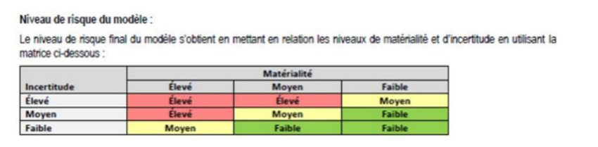
Materiality
Uncertainty

Model Risk Level
The final model risk rating is determined by combining the materiality and uncertainty assessments using the matrix below.

Uncertainty | High Materiality | Medium Materiality | Low Materiality
High | High | High | Medium
Medium | High | Medium | Low
Low | Medium | Low | Low

5. Model Review Cycle
The model will be reviewed in accordance with the standards established under the Financial Crime Model Management Framework, taking into consideration both its initial and evolving risk level.
6. Recommendations and Opportunities for Enhancement
As part of future model reviews, it is recommended that monitoring capabilities be expanded to include the following data elements, where available (currently unavailable):
- Detailed transaction information, such as contact details (telephone numbers, email addresses), messages, and transaction narratives.
Appendix I – List of Variables Considered for Model Development
Variable | Description
NB_P2P_IN | Number of incoming P2P transactions per month
MNT_P2P_IN | Amount of incoming P2P transactions per month
NB_P2P_OUT | Number of outgoing P2P transactions per month
MNT_P2P_OUT | Amount of outgoing P2P transactions per month
RATIO_P2P | Proportion of P2P transaction amounts relative to total transaction amounts at risk
RATIO_P2P_DT | Proportion of outgoing P2P transaction amounts
RATIO_P2P_CT | Proportion of incoming P2P transaction amounts
NB_P2P_JOUR | Number of daytime P2P transactions per month
MNT_P2P_JOUR | Amount of daytime P2P transactions per month
NB_P2P_NUIT | Number of nighttime P2P transactions per month
MNT_P2P_NUIT | Amount of nighttime P2P transactions per month
NB_P2P_ROND | Number of P2P transactions involving round-dollar amounts
NB_P2P_RD_NUIT | Number of nighttime P2P transactions involving round-dollar amounts
MNT_P2P_ROND | Total amount of round-dollar P2P transactions
MNT_P2P_RD_NUIT | Total amount of round-dollar P2P transactions conducted at night per month
NB_FD_RAPID | Number of rapid movement of funds transactions
MNT_FD_RAPID | Amount associated with rapid movement of funds transactions
ORPHELIN | Indicates whether the customer holds only one product (e.g., a bank account) with National Bank of Canada (value = 1) or multiple products (e.g., bank account, credit card, mortgage, etc.) (value = 0)
RECENCE | Number of years the customer has maintained a relationship with National Bank of Canada
ENT_NUM | Numbered corporation
Appendix II – References
- Tax, D. M. J., & Duin, R. P. W. (2004). Support Vector Data Description. Machine Learning, 54(1), 45-66.
- Tax, D. M. J., & Duin, R. P. W. (1999). Support Vector Domain Description. Pattern Recognition Letters, 20(11-13), 1191-1199.
- Chang, W.-C., Lee, C.-P., & Lin, C.-J. (2015). A Revisit to Support Vector Data Description (SVDD).
- Liu, F. T., Ting, K. M., & Zhou, Z.-H. (2008). Isolation Forest. In Proceedings of the Eighth IEEE International Conference on Data Mining (ICDM) (pp. 413-422). IEEE.
- Liu, F. T., Ting, K. M., & Zhou, Z.-H. (2012). Isolation-Based Anomaly Detection. ACM Transactions on Knowledge Discovery from Data.

