**Installation Guide**

This part illustrates how to install the mobile shopping application on your computer.

First, you need to go to the URL and download Android Studio. The recommended version is 4.1.2.

<https://developer.android.com/studio/archive>

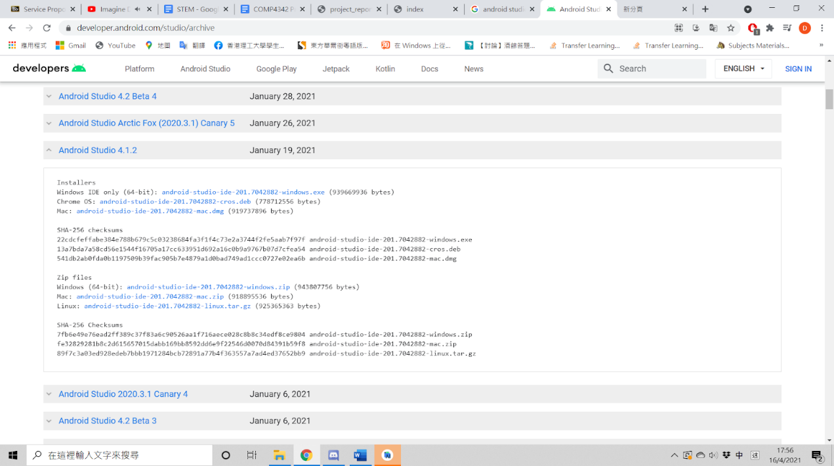

Second, you need to download XAMPP to connect to the MariaDB database. The recommended version is 8.0.2.

<https://www.apachefriends.org/download.html>

In the directory of XAMPP, go to your htdocs folder and put all the PHP format documents into the folder.

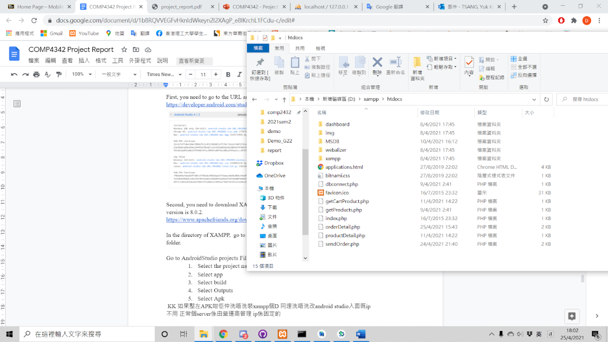

run the XAMPP and start the first two modules (Apache & MySQL).

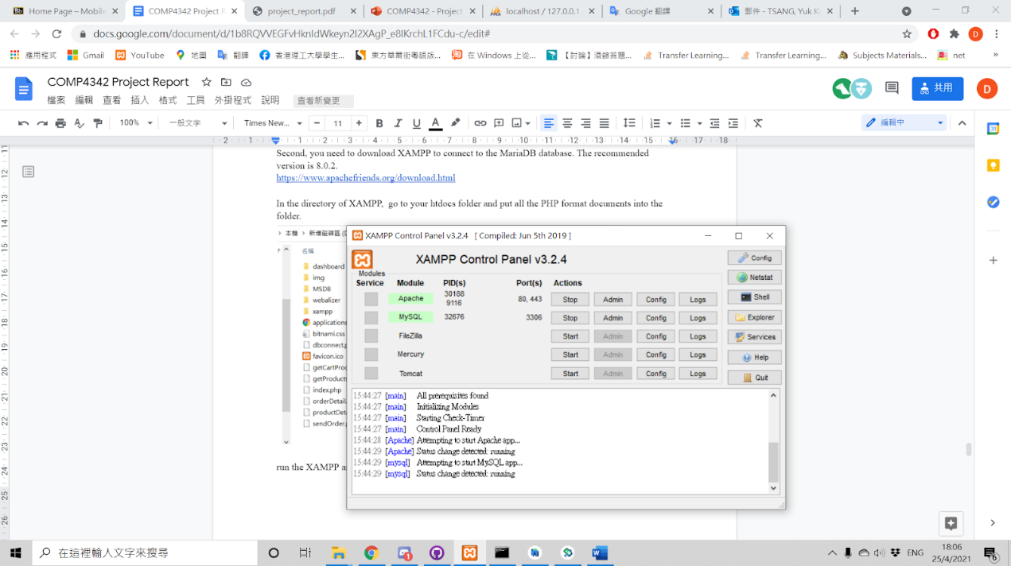

Run the Android Studio and click the Open an Existing Project. Then, select the MobileShopping application and click “OK” to open it.

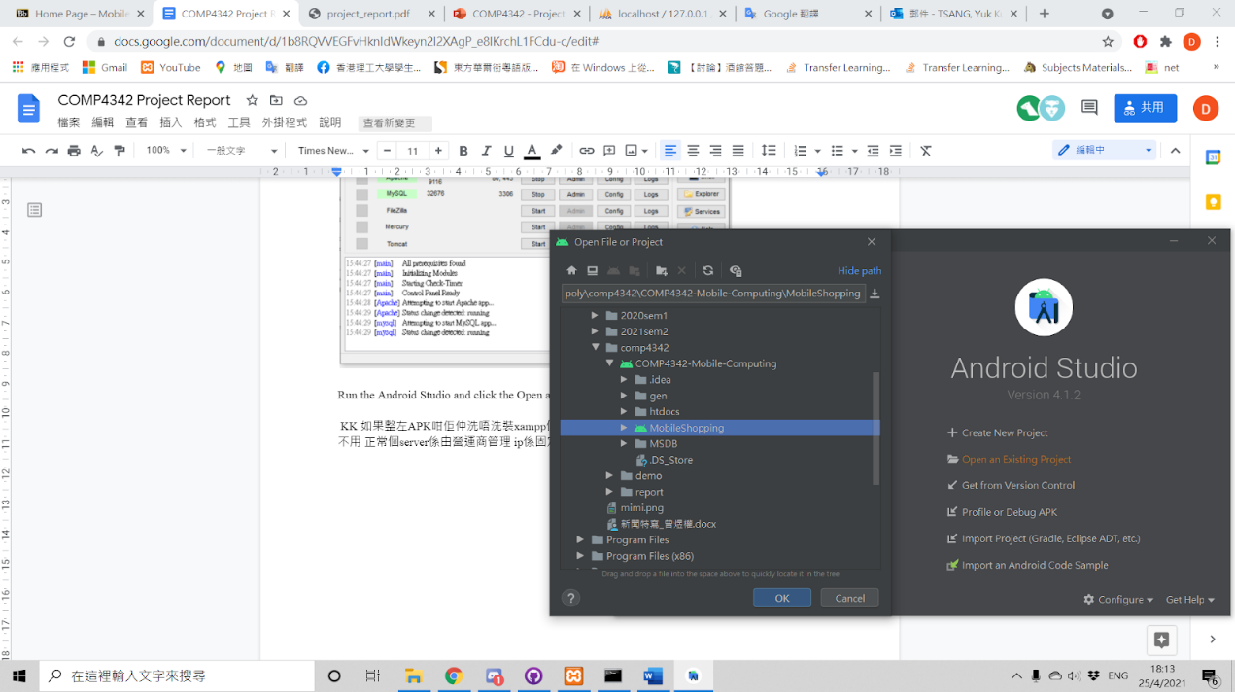

Open the APIUrl.java in Android Studio, you need to add your IP address in it.

the input must be “String url ="[http://XXXXXXXXXX](http://xxxxxxxxxx)"; ”, which XXX is your IP address.

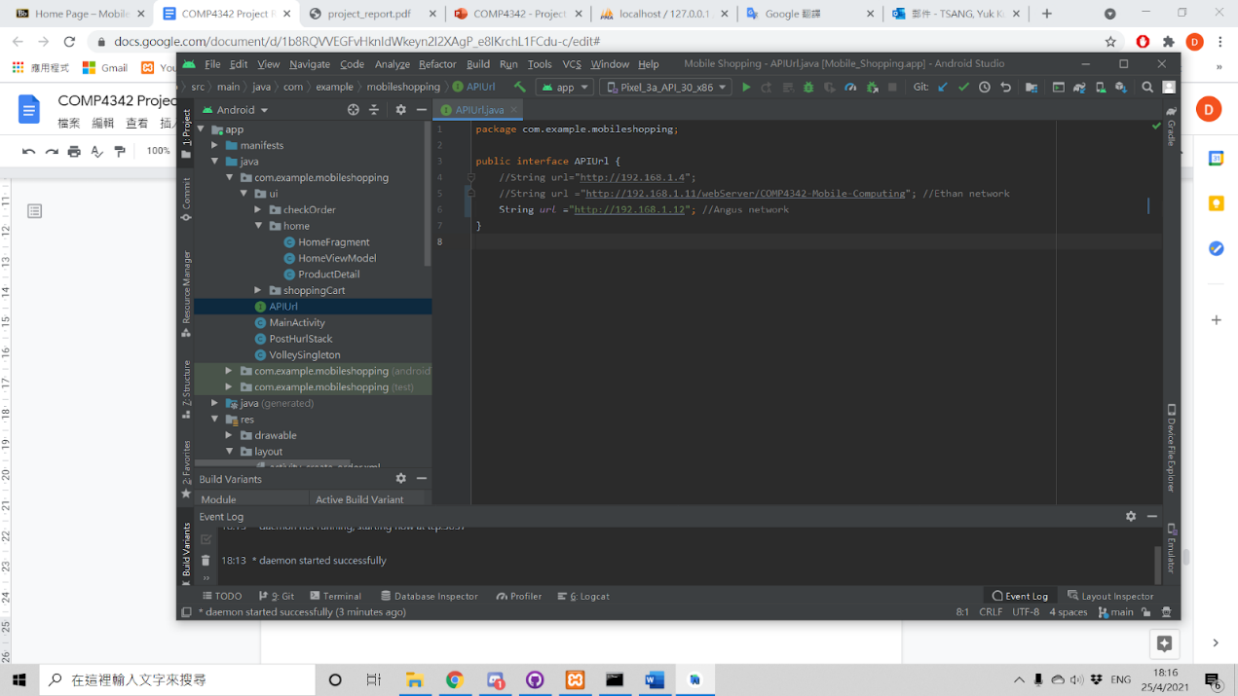

 Then, you can run our mobile shopping application.