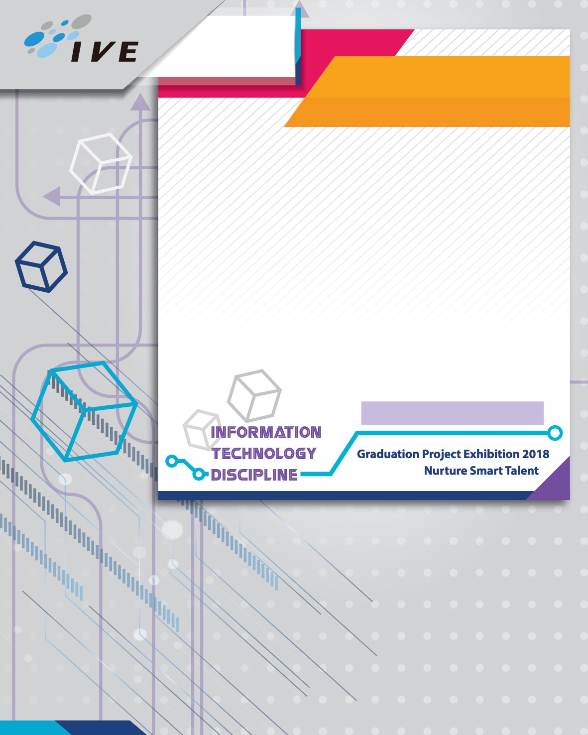09 **IT/LWL**

# Higher Diploma in

**Software Engineering**

Automated Data Collecting System for Environment Using UAVs and Smartphones

**Project Description**

This project is to develop a Data Collection System. Our system will help the meteorologists to measure the weather. We analyzed their requirements to develop our system to provide easy deploy instruments and performing weather analysis.

This project is to develop a client-side system which consists of three parts including an unmanned aerial vehicle (UAV), a computer application and a mobile application.

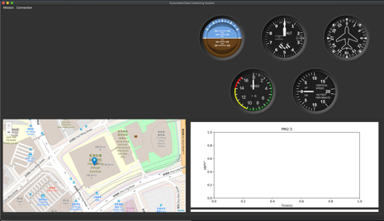

**Project Features**

## Real time Map

## Real time flight instruments

## Real time video Streaming

## Data Collecting

## Siu Chi Wang, Wong Ming Yuen, Kwok Tsz Lung, Chau Yat Sum