Lab 06

1. Required
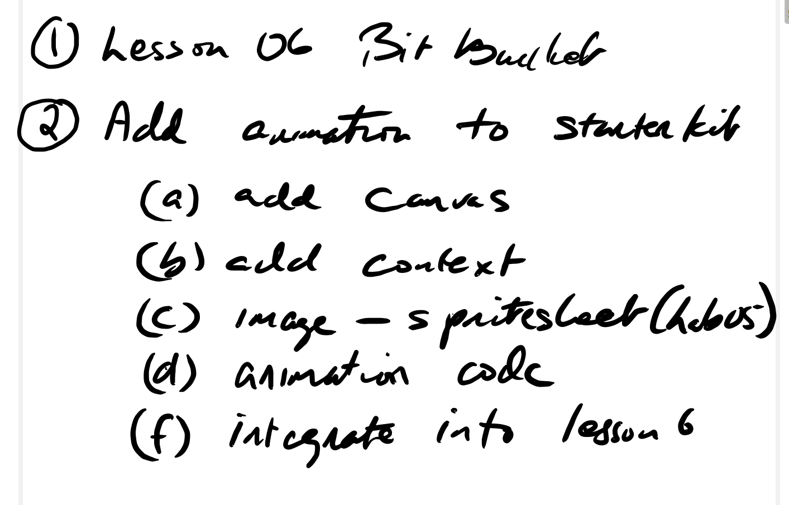

2. Sample Screen
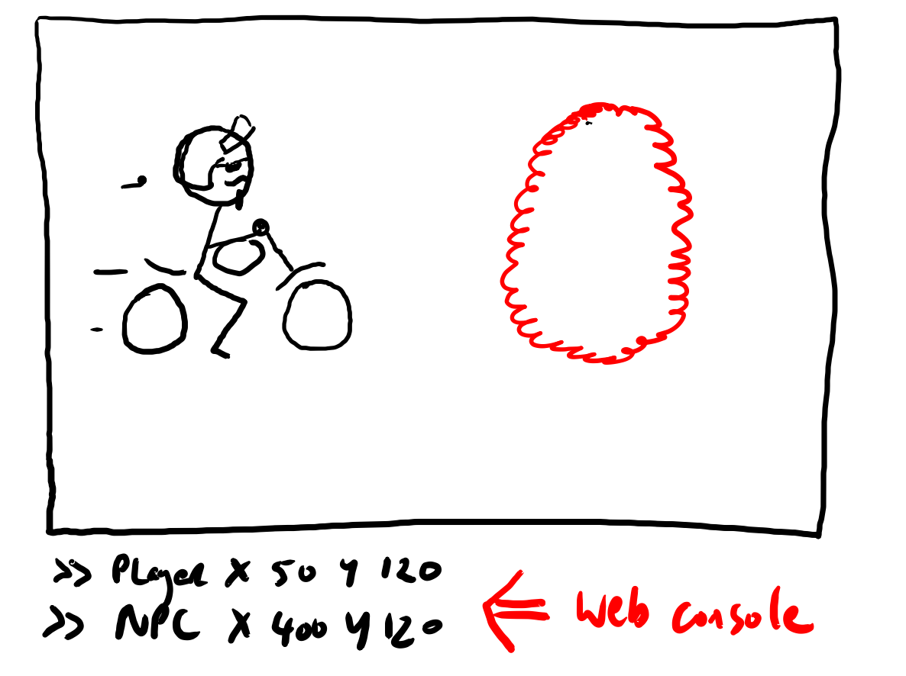

3. Rubric

0 - 35 Basic Attempt
35 - 75 Intermediate Requirements as Published
75+ Expert mark with gameplay and or visual effect(s)

