Person类
public class Person {
public Person() {
super();
}

public Person(String name, int age) {
super();
this.name = name;
this.age = age;
}

public String name;

private int age;

public int getAge() {
return age;
}

public void setAge(int age) {
this.age = age;
}
}

Main方法

ArrayList
Collection collection = new ArrayList();
Person person1 = new Person("name1", 1);
Person person2 = new Person("name2", 2);
Person person3 = new Person("name1", 1);
collection.add(person1);
collection.add(person2);
collection.add(person3);
collection.add(person1);
System.out.println(collection.size() + "");

输出结果时4

HashSet
Collection collection = new HashSet();
Person person1 = new Person("name1", 1);
Person person2 = new Person("name2", 2);
Person person3 = new Person("name1", 1);
collection.add(person1); //1
collection.add(person2); //2
collection.add(person3); //3
collection.add(person1); //4
System.out.println(collection.size() + "");

输出结果是3 ，1和4是同一个，会4不会被添加

重写hashcode和equal方法

public class Person {
public Person() {
super();
}

public Person(String name, int age) {
super();
this.name = name;
this.age = age;
}

public String name;

private int age;

public int getAge() {
return age;
}

public void setAge(int age) {
this.age = age;
}

@Override
public int hashCode() {
final int prime = 31;
int result = 1;
result = prime * result + age;
result = prime * result + ((name == null) ? 0 : name.hashCode());
return result;
}

@Override
public boolean equals(Object obj) {
if (this == obj)
return true;
if (obj == null)
return false;
if (getClass() != obj.getClass())
return false;
Person other = (Person) obj;
if (age != other.age)
return false;
if (name == null) {
if (other.name != null)
return false;
} else if (!name.equals(other.name))
return false;
return true;
}
}

再输出

结果是2 ，1和4是同一个，并且，3和他们的hashcode相等，并且equal相等，被认为是同一个对象
(hashset会先比较hashcode，如果hashcode相等，再比较equal)

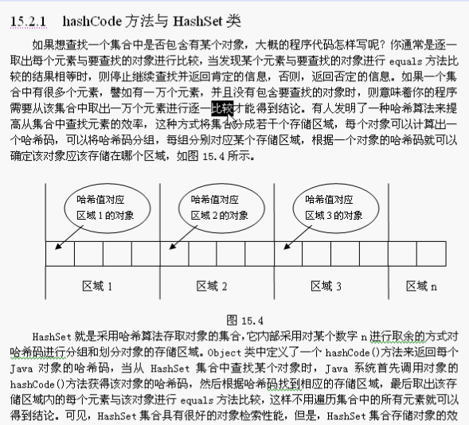

当一个对象被储存进HashSet集合中以后，就不能修改这个对象中的那些参与计算哈希值的字段了，否则，对象修改后的哈希值与最初存储进HashSet集合中的哈希值就不同了
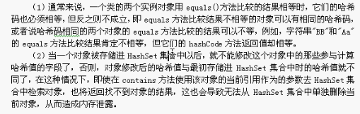
会造成内存泄露

