# Ethan Cramer

CSCE 5218

Homework 1

# 1. Setting Up Python

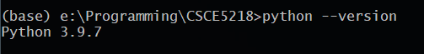

***Please note:*** I chose to leave my Python version as 3.9 and downgraded to 3.8 inside of the virtual environment. If this is not ok, let me know and I can downgrade my base version as well.

# 2. Virtual Environment

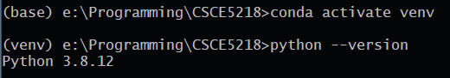

# 3. Jupyter Notebook

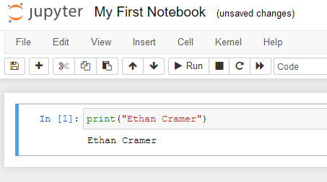

# 4. VS Code

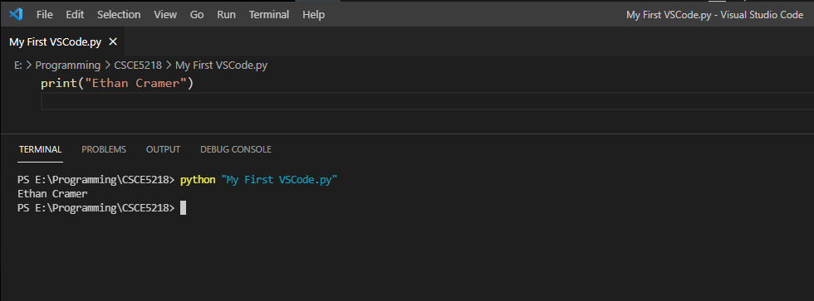

# 5. Setting up GIT

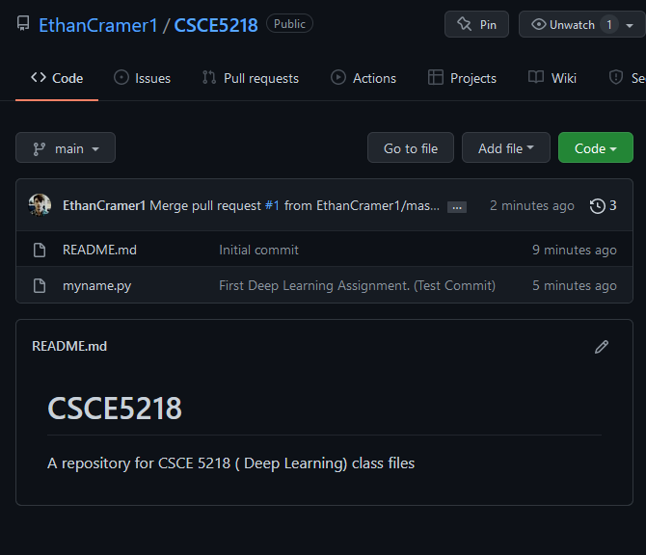

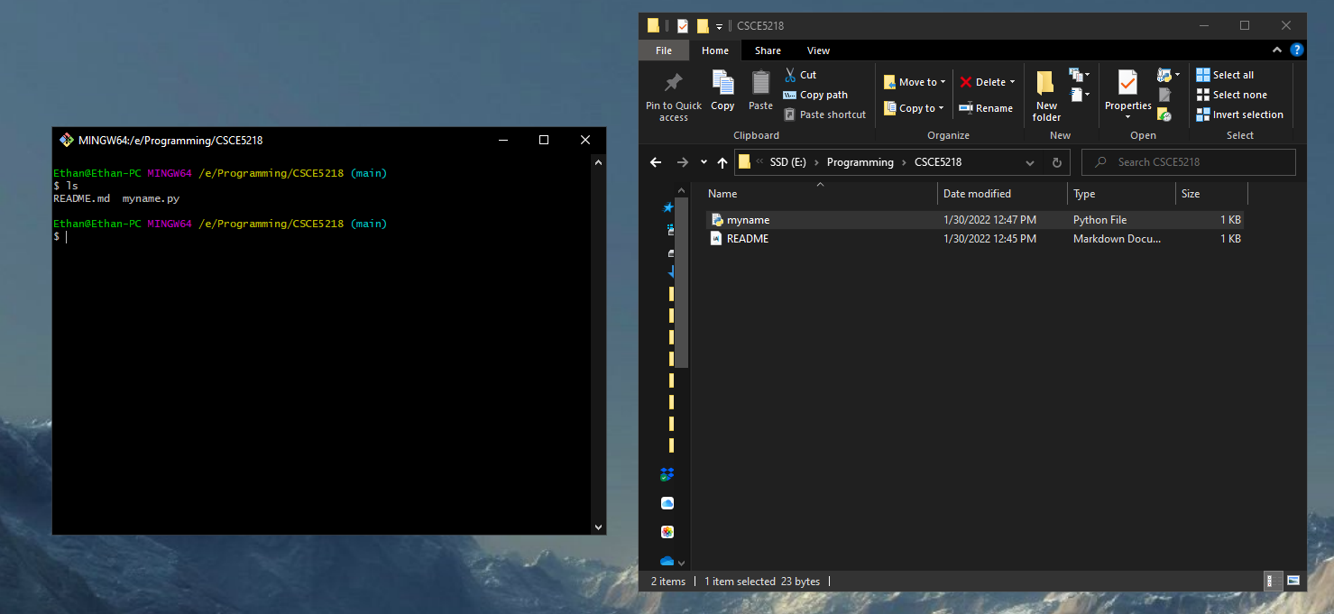

[**https://github.com/EthanCramer1/CSCE5218**](https://github.com/EthanCramer1/CSCE5218)