Contents
I. Game Overview 1
II. Game Play Mechanics 2
III. Controls 3
IV. Saving and Loading 4
V. Menus and Screen Descriptions 5
VI. Game World 6
VII. Levels 7
VIII. Characters 8
IX. Non-player Characters 9
X. Enemies 10
XI. Weapons 11
XII. Items 12
XIII. Abilities 13
XIV. Vehicles 14
XV. Scripts Title Name 15
XVI. Scoring 16
XVII. Puzzle / Mini Games 17
XVIII. Bonuses 18
XIX. Cheat Codes 19
XX. Future Features 20

I. Game Overview
Night of the Living Chud is a first-person horror game set in a dark forest environment. The player explores the map to collect six missing person photographs while being hunted by a mysterious creature.
The goal of the game is to collect all six photos and survive. The player wins once all photos are collected. The player loses if the enemy catches them.

II. Game Play Mechanics
The game now includes two playable difficulty modes:
Normal Mode
Designed as the standard gameplay experience. Includes a page locator system that helps the player locate the nearest missing person photo.
Omar Mode
An unlockable hard mode that becomes available after beating Normal Mode. Omar Mode removes the page locator and replaces the standard enemy with a more difficult variant of the creature. This mode is intended to create a more stressful and disorienting experience.
The game also includes:
A dynamic enemy aggression system
A stamina-based sprint mechanic
Environmental tension through audio and lighting effects
A nearest-photo locator system in Normal Mode

III. Controls
W → Move forward
A → Move left
S → Move backward
D → Move right
Mouse → Look around
Shift → Sprint (uses stamina)
F → Toggle flashlight
E → Interact / close UI
ESC → Pause

IV. Saving and Loading
The game does not include a save or load system. Each playthrough is completed in one session.

V. Menus and Screen Descriptions
Main Menu
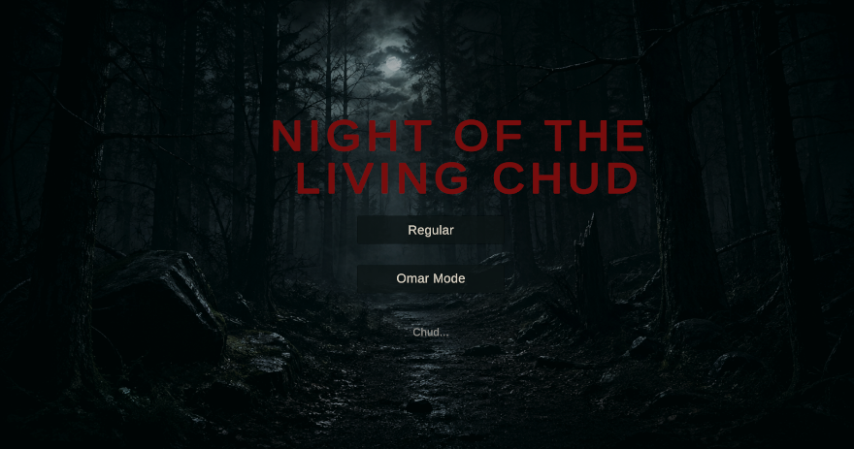Displays game title and start button, as well as Omar Mode
Pause Menu
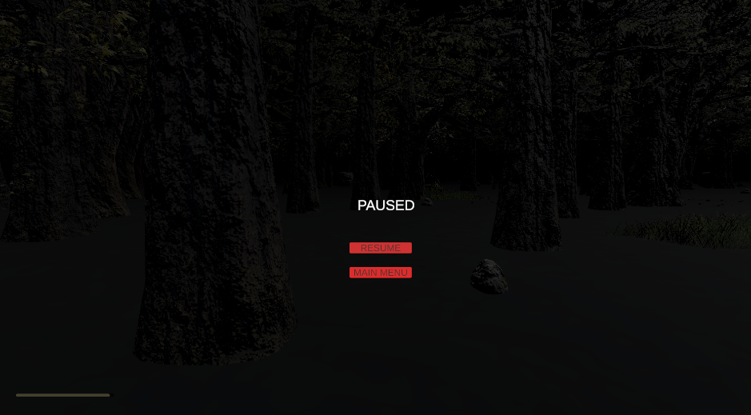
Resume game
Return to main menu
Win Screen
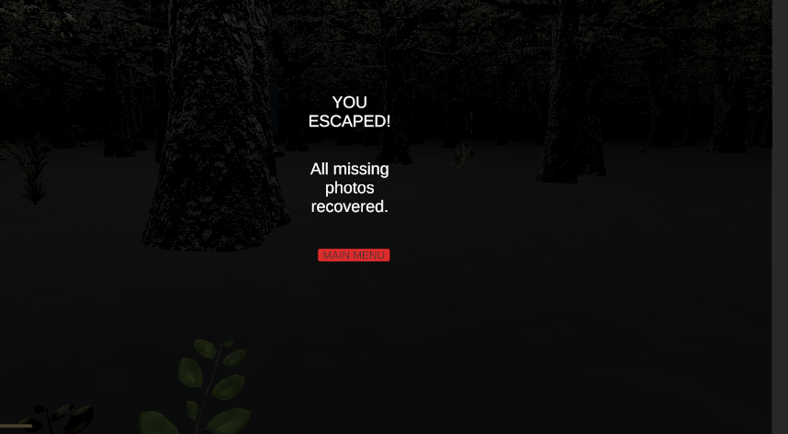
Appears after collecting all photos
Game Over Screen
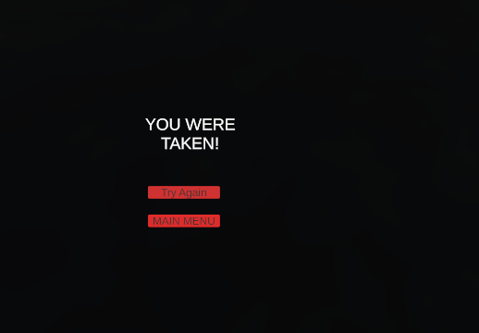
Appears when the player is caught
Photo Inspection Screen 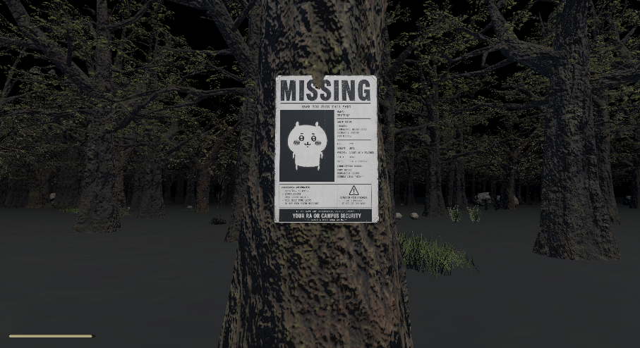
Shows a zoomed-in version of collected photos
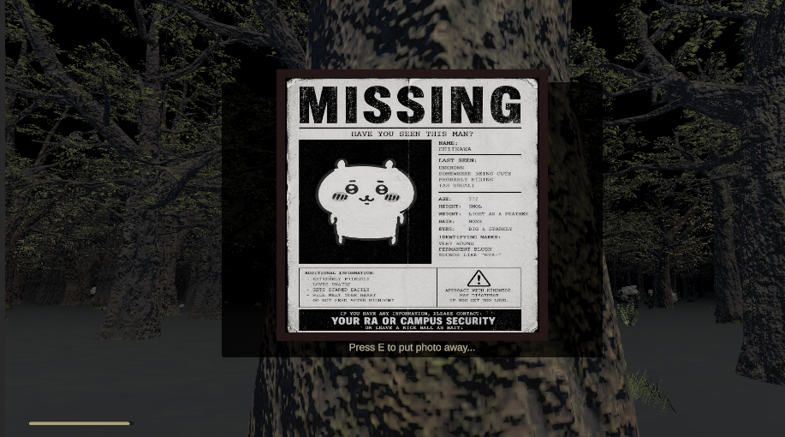

VI. Game World
The game takes place in a dark forest environment featuring:
Dense tree clusters
Cemetery-style stone walls
Fog and low visibility
Minimal lighting for atmosphere
The world is designed to feel isolated and unsettling.
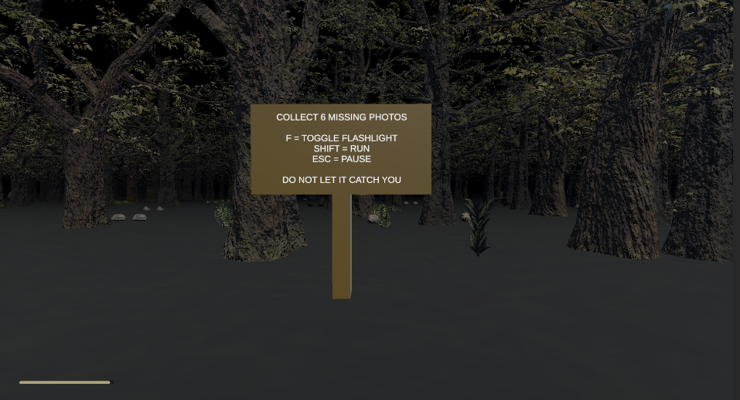

VII. Levels
The game currently contains two playable versions of the main level:
Level1_Normal
The standard version of the game. Contains four missing person photos and includes the page locator system to assist the player.
Level1_OmarMode
A harder version of the game unlocked after completing Normal Mode. Contains six missing person photos and disables the locator system, forcing the player to explore the environment manually while being chased by the Omar enemy variant.
Difficulty increases dynamically as photos are collected.

VIII. Characters
Player
First-person character
Can move, sprint, and interact
Limited stamina system

IX. Non-player Characters
The game includes a tutorial sign that explains controls and objectives to the player at the start of the game.


X. Enemies
The Chud (Spider Variant)
A multi-headed spider-like creature that stalks the player throughout the forest.
Enemy behaviors include:
Teleportation stalking
Direct chasing
Fake sightings
Watching/staring behavior
Progressive aggression scaling
Behavior progression:
Early game: slow stalking and observation
Mid game: teleportation and pressure
Late game: direct aggressive pursuit
Omar Variant
A harder version of the enemy used exclusively in Omar Mode. This variant increases tension by removing player assistance systems and creating a more difficult survival experience.

XI. Weapons
The player has no weapons. The game focuses on survival and avoidance.

XII. Items
Missing Person Photos
Main objective items
Trigger enemy behavior changes

XIII. Abilities
Sprinting (limited by stamina)
Flashlight usage

XIV. Vehicles
None.

XV. Scripts Title Name

GameManager.cs
EnemyChase.cs
PlayerMovement.cs
FlashlightToggle.cs
FlashlightFlicker.cs
HeartbeatController.cs
CollectiblePage.cs
SignInspect.cs
SpiderWiggle.cs
PageLocator.cs
MainMenu.cs

XVI. Scoring
There is no scoring system. Progress is tracked by collected photos.

XVII. Puzzle / Mini Games
No traditional puzzles. The challenge comes from exploration and survival.

XVIII. Bonuses
Unlockable Omar Mode
Completing Normal Mode unlocks Omar Mode, a harder version of the game with increased difficulty and reduced player assistance.

XIX. Cheat Codes
No cheat codes are included.

XX. Future Features
Randomized photo spawn locations
Additional maps and environments
More enemy variants
Expanded hard mode systems
Improved UI and objective tracking
Voice lines and scripted scare events
Enhanced environmental interaction
Additional unlockable game modes

