Calculator Project

User Manual

Version <1.0>

Revision History

| **Date** | **Version** | **Description** | **Author** |
| --- | --- | --- | --- |
| 12/1/23 | 1.0 | Started User Manuals | Barret Brown, Ethan Doughty, Minh Vu, Adam Berry, Bisshoy Bhattacharjee |
|  |  |  |  |
|  |  |  |  |
|  |  |  |  |

User Manual

# Introduction:

**This is an easy to use program coded in C++ to simulate a calculator. To start using this you will want to simply execute the main executable (.exe). The program will then prompt the user for additional actions.**

# Getting Started:

**Now that the program is open and running you should see it asks you for your expression to enter. The calculator recognizes addition (+), subtraction (-), multiplication (), division (/), exponents (^), and the modulus operator (%) as well as parentheses as the symbols inside expressions anything else will not be recognized so if using (**) for exponents that will instead throw an error. Note that the program will run the same with or without whitespaces in the math expression. Once an expression is entered, the program will return the answer on a new line and write the resulting contents to the history.txt file.**

# Advanced features:

**If you want to run the calculator exclusively from the CLI you can write the expression as in the run command there, ex: ./calculator “5+(5+5-2)” would send back 13 to the CLI.**

**To increase utility, a calculation history text file has been created to keep track of expressions and their solutions. This file can be saved/deleted within the executable program. If the file is saved, and the program is started again, the program will simply append new expressions and their solutions.**

# Troubleshooting:

**If you are experiencing issues with running the program, make sure that there are no preceding spaces before the command, and that there are only zero or one parameter(s). (e.g. <./main 5+5> or just <./main>).**

**if you’re receiving an incorrect result try adding parentheses to ensure that the correct equation is being entered.**

**When running from the CLI (ex: ./calculator “5+(5+5-2)”) if experiencing “Only 1 expression allowed” make sure to enclose the expression in quotes to make sure it properly parses that expression.**

# Glossary of terms:

* **CLI: Command Line interface, this is the terminal that the program runs in and the user types commands**
* **Executable, the file you click on to run the program**

# Examples:

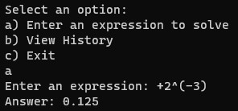

This expression shows that negative exponents work, and preceding addition signs also work

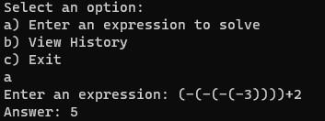

This expression shows that having multiple negative signs will work as intended

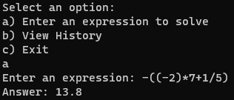

Division works as intended, as do overarching negative symbols.



You can type out the expression in the same command as when you’re running the executable, as long as the expression has double quotes.