Life 102 Notes
Mitosis & Cell Cycle
Chromatid: One half of the chromosome.
Centromere: The constricted middle of the chromosome.
Chromatin: The DNA and histones in the nucleus of a non-diving cell. It is the unwound DNA that is present during the cells normal growth and development stage.
Chromosome: Super condensed DNA that is present in the cell during cell division. They can be one chromatid or two.
Types of cell division: Binary fission(prokaryotes), Mitosis(eukaryotes), Meiosis(eukaryotes).
- Mitosis produces identical daughter cells while Meiosis produces genetically different cells.
Interphase: It is the first phase of the cell cycle. It is the longest phase of the cell cycle involving three sub phases. The typical duration of this phase is 23 hours.
- G1 phase (gap 1) the cells grow, synthesize cell organelles and other macromolecules. The cell also accumulates sufficient energy required for division.
- S phase (synthesis) the existing DNA is replicated in the nucleus. This process exerts energy.
- G2 phase (gap 2) cells grow further in size making more proteins and organelles. All preparations of mitosis are completed. New DNA is assessed for correctness.
- G0 phase is what some cells are when not preparing to divide (some cells that never or rarely divide) remain in G0 permanently.
M Phase: Second step of the cell cycle. The cell divides its genetic material (DNA) and cytoplasm to form two new cells. This is done by either Mitosis or Meiosis.

- Mitosis or karyokinesis is the nuclear division period and consists of four phases, prophase, metaphase, anaphase, and telophase.
- Cytokinesis is the process where the cytoplasm of the cell splits from two independent cells. This takes place toward the end of mitosis.
Checkpoints: G1, G2 & M checkpoints.
Mitosis: is part of the m phase (second step of cell cycle). This is where the nucleus divides into to separate daughter cells each with the same number of chromosomes.

- Prophase: Chromatin condenses into chromosomes, and the nuclear envelope breaks down. (spindle fibers appear from the centrosomes)
- Prometaphase: Spindle fibers reach out and start to attach to chromosomes.
- Metaphase: Spindle fibers attach to the centromere of each pair of sister chromatids.
(chromosomes are lined up in the middle) AKA the metaphase plate.
- Anaphase: Sister chromatids separate, and the centromeres divide.
(sister chromatids are pulled away)
- Telophase: chromosomes reach the opposite poles and begin to decondense. Nuclear envelopes from around the chromosomes.
(chromosomes arrive at apposite poles)
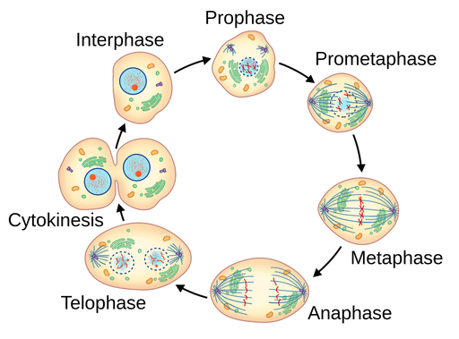
- Cytokinesis: the cytoplasm splits into two and the cell divides. This process is different in plant and animal cells. Cleavage furrow is where the cell is separating.

Ploidy: The number of chromosomes sets in a cell. Haploid, diploid, triploid, tetraploid.

Peto’s paradox prediction: Body size relates to an overall species’ risk of developing cancer because bigger animals have more cells. More cells mean more mitosis therefore a higher risk of genetic mutation and predisposition to cancer. (Larger animals seem to have lower cancer risk for some reason).
Meiosis:
DNA: is found in the nucleus and is wound around histone proteins. Chromatin is dna in loose uncoiled form. Chromosomes are DNA tightly coiled and condensed during cell division. Chromatid is a single strand chromosome is two chromatids. Centromere is where chromatids attach.
Gene: one section of DNA strand that code for one trait.
Homologous chromosomes: one inherited by mother one from the father. Same gene sequence and location but may carry different versions alleles of those genes.
Haploid:1 Copy of each chromosome.
Diploid: Two copies of each chromosome.
- Meiosis splits one cell into four cells while mitosis splits one cell into two cells.
- Mitosis creates 2 identical diploid cells while meiosis make 4 genetically different haploid cells.
- Haploid cells are only created in the 1rst and 2nd division of meiosis.
Zygote: a diploid cell resulting from the fusion of two haploid gametes. Formed by haploid sperm and haploid egg.
- As the embryo develops the cells will become specialized so they can make all of the different cell types in our body.
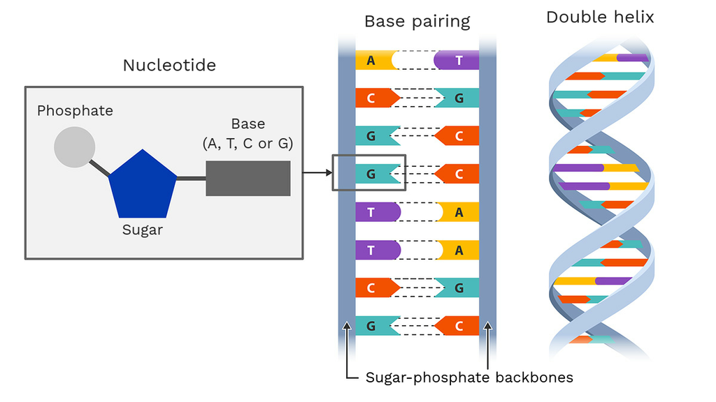
`
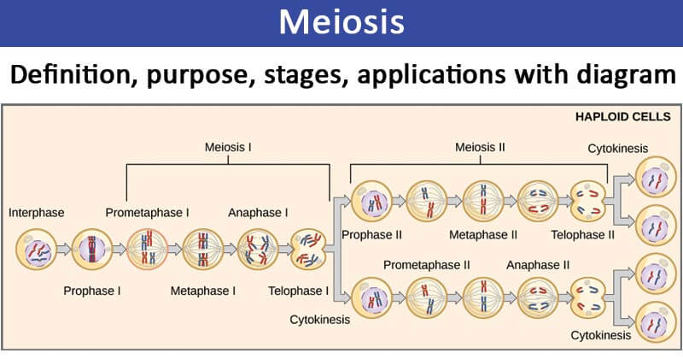
Nucleotides: 3 nucleotides = 1 codon = 1 amino acid in a protein.
Codon: Composed of 3 nucleotides the encode a specific amino acid (AUG, GGC, UAA).
- There are 64 codons but only 20 amino acids, so multiple codons can code for the same amino acid. (This is called redundancy or degeneracy of the genetic code).
Ploidy: number of chromosomes in a organism
Gametes: are reproductive cells that contain half the number of chromosomes of a normal body cell (they are haploid). Produced by meiosis.
Somatic Cells: body cells everything that is not a gamete. Produced by mitosis.
- Genetic variation in meiosis occurs in prophase 1 and metaphase 1.
Principle of segregation: each gamete contains only 1 allele for each gene.
Principle of independent assortment: the genes and alleles go into different daughter cells at random.
Meiosis 1: (Diploid)
- Starts with 1 diploid cell
- Interphase: G1, S, G2
- Prophase 1 (recombination & synapsis happens) Homologous chromosomes pair up and form tetrads. (This is called synapsis).
- Metaphase 1 (independent assortment)
- Anaphase 1 (homologous chromosomes are pulled apart)
- Telophase 1 & cytokinesis
- Interphase (no s phase)
- Ends with two haploid cells
Meiosis 2: (Haploid)
- Prophase 2
- Metaphase 2
- Anaphase 2
- Telophase 2 and cytokinesis
- 4 new genetically different haploid daughter cells with 23 chromosomes.
(Mitosis unlike Meiosis only involves diploid cells).
Fertilization: haploid sperm and haploid egg form diploid zygote
Synapsis: pairing of homologous chromosomes
Euchromatin: DNA loosely wound around histone proteins.
Heterochromatin: DNA tightly wound around histone proteins.
- DNA replicates approximately 50 nucleotides per second. Base pair errors are made during replication mutation is a change in genetic code.
Mutation: any change in a DNA sequence that usually happens during DNA replication. In sex cells (gametes) it may affect individuals’ offspring/ children. In body cells (somatic cells) it may affect the individual.
Genetic Variation: when homologous chromosomes form pairs in prophase 1 of meiosis 1, crossing over can occur. Results in genetic variation in daughter cells and offspring. During metaphase 1, the tetrads move to the metaphase plate with kinetochores facing opposite poles. Results in genetic variation in daughter cells.
Heredity: refers to the genetic heritage passed down by our biological parents. It is the transmission of traits from one generation to the next. These traits can be physical, or behavioral. Genetics – is the study of heredity.
Genotype: What we can’t see of a gene. The genetic makeup of a organism and specific combination of alleles it has. (genetic)
Phenotype: What we can see from a gene. Results from the genotype and the environment. (physical)
Alleles: Different versions of the same gene. You inherit two alleles for each gene one from each parent. Coded from hundreds or thousands of amino acid proteins. In diploid organisms like humans each gene is represented by two alleles, one inherited from each parent.
Tetrad: A group of four sister chromatids. A homologous chromosomes form into a tetrad, one chromosome from mother and one from father. (Two x shaped chromosomes pair up).
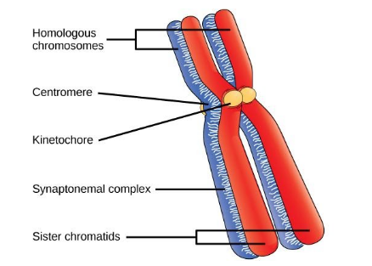
Mendel’s Laws:
Law of segregation: The two forms of a gene (now as the alleles) present in each organism segregate into different cells during gamete formation.
Law of independent assortment: The two alleles of many different genes present in any given (diploid) organism segregate/ assort from one another in a random fashion.
Law of dominance: Alleles can be dominant or recessive. The dominant allele, if present, will always determine the trait

Type of inheritance | Definition
Complete dominance | One allele completely masks the other
Incomplete dominance | One allele does not completely mask the other (Somewhere in between).
Codominance | Neither allele completely masks the other result is a little of each.
Multiple alleles | More than one allele for a trait
Polygenic traits | More than two genes control a trait
Sex linked genes | The gene is located on the x chromosome
Heterozygous: The genotype consists of two different genes ( for example Bb). The alleles of the gene are different.
Homozygous: The genotype consists of two of the same allele ( for example BB). The alleles that are the same.
- Each gene has two alleles Ex: a pea plant might have a Tt for tallness T from one parent t from another parent. When the plant makes gametes, it passes on only one allele per gene, not both. It is completely random which gene is passed on.
- The pea plant has three possible genotypes to be passed on TT, Tt, tt. (Tt and tT represent the same combination of alleles).

Inheritance:
Prokaryotes cell division:
- have circular chromosome
- divide by binary fission
- no spindle fibers
Eukaryotes cell division:
- have linear chromosomes
- divide by mitosis
-spindle fibers
Mitosis starts with 23 pairs of homologous chromosomes 1 maternal (from mother) 1 paternal (from father). End with two cells each with 23 pairs of homologous chromosomes. Meiosis will end up with four cells with 23 individual chromosomes.
Eye color = polygenic (more than one gene, 15+, controls expression of the trait). It is related to the amount of melanin (pigment) in front layer of the iris.
Pleiotropy: In genetics, it refers to a single gene controlling or influencing multiple and possibly unrelated phenotypic (observable) traits. Cystic fibrosis & Sickle Cell Anemia are genetic disorders that are pleiotropy.
Epistasis: When the expression of one gene is affected by or modified by the other gene, often masking or altering its effect on the phenotype.
Karyotype: Display of all the chromosomes in an organism. Each number pair represents a pair of homologous chromosomes, (two chromosomes) one from mother and father.

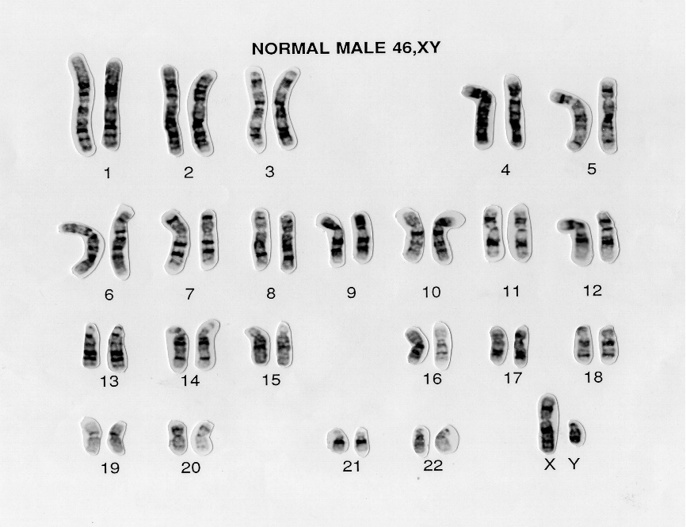

In this species of mouse, brown fur (B) is dominant to albino fur (b).
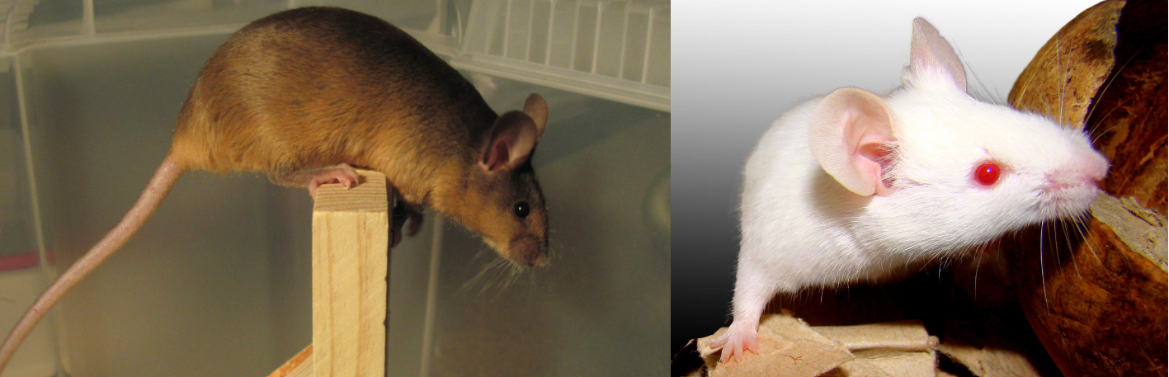
Monohybrid cross: One trait
Dihybrid cross: two traits
Foil: First, Outer , Inner, Last – Male = Aa Female = Bb
First = AB Outer = Ab Inner = aB Last = ab
Gametes = AB, Ab, aB, ab
B = brown allele,
b = albino allele
Punnett Square #1 Brown parent BB with Albino parent bb
 | B | B
b | Bb (brown) | Bb (brown)
b | Bb (brown) | Bb (brown)

Punnett Square #2 Brown parent Bb with Albino parent bb
 | B | b
b | Bb (brown) | Bb (albino)
b | Bb(brown) | Bb (albino)

Curved Horns = C Straight horns = c Gray color = G brown coat = g
Punnett Square #3 – Jackaolopes - Male = Gg cc Female = gg Cc
The male is heterozygous for coat color and homozygous recessive for horn-type.
The female is homozygous recessive for coat color and heterozygous for horn-type.

 | Gc | gc
gC | Gg Cc (gray curved) | gg Cc (brown curved)
gc | Gg cc (gray straight) | gg cc (brown straight)

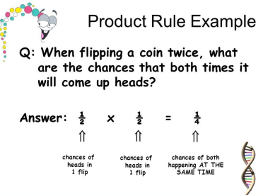
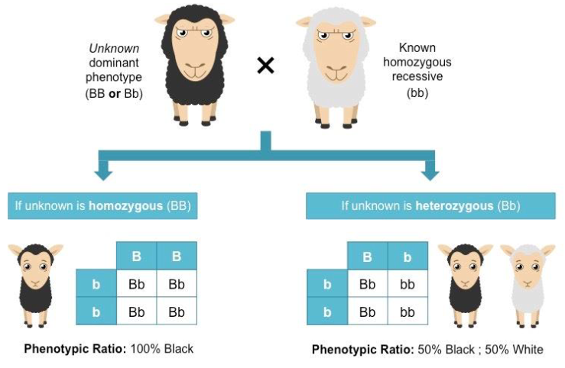
Test Cross: Identifies whether an organism exhibiting a dominant trait is homozygous or
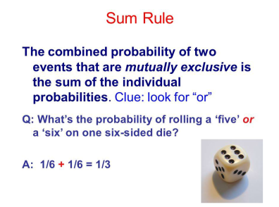

heterozygous for a specific Allele.
If genes are on the same chromosome they cannot independently assort. We observe the jackalope having 2 phenotypes instead of four pictured above. The genes for coat color and horn type are most likely located on the same chromosome. Explaining why there is only curved horn and brown coat or a straight horn and gray coat phenotype.
Sex determination: Female sex chromosomes are XX. Male sex chromosomes are XY. All female gametes are X. Male gametes can be X or Y. It is the male gamete that determines the genetic sex of the Zygote.
DNA molecules: Are composed of nucleotides, which include a sugar, a phosphate group, and one of four nitrogenous bases: adenine (A), thymine (T), cytosine(C), or guanine (G). A pairs with T and C pairs with G. These bases are held together by Hydrogen bonds. The side of the DNA latter on the other hand or held together by Covalent bonds (Specifically phosphodiester bonds).
- DNA molecules naturally form a double helix shape, which looks like a twisted latter.
- A DNA monomer is a nucleotide.
Okazaki fragments: Chunks of DNA synthesized for the lagging strand. New bases can only be added to the 3’ OH end so the lagging strand is synthesized discontinuously.
Helicase: The enzyme that unzips the DNA so it can be replicated.
Polymerase: The enzyme that adds the new nucleotides to the growing DNA strands, and creates the bonds between the nucleotides.
Replication fork: The area where DNA is unzipped and the DNA replication begins.
Chromosomes:
X-Inactivation: In embryonic development of every female mammal one of two X chromosomes in each cell inactivates by supercoiling into a structure know as a Barr Body.

