Computer Program Solutions

Question 2

Ethan Van Rensburg – System Development Learnership Candidate

*18 – 23 June 2024*

Contents

a) Requirements: 1

**Interface Design:** 1

**Interface Output:** 2

b) System Architecture: 3

**UML Relationship Diagram** 3

c) Operational Flow: 4

**Flow Chart:** 4

**Pseudocode:** 5

d) Data Structures: 9

**Application Programming Interfaces:** 9

**Classes:** 9

**Objects:** 9

# Requirements:

## **Interface Design:**

The program is described in the document as needing to prompt the workers for their shifts and work hours using Scanner.

## **Interface Output:**

The program will then take any inputs and values from the worker/user and display the suitable results in the output pane.

# System Architecture:

## **UML Relationship Diagram**

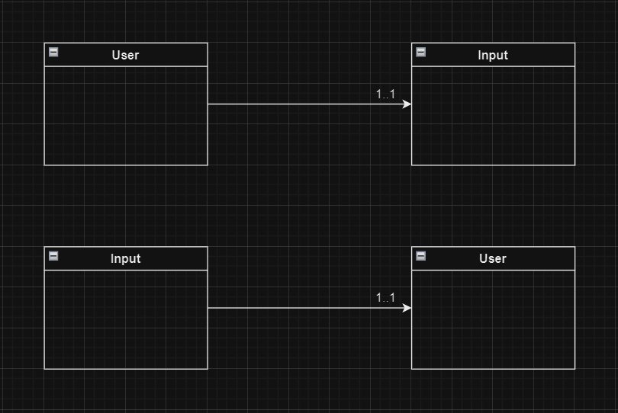

# Operational Flow:

## **Flow Chart:**

The pdf file for the flowchart will be provided, this link is here just in case.

[Click here](../../Downloads/Flowchart.pdf)

## **Pseudocode:**

The following is a sample of pseudocode to showcase the formatting of all the Shift classes and their executable code:

Start

1. Declare and initialize variables:

- hours (integer)

- hourly1 (double) = 50

- hourly2 (double) = 70

- hourly3 (double) = 90

2. Display a menu for shift selection:

- "Please select your assigned shift:"

- 1 - Morning Shift

- 2 - Day Shift

- 3 - Night Shift

- Read the user's choice into shifChoice (integer).

3. Switch on shifChoice:

a. Case 1 (Morning Shift):

- Prompt the user: "How many hours do you work in a week?"

- Read the input into hours.

- Try the following:

- Create a file named "Hours.txt" (path: C:\Users\ETHAN.V\Documents\NetBeansProjects\Ethan_UrbanFurn).

- Append the line "Hours Worked: <hours>" to the file.

- Calculate weekPay = hours * hourly1.

- Display payroll details:

- "Payroll:"

- "----------"

- "Hours Worked: <hours>"

- "Shift: Morning"

- "Hourly Pay Rate: R<hourly1>"

- "Regular Pay: R<weekPay>"

- "Overtime Pay: R0.00"

- "Total of Regular and Overtime: R<weekPay>"

- "Retirement Deduction: R0.00"

- "Net Pay: R<weekPay>"

- End of Case 1.

Case 2 (Day Shift):

1. Declare and initialize variables:

- hours (integer)

- hourly2 (double) = 70

2. Prompt the user: "How many hours do you work in a week?"

Read the input and store it in the 'hours' variable.

3. Try the following:

a. Create a file named "Hours.txt" (path: C:\Users\ETHAN.V\Documents\NetBeansProjects\Ethan_UrbanFurn).

b. Append the line "Hours Worked: <hours>" to the file.

c. Calculate weekPay = hours * hourly2.

4. If 'hours' is equal to 40 and not equal to 0:

a. Call the method 'retire2' from the 'plan' object with the following arguments:

- weekPay

- hours

- hourly2

b. End of Case 2.

5. Else if 'hours' is greater than 40 and not equal to 0:

a. Calculate overtime hours: overTime = hours - 40.

b. Calculate overtime pay: calcOver = overTime * (70 * 1.5).

c. Calculate total pay (including overtime): weekOver = calcOver + (40 * 70).

d. Call the method 'retireOver2' from the 'plan' object with the following arguments:

- weekOver

- hours

- calcOver

- hourly2

e. End of Case 2.

6. Else:

a. Display "Invalid input."

b. End of Case 2.

Case 3 (Night Shift):

1. Declare and initialize variables:

- hours (integer)

- hourly3 (double) = 90

2. Prompt the user: "How many hours do you work in a week?"

Read the input and store it in the 'hours' variable.

3. Try the following:

a. Create a file named "Hours.txt" (path: C:\Users\ETHAN.V\Documents\NetBeansProjects\Ethan_UrbanFurn).

b. Append the line "Hours Worked: <hours>" to the file.

c. Calculate weekPay = hours * hourly3.

4. If 'hours' is equal to 40 and not equal to 0:

a. Call the method 'retire3' from the 'plan' object with the following arguments:

- weekPay

- hours

- hourly3

b. End of Case 3.

5. Else if 'hours' is greater than 40 and not equal to 0:

a. Calculate overtime hours: overTime = hours - 40.

b. Calculate overtime pay: calcOver = overTime * (90 * 1.5).

c. Calculate total pay (including overtime): weekOver = calcOver + (40 * 90).

d. Call the method 'retireOver3' from the 'plan' object with the following arguments:

- weekOver

- hours

- calcOver

- hourly3

e. End of Case 3.

6. Else:

a. Display "Invalid input."

b. End of Case 3.

End

# Data Structures:

## **Application Programming Interfaces:**

The program utilized 2 primary APIs in Java for their imports and objects/functions:

The Scanner API was useful in calling on objects for input purposes. The IO API helped in allowing the read/write functions for input documentation.

## **Classes:**

The program and the team initially began using multiple classes in Multi-Level Inheritance but then transitioned to a single Main class:

## **Objects:**

Within the program, many objects and their methods were used alongside each other to produce the needed results of calculations and displays.

Firstly, a Scanner created object was the primary asset for input and data:

Secondly, the different objects were created for the read/write methods and functions, each had a dedicated purpose, such as creating the file; writing the text/inputs into the file, and finding the file for reading and writing.

Finally, the last object of completion was using an instance of the main class itself to call its own methods outside its main method:



