Computer Program Solutions

Question 4

Ethan Van Rensburg – System Development Learnership Candidate

*18 – 23 June 2024*

Contents

a) Test Assessment: 1

Objectives 1

Test Strategy Development: 2

Cycle 1: 2

Cycle 2: 2

b) Test Result Recording: 3

Cycle 1: 3

1: 3

2: 4

3: 5

4: 6

5: 7

6: 8

7: 9

8: 10

9: 11

10: 12

11: 13

12: 14

13: 15

Cycle 2: 16

1: 16

2: 18

3: 19

4: 20

5: 21

6: 22

# Test Assessment:

## Objectives

**Determine the Range of Hours:**

In the program’s requirements, a work week is needed to be analyzed for both regular time and overtime. The regular/base working hours are 40, which we can identify as our minimum. There can also be additional hours, this being overtime, which exceed our marked base of 40 hours.

**Determine the Maximum number of Users:**

Due to UrbanFurn’s factory-based operations and the company being based in industrial workings, the workforce on average ranges between operations workers, accountants, managers and supervisors. The average amount estimated by UrbanFurn for operational procedures and payroll delivery was about 400 users. Therefore, the system should be noted for delivery for 400 end users within UrbanFurn’s operations and their software equipment.

**Determine the validity of Calculations:**

The program’s main goal is to provide accurate and suitable calculations for regular pay and overtime pay towards the factory workers of UrbanFurn and their weekly salary. Therefore, the manual and unit tests will search for these suitable results and will correct any issues if they are present.

**Determine the relationship between Shifts:**

All shifts follow a similar setup of calculations and input requirements to display results. With this in mind, the program must be tested on the relationship between these sections of the main code to discover their underlying links and cooperation.

**Determine the connections between methods:**

The program is comprised of multiple methods, the main method includes the calculation of the different shifts, but alongside it are other methods. The remaining four methods help to calculate retirement deductions for shifts 2 and 3, based on regular pay and overtime pay. These methods must be tested in their validity and sharing of variables and calculations to determine if they are suitable for final outputs and displays.

# Test Strategy Development:

## Cycle 1:

1. When run, the program displays the 3 shifts of UrbanFurn in a numbered list. Alongside the display, the system also allows the user to enter the shift they operate in.
2. After the number is entered, the user will be prompted to enter their hours of work.
3. After the needed values are inputted, the user will be given their results and calculations.
4. If the user had chosen shift 2 or 3, they will be presented with the retirement plan prompt.
5. Choosing no will not add the deductions to the net pay.
6. Choosing yes will add the deductions to the net pay.
7. The same can be done within shift 3.
8. Alongside the regular pay, there is also the overtime calculations for shift 1.
9. Alongside the regular pay, there is also the overtime calculations for shift 2.
10. Alongside the regular pay, there is also the overtime calculations for shift 3.
11. If the user inputs an incorrect shift number, the system will reject their action and they will need to re-run the program.
12. If the user inputs an incorrect number of work hours, they will then be rejected and will need to re-run the program.
13. All hours inputted are processed and saved into a text file called Hours.

## Cycle 2:

The second cycle will involve the implementation of unit testing for the program’s main functions and methods. The test cases will test the minimum and maximum work hours allowed by the payroll system. The main case will test the main method for the 3 shifts and their calculations, while the other 4 test cases will test the retire methods for regular and overtime pay of shifts 2 and 3.

# Test Result Recording:

## Cycle 1:

### 1:

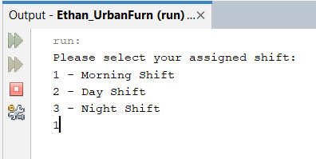

### 2:

### 3:

### 4:



### 5:

### 6:

### 7:

### 8:

### 9:

### 10:

### 11:

### 12:

### 13:

## Cycle 2:

### 1:

### 2:

### 3:

### 4:

### 5:

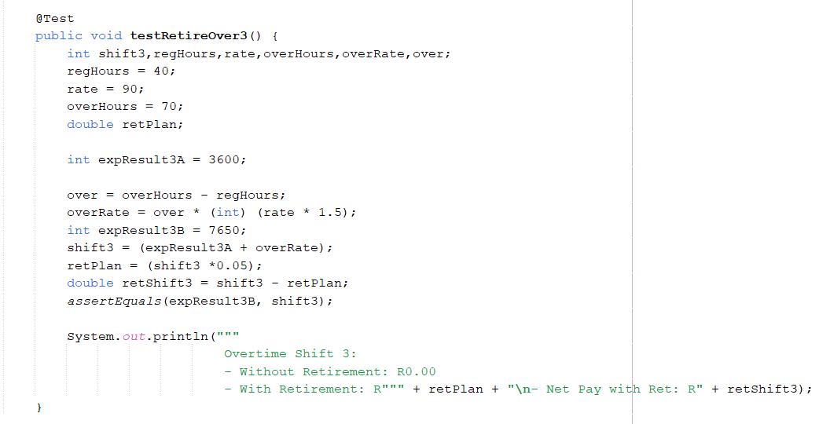

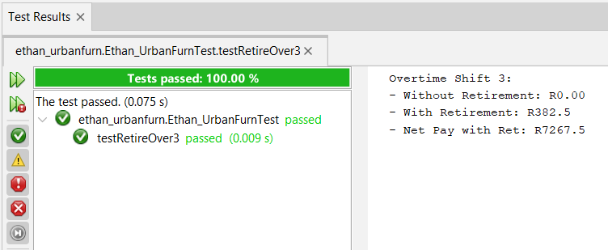

### 6:

