Computer Program Solutions

Question 5

Ethan Van Rensburg – System Development Learnership Candidate

*18 – 23 June 2024*

Contents

**Step 1:** 1

Step 1.1: 2

Step 1.2: 3

Step 1.3: 4

Step 1.4: 5

Step 1.5: 6

Step 1.6: 7

Step 1.7: 8

Step 1.8: 9

Step 1.9: 10

Step 1.10: 11

**Step 2:** 12

Step 2.1: 13

Step 2.2: 14

Step 2.3: 15

Step 2.4: 16

**Step 3:** 17

Step 3.1: 18

Step 3.2: 19

Step 3.3: 20

Step 3.4: 21

Step 3.5: 22

Step 3.6: 23

Step 3.7: 24

Step 3.8: 25

Step 3.9: 26

Step 3.10: 27

**Step 4:** 28

Step 4.1: 29

Step 4.2: 30

Step 4.3: 31

Step 4.4: 32

Step 4.5: 33

Step 4.6: 34

Step 4.7: 35

Step 4.8: 36

**Feedback:** 37

# **Step 1:**

If the Apache NetBeans IDE application is not installed, then the program will not be able to be run sufficiently. Therefore, it is imperative that it is installed for the program to be executed and used. If the application has been installed, then skip over to Step 2.

### Step 1.1:

Search online for the Apache NetBeans download and click the link below.

### Step 1.2:

After clicking the link, find the next download link and download the latest version.

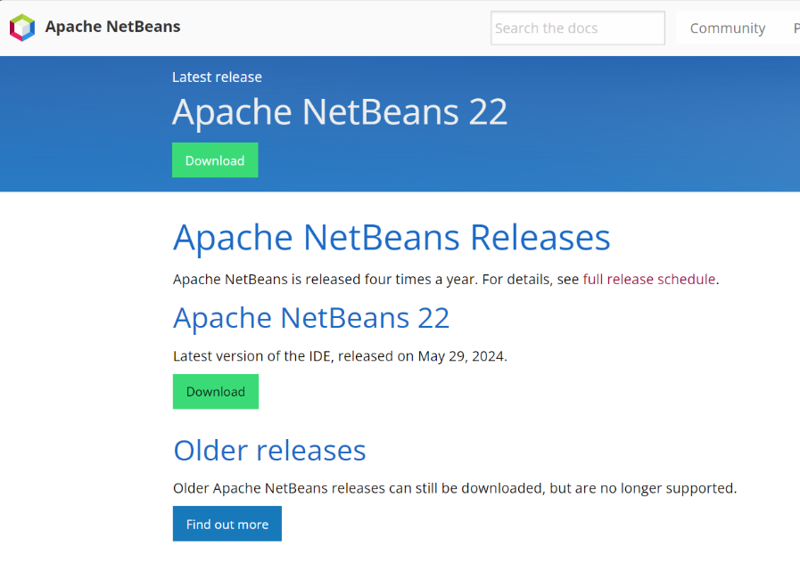

### Step 1.3:

Locate the installer and packages heading with the latest version’s name.

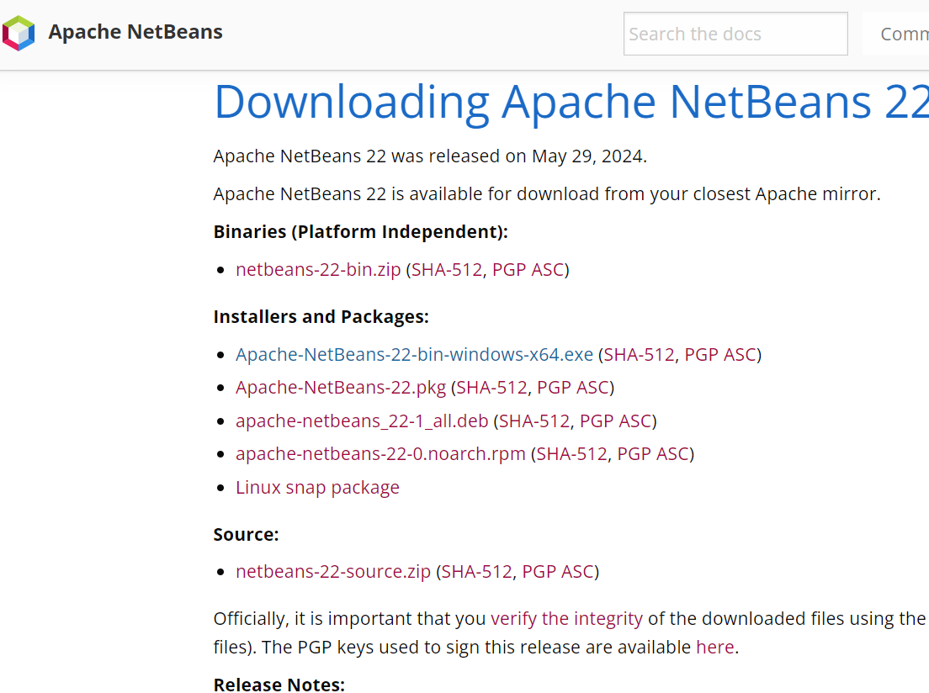

### Step 1.4:

Locate the secure download link suggested by the download site and click it to begin the installation of the installer file.

### Step 1.5:

Wait until the download has completed and then click on the open file link.

### Step 1.6:

The installer will then activate and prompt the user for potential customization, this can be ignored for now. Click the Next button to continue.

### Step 1.7:

There will be a Terms and Conditions screen that will display, the user should click the accept box and then click the Next button.

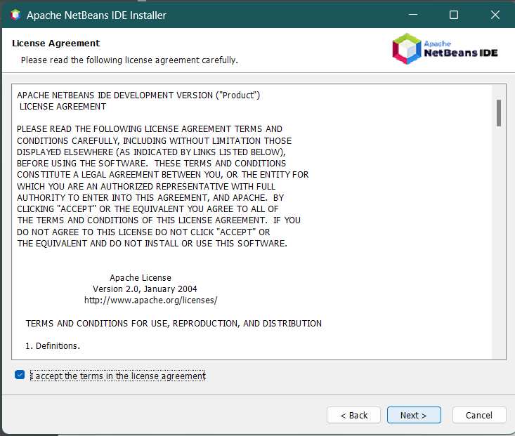

### Step 1.8:

The installer will then present both the location of where the application will be installed and the Java Development Kit / JDK that will be downloaded with it. If there any changes that need to be made or added, the user can click the brows button for editing. Click the Next button after all options are to your liking or are like below:

### Step 1.9:

After all changes are made, the installer will then finally prompt the user to begin the full installation. The user can also check that the application checks for updates. After all is read, click the Install button to start the installation.

### Step 1.10:

After the installation is complete, the user will be presented with a menu from the installer, the user should read what is said based on their choices and then click the Finish button.

# **Step 2:**

After the Apache NetBeans application has been installed, the user must then locate the program and download it for their device to use, the project is likely to be zipped, so the user must then extract the files and save that to their downloads. Delete the old, zipped folder and keep the new extracted file in your downloads.



### Step 2.1:

Locate and open the Apache NetBeans application.

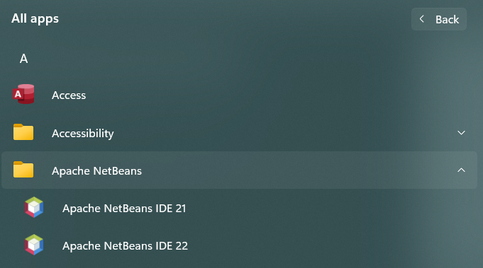

### Step 2.2:

The user will then be presented with the start-up menu, they should then select the “Open Project” tab to open the program.

### Step 2.3:

The user must then click on the Desktop icon and find the Downloads section, double click on it and find the Arrays_ParallelBMI folder. Open its files until reaching the same file branch as below and then click Open Project:

### Step 2.4:

The user must then navigate the Projects pane and the program’s files for the file and double click it to open the program.

# **Step 3:**

After the program has been installed and imported, the IDE will then make it able to be run and executed for UrbanFurn.

### Step 3.1:

The user must look to the top left of their IDE, the ribbon will have many actions to choose from. The user must find and click the green arrow button / Run button to execute the program’s code.

### Step 3.2:

After clicking the Run button, the user will then be prompted to enter their shift number for the 3 shift types: Morning, Day and Night.

### Step 3.3:

After the user chooses their shift, they will then be prompted to enter their work hours for the week.



### Step 3.4:

If the user selects the first shift and their hours are below or equal to 40, they will then be presented with the following results:

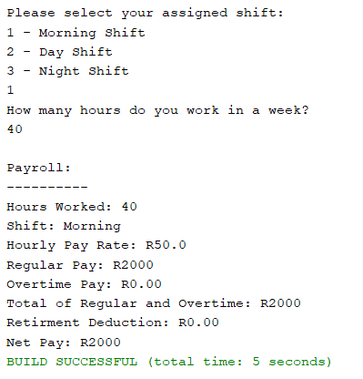

### Step 3.5:

If the user selects the second shift and their hours are below or equal to 40, they will then be presented with the following:



### Step 3.6:

If the user selects yes, their results will be as such:

### Step 3.7:

If the user selects no, their results will be as such:

### Step 3.8:

If the user selects the third shift and their hours are below or equal to 40, they will then be presented with the following results:



### Step 3.9:

If the user selects yes, their results will be as such:

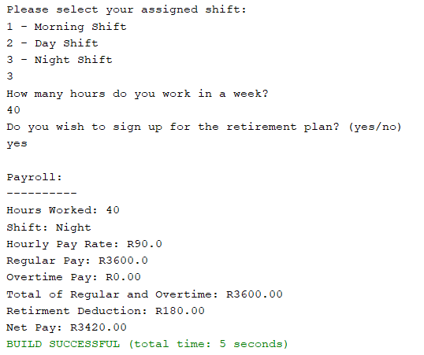

### Step 3.10:

If the user selects no, their results will be as such:

# **Step 4:**

If the user’s input is not within the base range of 40, their work hours are considered overtime and the following steps will result:

### Step 4.1:

After the user chooses their shift, they will then be prompted to enter their work hours for the week.



### Step 4.2:

If the user selects the first shift and their hours are greater than 40, they will then be presented with the following results:

### Step 4.3:

If the user selects the second shift and their hours are greater than 40, they will then be presented with the following:



### Step 4.4:

If the user selects yes, their results will be as such:

### Step 4.5:

If the user selects no, their results will be as such:

### Step 4.6:

If the user selects the third shift and their hours are greater than 40, they will then be presented with the following results:



### Step 4.7:

If the user selects yes, their results will be as such:

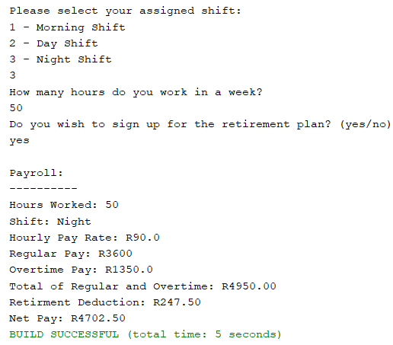

### Step 4.8:

If the user selects no, their results will be as such:

# **Feedback:**

If there are any issues or concerns, ensure to view the test case document with the possible outcomes.