Computer Program Solutions

Question 6

Ethan Van Rensburg – System Development Learnership Candidate

*18 – 23 June 2024*

Contents

a) Test Cases: 1

Case 1: 1

Case 2: 3

Case 3: 4

# Purpose Description:

UrbanFurn had requested that the developer create a system for end-user delivery, below is an in-depth description of what was produced:

The program created was a Payroll calculation program that is used for end-user satisfaction and the delivery of results. The program begins its execution by prompting a user to enter their shift at UrbanFurn, then the program will ask for the suitable hours the user had worked during a week. After the hours and shifts are collected, the system then calculates the pay of the user based on the hourly rate per shift. The final results are shown in a display like below:

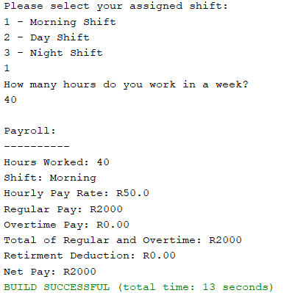

The program designed is based solely on an input output system, which takes in certain information, processes the data given and produces suitable results and outcomes. The development process created a UML Diagram to visualize the relationship between users and outputs:

The program also utilized an interface object to process the information given and store them in a suitable text file for records and management.

# Code Layout:

Below is the format and structure of the code created and used for UrbanFurn’s product:

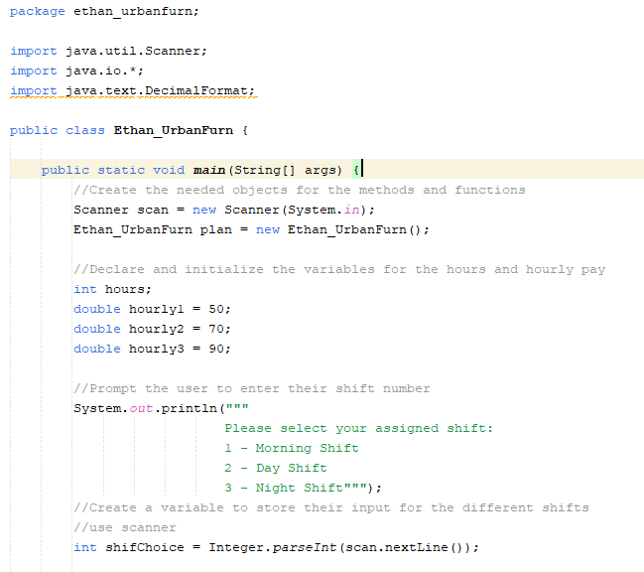

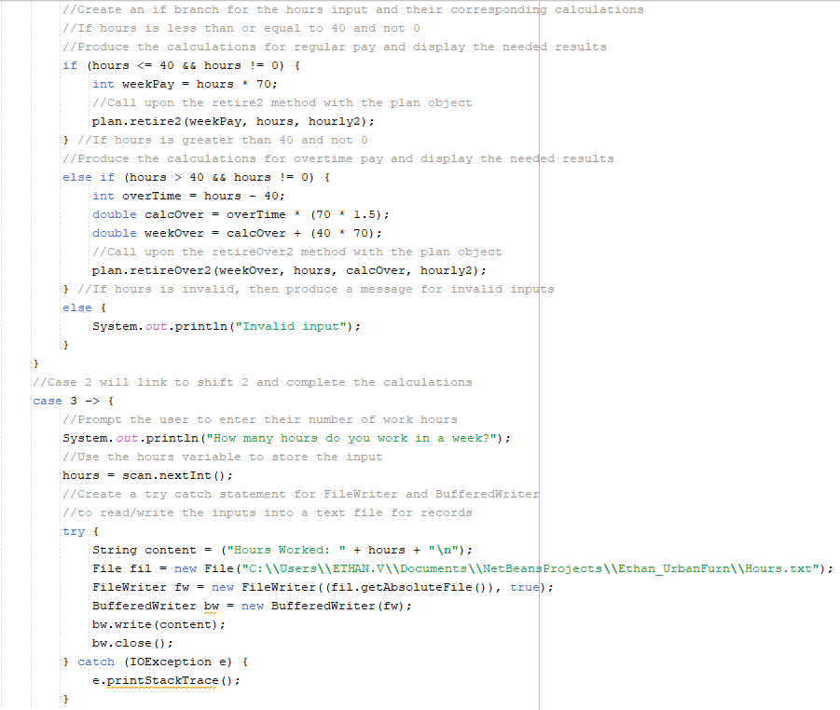

# Change Log:

