

High-Level Design (HLD)
Revision <0.1>
Last Print Date: 11/8/2026 - 11/8/2026

<SmartAT>

Primary Author(s): zhiqiang.guo@borqs.com

Key Contributors: N/A

Approvals:

Role | Signature | Date
Software Engineering Manager
Legal Notices and Disclaimers

Disclaimers
INTEL CORPORATION MAKES NO WARRANTY OF ANY KIND WITH REGARD TO THIS MATERIAL, INCLUDING, BUT NOT LIMITED TO, THE IMPLIED WARRANTIES OF MERCHANTABILITY AND FITNESS FOR A PARTICULAR PURPOSE. INTEL CORPORATION ASSUMES NO RESPONSIBILITY FOR ANY ERRORS THAT MAY APPEAR IN THIS DOCUMENT. INTEL CORPORATION MAKES NO COMMITMENT TO UPDATE NOR TO KEEP CURRENT THE INFORMATION CONTAINED IN THIS DOCUMENT.
THIS SPECIFICATION IS COPYRIGHTED BY AND SHALL REMAIN THE PROPERTY OF INTEL CORPORATION. NO LICENSE, EXPRESS OR IMPLIED, BY ESTOPPEL OR OTHERWISE TO ANY INTELLECTUAL PROPERTY RIGHTS IS GRANTED HEREIN.
INTEL DISCLAIMS ALL LIABILITY, INCLUDING LIABILITY FOR INFRINGEMENT OF ANY PROPRIETARY RIGHTS, RELATING TO IMPLEMENTATION OF INFORMATION IN THIS SPECIFICATION. INTEL DOES NOT WARRANT OR REPRESENT THAT SUCH IMPLEMENTATIONS WILL NOT INFRINGE SUCH RIGHTS.
NO PART OF THIS DOCUMENT MAY BE COPIED OR REPRODUCED IN ANY FORM OR BY ANY MEANS WITHOUT PRIOR WRITTEN CONSENT OF INTEL CORPORATION.
INTEL CORPORATION RETAINS THE RIGHT TO MAKE CHANGES TO THESE SPECIFICATIONS AT ANY TIME, WITHOUT NOTICE.

Legal Notices
Intel software products are copyrighted by and shall remain the property of Intel Corporation. Use, duplication or disclosure is subject to restrictions stated in Intel's Software License Agreement, or in the case of software delivered to the government, in accordance with the software license agreement as defined in FAR 52.227-7013.

The Intel logo is a registered trademark of Intel Corporation.
< Intel Trademarks Go Here >

< Other Company Trademarks Go Here >
Other brands and names are the property of their respective owners.
Abstract
Copyright © 2003-2002, Intel Corporation, All Rights Reserved.

Copyright © 2003-2002, Intel Corporation, All Rights Reserved.

Copyright © 2003-2002, Intel Corporation, All Rights Reserved.

Copyright © 2003-2002, Intel Corporation, All Rights Reserved.

Copyright © 2003-2002, Intel Corporation, All Rights Reserved.

Copyright © 2003-2002, Intel Corporation, All Rights Reserved.

Copyright © 2003-2002, Intel Corporation, All Rights Reserved.

Copyright © 2003-2002, Intel Corporation, All Rights Reserved.

Copyright © 2003-2002, Intel Corporation, All Rights Reserved.

Copyright © 2003-2002, Intel Corporation, All Rights Reserved.

Copyright © 2003-2002, Intel Corporation, All Rights Reserved.

Copyright © 2003-2002, Intel Corporation, All Rights Reserved.

Copyright © 2003-2002, Intel Corporation, All Rights Reserved.

Copyright © 2003-2002, Intel Corporation, All Rights Reserved.

Copyright © 2003-2002, Intel Corporation, All Rights Reserved.

Copyright © 2003-2002, Intel Corporation, All Rights Reserved.

SmartAT is a web server, which provides interfaces for MTBF client to upload test result to it, device snapshots and error logs at the same time, and also provides web portal for end user to check the results and statistics online.
This document provides the server design process, and how we support it.
Revision History

Revision | Date | Author | Reason for Changes
v0.1 | 11/01/2013 | Zhiqiang.guo@borqs.com | Init Version
Table of Contents

1. Introduction 1
1.1 Purpose of this Document 1
1.2 Document Scope 1
1.3 Terminology 2
1.3.1 Acronyms 2
1.4 Related Documents 2
1.4.1 Document Structure for Design Specifications 2
1.5 Document Organization 3
1.6 Document Syntax 3
2. Methodologies and Notations 4
3. Assumptions and Dependencies 4
4. High-level Design 4
4.1 Design Decomposition 4
4.2 Component Descriptions 5
4.2.1 System Component Descriptions 5
4.2.1.1 Internal Components 6
4.2.1.2 Internal Methods 8
4.2.2 Other system aspects 8
4.3 Design Strategies 8
4.3.1 Error Prevention Strategy 8
4.3.2 Product Installation Strategy 8
4.3.3 Initialization and Shutdown Strategies 8
4.3.4 Interoperability and Compatibility Support 8
4.3.4.1 Target hardware/software environment 8
4.3.4.2 Imported Interfaces 8
4.3.4.3 Exported and Defined Software Interfaces 8
4.3.4.4 Product Standards 8
4.4 Product Requirements Document (PRD) Correlation 9

Introduction

Purpose of this Document
This software High-Level Design (HLD) document supplements the SmartAT Software Architecture Specification by providing further levels of decomposition and design detail. Please refer to the SmartAT Software Architecture Specification for the first level design decomposition and architectural description.
This HLD specifies the implementation, including inter-component dependencies, providing sufficient design detail that any product based on this HLD will satisfy the product requirements specified in the SmartAT Product Requirements Document (PRD). The product implement should satisfy the PRD, regardless of which product development team (PDT) implements the design.
This HLD, once completed, will enable the product development team (PDT) to complete the low-level design, coordinate commitments, make good estimates of effort, start test planning and to schedule for Plan of Record (POR).

Document Scope
The SmartAT high-level design covers all levels of design other than the architectural specification and the low-level design of the individual components. Where needed to ensure a complete understanding of the product, the HLD may reference other design documents such as external product specifications (EPS).
Anyone interested in understanding the SmartAT internal design should read this document.

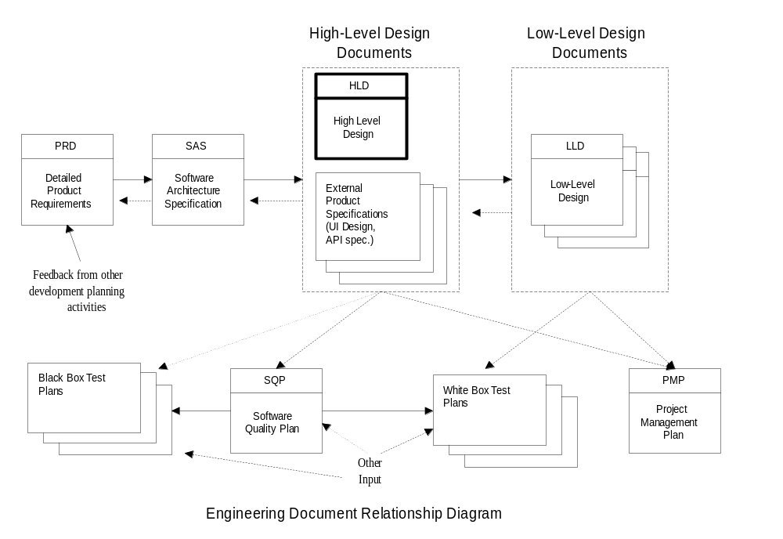Terminology

Acronyms
Acronym | Description
HLD | High-Level Design
UML | Universal Modeling Language
Table: Definition of Acronyms used.

For additional terminology, see “Appendix A: Definitions”.

Related Documents

Document Name | Revision | Doc Number
<SmartAT> PRD | 0.1
Table: Related Documentation

Document Structure for Design Specifications

Document Organization

The data flow in SmartAT
SmartAT schema definition (mandatory, optional items)
SmartAT server layout

Document Syntax
If you use any typographical conventions (document formatting or special symbols to convey some meaning, such as: all hidden text is instructional, bold means Warning, etc…), include your format style or symbol list and the corresponding meaning here. After reading this section, your readers should be able to interpret the typographical conventions used in your document.

Methodologies and Notations
This is a detailed explanation of any complex design concepts or representation used in the high-level design specification. Whenever possible, you should reference external literature that explains the techniques you choose to document your design. Include any concepts or representations that may be unique to your design or modified from a common methodology. See Appendix B for some examples of design notation.

Assumptions and Dependencies

SmartAT should be deployed on Linux OS, 12.04 LTS and later version is required. Python runtime should be ready and currently only support version 2.7.x.
For uploading test results to SmartAT, invoke the upload related APIs accordingly.
For accessing the web portal of SmartAT, Chrome and Firefox are supported and Chrome is suggested.

High-level Design

Design Decomposition

SmartAT consists of 4 modules: account module, group module, session module, case module
SmartAT can be accessed in two modes,
- MTBF-server mode: MTBF client works on a computer, generates and then upload test results to SmartAT.
- Browser-server mode: End user access SmartAT on its PC via browser.
The entity relationship diagram as below

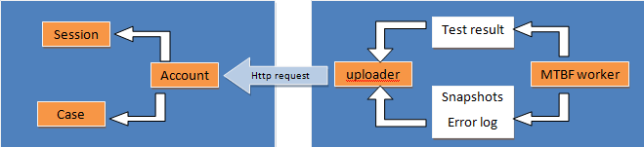
MTBF-server mode

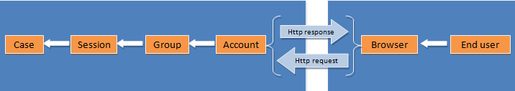
Browser-server mode

Component Descriptions

System Component Descriptions

Time sequence of MTBF-server mode

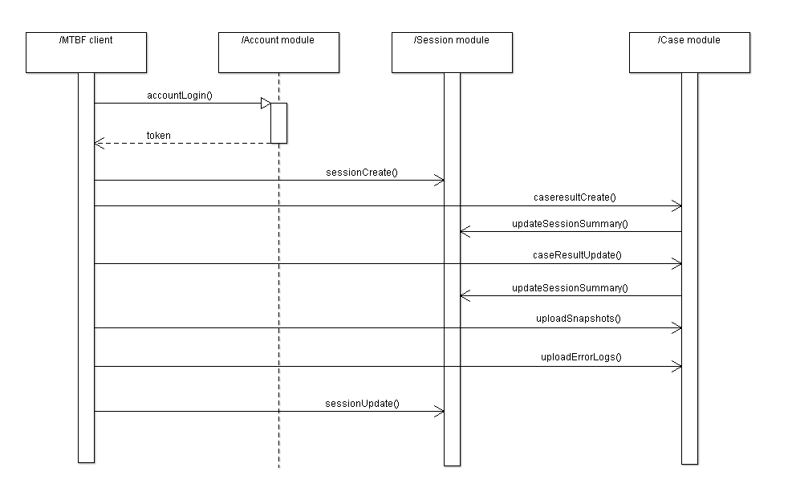

Time sequence of Browser-server mode

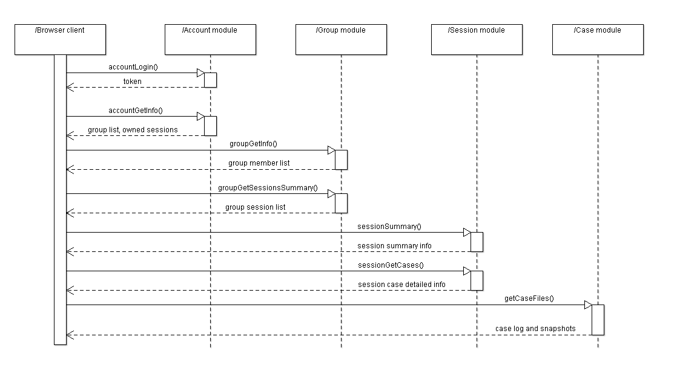

Internal Components
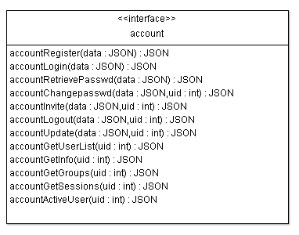
Account module
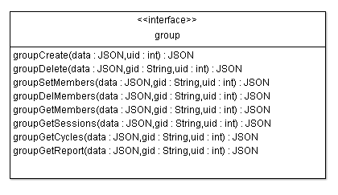
Group module
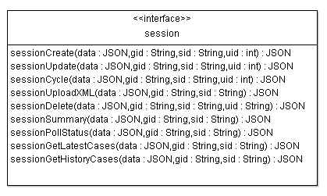
Session module
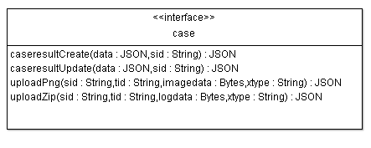
Case module

Internal Methods
This section defines internal methods that operate on internal data structures. If there are modules that implement a protocol or sequence of operations, the state-transition diagram should be shown here. Internal utility functions with a short explanation of the input, output, and transformation operations included here. The scope of the methods and justification (for global and non-local scope) is provided.

Other system aspects

Design Strategies

Describe how your software is designed to prevent errors. This may include data integrity checks, the use of assertions, and design for testability strategies.

Product Installation Strategy
SmartAT is stored on Github, user can get its own repo and deploy the server according to the instruction step by step.

Initialization and Shutdown Strategies
SmartAT is a server process, so only one instance of it alive each time.
When launch SmartAT, it will record its process id in a pid file which can be located at “/tmp/smart-web.pid”
When shutdown a SmartAT process, the process should be killed by its id.

Product Standards
Python PEP8 Coding Style Standard

Product Requirements Document (PRD) Correlation

Statement of PRD Requirement | Design Implementation
Req#1: Ease of use | UI implemented with interactive help facility. UI Design guidelines followed to ensure that it was consistent with other products in the same product family. All prompts requesting information from the user include text describing what information the user should input and where the user may find the information if they do not know the answer.
Table: Correlation of requirements to high-level design specification.
Appendix A Definitions

Term | Definition

Appendix 2 Design Description Techniques
- Execution Scenarios
This technique is very effective in conveying your design to others and confirming to yourself that your design is complete. Using this technique, you can describe typical execution scenarios at a moderate level of detail. In these scenarios, you take a high-level task and walk through an informal description of the sequence of steps performed internally within your design. You may make note on what milestones are reached along the way. You do not need to describe the logic in full detail, but you may describe some of the decisions the code must make.
An execution scenario gives the reader more information about what functions are performed in which architectural components. Since the scenario is relatively brief, it makes it easy for the reader to understand the “information flow”. For example, your notes may indicate that a piece of data obtained during one step will be saved and used a few steps later.
Execution scenarios are not strictly required in any design document, since they cover information that can be described in other ways. However, you will find that they help the reader understand your design for a very little investment of your time and effort to write them down. Making your design understood is one of the keys to passing a design review.
The following is an example of an execution scenario. Many execution scenarios will be shorter than this one. If they get much longer than this example, you might want to consider splitting them into several scenarios. The example below could have been split after step 5, since this marks the completion of one “phase”. Also, note that this example scenario is taken out of context so it contains some undefined terms. In your actual design document, your scenario will refer only to terms and figures you have already defined.
Example Execution Scenario One:
Under the redirector model, communications take place according to the following scenario;
- The Ring 3 client invokes the WinSock interface to obtain a socket and request a connection setup. This will establish communications with the other system (at the far end of the communications link).
- WinSock forwards the connection setup request to the appropriate transport stack (e.g., TCP/IP).
- When a connection completion is received from the far end, it percolates up through the transport stack to WinSock, and WinSock forwards the notification to the Ring 3 client. At this point, the socket is connected.
- The Ring 3 client invokes the WinSock proxy’s ioctl mechanism, specifying the TranslateHandle command, to convert the socket corresponding to the transport connection to a Ring 0 handle used to refer to that connection. As with the previous scenario, the WinSock pass through component would be unnecessary if the stack itself had implemented the TranslateHandle ioctl.
- The SIO proxy creates a new device and a local stream and then returns the handle of the device to the WinSock proxy. The WinSock proxy associates the link with the socket and returns the device name handle to the Ring 3 client. The handle returned is a string suitable for use with the SIO_create command, which the task will call to open the stream for the transport connection. If desired, the media client can modify the string to insert stacking drivers before the transport device. This completes the linking up necessary to allow the media client to send or receive data on the transport connection.
- If the WinSock socket being redirected corresponds to a bi-directional connection, two devices must be created, since the streams are unidirectional.
- For output streams, the media client passes filled buffers to the SIO proxy using SIO_issue. The proxy notifies the WinSock proxy of the availability of buffers via an unspecified interface. The SIO proxy then uses WinSock primitives to send the data over the transport connection.
- Similarly, for input streams the SIO proxy makes buffers available using SIO_issue. The WinSock proxy receives using these buffers and notifies the SIO proxy of the available data. The media client receives the filled buffers from the SIO proxy, using SIO_reclaim.
- Any errors, other than data send and receive errors, follow the path of connection set up and are handled by the Ring 3 client. Lost or truncated data errors follow the data path and are handled by the media client.
- When data transmission is complete or when a disconnection indication is received, the Ring 3 client instructs the Ring 0 client to stop using the redirected stream. The Ring 3 client then initiates the connection tear-down sequence.

- Object Persistence Graph
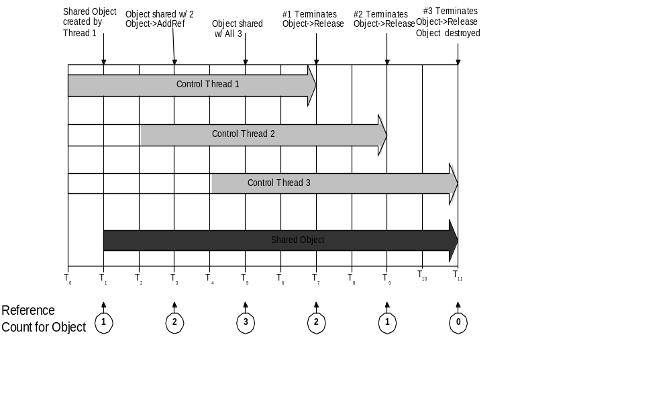
Figure: Reference Counting Example

