SmartAT User Guide

For MTBF result collecting and presenting

|  |
| --- |
| Copyright© 2013 Intel Corporation. All rights reserved.  *Other names and brands may be claimed as the property of others. |

Contents

1 SmartAT Overview 3

1.1 What is SmartAT? 3

1.2 How does SmartAT work? 3

1.3 Feature list 4

2 Prerequisites 4

3 Using SmartAT 5

3.1 Account management 5

3.2 Group management 8

3.3 Test session management 10

3.4 Test case management 11

4 Troubleshooting 14

5 Known Issues 15

A Appendix 15

# SmartAT Overview

## What is SmartAT?

SmartAT is a web server, which provides interfaces for MTBF client to upload test result to it, device snapshots and error logs at the same time, and also provides web portal for end user to check the results and statistics online.

This document provides comprehensive information about SmartAT, with an overview, instructions, troubleshooting information.

## How does SmartAT work?

The figure below represents the workflow of SmartAT

Figure 1‑1. SmartAT workflow

## Feature list

SmartAT is designed to meet all the requirements in *FRS-SmartAT.xlsx* and the key features are,

* Account management
* Project/product management
* Test cycle management
* Test session and test case result management
* Test report calculation and present.

# Prerequisites

Make sure you have these items in place before starting:

* A network accessible PC.
* Function browser at the PC, Firefox or Chrome is required.

# Using SmartAT

## Account management

This section presents the functions of account management.

### Access SmartAT on the host PC

Launch browser at PC then render:

http://<HOSTNAME >/smartserver

When you see the below screen, you are at the login page of SmartAT now.

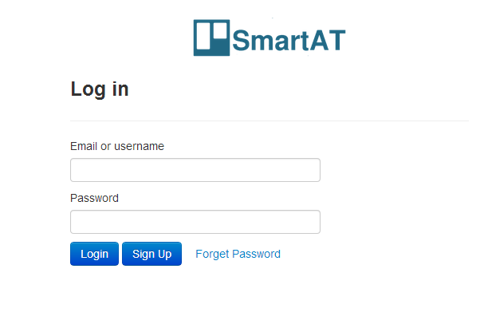

Figure 3‑1.SmartAT login page

### Login SmartAT

### 3.1.2.1 New to SmartAT

If you are new to SmartAT, please check the “Sign Up” button to register,

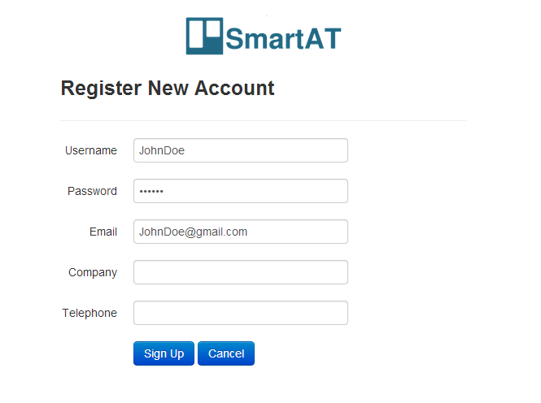Figure 3‑2.SmartAT SignUp page

With username, password and valid mail address input, click “Sign Up” button then an email will be sent to the mail address, please check your mail box then click the “link” inside of the mail to active your account.

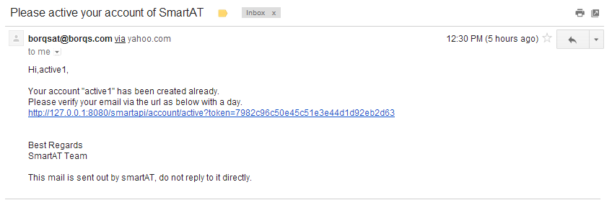

Link to click

Figure 3‑3.SmartAT account active mail

### 3.1.2.2 Already a user of SmartAT

If you have an active account of SmartAT, input username/email address and password into the corresponding fields shown in Figure 3-1, then click “Login” button.

### Further account settings

After login to SmartAT, there’s a “Account Settings” button on the right-up corner, click it to do furture account settings

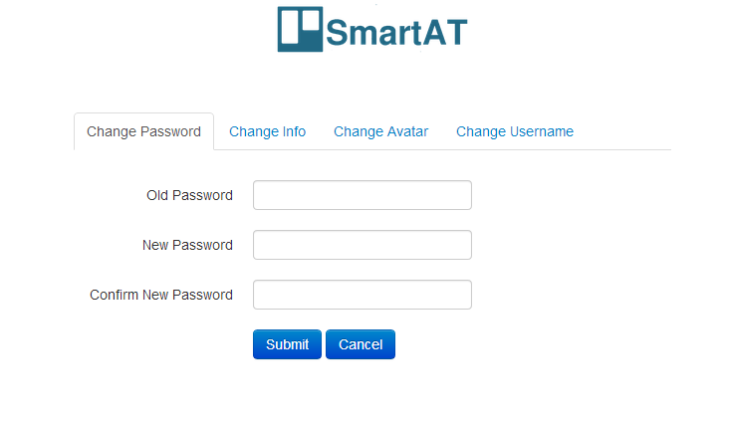Figure 3‑4. SmartAT further account settings page

In this page, you can

* Update password
* Update company and telephone number
* Upload/update avatar
* Update username

## Group management

For a new product or project, you can create a group for it and this section presents the functions of group management.

### List the joined groups

After login SmartAT, you will see this page,

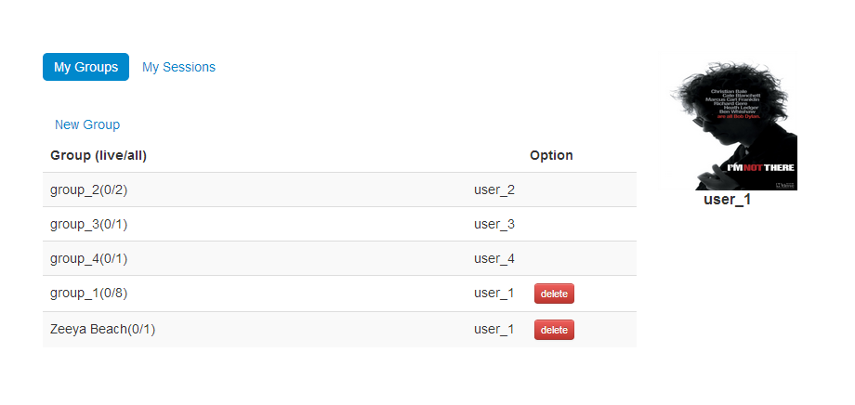Figure 3‑5. SmartAT group list page

User avatar

Group owner can delete its group

Group owner name

Group name

Live and all session count

### List the test sessions user started

Click the “My sessions” link to see all the sessions current user started.

### Generate a new group

Click the “New Group” button to see,

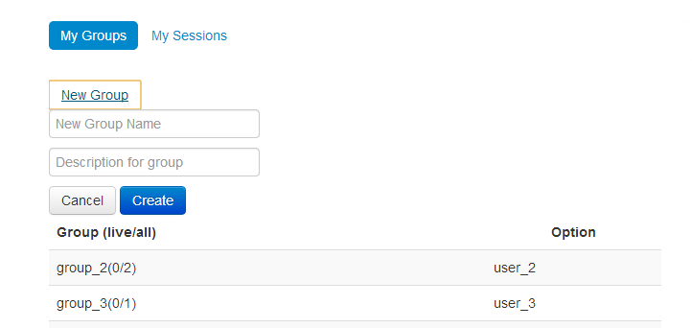

Figure 3‑6. SmartAT new group page

Input unique group name and optionally provide some group description then click the “Create” button, a new group will be generated.

### List the sessions of a group

Click the group name and then all the sessions of it will be shown like below,

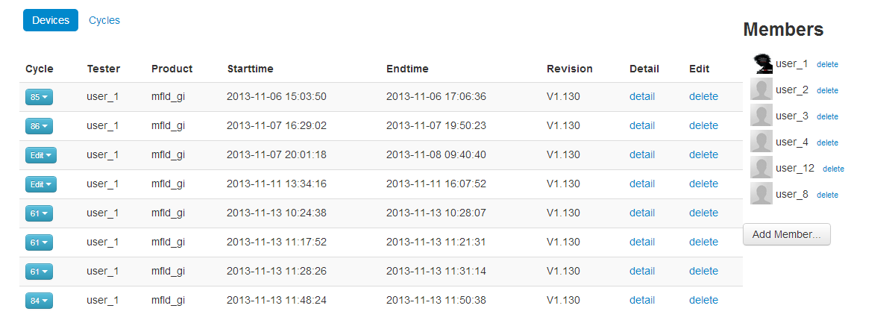

Cycle management button

Group member list

Basic session info

Figure 3‑7. SmartAT session list page

### Group member management

By clicking the “delete” link after member name, you can remove a member from current group.

By clicking the “Add Member” button, you can add more members to current group or modify permission of a member.

### Test cycle management

By clicking the “Cycle management button” marked in Figure 3-7, you will see a list like below,

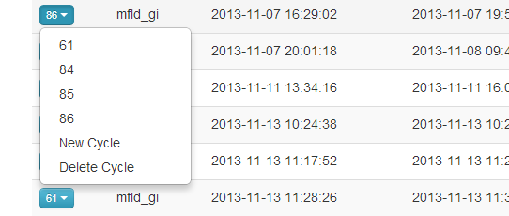

Figure 3‑8. SmartAT cycle management page

* By clicking the number in the list, you can add session to exist cycle
* By clicking the “New Cycle” button, you can generate a new cycle and add current session to it.
* By clicking the “Delete Cycle” button, you can remove session from its current cycle.

## Test session management

This section presents the functions of test session management.

### Remove a session

By clicking the “delete” link in a session item(shown in Figure 3-7), you can remove a session.

### View detail info of a session

By clicking the “detail” link in a session item(shown in Figure 3-7), you will find the session detail info like below,

Query the corresponding cases

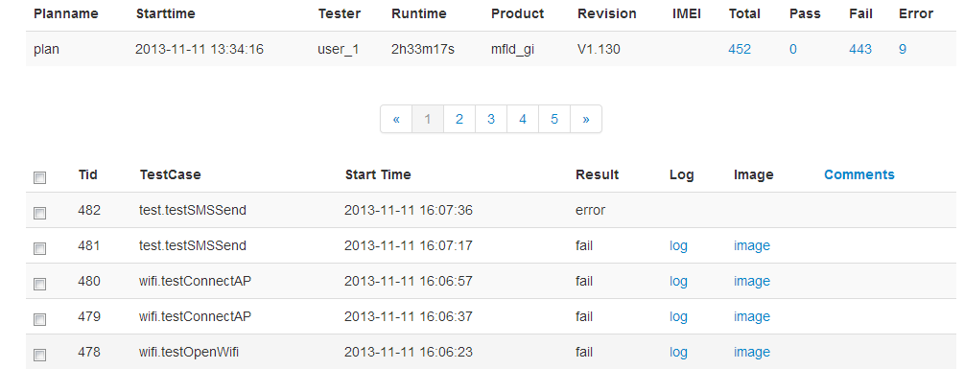

Button to add comments to case

Link to download error logs

Link to view snapshots of device

Paging the cases

Figure 3‑9. SmartAT session detail info page

## Test case management

This section presents the functions of test case management

### Checking the test case result

In a session detail info page, all the cases of a session will be listed.

### Debugging test case

* By clicking the “log” link shown in Figure 3-9, you can download the error log of a case.
* By clicking the “Image” link shown in Figure 3-9, you can view all the snapshots of a case during the test.

SmartAT will only collect “Log” and “Image” of fail case currently.

### Add comments to test case(s)

SmartAT supports add comments to multi-cases by checking the checkbox in the front of each case item, see Figure 3-9, then click the “Comments” button to get the view below,

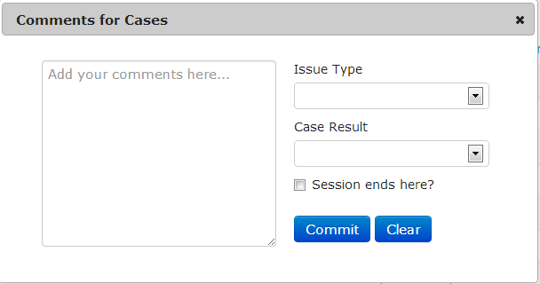

Figure 3‑10. SmartAT test case comments page

With this function, you can update the result of test cases for calculating a report, for example, during the MTBF test, UI freeze at phone for a while and all the cases within this freeze will be recorded as fail, but according to the report rules, the result of these cases should be block and block by this UI freeze issue. This is also saying that you should be careful when adding comments to cases as wrong comments may make the report coming after inaccurate.

Whenever added a wrong comments to cases, please use the “Clear” function to undo it.

### Test report calculation and present

By adding several sessions into a cycle, executed on the same software release to make the report significant, SmartAT can calculate the session result then present a report.

The rules to do the calculation is from the MTBF rules of AT&T.

* + - 1. Add sessions to a cycle

Select several sessions executed on the same software release then add them into a same cycle, like instructed in section 3.3.

* + - 1. Trigger the calculation of a report

There is a “Cycles” button in Figure 3-7, click this button to see all the cycles of current group, picture as below,

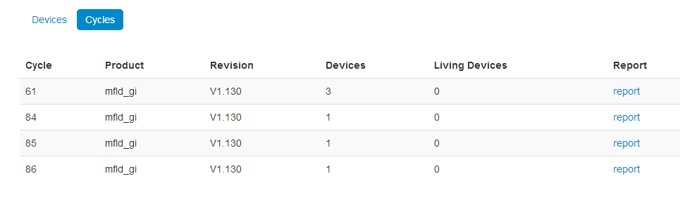Figure 3‑9. SmartAT group cycle summary page

By clicking the “report” link shown in Figure 3-9, you will get the report of corresponding cycle, picture as below,

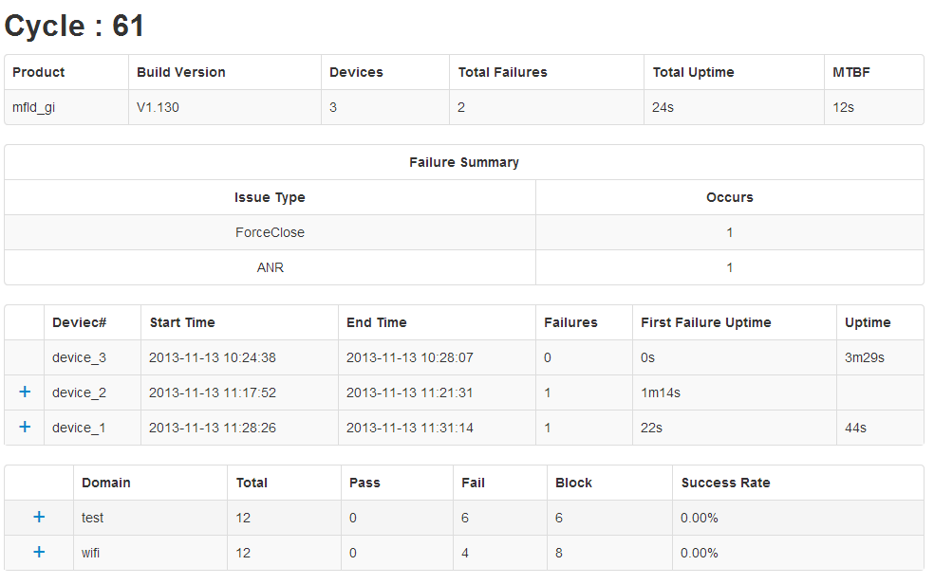Figure 3‑9. SmartAT group cycle summary page

Component summary list

Expand to see session issue list

Session summary list

Cycle issues list

Cycle summary info

* Uptime = (session endtime) – (session starttime) – (session blocktime), session endtime might be the time that critical issue happened, session blocktime is the time that block cases last for.
* Failures = (critical issue count) + (none-critical issue count), critical issues include phone hang, kernel reboot/panic, system server crash and etc. none-critical issues include application/process force close/ANR, core dump and etc.
* First failure uptime is the time that first failure occurs during the test.

# Troubleshooting

1. Q: Can not access SmartAT in browser?

A: Please check the settings of your Proxy server.

1. Q: Can not login SmartAT?

A: Please double check your username and password to see if they are correct. If you forget your password, please click the “Forget your password” link at the login page to retrieve your password.

# Known Issues

1. Appendix
2. To review the features of SmartAT, please check *FRS-SmartAT.xlsx*
3. To review the design of SmartAT, please check *SmartAT-HLD.doc*
4. Acronyms

| Acronym | Description |  |
| --- | --- | --- |
| MTBF | Mean time between failure | |
| Session | A collection of test cases executed on the same device, same software release | |
| Group | A collection of test sessions for a project or a product | |
| SmartAT | Smart Automation Test | |