**Project Proposal**

Team Members: Chris Gargano, Jack Weiland, Marsalis Paige, Ethan Litke

Project Title: Yelp Dashboard

Project Category: Yelp Rating Analysis by Category & State

Project Description: To create an online dashboard which allows the user to analyze yelp reviews by geography and business category. Dashboard visuals will include:

1. Map with overlay data (# of reviews, average rating, etc.)
2. Bar chart of [measure]
3. Data Table (featuring filtered data)

The end result will display a map, graph, and data table that will allow the user to explore how many businesses are in their search area and what kind of ratings they have receive.

Github Repo: <https://github.com/cjgargano/UCI-Project-2>

Data Set: <https://www.kaggle.com/yelp-dataset/yelp-dataset/data>

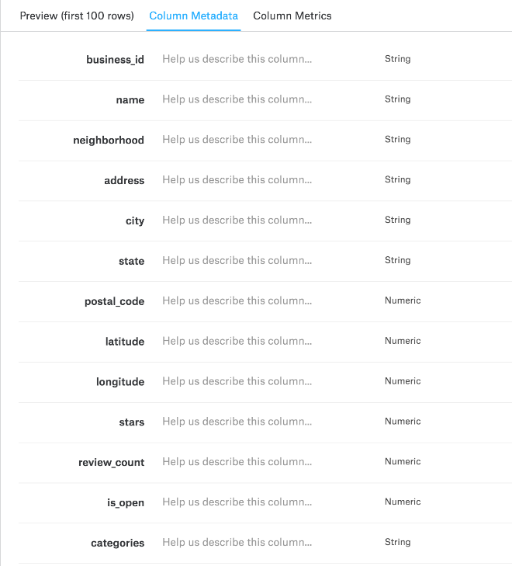

Main Tasks: Clean CSVs

Create SQLite database

Create Flask API

Create HTML file

Write Javascript code (d3.js, Leaflet, etc)

**Proposed Dashboard Design**

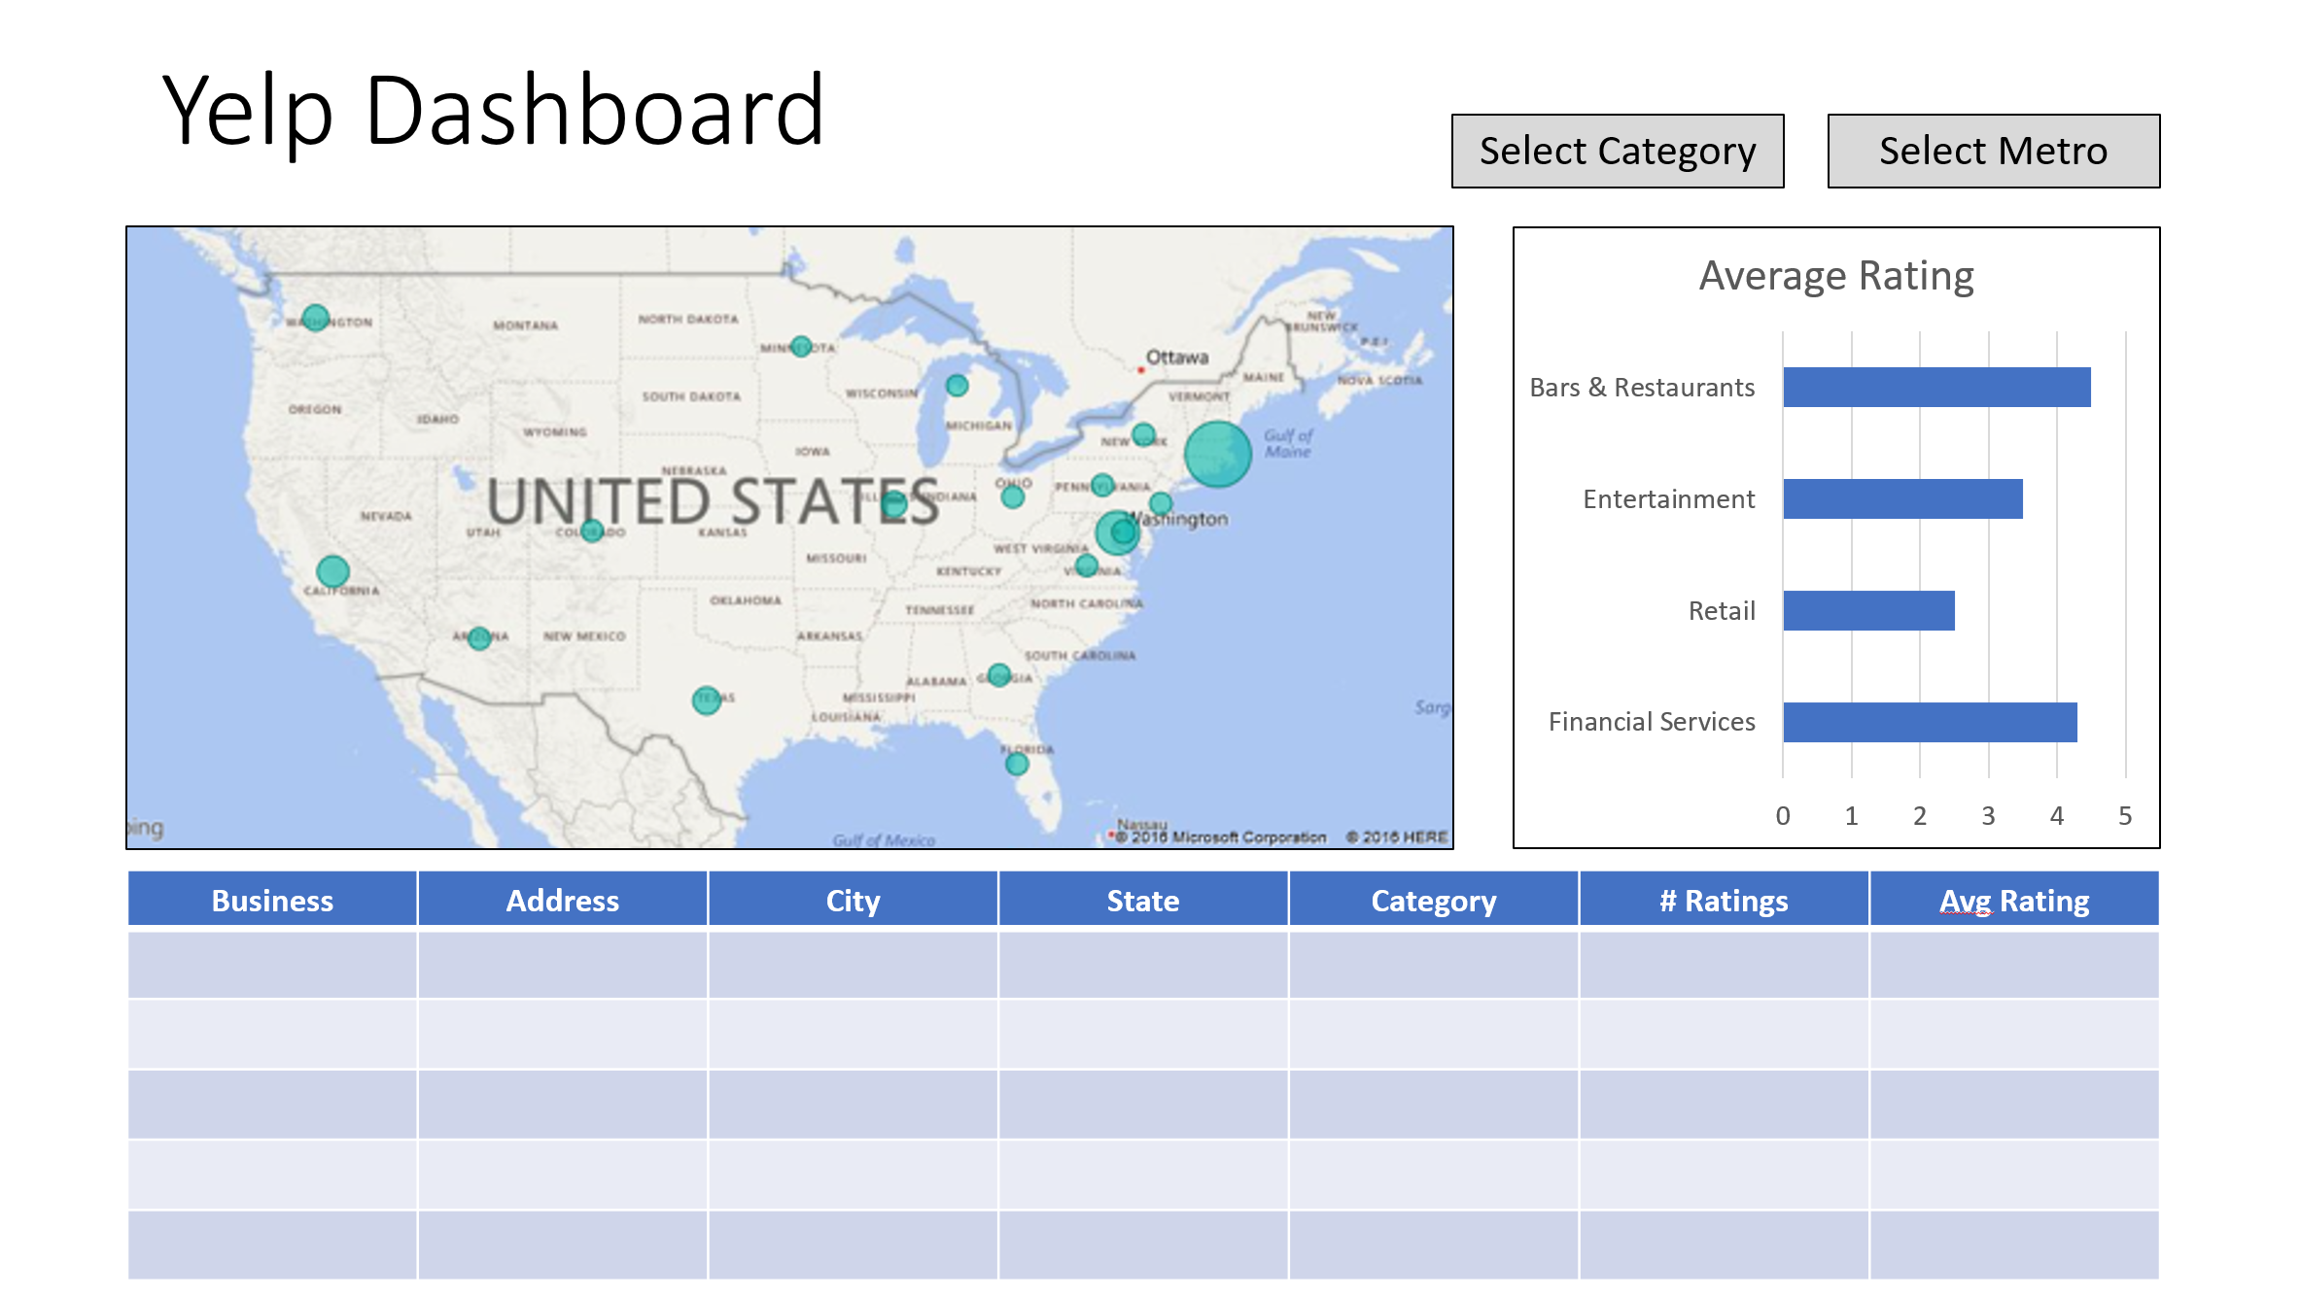

**Inspirational Dashboard Examples**

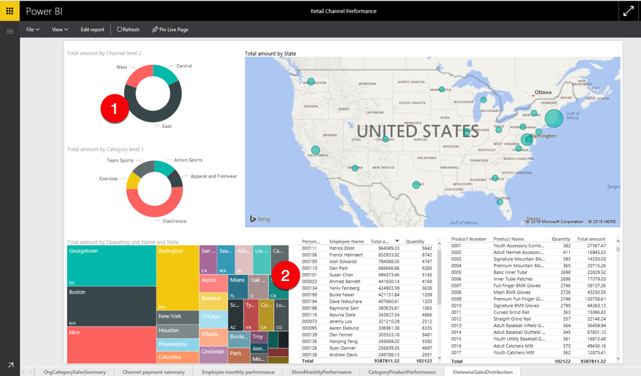

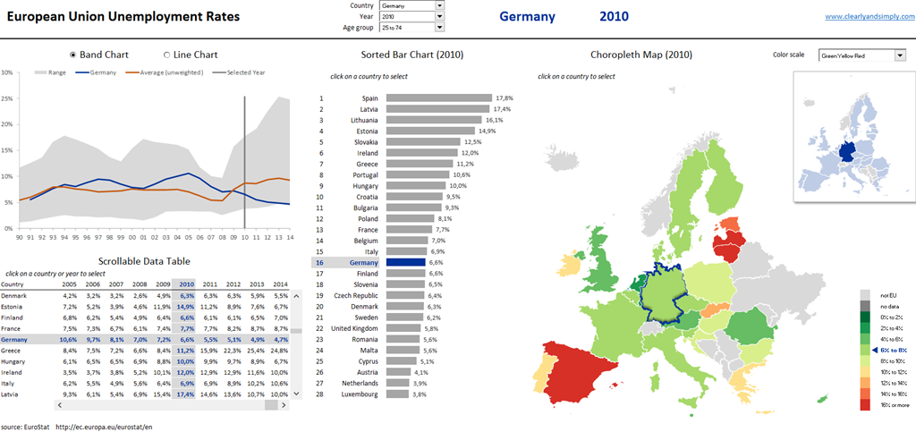

(but focused on the United States instead of Europe)

**Info-graphic type dashboard:**

