For Docker:

1. Git clone url
2. Inside the folder: docker-compose -f docker-compose.yml -f docker-compose.ci.yml run --rm robot
3. Using postman to send request

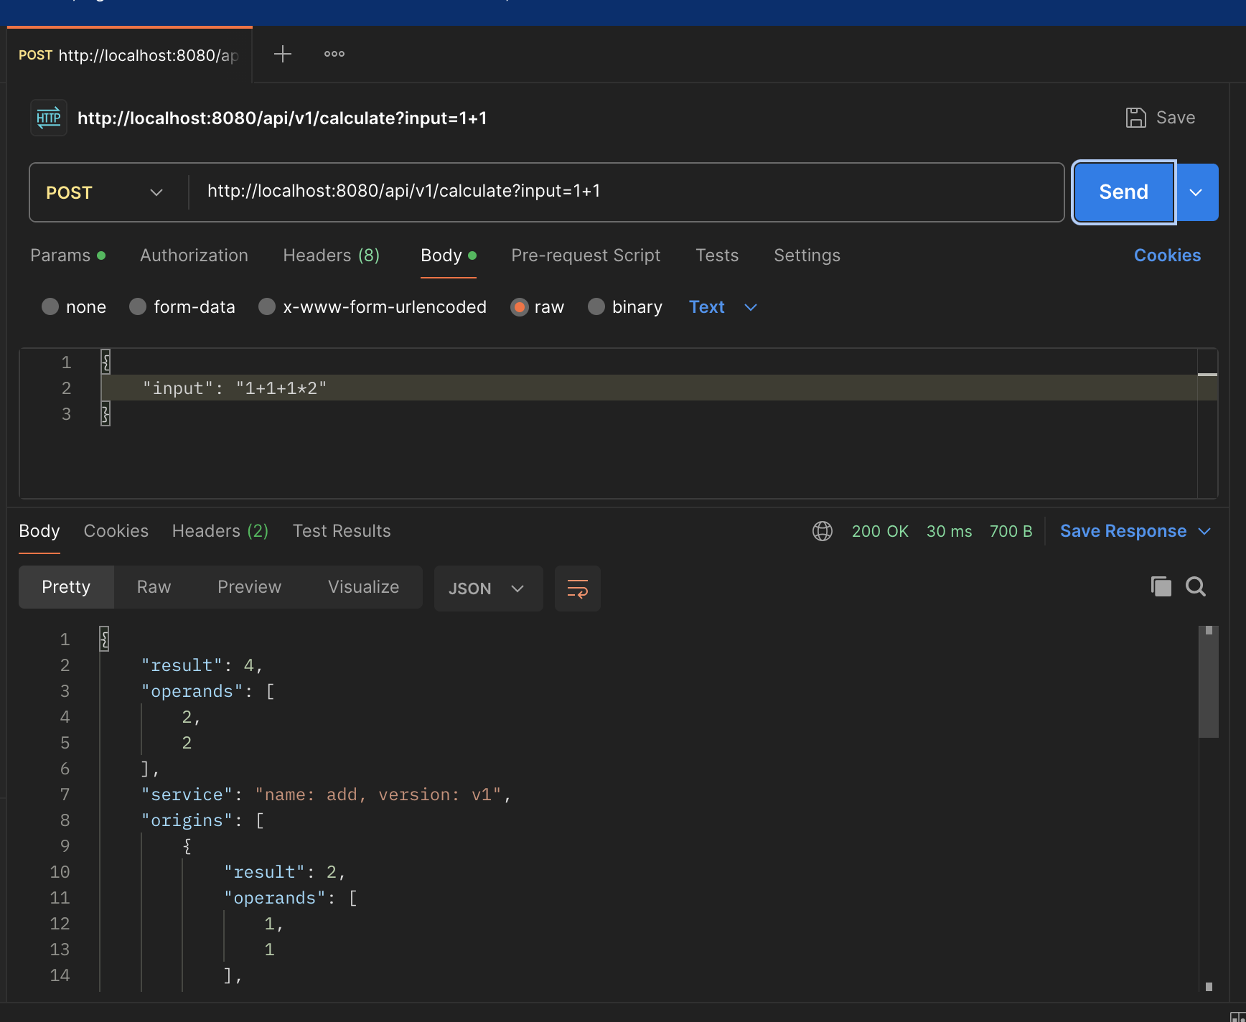

For k8s:

1. Install [minikube](https://minikube.sigs.k8s.io/docs/start/?arch=%2Fmacos%2Fx86-64%2Fstable%2Fbinary+download)
2. Install [kubectl](https://kubernetes.io/zh-cn/docs/tasks/tools/install-kubectl-macos/)
3. Install [Istio](https://istio.io/latest/docs/setup/install/helm/)
4. $ kubectl create namespace microcalc
5. $ kubectl label namespace microcalc -l istio-injection=enabled (This command does not work for me, I use “kubectl label namespace microcalc -l istio-injection=enabled”)
6. $ helm template helm/microcalc | kubectl apply -n microcalc -f - (need to modify domain name first at value.yaml)
   1. When you try to run this command you will probably run into error(see screenshot 1)
   2. And you need to modify gateway.yaml (see screenshot 2)

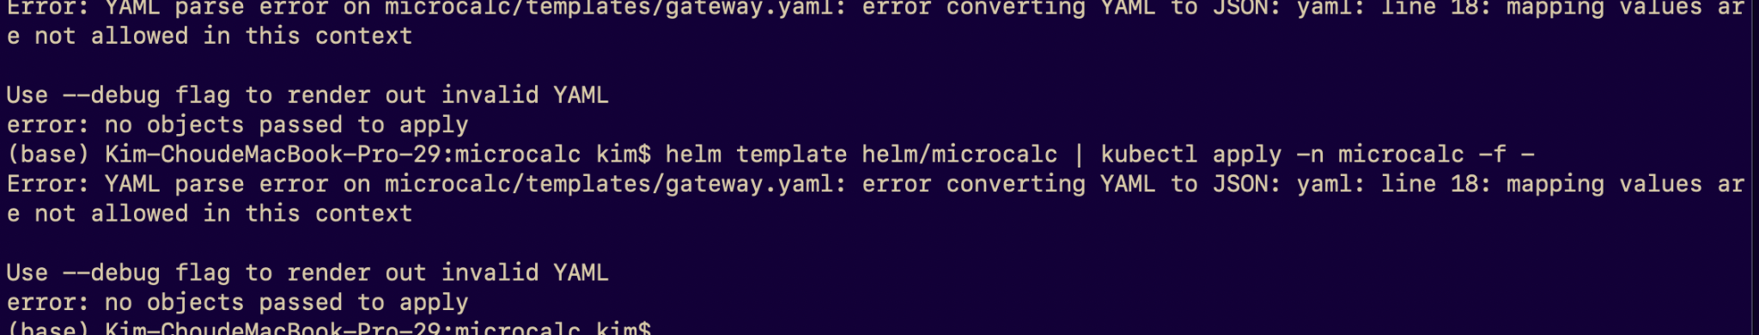

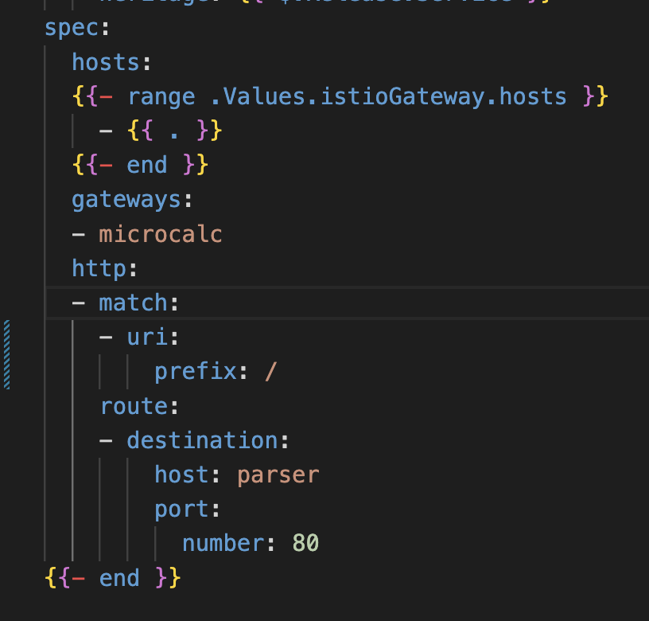

1. Check your deployment $ kubectl get pods -n microcalc

