SQL Project: Exploring Movie Ratings with Databricks
Le Chevallier Ethan / Big Data and Cloud Computing

1. Introduction
This project analyses the MovieLens dataset using SQL in Databricks. The dataset contains 100,000 ratings (from 1 to 5) given by 943 users to 1,682 movies. It is split into two files: u.data, which holds one rating per row (user, movie, rating, timestamp), and u.item, which describes the movies (identifier, title, release date, genres). The two files are connected through the movie identifier.
The objective is to answer two business questions: which are the five oldest movies with an average rating above 4.0 (Part 1), and which poorly rated movies are nevertheless the most rated by users (Part 2).
Data preparation: Both files were uploaded to a Unity Catalog volume and loaded into two tables, ratings and movies, with an explicit schema. u.data is tab-separated; u.item is pipe-separated and encoded in ISO-8859-1. A control query confirmed 100,000 ratings and 1,682 movies and showed that one movie ("unknown") has no release date.

2. Part 1: Oldest Highly Rated Movies

SQL approach
- Join ratings and movies on movie_id, so each rating is linked to its movie title and release date.
- Group by movie and compute the average rating with AVG(rating) and the number of ratings with COUNT(*).
- Keep movies with HAVING AVG(rating) > 4.0. HAVING is used instead of WHERE because the average only exists after the grouping. WHERE excludes the "unknown" movie, which has no date.
- Sort by release date (earliest first) and keep five rows with LIMIT 5.

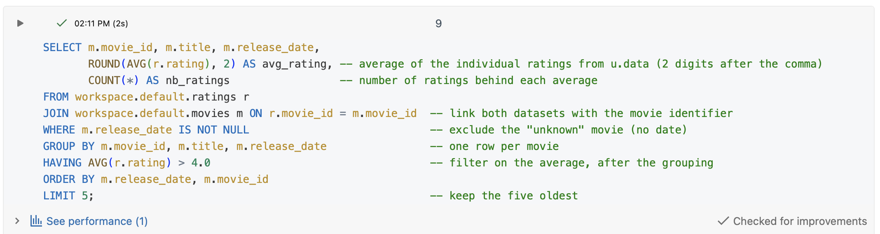

Results
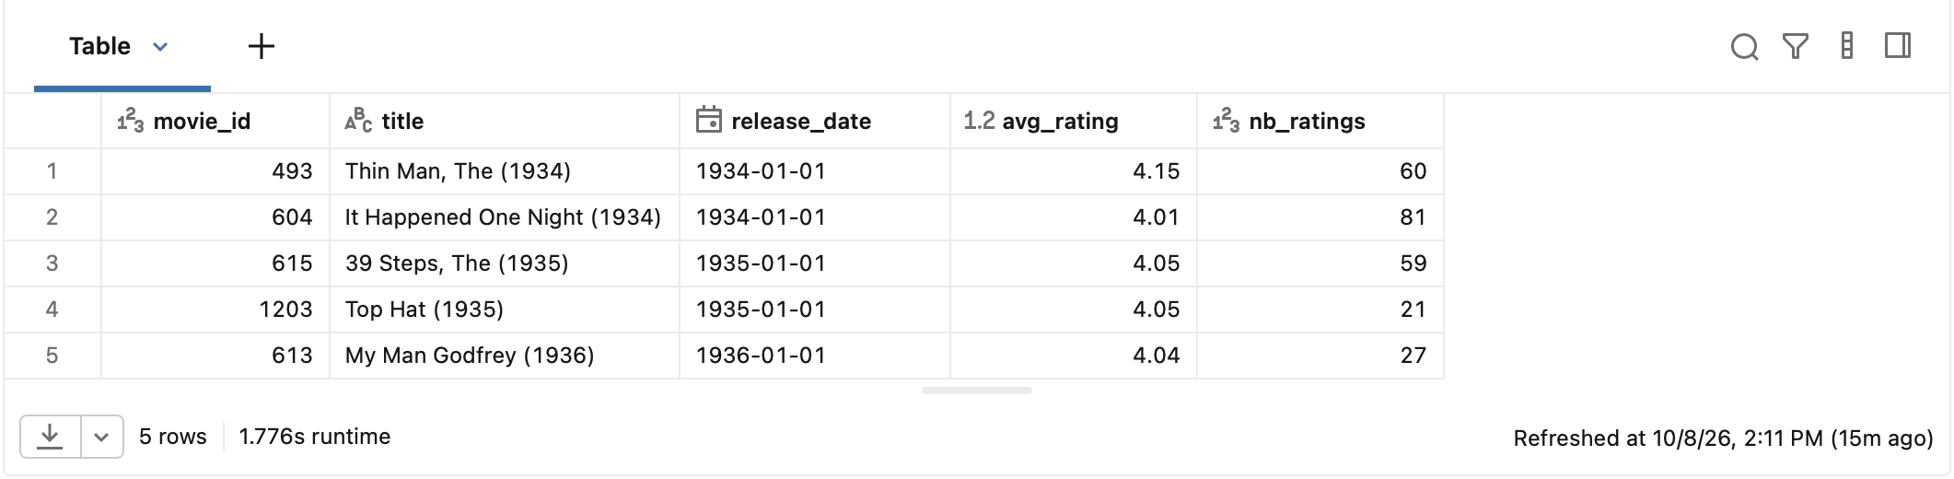

Interpretation
- The oldest of the five is The Thin Man (1934), with an average rating of 4.15 based on 60 ratings. It shares the release date 1934-01-01 with It Happened One Night, so the order between the two comes from the movie_id tie-break.
- The five movies received 60, 81, 59, 21 and 27 ratings respectively.
- The number of ratings should be taken into account. All five averages are close to the 4.0 threshold (from 4.01 to 4.15) but rest on very different volumes. An average built on 21 ratings (Top Hat) is much less reliable than one built on 81 ratings (It Happened One Night): a few additional ratings could move it below 4.0. Requiring a minimum number of ratings, for example 50, would remove Top Hat and My Man Godfrey from the list.

3. Part 2: Most Popular Bad Movies

SQL approach
- Same join and grouping as in Part 1, with the average rating and the number of ratings computed for every movie.
- HAVING AVG(rating) < 2.0 keeps only poorly rated movies. The number of ratings is used as a measure of popularity.
- ORDER BY nb_ratings DESC places the most rated movies first.

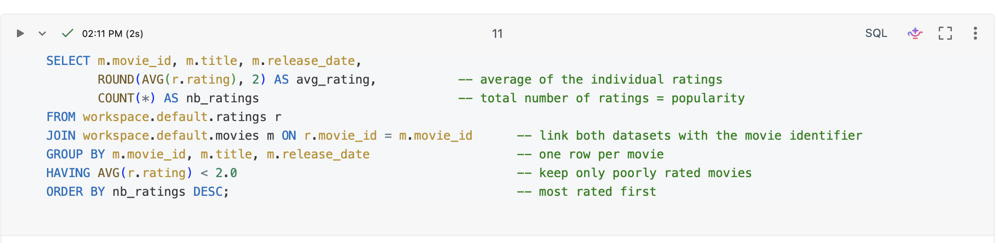

Results (10 most rated movies out of 129)
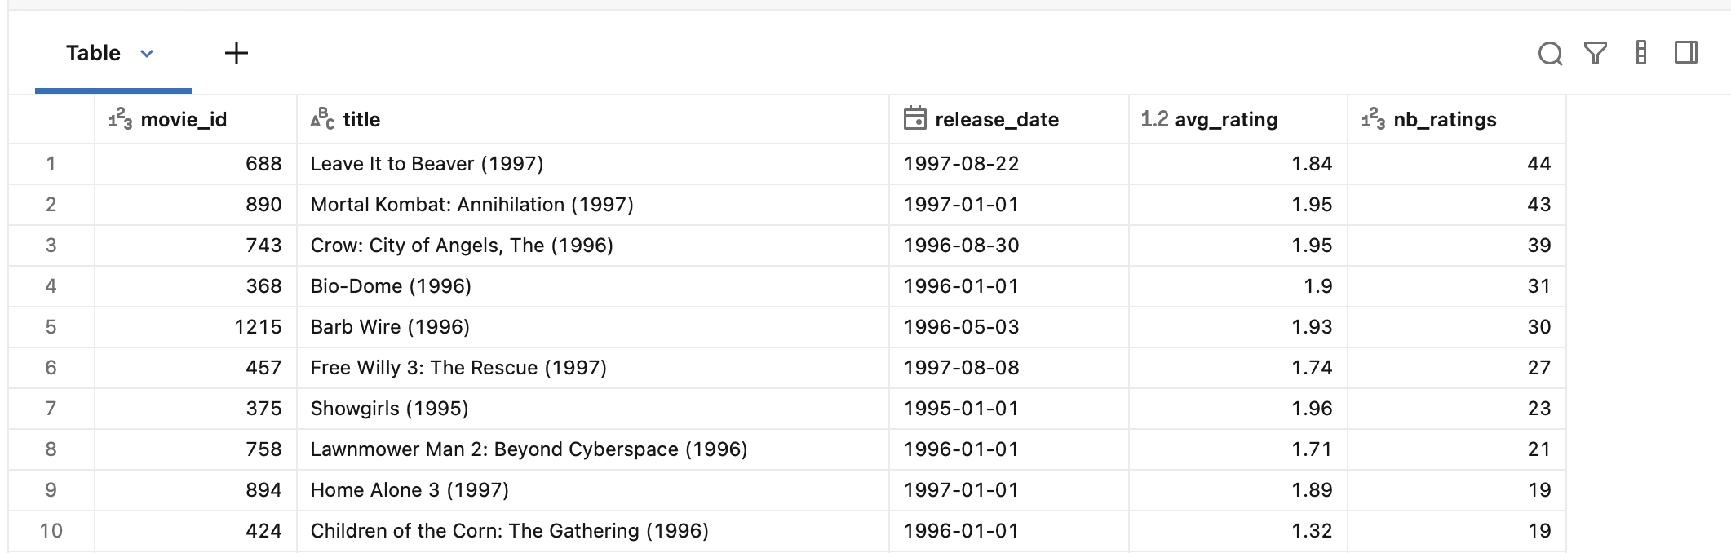

Interpretation
- In total, 129 movies have an average rating below 2.0. The one with the largest number of ratings is Leave It to Beaver (1997), with an average of 1.84 and 44 ratings.
- Popularity is very unevenly distributed among these movies: only 8 of the 129 received at least 20 ratings, while 97 received 5 ratings or fewer and 58 received a single rating. The tail of the list is therefore not very meaningful.
- The ten most rated movies were all released between 1995 and 1997, and several are sequels or follow-ups of well-known titles (Mortal Kombat: Annihilation, The Crow: City of Angels, Free Willy 3, Lawnmower Man 2, Home Alone 3).
- The result shows that popularity and rating quality are independent, a movie can be rated by many people and still be rated poorly.

4. Discussion
Average rating measures the perceived quality of a movie. Number of ratings measures how many users took the time to rate it, and therefore how reliable the average is.
Popularity describes how much attention a movie receives. In this project it is approximated by the number of ratings which is only a proxy because it does not tell whether viewers enjoyed the movie.
A movie with a very low average can still receive many ratings for several reasons:
- Rating a movie only requires having watched it, not having liked it. Disappointed viewers rate too and sometimes rate to warn others.
- Sequels, adaptations and heavily promoted releases attract a large audience before opinions are formed, and the same audience then gives low scores.
- Some movies are watched precisely because they have a bad reputation.
Two limits should be kept in mind. An average computed on very few ratings is unstable, which is why the number of ratings must be read together with the average. Also, users rate movies they chose to watch, so the averages describe this group of users and not the public.

5. Conclusion
The results of the two parts can be summarized here:
- Part 1: the oldest highly rated movie is The Thin Man (1934, 4.15 on 60 ratings). The five movies found all have averages close to 4.0 and very different numbers of ratings.
- Part 2: 129 movies have an average rating below 2.0. The most rated is Leave It to Beaver (1997, 1.84 on 44 ratings), and the top of the list is dominated by well-known titles released in 1995 to 1997.
Overall, the average rating alone is not enough to judge a movie, it must be combined with the number of ratings, and popularity should not be confused with quality. SQL aggregation made it possible to compute all these measures directly from the individual ratings.

