ACSE Labs10

姓名：廖冠勳

系級：電信

學號：0860306

Lab Report

Lab 10 – RF Impairments

1. Goal of Experiment :

* To Realize the Characteristic of Communication System,including of transmit IQ imbalance, carrier frequenct offset.
* Use IQ imbalance compensation technique to eliminate the imbalence effect in the transmittor .
* Realize a carrier frequency offset system ,then plot its constellation diagram then observe it.

1. Background of experiment :

* Effect of IQ Imbalance :
  + Principle of IQ Imblance :

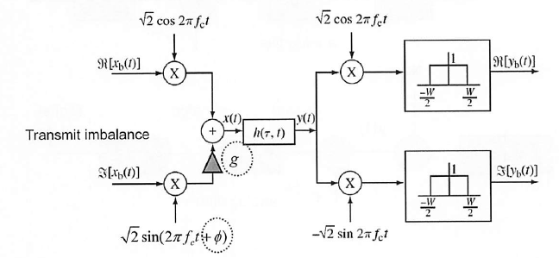

Signal at analog side will encouter a phase shit and additional gain due to analog circiut property ,which will arise a IQ imbalance effect in the transmiting side. The effect of the IQ imbalance is listed as below.

The IQ imbalance factor g and Ф will cause gain and phase shift in the $a_{Q}$ part this effect can be derived as below.

$$x\left(t\right)=a_{I}\left(t\right)\cos\left(wt\right)+a_{Q}\left(t\right) g\sin\left(wt+∅\right)$$

$$=a_{I}\left(t\right)\frac{e^{jwt}+e^{-jwt}}{2}+jga_{Q}\left(t\right)\frac{e^{j\left(wt+∅\right)}-e^{-j\left(wt+∅\right)}}{2}$$

Then we make a equuvilent equation of the above formulation :

$$LPF\left\{2x\left(t\right)e^{-jwt}\right\}=a_{I}+ja_{Q}\left(t\right)e^{j∅}= α \left[a_{I}\left(t\right) +ja_{Q}\left(t\right)\right]+β\left[a_{I}\left(t\right)-ja_{Q}\left(t\right)\right]$$

$$= α a(t)+βa^{*}(t)$$

Note :

We can use the formula above to generate the revicived signal to verify our systeme result.

$$x\left(t\right)=a_{I}\left(t\right)\cos\left(wt\right)- a_{Q}\left(t\right) g\sin\left(wt+∅\right)$$

$$= α a(t)+βa^{*}(t)$$

Where

$α=\frac{1}{2}(1+ge^{j∅})$ and $β= \frac{1}{2}(1-ge^{j∅})$

When α=1、β will be 0, so the effect of the IQ imbalance is that the imbalance signal can be viewed as linear combination of two spectrum signal in the sysmmetric side of spectrum.

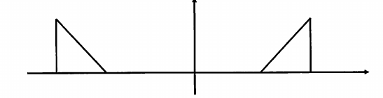

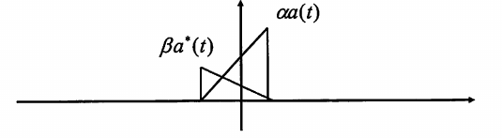

IQ imbalance will cause the sin part of signal a gain and phase shift.

* + Compensate the effect of IQ Imbalance :

From the IQ imbalance siganl we make the form as below :

$$x\left(t\right)=a_{I}\left(t\right)\cos\left(wt\right)+ a_{Q}\left(t\right) g\sin\left(wt+∅\right)$$

By the equation of sin and cos:

$$\sin\left(wt+∅\right)=\sin\left(wt\right)\cos\left(∅\right)+cos⁡(wt)sin⁡(∅)$$

The we can rewrite the IQ Imbalance function :

$$x\left(t\right)=a_{I}\left(t\right)\cos\left(wt\right)- a_{Q}\left(t\right)g\sin\left(wt+∅\right)$$

$$={[a}_{I}\left(t\right)-gsin∅a_{Q}(t)]cos\left(wt\right)-gcos∅a_{Q}\left(t\right)\sin\left(wt\right)$$

$$=a_{I}^{E}\left(t\right)\cos\left(wt\right)- a_{Q}^{E}(t)\sin\left(wt\right)$$

Then we can represent the above form as below :

$\left[\begin{matrix}a_{I}^{E}\left(t\right) \\ a_{Q}^{E}\left(t\right)\end{matrix}\right]= \left[\begin{matrix}1 & -gsin∅ \\ 0 & gcos∅\end{matrix}\right]\left[\begin{matrix}a_{I}\left(t\right) \\ a_{Q}\left(t\right)\end{matrix}\right]$ => $a^{E}\left(t\right)=Ha(t)$

With this matrix mutiplication form we can use the matrix inverse property to get the original signal a(t) :

${H^{-1} a}^{E}\left(t\right)=a(t)$

Where

$$a^{E}= \left[\begin{matrix}a_{I}^{E}\left(t\right) \\ a_{Q}^{E}\left(t\right)\end{matrix}\right]$$

* Effect of Carrier Frequency Offset (CFO):
  + Principle of the CFO effect

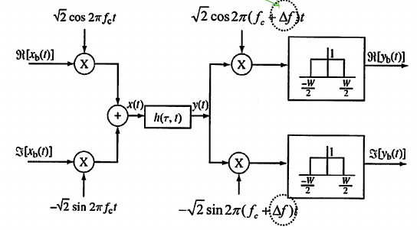

Without loss of generality,we can represent the transmission signal as below :

$$Real\{a\left(t\right)e^{jwt}\}$$

The CFO effect in the reciever can be represented as :

$$e^{-j\left(w+∆w\right)t}$$

Therefore, the received signal can be writed as :

$$Real\left\{a\left(t\right)e^{jwt}\right\} ×e^{-j\left(w+∆w\right)t}$$

Simplify this formula for convience :

$$a\left(t\right)e^{jwt}×e^{-j\left(w+∆w\right)t}=a(t)e^{-j∆wt}$$

We can observe that this signal will be rotated in the time domain, this will make the signal in freqency domain shift it fft signal.

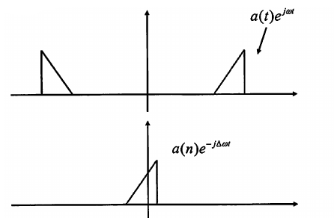

C. Experiment result and analysis :

* Practice Experiment Result :
  + Practice 1 – IQ imbalance
    - Notation of Practice 1 :

From background of this experiment, we can utilize the below formula to generated the signal to verify our received signal which is indicated as generated signal in the graph.

* + - 10 points transmission and receive signal:
      * g = 1 Ф = 1

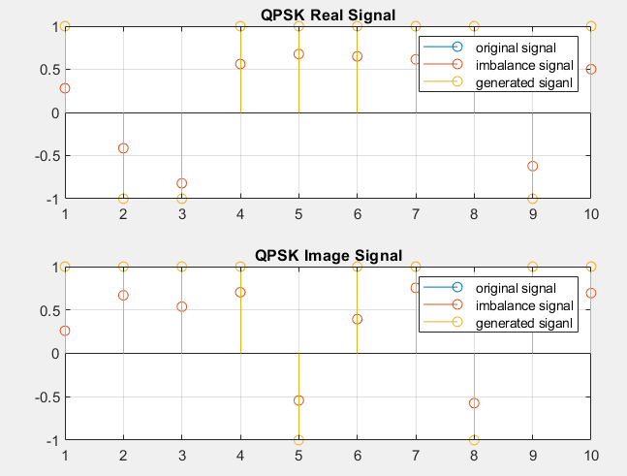

From the $a_{I}\left(t\right)\cos\left(wt\right)+a_{Q}\left(t\right) g\sin\left(wt+∅\right)$, we use parameters in title then we can get

$$a_{I}\left(t\right)\cos\left(wt\right)+a_{Q}\left(t\right)*1*\sin\left(wt+0\right)= a_{I}\left(t\right)\cos\left(wt\right)+a_{Q}\left(t\right)\sin\left(wt\right)$$

This result indicate that we can get original signal as show above.

* + - * g = 1 Ф = pi/3

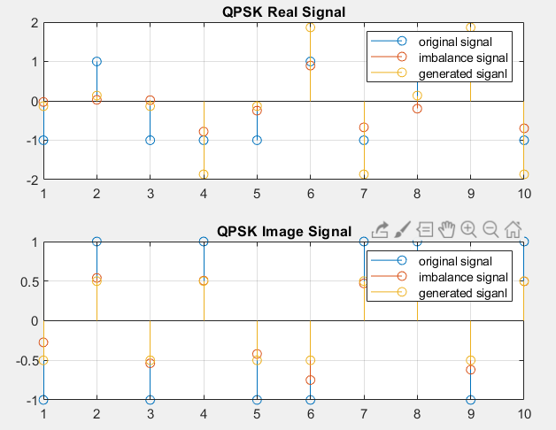

We utilize the formula metioned in the backgroun and parameters in the title again then we can get :

$$a_{I}\left(t\right)\cos\left(wt\right)+a_{Q}\left(t\right)*1.5*\sin\left(wt+π/3\right)$$

From this result , we can observe the imaginary part of this signal is mutipled by the gain of imbalance factor and is shifted the phase cause of phase imbanace.

* + - 1000 points :
      * Notation of this part :

We use more points then plot its constellation graph to get the distribution of received signal them compare it with original signal.

* + - * g = 1 Ф =0

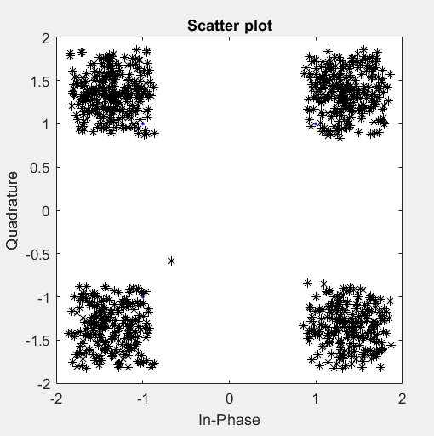

Similar to the above result we can get recieved signal distributed around its original signal.

* + - * g = 1 Ф = π/3

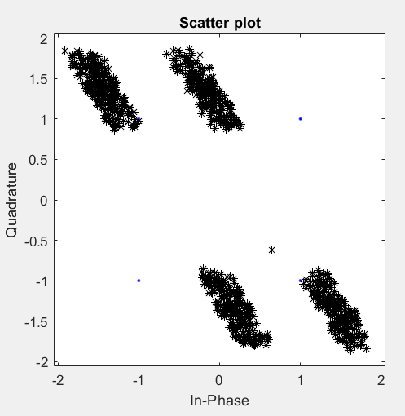

From background we can get $a_{I}\left(t\right)\cos\left(wt\right)+a_{Q}\left(t\right)*1.5*\sin\left(wt+π/3\right)$. In this situation , we can observe that the shifted phase rotate the signal in the constellation graph.

* + - * g = 1.5 Ф = π/3

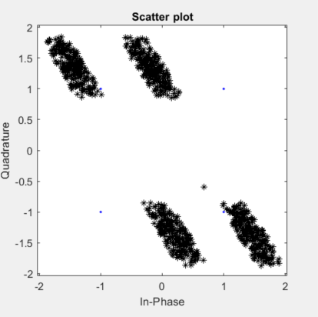

We can compare this result to the previous one, there is a small gain in the digram.

* + Practice 2 – IQ imbalace Compensation : (1000 points)

|  |  |
| --- | --- |
|  |  |
| g = 1 Ф = 1.5 | g = 1 Ф = 0 |

From the background ${H^{-1} a}^{E}\left(t\right)=a(t)$ indicate that we can add this compebsation block to eliminate the effect of IQ imbalance. The result of this experiment verify the equation we have derived.

Therefore, we can test the communication system while offline time to get the gain and phase shift of the communication system to design this matrix for compensation.

$$H=\left[\begin{matrix}1 & -gsin∅ \\ 0 & gcos∅\end{matrix}\right]$$

It’s a useful technuque to solve such this problem.

* + Practice 3 – Carrier Frequency Offset :

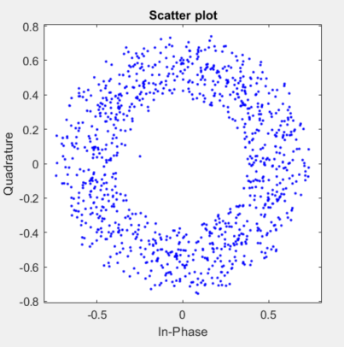

CFO is a common problem in the communication system. By the derived equation above :

$$a\left(t\right)e^{jwt}×e^{-j\left(w+∆w\right)t}=a(t)e^{-j∆wt}$$

The $e^{-j∆wt}$ term can form a circle in the constellation graph.Which make QPSK signal to form the donut shape showed in above praph.

* Home work Experiment Result :
  + Derive of home work :

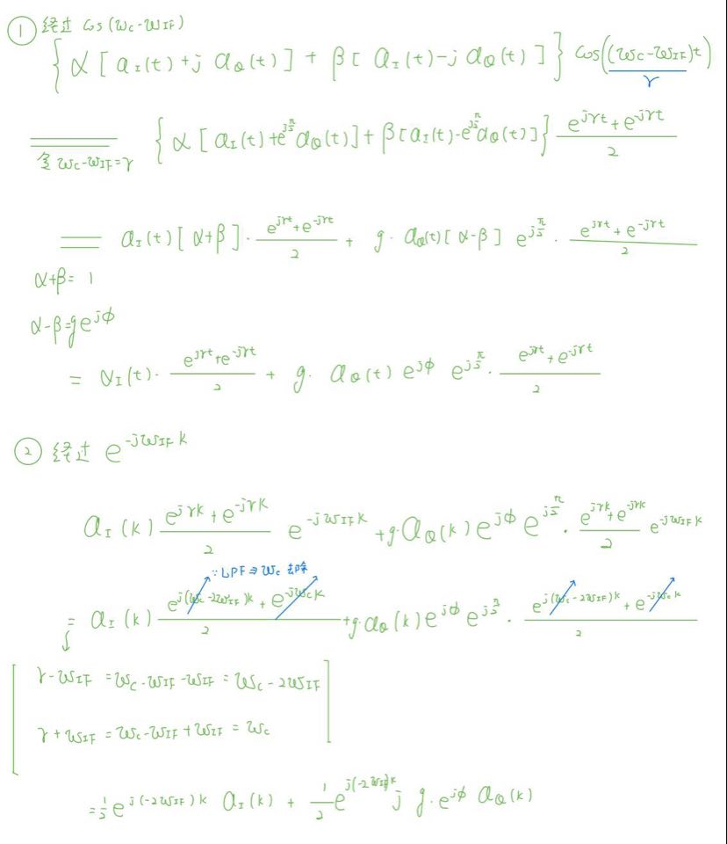

* + Experiment result :

|  |  |
| --- | --- |
| Signal Type | QPSK |
| Carrier  Frequency |
| DAC UP factor | 16 = sampling rate of the DAC / symbol rate |
| DMA UP factor | 4 = sampling rate for DMA filter / sampling rate of the DAC |
| DMA Filter  Pass and stop Freq |  |
| System Architecture | All system view :    Transmitter :    Reciever : |
| Experiment  Result |  |
| Aanlysis | From the derevied equation , we can get: $\frac{1}{2}e^{-j2w_{IF}k}[a_{I}\left(k\right)+j*g*e^{jФ}*a_{Q}(k)$ ]  Unlike practice 1 : $$x\left(t\right)=a_{I}\left(t\right)\cos\left(wt\right)- a_{Q}\left(t\right) g\sin\left(wt+∅\right)$$ The term of $\frac{1}{2}e^{-j2w_{IF}k}$ will make both real and imaginary part of signal be rotated. The reason is that both blocks in IF reciever will contribute the rotation term. |