ACSE Labs11

姓名：廖冠勳

系級：電信

學號：0860306

Lab Report

Lab 11 – Equalization

1. Goal of Experiment :

* To Realize the Property of Communication System,including of multipath channel effect, equlaizer.
* Use equlizer technique to eliminate the multipath effect in the reciever and relize how to design the specific equalizer to achieve the goal in this experiment.
* Realize a the channel effect can be compeletly removed by equalizer however equalizer also arises noise amplified in the reciever.

1. Background of experiment :
   * Principle of Multipath effect :

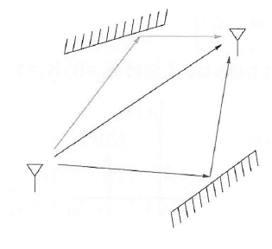

Signal at tranmission side will encouter scattering and refraction, which will arise a multipath effect in the transmitting branch. The effect of the multipath can be modeled as below.

$$y\left(t\right)=\sum_{i}{α(i)(x-τ)}$$

From this eqaution we can view mutipath channel effect as a impulse response in time domain.

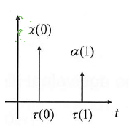

Therefore we can design the multipath by deriving the below equation to get the close form of it.

In the reciever ,we can represent the multipath signal as below : $$y\left(t\right)=Re\left\{y_{b}\left(t\right)e^{j2πf_{c}t}\right\}= \sum_{i}{α\left(i\right)Re\{x_{b}(t-τ\left(i\right)e^{j2πf_{c}\left(t-τ\left(i\right)\right)}\}}=Re\{\{\sum_{i}{α\left(i\right)x_{b}(t-τ\left(i\right)e^{j2πf_{c}\left(-τ\left(i\right)\right)}}\}e^{j2πf_{c}t}\}$$

We can observe that the multipath channel effect will cause a gain and phase rotation term in the reciever. We can examine the effect by this gain property.

* + Designing equalizer method :

Let introduce the sampling period of ADC, $T_{ADC}$,into our inference, assume that the delay of the mutipath signal is multiple of sampling period $T_{ADC}$, which can be defined as $τ\left(i\right)=K_{i}T$:

$$y_{b}\left(t\right)= \sum_{i}{α_{b}\left(i\right)\{x_{b}(t-τ\left(i\right))\}} → y_{b}\left(mT_{ADC}\right)= \sum_{i}{α_{b}\left(i\right)\{x_{b}\left(m-K_{i}\right)T_{ADC}\}}$$

From above equation , we can conclude that the mutipath effect can be implemented by a tap period of $T_{ADC}$.Which can be coded as below :



|  |  |
| --- | --- |
| Zeros(1,63) | ADC interval tap between two signal path gain |
| Channel gain | $α_{b}\left(i\right)$ in the above description |
| conv | Add mutipath effect in the transmission signal |

Remark :

The mutipath effect can be represented as the below in time domain:

$$y_{b}\left(m\right)= α_{b}\left(0\right)x_{b}\left(m\right){+α}_{b}\left(1\right)x_{b}\left(m-1\right)$$

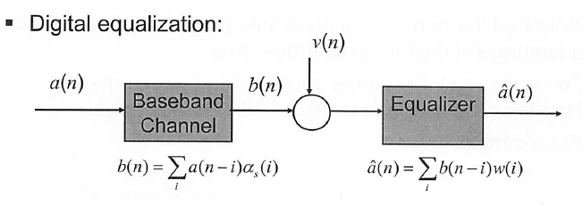

Then we transfer this effect into frequency domain :

$$H\left(z\right)= α_{b}\left(0\right){+α}_{b}\left(1\right)z^{-1}$$

Therefore the equalizer can be used as inverse of the mutipath trnasfer function to recover the signal in this case, we can get the form :

$$\frac{1}{H\left(z\right)}=\frac{1}{α_{b}\left(0\right){+α}_{b}\left(1\right)z^{-1}}$$

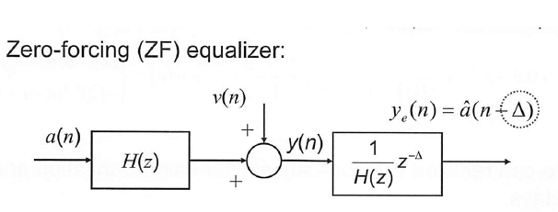

After getting the $\frac{1}{H\left(z\right)}=\frac{1}{α_{b}\left(0\right){+α}_{b}\left(1\right)z^{-1}}$, we then transfer this function in the time domain by the z-transform formula :

|  |  |  |
| --- | --- | --- |
| Trnsform | Time domain | ROC |
|  |  |  |
|  |  |  |

After getting the time domain form of the filter, we can utilize convolution with it to get the recovered signal.

* + Notation : the implementation of filter :

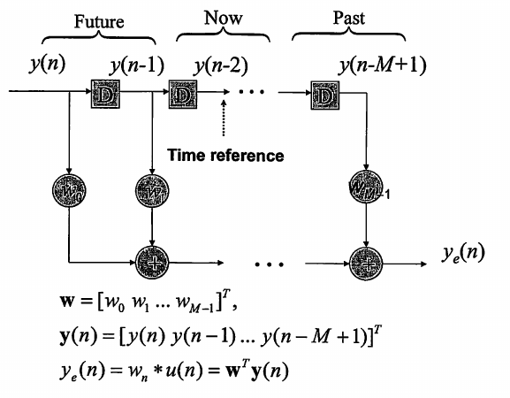

* + Equlizer will also arise AWGN amplified in the channel :

We can view the frequncy respone by the below graph :

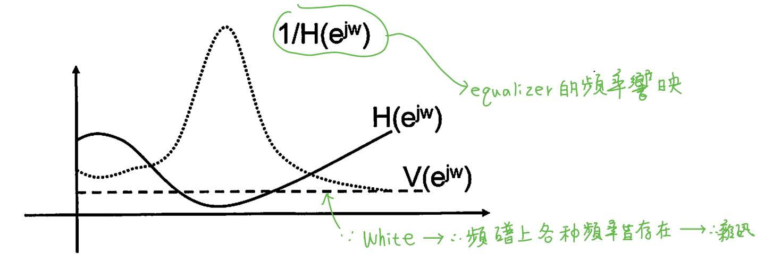

Then we formulate the equlizer effect in the frenqency domain :

$$Y_{e}\left(z\right)=\left[A\left(z\right)+\frac{V\left(z\right)}{H\left(z\right)}\right]z^{-∆}$$

When the $\frac{1}{H\left(Z\right)}$ is very large somewhere in the frequency domain, it will cause very large gain on the noise.

C. Experiment result and analysis :

* Practice Experiment Result :
  + Practice 1 :
    - Notation of Practice 1 :

From background of this experiment, we can utilize the below formula to relize how the relationship between non-mutiple and mutiple delay for the mutipath system.

$$y\left(t\right)=Re\left\{y_{b}\left(t\right)e^{j2πf_{c}t}\right\}$$

$$= \sum_{i}{α\left(i\right)Re\{x_{b}(t-τ\left(i\right)\}e^{j2πf_{c}\left(t-τ\left(i\right)\right)}\}}$$

$$=Re\{\{\sum_{i}{α\left(i\right)x_{b}(t-τ\left(i\right){)e}^{j2πf_{c}\left(-τ\left(i\right)\right)}}\}e^{j2πf_{c}t}\}$$

For simplicity , we only use the baseband signal for analysis :

$$y_{b}\left(t\right)= \sum_{i}{α\left(i\right)x_{b}(t-τ\left(i\right){)e}^{j2πf_{c}\left(-τ\left(i\right)\right)}}$$

Where

$$τ\left(i\right)=m*T_{ADC}$$

List of parameter utilize in the experiment :

|  |  |
| --- | --- |
| Signal | [1 zeros(127)] |
| Signal Length | 128 |
| $$α\left(1\right)$$ | 1 |
| $$α\left(2\right)$$ | -0.5 |
| ADC Tap interval($T_{ADC}$) | 64 |
| Non – multiple Tap interval | 67 |

The original transmission signal is :

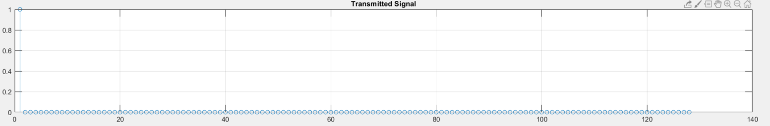

* + - * Multiple Tap interval :

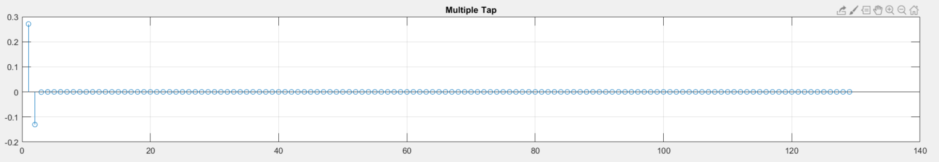

From the $\sum_{i}{α\left(i\right)x_{b}(t-τ\left(i\right){)e}^{j2πf_{c}\left(-τ\left(i\right)\right)}}$, we use parameters in list of parametors then we can get

$$1*x_{b}(t-0{)e}^{j2πf_{c}*\left(0\right)}+\left(-0.5\right)*x_{b}(t-1{)e}^{j2πf_{c}\left(-1\right)}$$

This result indicate that we can get original signal as show above. We can verify the accuracy of recieved signal by its gain whether is positive or negtive.

* + - * Non - Multiple Tap interval

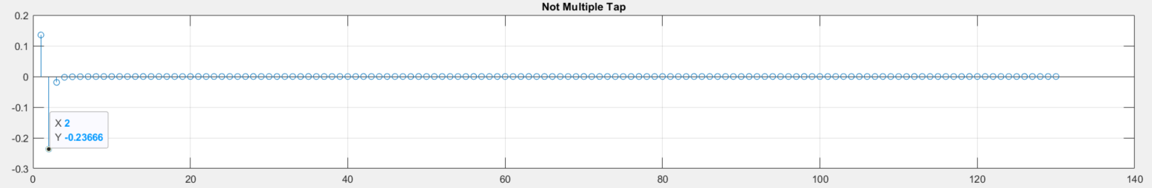

We utilize the formula metioned in the background and parameters in the list again then we can get :

$$1*x_{b}(t-0{)e}^{j2πf_{c}*\left(0\right)}+\left(-0.5\right)*x_{b}(t-1{)e}^{j2πf_{c}\left(-1-67/64\right)}$$

From this result , we can observe that the non-multiple part of the signal can be modeled as :

$$τ\left(i\right)=m*T_{ADC}+K , T_{ADC}∤K$$

In this case , the additional term is :

$$e^{j2πf_{c}\left(-67/64\right)}$$

which will cause a lager gain relative to the Mutiple Tap case.

* + Practice 2 & 3 :
    - Notation :

From background of this experiment, we can utilize the below formula to make some analysis.

Add AWGN :

$$Y_{e}\left(z\right)=\left[A\left(z\right)+\frac{V\left(z\right)}{H\left(z\right)}\right]z^{-∆}$$

Design the equalizer in time domain :

$$\frac{1}{H\left(z\right)}=\frac{1}{α_{b}\left(0\right){+α}_{b}\left(1\right)z^{-1}}$$

* List of parameter utilize in the experiment :

|  |  |  |
| --- | --- | --- |
| Signal | | [1 zeros(127)] |
| Signal Length | | 128 |
| Causal | $$α\left(1\right)$$ | 1 |
| $$α\left(2\right)$$ | -0.5 |
| Non - Causal | $$α\left(1\right)$$ | 0.5 |
| $$α\left(2\right)$$ | -1 |
| ADC Tap interval($T_{ADC}$) | | 64 |
| AWGN SNR(db) | | -10 |

The original transmission signal is :



I add some AWGN and then makesome channel to get the received signal:

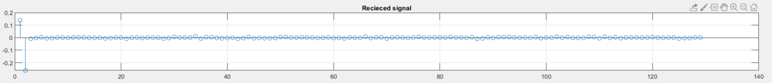

For recover the non-causal signal we can design the filter as :

$$\frac{1}{H\left(z\right)}=\frac{1}{0.5-z^{-1}}=\frac{2}{1-2z^{-1}}$$

From the background we have metioned that the time domain form of equalizer is that :

$$h\left[n\right]=2* -\left(2^{n+1}\right)*u[-n-1]$$

therefore we can convolve the time domain form of the filter to get the recovered signal.

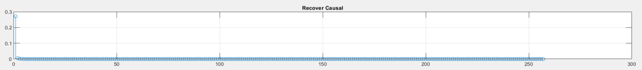

However awgn is spread uniformly in the channel. The filter is low pass filter. It can be examined by the form :

$$\frac{1}{H\left(z\right)}=\frac{1}{0.5-z^{-1}}=\frac{2}{1-2z^{-1}}$$

When z = 1 , gain is -2, when z = -1 , gain is 2/3. This filter cause little gain on the awgn.

Similar to the non – causal signal , we can also design the equalizer below in the frequency domain :

$$\frac{1}{H\left(z\right)}=\frac{1}{1-{0.5z}^{-1}}$$

Then we transfer it to the time domain, we can get :

$$h\left[n\right]=\left({0.5}^{n}\right)*u[n]$$

Just like the same process above, we compare non-AWGN channel and AWGN channel, we can get the below result.

* Non -AWGN channel :

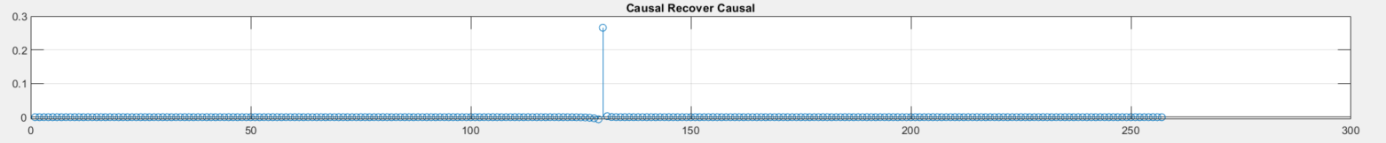

* AWGN channel :

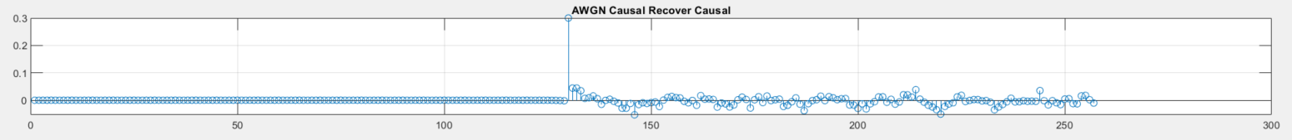

We can observe that the filter will amplify the AWGN signal.This result meet with our inference in the frequency domain.

* Home work Experiment Result :
  + Experiment result :

|  |  |
| --- | --- |
| Signal Type | [1 zeros(127)] |
| Carrier  Frequency |
| DAC UP factor | 16 = sampling rate of the DAC / symbol rate |
| DMA UP factor | 4 = sampling rate for DMA filter / sampling rate of the DAC |
| ADC Tap interval($T_{ADC}$) | 64 |
| Multipath signal gain | $α\left(1\right)=0.3, α\left(2\right)=1$, $α\left(3\right)=0.3$ |
| System Architecture | Transmitter :    Reciever : |
| Experiment  Result | Transmission signal :    Received signal :    Recover signal : |
| Aanlysis | From the previous formula , we can get: $$\frac{1}{H\left(z\right)}=\frac{1}{α_{b}\left(0\right){+α}_{b}\left(1\right)z^{-1}}$$ In this case, the delayed signal are transmitted in three paths, so therefore we can model the signal as : $$y_{b}\left(t\right)=0.3x_{b}\left(t\right)+x_{b}\left(t-1\right)+0.3x_{b}\left(t-2\right)$$ Based on the equation above, we transfer it to frequency domain: $$H\left(z\right)=0.3+z^{-1}+0.3z^{-2}$$ Then inverse it to get the fequency domain of the equalizer: $$\frac{1}{H\left(z\right)}=\frac{1}{0.3+z^{-1}+0.3z^{-2}}$$ Decompose by the process : $$\frac{1}{0.3+z^{-1}+0.3z^{-2}}=\frac{10}{3+{10z}^{-1}+3z^{-2}}=10*\frac{\frac{8}{3}}{3z^{-1}+1}*\frac{-8}{z^{-1}+3} = 10*\frac{\frac{8}{3}}{1+3z^{-1}}*\frac{-\frac{8}{3}}{{1+\frac{1}{3}z}^{-1}}$$ Therefore we can get the time domain form of this process : $$80*{\left(-3\right)}^{n}*u\left[-n-1\right] ℵ 8*{\left(-\frac{1}{3}\right)}^{n+1}*u[n]$$ $ℵ$: The mutiplication in the frequency domain implies that the convolution in time domain.  For summerize, we can code it as below to recover the signal . |