ACSE Labs12

姓名：廖冠勳

系級：電信

學號：0860306

Lab Report

Lab 12 –Constant Envelop Modulation

1. Goal of Experiment :

* To Realize the Property of Communication System,including of QAM,PSK, MSK CPFSK, MSK, and GFSK.
* Use GFSK technique to modulate signal to make the modulated signal variaty increased.
* Use the Gaussian filter to make the signal transmitted in low demand of bandwidth.

1. Background of experiment :
   * Principle of PSK :

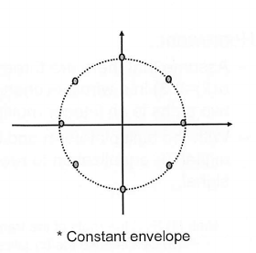

Signal can choose a digital modulated pattern like BPSK, QPSK, 8-PSK. The 8-PSK signal is showed above.We can formulate the formula of 8-PSK as below :

We can use N = 8 to generate a 8-PSK modulated signal. Therefore, The designed code for N-PSK can be written as :

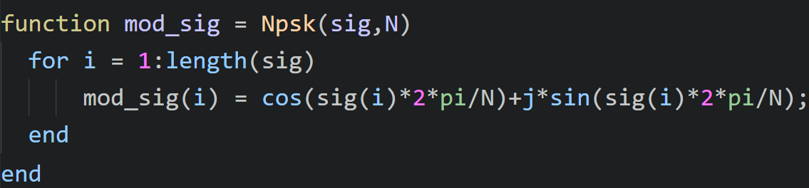

The n value in the notation above is the signal value itself. We can use this information to generate a N-PSK signal.

To increase the option of phase, we use the Continuous Phase Shift Keying to generate signal by the method of intergration.

is the signal information. is the phase shapping function which can be written as many form like rectangular or Gaussian.This modulated for of phase genrate more modulation option.

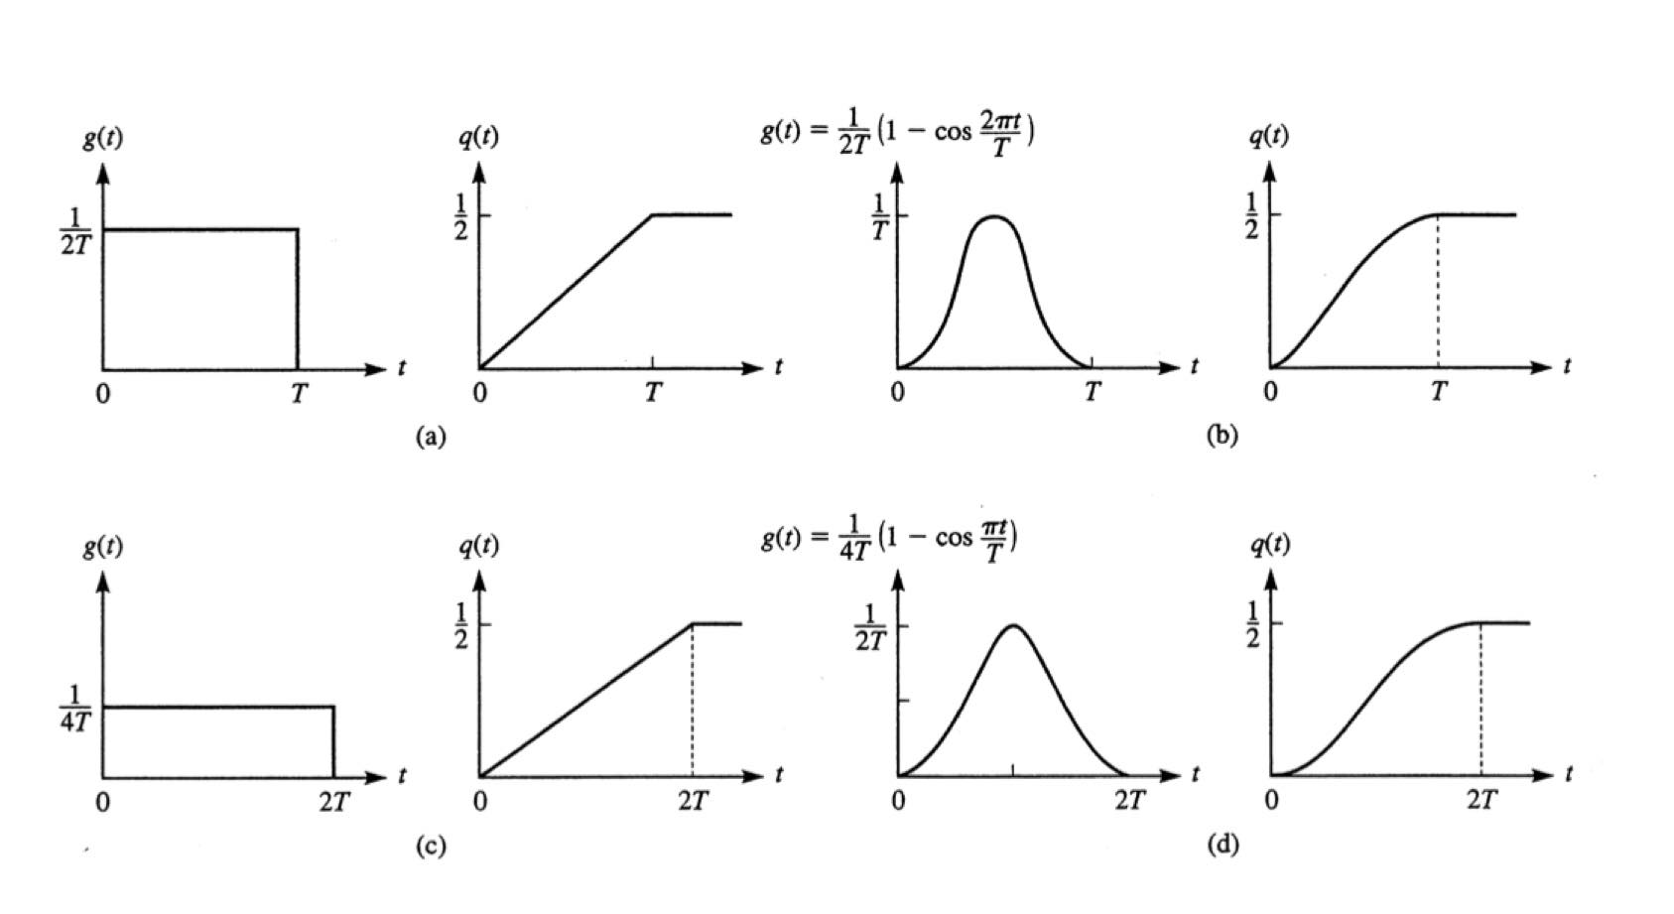

The option of is showed as below. Then we can use the intergration of to get the below formula :

Phase term

Memory term

We define some property in the above form. Let which is called modulation index of CPFSK scheme.However when , we can make the formula above as the below :

Signal at tranmission side will encouter scattering and refraction, which will arise a multipath effect in the transmitting branch. The effect of the multipath can be modeled as below.

Then we use this phase to get the signal :

Since has two frequency components :

So ，this result will gaurantee that we will make the CPSK signal orthogornal in the pass band.This special case is called minimum shift keying.

* + Gaussian Filter Shift Keying :

Let B be 3dB bandwidth of Gaussian filter. Its frequenct and impulse response can be represented as :

h

We can convolve the Gaussian filter to make the phase shapping as Gaussian type as below digram.

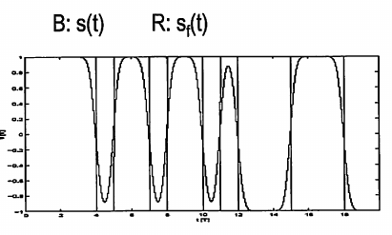

For a band spread signal, we will get a bandlimited in frequency domain. We will use less bandwidth by using this filter.

C. Experiment result and analysis :

* Practice Experiment Result :
  + Practice 1 :
    - Notation of Practice 2 :

From background of this experiment, we can utilize the below formula to relize how the relationship between time doamin and frequncy domain of the Gaussian filter.

From this result we can conculde that both time domain and frequency filter will be gaussian distribution shape.

* List of parameter utilize in the experiment :

|  |  |
| --- | --- |
|  | 2 |
|  | 1/2 |
| BT | 0.5 |
| M | 17 |

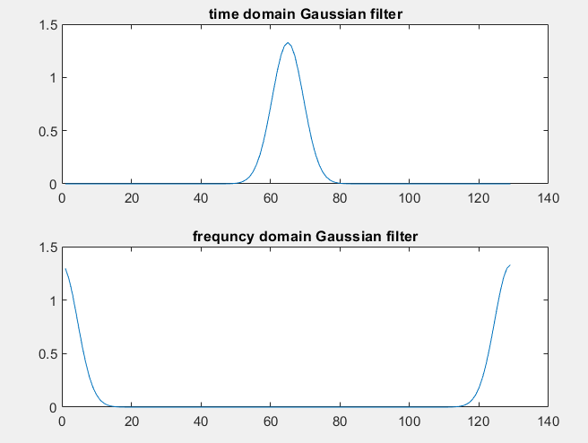

As we mentioned in the notation , we can get the gaussian shape like in the experiment.The Gaussian filter can be implemented as below code.

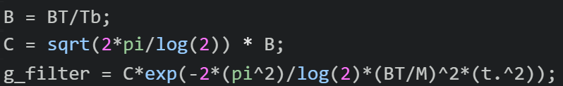

Notice :

This filter will cause a gain in both time and frequncy domain. To gaurantee a unit energy gain . We should Nomalize the filter by norm to get a unit energy gain response.



For different BT of Gaussian filter, we can get the below graph :

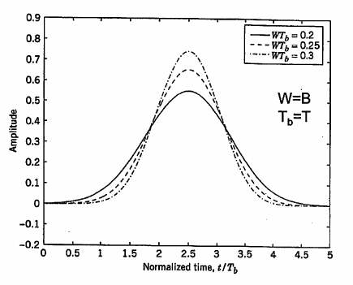

To verify this result I also do the experiment like above diagram:

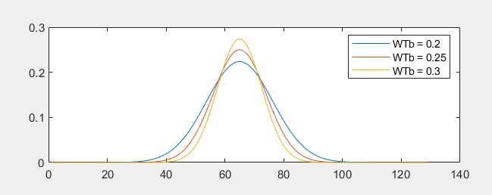

* + Practice 3 :
    - Notation :

From background of this experiment, we can utilize the below formula to make some analysis.

CPFSK of transmitted signal :

where :

* List of parameter utilize in the experiment :

|  |  |
| --- | --- |
|  | 1 |
|  | 1 |
|  | 0.15 |
| Modulation index | 0.3 |
| AWGN_SNR_DB | 10 |

* Block diagram and some notation in the experiment :

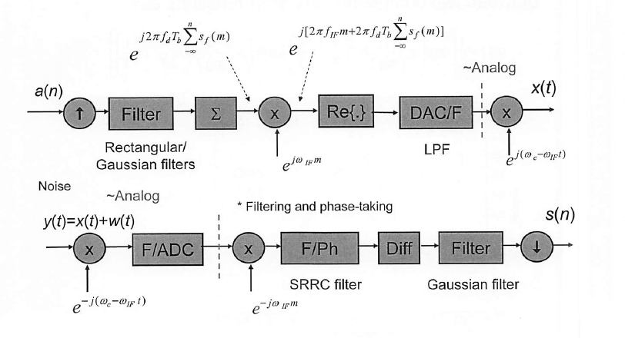

Frequency response and phase plot

* Experiment result :

|  |  |  |
| --- | --- | --- |
| Freqeuncy domain |  |  |
| Phase comparison |  | |
| Received Signal |  | |

We can get almost the same phase, frequency, and time respone of the transmitted and received signal. We will explore more property of some combination of parametors in the Homework experiment.

* Home work Experiment Result :
  + Experiment result :

|  |  |
| --- | --- |
| Signal Type | BPSK |
| DAC UP factor | 16 = sampling rate of the DAC / symbol rate |
| DMA UP factor | 4 = sampling rate for DMA filter / sampling rate of the DAC |
| ADC Tap interval() | 64 |
| System Architecture |  |

* List of parameter utilize in the experiment :

|  |  |  |  |
| --- | --- | --- | --- |
|  | 1 | 1 | 1 |
|  | 1 | 1 | 1 |
|  | 0.15 | 0.15 | 2*0.15 |
| Modulation index | 0.3 | 0.3 | 0.6 |
| AWGN_SNR_DB | 10 | 2 | 10 |
| Notation of Experiment | A | B | C |

|  |  |  |  |
| --- | --- | --- | --- |
|  | A | B | C |
| Freqeuncy domain |  |  |  |
| Phase comparison |  |  |  |
| Received Signal |  |  |  |

* By the experiment A & B Group, We can observe that the AWGN is not so cirtical to the CPFSK modulation system. B will cause a little shift impact on the phase.
* However, in the C group. We can observe more phase shift and frequncy shift. Based on our observation, we can explore more experiment on the modification of parametor .

Modulation index is abbreviated as Midx :

|  |  |  |  |
| --- | --- | --- | --- |
|  | Freqeuncy domain | Phase comparison | Received Signal |
| Midx : 0.9 |  |  |  |
| Midx : 1.8 |  |  |  |
| Midx : 2.7 |  |  |  |

From the previous formula we can get the phase form that :

CPFSK of transmitted signal :

Where :

h dominate the phase of the signal . As we increase the h , we will get a larger phase change which will cause a phase shift in this experiment result. The received signal will be changed cause of the phase changed.

We can verify this result by these experiment results . We only exreact the phase graph in the previous page :

|  |  |
| --- | --- |
|  |  |
|  |  |
|  |  |
|  |  |

is the base index for this experimnet. We can get that the received phase of this experimnt is in the range of . As we increase the mutiplication factor to the , the received phase is in the range of .This is about three times of 6 . Therefore, in the favor of this inference, we can predict the and in such manner.