ACSE Labs13

姓名：廖冠勳

系級：電信

學號：0860306

Lab Report

Lab 13 –MIMO Transmission

1. Goal of Experiment :

* To Realize the Property of Communication System,including of SISO, SIMO, MIMO techniques.
* Use SIMO technique to make the signal tranmit into different antenna of reciever and try to know how to design the SIMO detector.
* Using MIMO technique to transmit signal is a method of increasing capacity and diversity of a communication system.

1. Background of experiment :
   * Principle of SIMO system :

$$\left[\begin{aligned}y_{1} \\ y_{2} \\ . \\ \begin{aligned}. \\ y_{n_{R}}\end{aligned}\end{aligned}\right]$$

$$x(n)$$

$x(n)$ denote the transmission signal in the transmiter。For simplicity, we can represent the signal as the following form :

$$\left[\begin{aligned}h_{1} \\ h_{2} \\ . \\ . \\ . \\ h_{n_{R}}\end{aligned}\right]x(n)$$

$h_{1}、h_{2}......h_{n_{R}}$ is the channel gain of the chanel. We can integrate the channel effect into comlumn vector form per single transmit antenna.

Based on the coclusion of the single antenna, we expand more anttena to form a MIMO system.

* + MIMO System :

$$\left[\begin{aligned}y_{1} \\ y_{2} \\ . \\ \begin{aligned}. \\ y_{n_{R}}\end{aligned}\end{aligned}\right]$$

$$\left[\begin{aligned}x_{1} \\ x_{2} \\ . \\ \begin{aligned}. \\ x_{n_{T}}\left(n\right)\end{aligned}\end{aligned}\right]$$

As more transmission anttena increase in the transmitter, the more column vector that the transmission Matrix has.

Then we can form the transmission Matrix as below process :

$$\left[\begin{aligned}h_{11} \\ h_{21} \\ . \\ . \\ . \\ h_{n_{R}1}\end{aligned}\right]x_{1}(n)+\left[\begin{aligned}h_{12} \\ h_{22} \\ . \\ . \\ . \\ h_{n_{R}2}\end{aligned}\right]x_{2}(n)+........+\left[\begin{aligned}h_{1n_{T}} \\ h_{2n_{T}} \\ . \\ . \\ . \\ h_{n_{R}n_{T}}\end{aligned}\right]x_{n_{T}}(n)= \left[\begin{aligned}y_{1} \\ y_{2} \\ . \\ . \\ . \\ y_{n_{R}}\end{aligned}\right]$$

Then we intergrate all the channel effect of trnasmitter and reciever to form a neat matrix form :

$$\left[\begin{matrix}h_{11} & h_{12} & h_{13} \\ h_{21} & h_{22} & h_{23} \\ \begin{aligned}. \\ . \\ h_{n_{R}1}\end{aligned} & \begin{aligned}. \\ . \\ h_{n_{R}2}\end{aligned} & \begin{aligned}. \\ . \\ h_{n_{R}3}\end{aligned}\end{matrix} \right]\left[\begin{aligned}x_{1} \\ x_{2} \\ . \\ \begin{aligned}. \\ x_{n_{T}}\left(n\right)\end{aligned}\end{aligned}\right] = \left[\begin{aligned}y_{1} \\ y_{2} \\ . \\ \begin{aligned}. \\ y_{n_{R}}\end{aligned}\end{aligned}\right]$$

We can use randn function to generate the matrix. Therefore, the designed code for MIMO channel matrix can be written as :

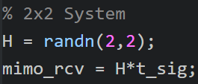

However, how can we eliminate the channel gain matrix in the reciever?

There are several methods to use in both SIMO and MIMO system.

|  |  |
| --- | --- |
| SIMO | Receive Beamforming |
| MIMO | Zero forcing detector (de-correlator) |
| MMSE detector |

I introduce it and make some inference to get their close form as blow.

* + SIMO system signal recover :

Assume a noise-free channel : we can use a row vector to get

$$\begin{matrix}[h_{1}^{*} & \begin{matrix}h_{2}^{*} & … & h_{n_{R}^{*}}]\end{matrix} \end{matrix}\left[\begin{aligned}h_{1} \\ h_{2} \\ . \\ . \\ . \\ h_{n_{R}}\end{aligned}\right]x(n)=\sum_{k=1}^{n_{R}}{{\left|h_{k}\right|}^{2}x(n)}$$

Therefore, we can properly desgin the row vector $\begin{matrix}[h_{1}^{*} & \begin{matrix}h_{2}^{*} & … & h_{n_{R}^{*}}]\end{matrix} \end{matrix}$ to get the original signal $x(n)$ by the following inference :

We make the $h_{n_{R}^{*}} = \frac{1}{h_{n_{R}}}$ to make ${\left|h_{k}\right|}^{2} = 1$ then we can get the recived signal :

$$\sum_{k=1}^{n_{R}}{{\left|h_{k}\right|}^{2}x(n)} = \sum_{k=1}^{n_{R}}{x(n)}=n_{R} * x(n)$$

Then we will get the signal $n_{R} * x(n)$ at reciever. We can divide this signal by factor $n_{R}$ to recover the signal x(n) .

Besides, the block of the system can be showed as below :

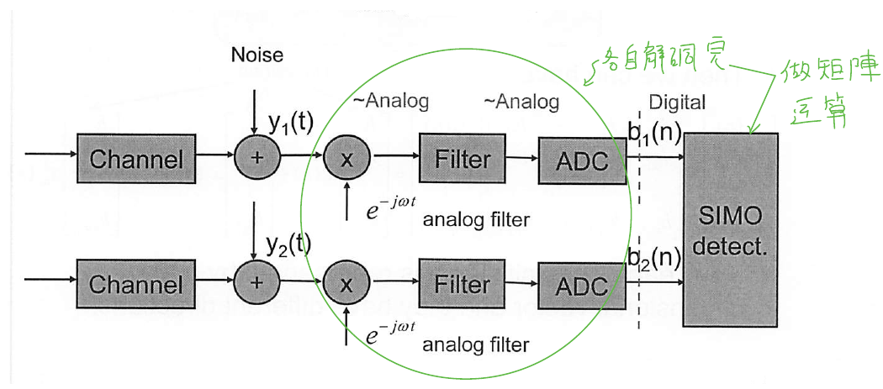

Practice 2 result is showed below :

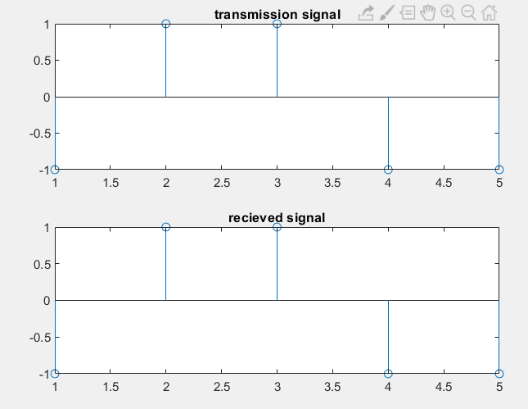

* + MIMO system signal recover :
    - Zero forcing detector :

We use a channel model to represent the process :

$$y=Hx+w$$

Then we can get the original signal x by tag both side of the euality.

$$H^{-1}y=x+H^{-1}w$$

y is the revcieved signal in the reciever side, we can get the origninal signal(x) plus noise by this execution. However, we will also receive the noise term

$$H^{-1}w$$

If the $H^{-1}$ is singular, this term may be blow out to make the received signal distorsion , just like the below diagram .

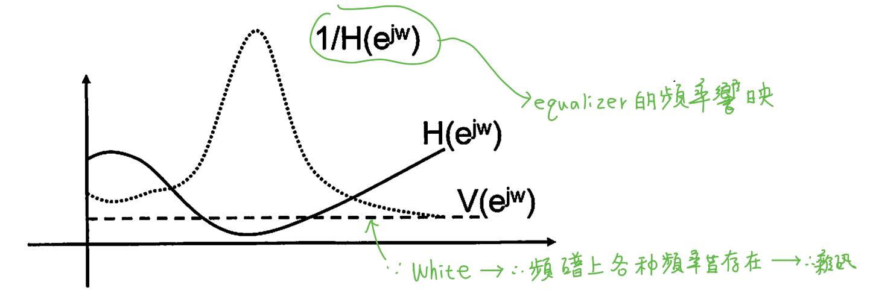

* Advantage of this MMSE dector is that it is easy to implement.
* However, the $H^{-1}w$ will make recived signal distorsion.
  + - MMSE detector

In the channel model:

$$y=Hx+w$$

Dector aims to get the sigal x by the channel model. Therefore, we can apply the MMSE principle to get the signal X :

$$\min_{w}⁡E\{{\left(x-Wy\right)}^{H}(x-Wy)\}$$

The physical meaning of this formula is that we aim to find a trasformation W that we can make the distance between x and Wy has the minimum distance.

Then we will get the below solution :

$$W=H^{H}{\left(HH^{H}+ρ^{-1}I\right)}^{-1}, if n_{T}>n_{R}$$

$$W={\left(H^{H}H+ρ^{-1}I\right)}^{-1}H^{H}, if n_{T}≤n_{R}$$

By the core design principle of this detector , we can get the closely approch of signal x by

$$x = Wy$$

Besides, the performance of MMSE detector is better than that of Zero forcing.

C. Experiment result and analysis :

* Practice Experiment Result :
  + Practice 3 :
    - Notation of Practice 3 :

From background of this experiment, we can utilize the below formula to relize how the relationship between MMSE and Zeroforcing detector.

* MMSE dector :

$$x = Wy$$

Where :

$$W=H^{H}{\left(HH^{H}+ρ^{-1}I\right)}^{-1}, if n_{T}>n_{R}$$

$$W={\left(H^{H}H+ρ^{-1}I\right)}^{-1}H^{H}, if n_{T}≤n_{R}$$

* Zero forcing dector :
$$H^{-1}y=x+H^{-1}w$$

* List of parameter utilize in the experiment :

|  |  |
| --- | --- |
|  | Zero forcing detector |
| ADC | 16 |
| DMA | 4 |
| Fc | 0.25 |
| AWGN(dB) | 17 |
| Channel | Random Channel |

* Block diagram :

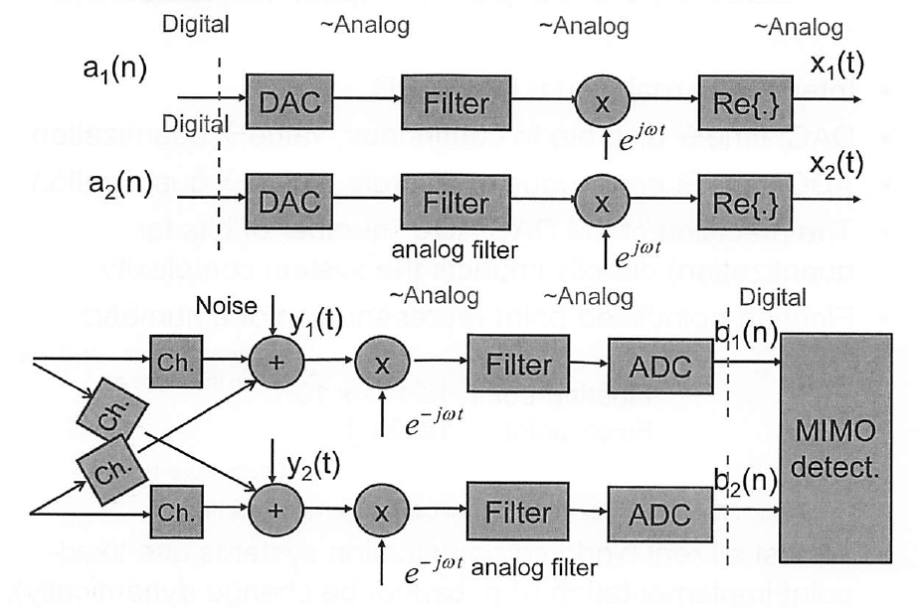

Recieve Branch 2

Recieve Branch 1

Transmission Branch 2

Transmission Branch 1

* Experiment result :
  + Zero forcing detection :

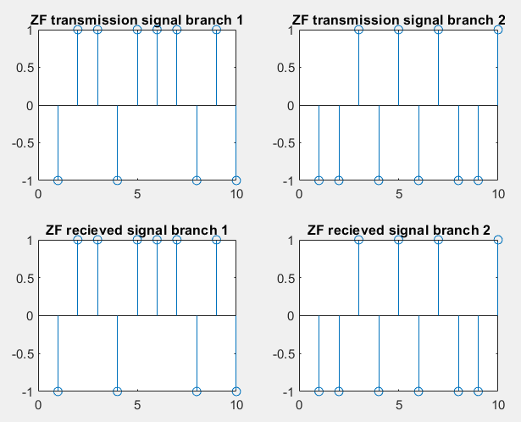

* + MMSE :

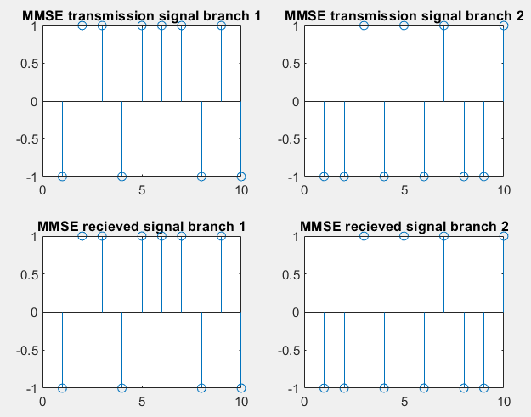

By the Zero Forcing :

$$H^{-1}y=x+H^{-1}w$$

we can get the origninal signal(x) plus noise by this execution. However, we will also receive the noise term

$$H^{-1}w$$

Zero forcing is lower perfomance due to this term.

* Home work Experiment Result :
  + Experiment result :

|  |  |
| --- | --- |
| Signal Type | BPSK |
| DAC UP factor | 16 = sampling rate of the DAC / symbol rate |
| DMA UP factor | 4 = sampling rate for DMA filter / sampling rate of the DAC |
| ADC Tap interval() | 64 |
| System Architecture |  |

* List of parameter utilize in the experiment :

|  |  |  |  |
| --- | --- | --- | --- |
|  | 1 | 1 | 1 |
|  | 1 | 1 | 1 |
|  | 0.15 | 0.15 | 2*0.15 |
| Modulation index | 0.3 | 0.3 | 0.6 |
| AWGN_SNR_DB | 10 | 2 | 10 |
| Notation of Experiment | A | B | C |

|  |  |  |  |
| --- | --- | --- | --- |
|  | A | B | C |
| Freqeuncy domain |  |  |  |
| Phase comparison |  |  |  |
| Received Signal |  |  |  |

* By the experiment A & B Group, We can observe that the AWGN is not so cirtical to the CPFSK modulation system. B will cause a little shift impact on the phase.
* However, in the C group. We can observe more phase shift and frequncy shift. Based on our observation, we can explore more experiment on the modification of parametor .

Modulation index is abbreviated as Midx :

|  |  |  |  |
| --- | --- | --- | --- |
|  | Freqeuncy domain | Phase comparison | Received Signal |
| Midx : 0.9 |  |  |  |
| Midx : 1.8 |  |  |  |
| Midx : 2.7 |  |  |  |

From the previous formula we can get the phase form that :

CPFSK of transmitted signal :

Where :

h dominate the phase of the signal . As we increase the h , we will get a larger phase change which will cause a phase shift in this experiment result. The received signal will be changed cause of the phase changed.

We can verify this result by these experiment results . We only exreact the phase graph in the previous page :

|  |  |
| --- | --- |
|  |  |
|  |  |
|  |  |
|  |  |

is the base index for this experimnet. We can get that the received phase of this experimnt is in the range of . As we increase the mutiplication factor to the , the received phase is in the range of .This is about three times of 6 . Therefore, in the favor of this inference, we can predict the and in such manner.