ACSE Labs14

姓名：廖冠勳

系級：電信

學號：0860306

Lab Report

Lab 14 –Fixed Point Implementation

1. Goal of Experiment :

* To Realize the Property of Communication System,including of realistic ADC and DAC simulationm techniques, physical meaning of SQNR, Dnamic range and Number of bits for utilization .
* Use realistic ADC technique to quantize signal to tranmit .
* Realize the how effect of various calculation impact the number of bits to use.

1. Background of experiment :
   * Realistic ADC :
     + Block Diagram of the realistic DAC/ADC :

|  |  |
| --- | --- |
| DAC | ADC |
| Analog  Digital | Digital  Analog |
| DAC is resposible for transform digital siganl to ananlog signal | ADC is resposible for transform analog siganl to digital signal |

* + - Quatization error for the realistic ADC and SQNR :

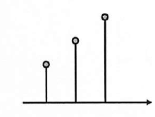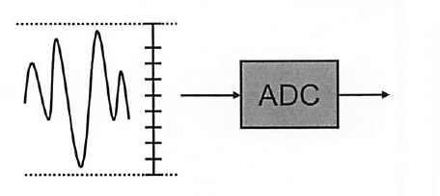

Sampling Rate

Quantization Level

Dynamic Range

Signal after quantized will fall into below range :

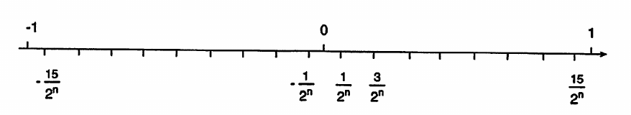

If signal falls into such kind of interval , it will arise a quatization erro.

Based on this conception, we can formulate the average quantization power , and the quntization error is uniformly distribution between Dynamic Range.

$$σ_{q}^{2}=\frac{1}{\frac{1}{2^{N}}-\left(-\frac{1}{2^{N}}\right)} \int_{-\frac{1}{2^{N}}}^{\frac{1}{2^{N}}}{X^{2} Fdx= }\frac{1}{3} {\left(\frac{1}{2^{N}}\right)}^{2}$$

Then we can tag 10*log10 in the both side of the above form to get the energy in dB :

$$10log10\frac{1}{3} {\left(\frac{1}{2^{N}}\right)}^{2}=-4.77-6.02N dB$$

N is number of bits utized in the quantization. We can conclude that we will will get $6.02N dB$ loss by every increase 1-bit for utilized.

* SQNR :

SQNR is assemble to the SNR, measure the quantization error of a reaistic ADC.It is defined as below :

$$SQNR =10\log_{10}{\frac{E\left\{x^{2}\left(n\right)\right\}}{E{\left\{x\left(n\right)-x_{Q}\left(n\right)\right\}}^{2}}}$$

Where :

$E\left\{x^{2}\left(n\right)\right\}$: signal power

$E{\left\{x\left(n\right)-x_{Q}\left(n\right)\right\}}^{2}$: quantization noise power

* + Dynamic Range (DR) and number of bits (NOB):
    - Some definition :
      * Dynamic Range (DR) : the position of decimal point
      * Number of quantization level (NQL) : the to store the signal.
    - Comparison between some calculation :

|  |  |  |  |
| --- | --- | --- | --- |
| Addition |  | $$NOB_{out}≪NOB_{1}+NOB_{2}$$ | $${01}_{2}+{01}_{2}={10}_{2}$$ 2-bits < 4-bits |
| Multiplication |  | $$NOB_{out}<NOB_{1}+NOB_{2}$$ | $${01}_{2}+{01}_{2}={01}_{2}$$ 2-bits = 2-bits |

* + - For example : for the 4-coeficient filtering operation :

$$y(n) = \sum_{i=0}^{3}{h\left(i\right)x(n-i)}$$

|  |  |  |
| --- | --- | --- |
|  | 1 multiplier  +  3 adders | NOB utilization is the most |
|  | 1 multiplier  +  1 adders | NOB utilization is the lowest |
|  | 1 multiplier  +  2 adders | NOB utilization is medium |

* + Following the below procedure to determine the DR and NOB for each blocz
    - Use floating-point simulations to determine the performance of the system (MSE, SNR. or BER)
    - Quantize the input of the first system and compare the performance with that of the unquantized case. This will determine the NQB for the ADC.
    - Quantize the output of the first system and determine the requirement for SQNR (output NQB).
    - Continue this process until the NQBs of all inputs and outputs are obtained.
    - For each system, we can determine the NQBs of its subsystems to meet the required SQNR.
* Practice Experiment Result :
  + Practice 3 :
    - Notation of Practice 3 :

From background of this experiment, we can utilize the below formula to relize how the relationship between MMSE and Zeroforcing detector.

* MMSE dector :

Where :

* Zero forcing dector :
* List of parameter utilize in the experiment :

|  |  |
| --- | --- |
|  | Zero forcing detector |
| ADC | 16 |
| DMA | 4 |
| Fc | 0.25 |
| AWGN(dB) | 17 |
| Channel | Random Channel |

* Block diagram :

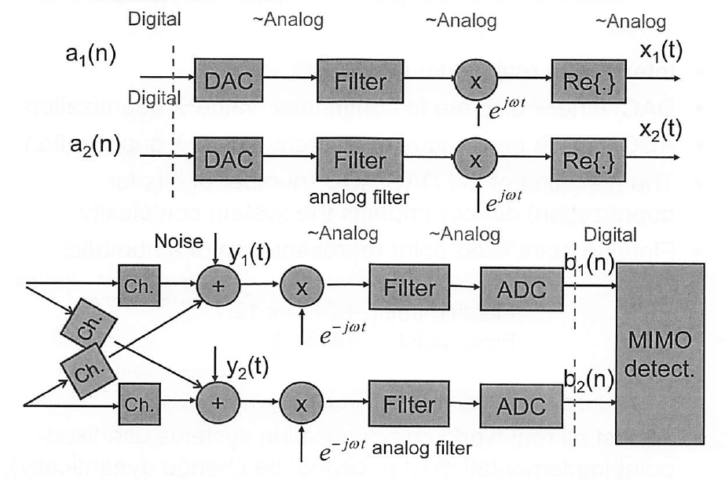

Recieve Branch 2

Recieve Branch 1

Transmission Branch 2

Transmission Branch 1

* Experiment result :
  + Zero forcing detection :

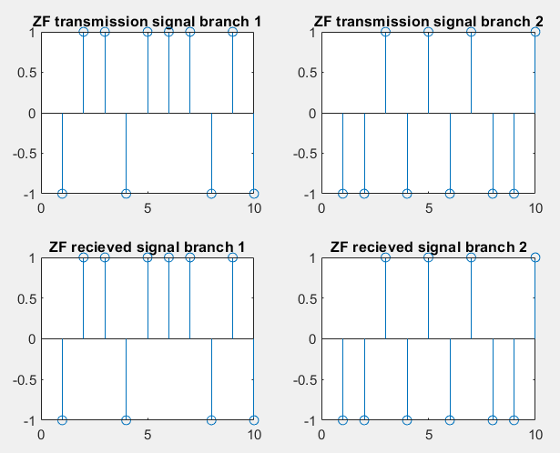

* + MMSE :

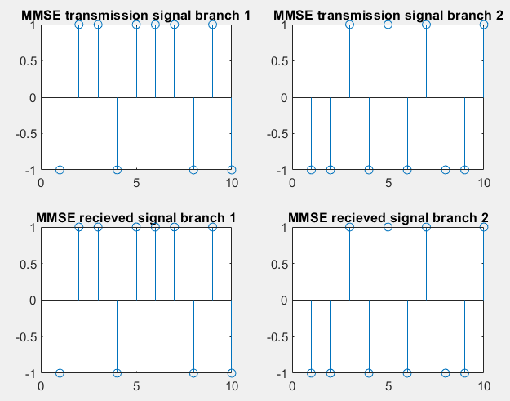

By the Zero Forcing :

we can get the origninal signal(x) plus noise by this execution. However, we will also receive the noise term

Zero forcing is lower perfomance due to this term.

* Home work Experiment Result :
  + Experiment result :

|  |  |
| --- | --- |
| Signal Type | BPSK |
| DAC UP factor | 16 = sampling rate of the DAC / symbol rate |
| DMA UP factor | 4 = sampling rate for DMA filter / sampling rate of the DAC |
| ADC Tap interval() | 64 |
| System Architecture |  |

* List of parameter utilize in the experiment :

|  |  |  |  |
| --- | --- | --- | --- |
|  | 1 | 1 | 1 |
|  | 1 | 1 | 1 |
|  | 0.15 | 0.15 | 2*0.15 |
| Modulation index | 0.3 | 0.3 | 0.6 |
| AWGN_SNR_DB | 10 | 2 | 10 |
| Notation of Experiment | A | B | C |

|  |  |  |  |
| --- | --- | --- | --- |
|  | A | B | C |
| Freqeuncy domain |  |  |  |
| Phase comparison |  |  |  |
| Received Signal |  |  |  |

* By the experiment A & B Group, We can observe that the AWGN is not so cirtical to the CPFSK modulation system. B will cause a little shift impact on the phase.
* However, in the C group. We can observe more phase shift and frequncy shift. Based on our observation, we can explore more experiment on the modification of parametor .

Modulation index is abbreviated as Midx :

|  |  |  |  |
| --- | --- | --- | --- |
|  | Freqeuncy domain | Phase comparison | Received Signal |
| Midx : 0.9 |  |  |  |
| Midx : 1.8 |  |  |  |
| Midx : 2.7 |  |  |  |

From the previous formula we can get the phase form that :

CPFSK of transmitted signal :

Where :

h dominate the phase of the signal . As we increase the h , we will get a larger phase change which will cause a phase shift in this experiment result. The received signal will be changed cause of the phase changed.

We can verify this result by these experiment results . We only exreact the phase graph in the previous page :

|  |  |
| --- | --- |
|  |  |
|  |  |
|  |  |
|  |  |

is the base index for this experimnet. We can get that the received phase of this experimnt is in the range of . As we increase the mutiplication factor to the , the received phase is in the range of .This is about three times of 6 . Therefore, in the favor of this inference, we can predict the and in such manner.