ACSE Labs12

姓名：廖冠勳

系級：電信

學號：0860306

Lab Report

Lab 15 –Testing

1. Goal of Experiment :

* Realizing the Property of Communication System,including of CPFSK, Indicies for the transmitter(i.e EVM and spectrum mask), interference performance, Blooth and EDR system.
* Use EVM indicies to evaluate the bias in the constellation graph of original signal with biased signal.
* Use spectrum mask to evaluate the transmitted signal bandwidth meeting with the requirement.

1. Background of experiment :
   * Principle of CPFSK :

To increase the option of phase, we use the Continuous Phase Shift Keying to generate signal by the method of intergration.

is the signal information. is the phase shapping function which can be written as many form like rectangular or Gaussian.This modulated for of phase genrate more modulation option.

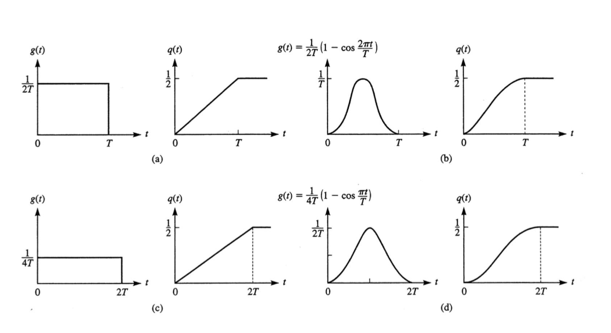

The option of is showed as below. Then we can use the intergration of to get the below formula :

Phase term

Memory term

We define some property in the above form. Let which is called modulation index of CPFSK scheme.However when , we can make the formula above as the below :

Signal at tranmission side will encouter scattering and refraction, which will arise a multipath effect in the transmitting branch. The effect of the multipath can be modeled as below.

Then we use this phase to get the signal :

Since has two frequency components :

So ，this result will gaurantee that we will make the CPSK signal orthogornal in the pass band.This special case is called minimum shift keying.

* + Gaussian Filter Shift Keying :

Let B be 3dB bandwidth of Gaussian filter. Its frequenct and impulse response can be represented as :

h

We can convolve the Gaussian filter to make the phase shapping as Gaussian type as below digram.

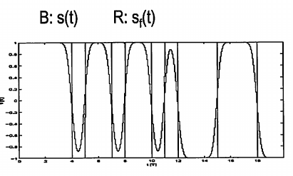

For a band spread signal, we will get a bandlimited in frequency domain. We will use less bandwidth by using this filter.

* + Spectrum mask evaluation :

Spectrum mask is a method of evaluating whether the transmitted signal will be confined in the limmited power. We can use the mask like below :

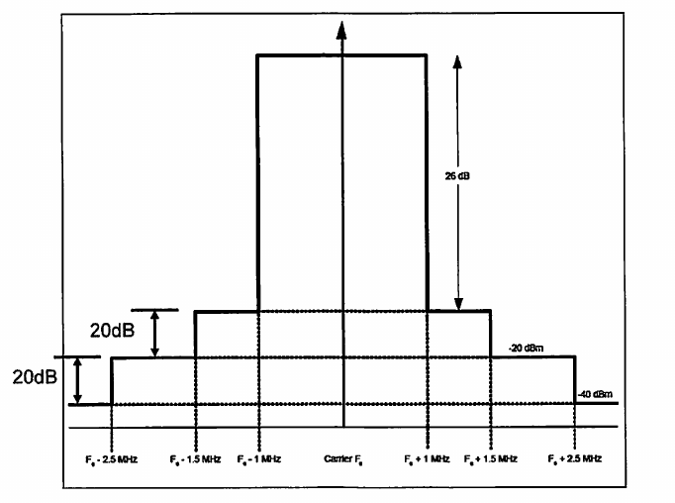

In this experiment, we use the DMA frequency as 64MHz and the Intermediate frequency is 2MHz which indicate that the center of the spectrum mask is

Then we can conffine the signal under the mask just like below :

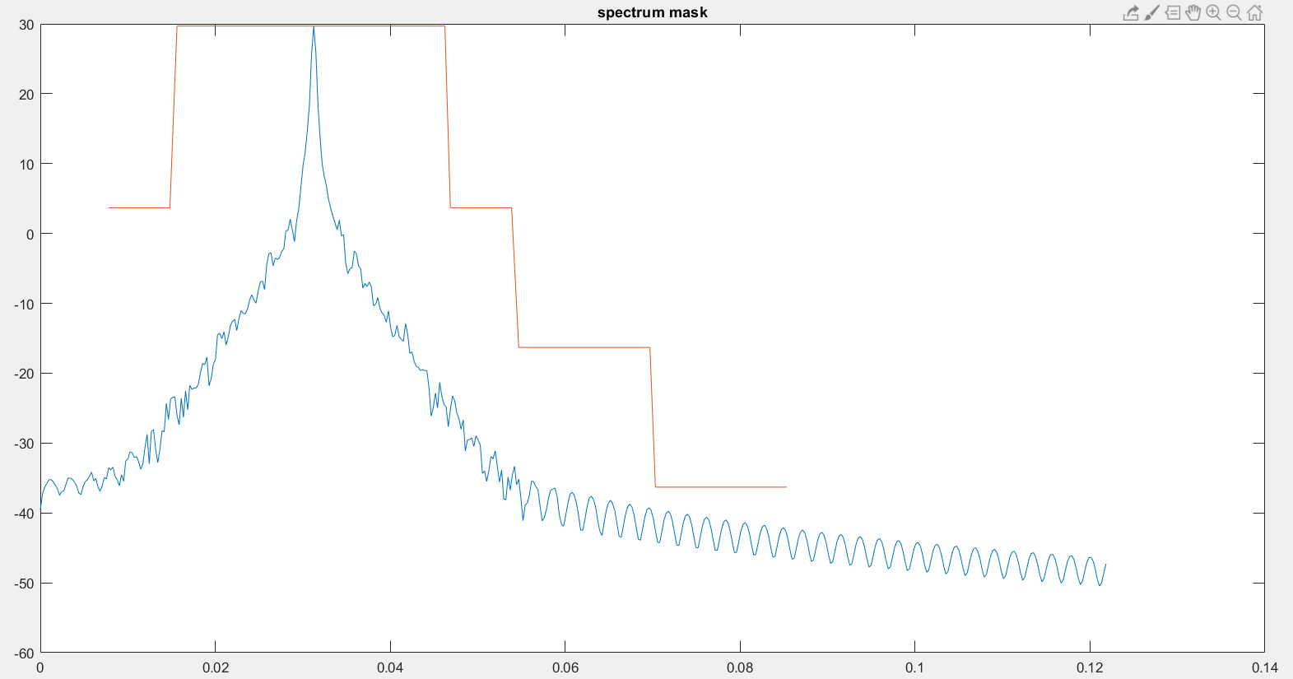

We can implement the spectrum mask just like below :

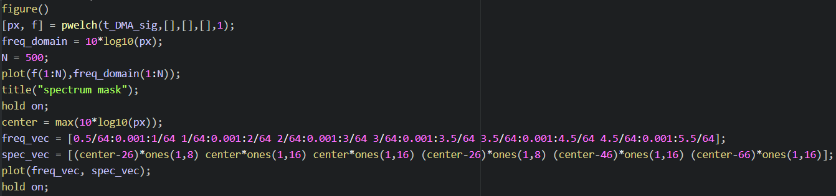

Use the freqency vector and the corresponding height to generate the spectrum mask.

* + EVM of the communication system :

An ideal signal in the reciever is ecpected locatting in a idea constellation position. However, the real-word transmitter will deviate from the ideal location due to some deviataion like IQ-imbalance in a random way. Just show as below :

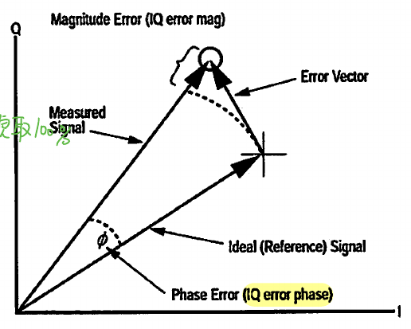

Therefore we use the below function to evaluate the offset :

00%

C. Experiment result and analysis :

* Practice Experiment Result :
  + Practice 1 :
* List of parameter utilize in the experiment :
* Parametors :

|  |  |
| --- | --- |
|  | 2 MHz |
|  | 16MHz |
|  | 64MHz |
|  | 150KHz |
|  | 2.4GHz |
| M | 17 |

* Block diagram of the communication system :

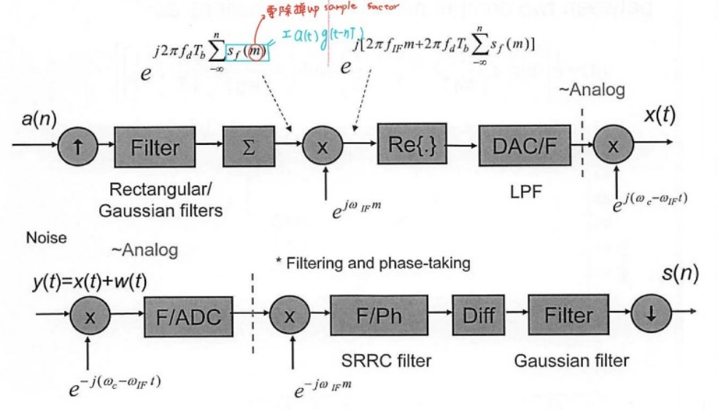

Plot spectrum mask here

* Experiment result :

I have used the srrc filter and butterwoth filter as my DMA filter. They will be different in some way like below :

|  |  |
| --- | --- |
| Srrc filter | Butter worth filter  Attenuation = -50dB |
|  |  |

Srrc filter can’t filter out all of the high frequency signal. The key point to eliminate all of the signal in the hight frequency. We can modify the IIR fitler to meet the requirement.

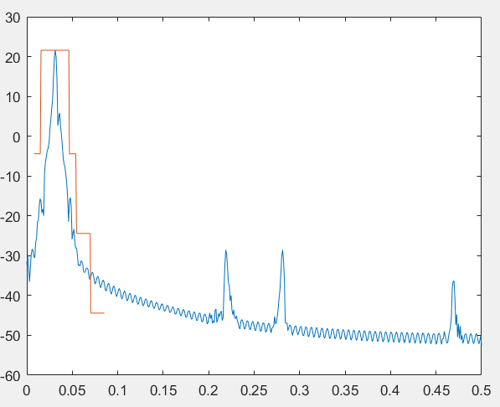

When attenuation is modified as 80dB, we will meet the requirement in the third stage. This is a obvious improvement of the implementation.

As we mentioned in the notation , we can get the gaussian shape like in the experiment.The Gaussian filter can be implemented as below code.

* + Practice 2 & 3 :
    - Notation :

From background of this experiment, we can utilize the below formula to make some analysis.

00%

* List of parameter utilize in the experiment :
* Parametors :

|  |  |
| --- | --- |
|  | 2 MHz |
|  | 16MHz |
|  | 64MHz |
|  | 150KHz |
|  | 2.4GHz |
| M | 17 |

* Transmitted signal :

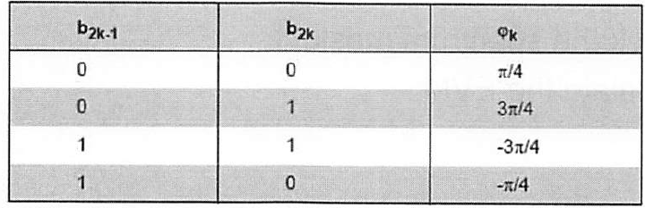

* Block diagram and some notation in the experiment :

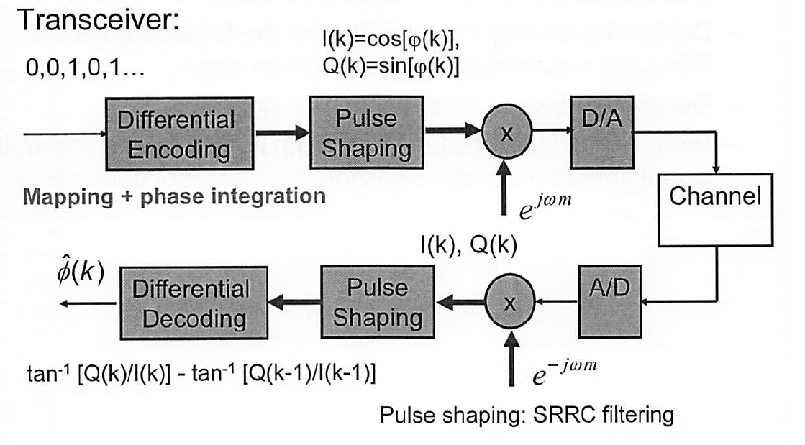

* Experiment result :
* 使用不同srrc & IIR filter與gaussian filter &　rectangular filter做比較外加AWGN的requirement
* 用原本系統改送qpsk訊號即可? 如何解調?

|  |  |  |
| --- | --- | --- |
| Freqeuncy domain |  |  |
| Phase comparison |  | |
| Received Signal |  | |

We can get almost the same phase, frequency, and time respone of the transmitted and received signal. We will explore more property of some combination of parametors in the Homework experiment.

* Home work Experiment Result :
  + Experiment result :

|  |  |
| --- | --- |
| Signal Type | BPSK |
| DAC UP factor | 16 = sampling rate of the DAC / symbol rate |
| DMA UP factor | 4 = sampling rate for DMA filter / sampling rate of the DAC |
| ADC Tap interval() | 64 |
| System Architecture |  |

* List of parameter utilize in the experiment :

|  |  |  |  |
| --- | --- | --- | --- |
|  | 1 | 1 | 1 |
|  | 1 | 1 | 1 |
|  | 0.15 | 0.15 | 2*0.15 |
| Modulation index | 0.3 | 0.3 | 0.6 |
| AWGN_SNR_DB | 10 | 2 | 10 |
| Notation of Experiment | A | B | C |

|  |  |  |  |
| --- | --- | --- | --- |
|  | A | B | C |
| Freqeuncy domain |  |  |  |
| Phase comparison |  |  |  |
| Received Signal |  |  |  |

* By the experiment A & B Group, We can observe that the AWGN is not so cirtical to the CPFSK modulation system. B will cause a little shift impact on the phase.
* However, in the C group. We can observe more phase shift and frequncy shift. Based on our observation, we can explore more experiment on the modification of parametor .

Modulation index is abbreviated as Midx :

|  |  |  |  |
| --- | --- | --- | --- |
|  | Freqeuncy domain | Phase comparison | Received Signal |
| Midx : 0.9 |  |  |  |
| Midx : 1.8 |  |  |  |
| Midx : 2.7 |  |  |  |

From the previous formula we can get the phase form that :

CPFSK of transmitted signal :

Where :

h dominate the phase of the signal . As we increase the h , we will get a larger phase change which will cause a phase shift in this experiment result. The received signal will be changed cause of the phase changed.

We can verify this result by these experiment results . We only exreact the phase graph in the previous page :

|  |  |
| --- | --- |
|  |  |
|  |  |
|  |  |
|  |  |

is the base index for this experimnet. We can get that the received phase of this experimnt is in the range of . As we increase the mutiplication factor to the , the received phase is in the range of .This is about three times of 6 . Therefore, in the favor of this inference, we can predict the and in such manner.