Making Property Insurance Sustainable In Terms Of
Economic And Social Value
Summary
“I am not afraid of storms, for I am learning how to sail my ship.”
― Louisa May Alcott, Little Women
The frequent occurrence of extreme weather has hampered the development of the insurance industry. Therefore, we develop a disaster risk assessment model, an insurance decision model, and a community preservation model to safeguard the sustainable development of insurance companies and communities.
For extreme weather prediction model, we select London and many regions in the United States as the research objects and select five local climate indicators, extreme weather types, and disaster numbers for modeling. Then, through the comparison of multiple models, the XGBoost model with higher accuracy is finally selected to predict the frequency of various extreme weather. Then, strategies Based on Inverse Ideas, the overall model is optimized to obtain an interpretable disaster prediction model. Finally, the prediction is made through the data of different conditions (time, place, climate) to obtain a more credible extreme weather prediction model.
For insurance decision model, we utilize the XGBoost model for probabilistic prediction of extreme weather. We also collect local insurance metrics and analyze the income and expenditure, which are used to make insurance decisions. In addition, we use ArcGIS mapping tools to visualize the data. Advice is provided to insurance companies on underwriting policies. Finally, integrating the model with community development realizes the combination of economic and social values.
For community preservation model, we determine six evaluation indicators such as history and culture as the factor set, and set three types of evaluation criteria as evaluation sets, so that the fuzzy comprehensive evaluation matrix can be determined. Then, the weight of each index is determined by the analytic hierarchy process, and the final expression of a fuzzy comprehensive evaluation is determined according to the fuzzy synthesis operator of the weighted average type. Finally, we select Hurst Castle as a landmark, and according to the analysis, we find that Hurst Castle has a high value. Therefore, we need to take protective measures against it, and we also write letters to the community about the landmark's plans, timelines, and cost proposals.
Finally, we perform a sensitivity analysis of the model. We analyze the local sensitivity by regional differences and period variations and find that the model predictions are as expected. We also replace the maximum temperature (TMAX) in the climate metrics with elevation data, and the results show no overfitting.

Keywords: XGBoost Model, Inverse Thinking, Insurance Decision Model, Fuzzy evaluation analysis
Contents
1 Introduction 3
1.1 Background 3
1.2 Restatement of the Problem 3
1.3 Our Work 3
2 Restatement of the Problem 4
3 Notations 5
4 Extreme weather prediction models 5
4.1 Sources and processing of datasets 5
4.2 Quantification and modelling of extreme weather 6
4.3 Prediction based on XGBoost 8
4.4 Innovative Modeling Strategies 9
4.5 Demonstration of a predictive model based on the USA 10
5 Insurance decision models 10
5.1 Establishment of insurance decision-making mechanism and model 10
5.2 Break-even analysis 11
5.3 Model demonstration: Henan Province, USA 12
5.4 Model application 13
6 Community Conservation Model 15
6.1 Application of PCE and AHP models 15
6.2 Case Study: Hurst Castle is disappearing 16
7 Sensitivity Analysis 18
8 Strengths and Further Discussion 20
8.1 Strengths 20
8.2 Further Discussion 21
9 Our Letter 22
10 References 23

Introduction

Background
Nowadays, extreme weather events are changing the landscape of the insurance industry. According to Boston Consulting Group^{[1]}, the world has suffered more than $1 trillion in losses due to more than 1,000 extreme weather events. At the same time, the global insurance coverage gap averages 57% and is on the rise. Insurance companies are facing a profitability crisis, while communities are facing an affordability crisis.
Meanwhile, the insurance industry will further impact community development and property development through a range of economic phenomena. Therefore, how to make property insurance sustainable is an urgent discussion.
Our team has worked hard to build relevant models for forecasting extreme weather, quantitatively analyzing its impact on the insurance industry, and demonstrating the models in relation to specific locations. In addition, we have incorporated various aspects such as economic, cultural and historical aspects to quantify the impact factors through modelling and provide recommendations for the development and building of the community.

Restatement of the Problem
Question 1: Discuss the circumstances under which and when insurance companies should choose to underwrite policies and demonstrate the modelling that has been done using two areas affected by extreme weather on two different continents.
Question 2: Reflect on what real estate decisions communities and property developers should make to assess where, how and whether to build in a particular location in the context of frequent extreme weather events.
Question 3: Develop conservation models to assess the cultural, historical, economic and other values of communities and make recommendations for their preservation.

Our Work
Firstly, in order to build a suitable model, we choose three regions, Henan Province, London and the United States (basically covering the whole country), for data collection ^{[2][3][4]}, which mainly include monthly maximum and minimum temperatures, monthly average precipitation, relative humidity, and barometric pressure. After cleaning the data and constructing the feature engineering, the optimal XGBoost model is finally selected through the comparative analysis of multiple models ^{[5]}. After constructing the XGBoost prediction model, we then use the Complementary number theoryt-Based optimization strategy, to obtain the disaster prediction model with interpretability, and lay the foundation for the subsequent insurance decision model.
Secondly, we build an insurance decision model to quantify the risk and help the insurance company to judge whether to accept the local policy or not. For a more intuitive presentation, we demonstrate the model in two regions at the same time and make suggestions on site selection for communities and property developers.
Then, we further developed a community preservation model to assess the value of the community and suggest effective measures to protect the buildings in the community through Analytic Hierarchy Process(AHP) and Fuzzy Comprehensive Evaluation Method(FCE). At the same time, we selected Hurst Castle in the UK as a landmark to assess the value of the community by taking into account the value of the landmark and the frequency of extreme weather in the local area, and finally made a decision to recommend the landmark to the community.
Finally, we analyze the results obtained in the insurance model and the conservation model for Hurst Castle in the UK and, taking into account the reality of the situation, we write the letter for the community about the future plans, timetable, and cost recommendations for the landmark.
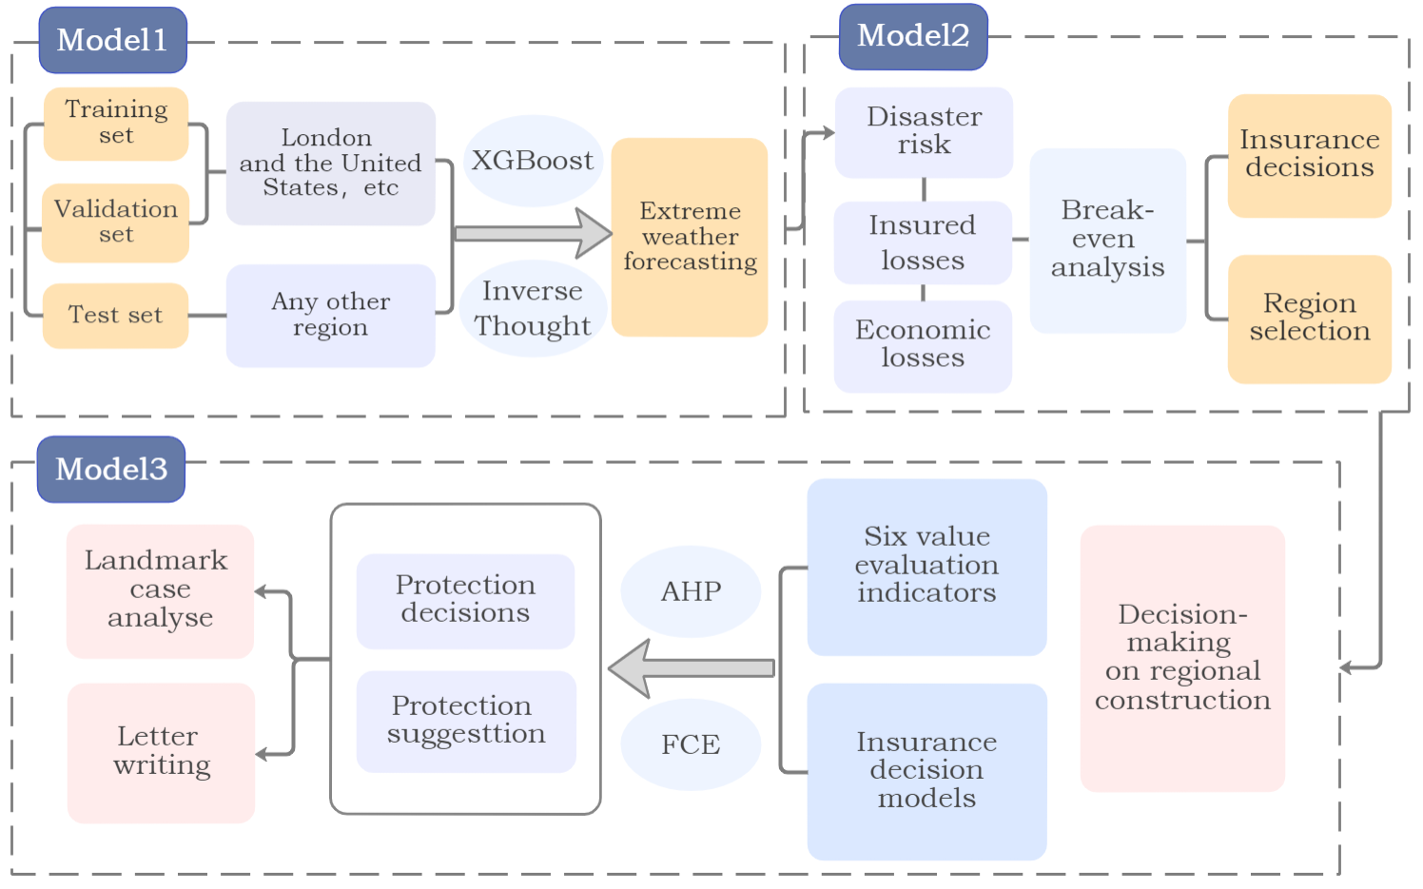
Figure 1: Model Framework

Restatement of the Problem
Assumption 1: It is assumed that only monthly maximum and minimum temperatures, precipitation, barometric pressure, relative humidity, and local historical records of extreme weather occurrences are taken into account in the prediction of extreme weather.
- Explanation: We have found through correlation studies that the frequency of extreme weather occurrences has the strongest relationship with local climate characteristics and historical disaster records, and that factors such as elevation and topography have little impact on the large regional extremes themselves, and that the model can be adjusted to solve the fitting problem.
Assumption 2: Assume that insurance costs are paid once a year and that for the same piece of business, the same amount is paid each year
- Explanation: there are many ways to pay insurance costs, and for the sake of uniformity, we chose the most common way to study.
Assumption 3: It is assumed that when extreme weather occurs, only the cost situation of insurance is considered to change, without considering other economic impacts on insurance companies and groups.
- Explanation: in order to simplify the model, we mainly consider the factors that have the greatest impact on insurance decisions.

Notations
Table 1: Notations
$$P_{Extreme}$$ | Probability of Extreme Weather
$$P_{Normal}$$ | Probability of Normal Weather
 | Predictive Probability
$$Q_{i}$$ | Amount of Insurance Claims
$$α_{i}$$ | Loss Ratio
 | Insurance Cost
 | Interest Rate

Extreme weather prediction models

Sources and processing of datasets
The frequency of extreme weather events has led to increased instability in the insurance industry. Therefore, we constructed a weather hazard prediction model to provide recommendations for insurance companies' underwriting decisions.
In order to achieve this goal, we mainly collected, organized and cleaned the historical weather data of London, UK and the US, and combined with the meteorological disaster data, simulated the correlation between weather conditions and extreme weather of the two regions in the past 8 years, so as to make an effective characterization process for the construction of the model. We further create evaluation metrics to predict the likelihood of extreme weather occurrence in the specified locations in the future. The data of climate information we used are summarized in the table below:
Table 2: Basic Weather Indicators
Object | Indicators | Description
Basic weather indicator | PRCP | Precipitation
 | TMIN | The Minimum Temperature
 | TMAX | The Maximum Temperature
 | HPa | Pneumatic
 | RH | Relative humidity

Quantification and modelling of extreme weather
To better utilize the data, we quantify the underlying climate metrics to predict weather extremes, and different extremes and levels of severity can have different impacts on property insurance. For example, different severity levels of extreme weather result in different fluctuations in property insurance costs. Overall, the frequent occurrence of extreme weather will lead to higher property insurance prices. Therefore, we use base climate indicators to predict different weather hazard scenarios and as indicators for our assessment of potential insurance claims.
Based on the above elaboration, we hope that the model can achieve the following goals:
- Predicting the frequency of unknown extreme weather events at different times, regions and climatic conditions
- Predict the types of extreme weather events that are most likely to occur in a given area, as well as their severity
- Assessing the insurance implications of the occurrence of extreme weather events
We compared XGBoost, Logistic Regression, Monte Carlo, Support Vector Machines(SVM), K-means Clustering and Random Forest. In the model comparison, we mainly use the more credible scoring method in the field of elephant classification prediction, which can be used to assess the goodness of the prediction results, as shown in the table below：
Table 3: Scoring Method
 | Predicted Positive | Predicted Negative
Actual Positive | True Positive (TP) | False Negative (FN)
Actual Negative | False Positive (FP) | True Negative (TN)
Explain with examples:
- TP is an actual storm with a predicted storm
- FP is an actual storm and no storm is predicted
- FN is no actual storm and a storm is forecasted
- TN is no actual storm and no storm predicted
Various evaluation indicators:
$$\begin{aligned}\text{Accuracy}=\frac{\text{TP + TN}}{\text{TP + TN + FP + FN}}\#\left(4-1\right)\end{aligned}$$
$$\begin{aligned}\text{Precision}=\frac{\text{TP}}{\text{TP + FP}}\#\left(4-2\right)\end{aligned}$$
$$\begin{aligned}\text{Recall}=\frac{\text{TP}}{\text{TP + FN}}\#\left(4-3\right)\end{aligned}$$
$$\begin{aligned}\text{F1}=\frac{2×\text{Precision}×\text{Recall}}{\text{Precision + Recall}}\#\left(4-4\right)\end{aligned}$$
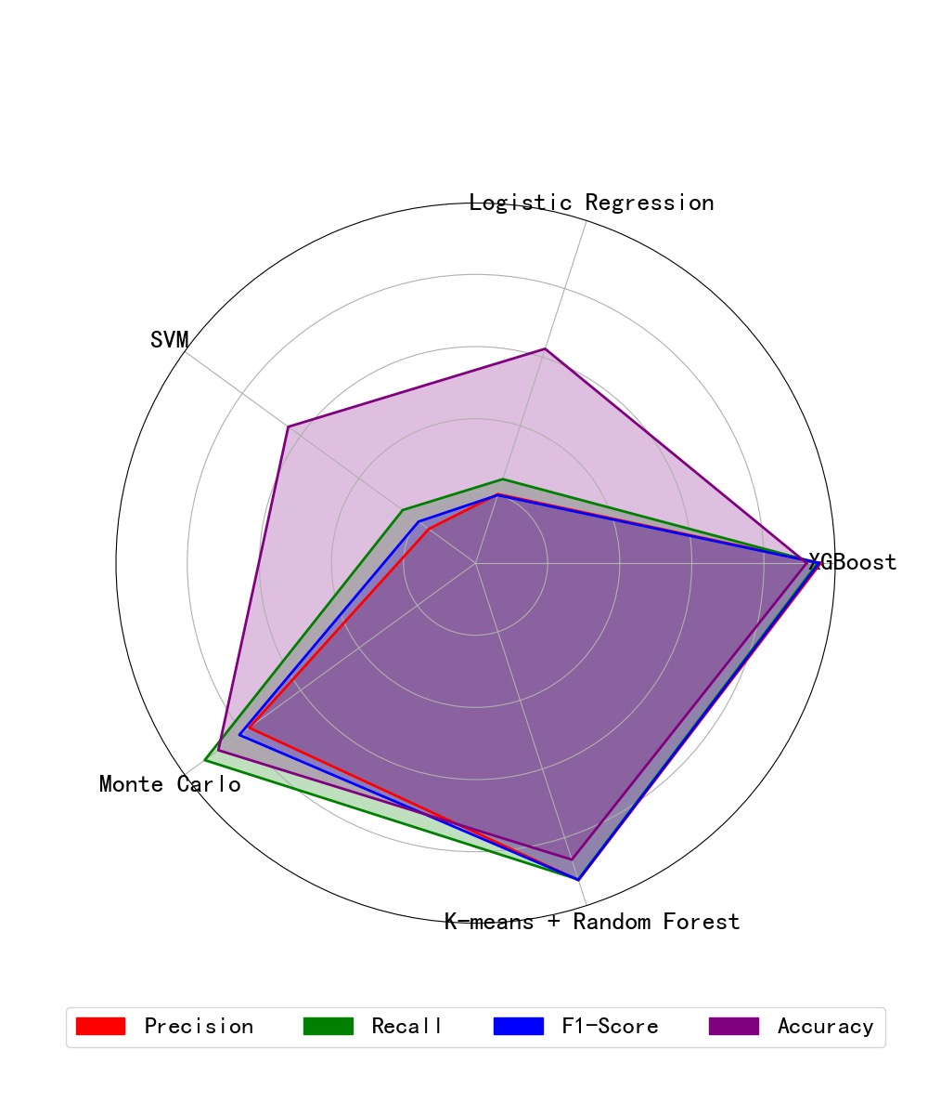
Figure 2: Comparison of Five Models
Based on the above analysis, we evaluated the five models by comparing them, and the evaluation of the five models is shown in Figure 2. We finally decided to use XGBoost to build a prediction model for extreme weather.
The XGBoost model is an integrated learning algorithm. The idea of its implementation is to optimize the loss function iteratively by reducing the residuals by integrating several weak learners and integrating them into a new model. Based on the XGBoost model, we can predict the probability $p$ of extreme weather occurring in a certain place.

Prediction based on XGBoost
In the extreme weather prediction model, we optimize the objective function of the following equation by using the gradient boosting algorithm with the training data ${(x_{i},y_{i})}_{i=1}^{n}$, where $x_{i}$ is the feature vector, which is the meteorological data, and $y_{i}$ is the corresponding target label, which is the extreme weather. The objective function consists of two parts, the loss function and the regular term. The former is used to measure the probability or error and the latter is used to adjust the model complexity, especially for overfitting cases.
$$\begin{aligned}\text{Objective}\left(θ\right)=L\left(θ\right)+Ω\left(θ\right)\#\left(4-5\right)\end{aligned}$$
Considering that extreme weather is multi-categorical, we adopt a multi-categorical approach using logarithmic losses:
$$\begin{aligned}L\left(θ\right)=-\frac{1}{n}\sum_{i=1}^{n}{\sum_{k=1}^{K}{y_{ik}}}\text{log}\left(p_{ik}\right)\#\left(4-6\right)\end{aligned}$$
where $y_{i}$ is the true extreme weather category label for local climate sample $i$, $p_{i}$ is the model's $k$-category prediction probability for sample $i$, and $y_{ik}$ is an indicator function of whether sample $i$ belongs to category $k$ or not. The loss function measures the difference between the model's prediction for each weather data sample and the actual situation; the smaller the log loss, the better the model fits the data.
$$\begin{aligned}Ω\left(θ\right)=γT+\frac{1}{2}λ\sum_{j=1}^{T}{w_{j}^{2}}\#\left(4-7\right)\end{aligned}$$
In Eqs. (4-7), T is the number of leaf nodes of the tree, $w_{i}$ is the weight of the $j$th leaf node, which makes the results of disaster occurrence predicted by the base model more reliable, and γ and λ are hyperparameters of the regularization term.
During training, an updated $f$ function is added at each new round of training as described above to minimize its objective function, and when the training reaches the $t$th round, the algorithmic function of this study is shown in the following equation:
$$\begin{aligned}\left\{\begin{matrix}{\text{Objective}}_{t}\left(θ\right)=L_{t}\left(θ\right)+Ω_{t}\left(θ\right) \\ L_{t}\left(θ\right)=-\frac{1}{n}\sum_{i=1}^{n}{\sum_{k=1}^{K}{y_{ik}}}\text{log}\left(p_{ik}^{\left(t\right)}\right) \\ Ω_{t}\left(θ\right)=γT_{t}+\frac{1}{2}λ\sum_{j=1}^{T_{t}}{w_{j}^{2}}\end{matrix}\right.\#\left(4-8\right)\end{aligned}$$
The optimization process of the overall objective function uses a gradient boosting algorithm to iteratively optimize the loss function and regularization term to finally obtain the extreme weather conditions predicted by the overall model.

Innovative Modeling Strategies
With the XGBoost model, we can effectively predict the types of local extreme weather occurrences and the frequency of occurrence of various extreme weather types.
In order to have a more intuitive picture of how often extreme weather occurs in a region, we envisioned a probability calculation of extreme weather types with their weights. The idea of this algorithm is to assign a weight to each extreme weather type, and then calculate the total probability of extreme weather occurrence based on these weights and the corresponding probability values. If we have $n$ extreme weather types, for each of which we have a probability $p_{i}$ and a weight $w_{i}$, so that the probability of an extreme weather event can be expressed as follows:
$$\begin{aligned}P_{Extreme}=\sum{i}=1^{n}w_{i}·p_{i}\#\left(4-9\right)\end{aligned}$$
Where the weights $w_{i}$ need to be derived by some means (e.g., expert evaluation or data analysis). However, due to the poor interpretability of this idea and the complexity of the implementation. Therefore, we propose another algorithmic idea in this regard: the Complementary number and weight adjustment based on the probability of normal weather conditions. This algorithm considers the probability of normal weather types and performs complementary operations to estimate the probability of extreme weather. If the probability of normal weather is $P_{Normal}$, the probability of extreme weather, $P_{Extreme}$, can be calculated by complementing the probability of normal weather and multiplying it by a weight hyperparameter-$w$, obtained from a grid search:
$$\begin{aligned}P_{Extreme}=w·\left(1-P_{Normal}\right)\#\left(4-10\right)\end{aligned}$$
Assuming that the model predicts the probability of normal weather as $P_{Normal}$, according to the above formula, we can calculate the probability of extreme weather occurrence. The advantage of this method is that it is simple and straightforward, easy to implement, and at the same time, it can be well adapted to different datasets and prediction tasks by adjusting the weight hyperparameters.
Now, if we have a specific $P_{Normal}$ value, we can directly calculate the probability of extreme weather occurrence.
For further consideration: we add an $L_{2}$ regular term to this to adjust the calculation of the probability of extreme weather occurrence, in order to control the size of the weighting parameter w, so as to avoid overfitting. With the addition of the $L_{2}$ term, our goal is to minimize the loss function containing the $L_{2}$ term, which is usually of the form $λ·‖w‖2^{2}$, where λ is the strength parameter of the regularization, and $‖w‖2^{2}$ is the $L_{2}$ parameter of the weight $w$(i.e. $w^{2}$). Therefore, the algorithm-tuned objective function can be expressed as minimizing the loss of the following form. The final optimization formula is as follows:
$$\begin{aligned}loss=-\left[w·\left(1-P_{Normal}\right)\right]+λw^{2}\#\left(4-11\right)\end{aligned}$$
It is important to note that "loss" here is a term used for descriptive purposes, but we are actually calculating the probability of extreme weather conditions occurring. The regular term is added primarily to control the size of $w$, not to minimize the loss function in the traditional sense. However, if we think in terms of optimization, we can adjust the value of λ to balance the complexity of the model and the fit to the training data.
Therefore, after considering $L_{2}$ regularization, the calculation of the probability of extreme weather occurrence can be adjusted by analytical method or numerical optimization method to adjust the $w$-value to achieve a more robust model performance. This approach can improve the generalization power of the model, reduce the risk of overfitting, and make the model perform better on untrained data.

Demonstration of a predictive model based on the USA
In order to demonstrate the mechanism of extreme weather prediction models more intuitively, we collected climate data, types of extreme weather, and records of extreme weather occurrences for the U.S. region from 2000 to 2020 as an example. We predicted the types of extreme weather in the U.S. and evaluated the frequency of extreme weather occurrence. Then, through the complementary number thinking strategy, we finally derived the frequency of extreme weather occurrence in the U.S. each year. The results obtained are highly consistent with the actual situation, as shown in Fig. 3.
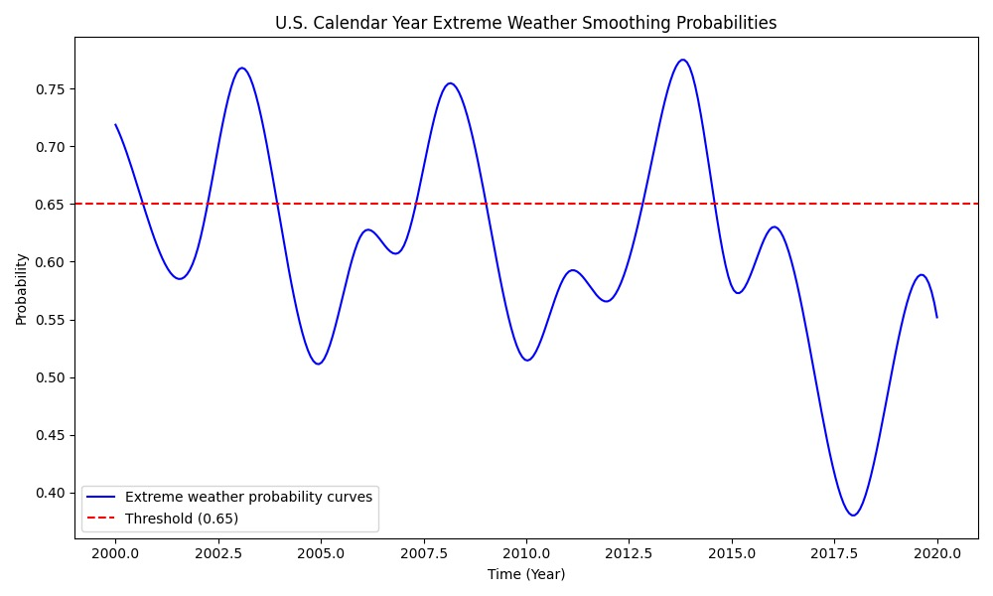
Figure 3: Extreme Weather Forecasts for the United States
The model's predictions allow us to effectively understand the frequency of extreme weather in the U.S. and apply it to insurance decision-making activities.

Insurance decision models

Establishment of insurance decision-making mechanism and model
Risk ^{[6]} is the uncertainty between investment and return in a future period. Based on the XGBoost model, we can predict the probability $p_{i}$ of extreme weather in a certain place. However, this is obviously not enough to help insurance companies make insurance decisions.
Therefore, in order to further measure the willingness of insurance companies to take risks, we define the average insurance payout amount $Q_{ac}$ per year in the region and obtain the potential insurance payout amount $Q_{i}$ for the specified location.
$$\begin{aligned}Q_{i}=p_{i}·Q_{ac}\#\left(5-1\right)\end{aligned}$$
Considering that risk prediction should involve a time factor, we equate the risk assessment period to the insurance contract period, which is $t$ years. At the same time, due to the variability between regions, we set the insurance claim rate of the region as $α_{i}$ and the insurance cost of the region for one year as $y_{i}$.
$$\begin{aligned}y_{i}=\left(1-α_{i}\right)·Q_{i}=\left(1-α_{i}\right)·p_{i}·Q_{ac}\#\left(5-2\right)\end{aligned}$$
Since the term of the insurance contract may be greater than one year, we further consider the time value of money in conjunction with the compound present value formula. where the interest rate in the specified area is $i$.
Combining the above analyses, we obtain the insurance income of the insurance company in year $t$ as $Y_{i}$:
$$\begin{aligned}Y_{i}=\sum_{t=1}^{t}{\frac{c_{t}}{{\left(1+i\right)}^{t-1}}}=\sum_{t=1}^{t}{\frac{\left(1-α_{i}\right)·p_{i}·Q_{ac}}{{\left(1+i\right)}^{t-1}}}\#\left(5-3\right)\end{aligned}$$
Meanwhile, the insurance company's total operating costs in year $t$ are $C_{i}$ and other operating costs are $C_{0}$.
$$\begin{aligned}C_{i}=C_{0}+\sum_{t=1}^{t}{\frac{α_{i}·p_{i}·Q_{ac}{\left(1+i\right)}^{t-1}}{{\left(1+i\right)}^{t-1}}}=C_{0}+\sum_{t=1}^{t}{α_{i}·p_{i}·Q_{ac}}\#\left(5-4\right)\end{aligned}$$
Final decision conditions:
$$\begin{aligned}\left\{\begin{aligned}Y_{i}≥C_{i} Accept \\ Y_{i}<C_{i} Refuse\end{aligned}\right.\#\left(5-5\right)\end{aligned}$$

Break-even analysis
To further explore the factors influencing insurance assumptions, in a given year we assume that revenues $y$ and costs $c$ are equal. $(1-α_{i})·p_{i}·Q_{ac}=c_{0}+α_{i}·p_{i}·Q_{ac}$. we obtain a break-even insurance payout rate of $α^{*}$.
$$\begin{aligned}α^{*}=\frac{c_{0}}{2p_{i}·Q_{ac}}-\frac{1}{2}\#\left(5-6\right)\end{aligned}$$
The larger the value of $α^{*}$, which is the insurance payout ratio at break-even, the greater the ratio of local insurance claims to insurance costs. The local resilience of insurance companies to risk can be enhanced by improving the guidelines for terms and conditions.
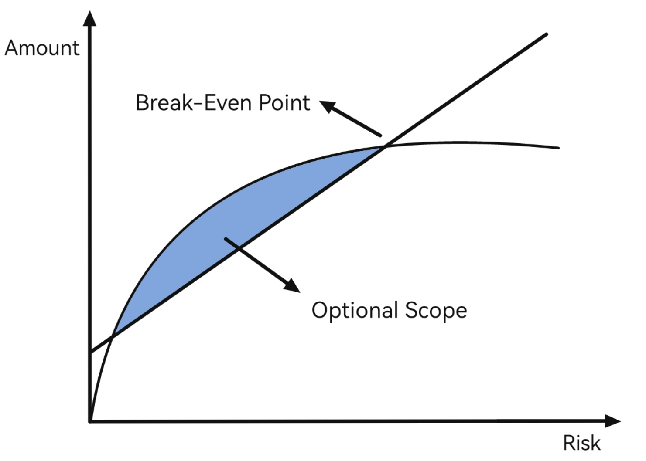
Figure 4: Break-even Point

Model demonstration: Henan Province, USA
Insurance Decision Making Presentation
An insurance decision model can help an insurer determine whether to underwrite a policy in a given city. We will use Henan Province as an example. Through the extreme weather prediction model, we predict the types of extreme weather in the local area and the frequency of occurrence of different types. Then, through the optimization strategy of the complementary weighted parameter idea, we get the probability of extreme weather^{[7]} occurring in Henan Province as $p_{i}$. After calculation and evaluation:
Average insurance revenue $Y_{i}=p_{i}·1.638×{10}^{9}$ average cost $C_{i}=p_{i}·2.457×{10}^{9}$.The results indicate that insurance compensation is likely to be greater than insurance revenue in this location, making the insurance company more economically risky. Therefore, we do not recommend insurance companies to underwrite policies in Henan Province. To make the decision more accurate, the insurance company can decide whether it chooses to underwrite policies in the locality, taking into account the company's other sources of income and costs and expenses.
Insurance Site Selection Presentation
The insurance decision model can also help insurance companies to make location decisions and make optimal address choices in a wide range of areas. Let's take the United States as an example, with the following indicators related to insurance:
Table 4: U.S. Insurance Indicators
$$indicators$$ | $$estimated value$$
loss Ratio Compensation rates $\left(α\right)$ | $$76\%$$
Average Insured losses$(Q_{ac})$ | $$6.7×{10}^{10}$$
Discount rate of funds$\left(i\right)$ | $$5\%$$
Through extreme weather forecasting, and insurance decision-making model evaluation, we have used the ArcGIS mapping tool GeoPandas to create a diagram, which will be useful for advising insurance companies on insurance decisions.
Through the following diagram, we can clearly understand the differences in insurance risks in different regions. The southeastern region of the United States has the highest frequency of extreme weather, the larger the potential insurance claims, and the lower the recommendation index for underwriting policies.
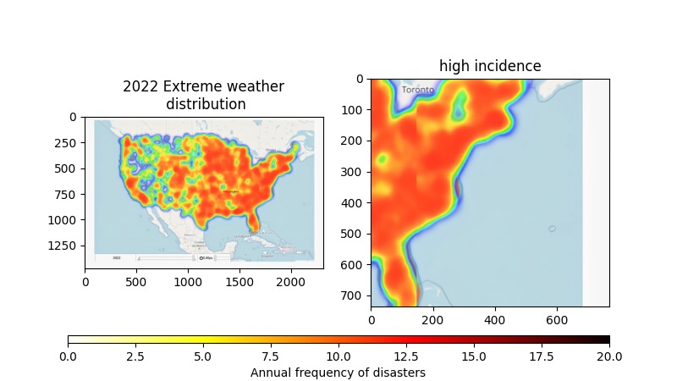
Figure 5: Regional Risk Differences in the United States

Model application
Construction Site Selection
Communities and property developers should consider social value for growing communities and populations in addition to basic insurance affordability when building places. Therefore, on top of the original insurance decision-making model, we should also consider local values such as history, culture and ecology. We should further analyze the weighting of the different influencing factors. As a result, the insurance decision model is improved to obtain the community building decision model as follows.
We obtain the community's overhead in year $t$ as $Y^{*}$, consisting of the insurance overhead and other overhead $Y_{1}$:

$$\begin{aligned}Y_{i}=Y_{1}+\sum_{t=1}^{t}{\frac{\left(1-α_{i}\right)·p_{i}·Q_{ac}}{{\left(1+i\right)}^{t-1}}}\#\left(5-7\right)\end{aligned}$$

$$\begin{aligned}Y_{1}=\sum_{i=1}^{{Num}_{factor}}{{Indicator}_{i}·w_{i}}\#\left(5-8\right)\end{aligned}$$
At the same time, the total income of the community in year $t$, $C$, consists of insurance compensation received and other income $C_{1}$:
$$\begin{aligned}C_{i}=C_{1}+\sum_{t=1}^{t}{α_{i}·p_{i}·Q_{ac}}\#\left(5-9\right)\end{aligned}$$
$$\begin{aligned}C_{1}=\sum_{i=1}^{{Num}_{factor}}{{Indicator}_{i}·w_{i}}\#\left(5-10\right)\end{aligned}$$
Both $C_{1}$ and $Y_{1}$ are determined by the weights of each influencing factor. Finally, the comparison between $Y_{1}$ and $Y_{1}$ can be used to decide whether or not to build a community at the site.
Construction proposals
In the prediction of extreme weather based on the XGBoost model, we can predict the types of extreme weather that are most likely to occur in a given location, and construction in different areas can be improved to take into account the types of hazards, so that disaster preparedness can be achieved and possible property damage can be reduced. Overall, in areas with a high frequency of extreme weather, communities and real estate developers can consider adopting disaster-resistant building designs to ensure that new buildings are more resistant and sustainable in the face of extreme weather events. Figure 6 presents recommendations for building in areas where common types of disasters occur.
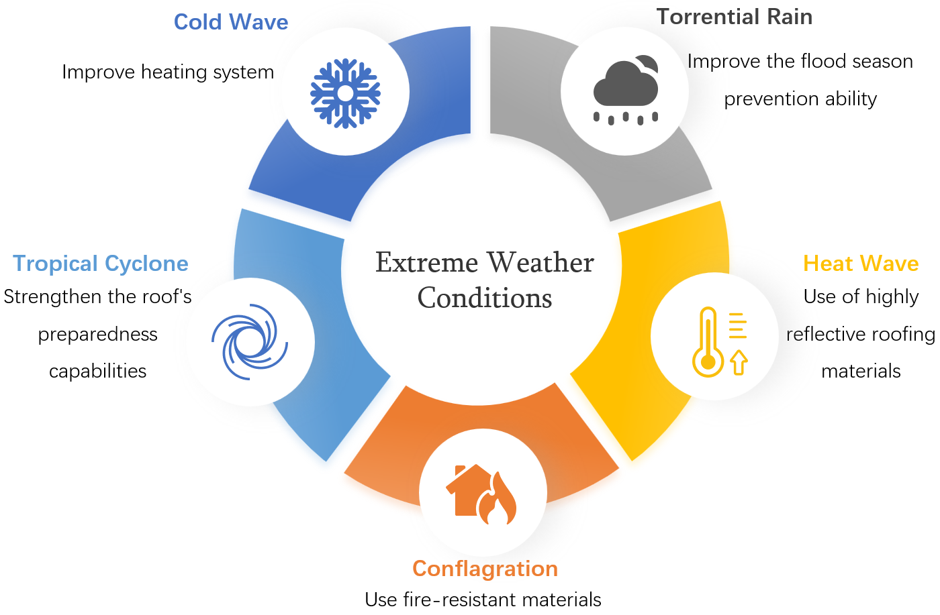
Figure 6: Construction Proposals

Community Conservation Model

Application of PCE and AHP models
In addition to the insurance decision model, we also build a community preservation model to assess the value of the community.
First, determine the factor set. The factor set^{[8]} is a general set composed of various factors that affect the evaluation object. We use history, culture, military, economy, government, and ecology as our evaluation indicators.
$$\begin{aligned}U=\left\{u_{1},⋯{,u}_{i}\right\}\#\left(6-1\right)\end{aligned}$$
Secondly, determine the set of comments. The comment set^{[8]} is a set composed of various results that evaluators may make on the evaluation object. The evaluation criteria are excellent, good, and average.
$$\begin{aligned}V=\left\{v_{1},⋯{,v}_{i}\right\}\#\left(6-2\right)\end{aligned}$$
Next, determine the fuzzy comprehensive evaluation matrix:
$$\begin{aligned}R=\left(\begin{matrix}u_{1}v_{1} & ⋯ & u_{1}v_{j} \\ ⋮ & ⋱ & ⋮ \\ u_{i}v_{1} & ⋯ & u_{i}v_{j}\end{matrix}\right)\#\left(6-3\right)\end{aligned}$$
Then, determine the weight of each indicator. Since historical, cultural, military, economic, governmental, and ecological data are subjective and diverse, it is difficult and incomplete to directly present them, so we choose the analytic hierarchy process.
First, construct the judgment matrix. In other words, based on a two-by-two comparison of the elements with each other, the weight of each criterion layer on the target layer is determined. We use Santy's 1-9 scale method^{[9]}.
Table 5: Scale Method of Santy
Value | Meaning
1 | Both are equally important
3 | The former is slightly more important than the latter
5 | The former is significantly more important than the latter
7 | The former is extremely important than the latter
9 | The former is more strongly important than the latter
2,4,6,8 | Expresses the median value of the above adjacent judgments
The reciprocal of 1~9 | Indicates the importance of comparing the exchange order of the corresponding two elements

Set the matraix:
$$\begin{aligned}A={\left(a_{ij}\right)}_{m×n}=\left(\begin{matrix}a_{11} & ⋯ & a_{1n} \\ ⋮ & ⋱ & ⋮ \\ a_{m1} & ⋯ & a_{mn}\end{matrix}\right)\#\left(6-4\right)\end{aligned}$$
Where the constraints on matrix are:
$$\begin{aligned}\left\{\begin{aligned}a_{ij}>0 \\ a_{ij}=\frac{1}{a_{ji} } \\ a_{ii}=1 \end{aligned}\right.\#\left(6-5\right)\end{aligned}$$
Next, follow the row elements of the matrix to the product and then to the power of $\frac{1}{n}$ :
$$\begin{aligned}{\vec{W}}_{i}=\sqrt[m]{\prod_{j=1}^{m}{a_{ij}}}\#\left(6-6\right)\end{aligned}$$
Normalizing $W$(so that the sum of the elements in the vector equals 1) is the sorting power vector, denoted as $W$(The elements of $W$ are the ranked weights of the factors at the same level concerning the relative importance of a factor at the previous level), like that:
$\begin{aligned}W={\left(W_{1},W_{2}⋯W_{n}\right)}^{T}\#\left(6-7\right)\end{aligned}$
$\begin{aligned}w_{i}=\frac{\vec{w_{i}}}{\sum_{j=1}^{m}{\vec{w_{j}}}}\#\left(6-8\right)\end{aligned}$
That is, calculate the weight of each indicator:
$$\begin{aligned}\vec{w_{i}}=\left(w_{1},⋯,w_{n}\right)\#\left(6-9\right)\end{aligned}$$
It is the requested eigenvector, which is also the result of the hierarchical single ordering of the judgment matrix.
Next, after obtaining the weights of the indicators, perform a fuzzy synthesis of judgments, that is:
$$\begin{aligned}B=\vec{w_{i}}·R\#\left(6-10\right)\end{aligned}$$
Finally, through a fuzzy synthesis operator of the weighted average type, the final expression of the fuzzy synthesis judgment is determined as:
$$\begin{aligned}B=\left(w_{1}u_{1}v_{1}+⋯+w_{n}u_{i}v_{1},⋯,w_{1}u_{1}v_{j}+⋯+w_{n}u_{i}v_{j}\right)\#\left(6-11\right)\end{aligned}$$

Case Study: Hurst Castle is disappearing
Selection of the case
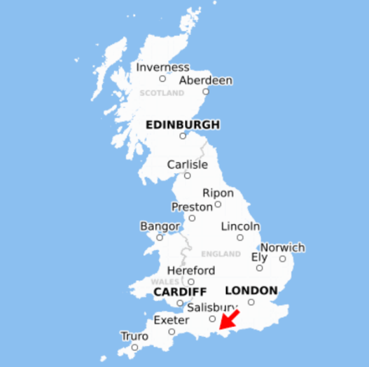
To demonstrate the community preservation model, Hurst Castle^{[10]} in the United Kingdom is selected as a landmark for our study. As the problem of global warming increases, the sea level is rising. Hurst Castle, which is located in the coastal area, faces great challenges. We will assess the local area by using extreme weather prediction models and community preservation models. Predicting the frequency and type of extreme weather in the local area in the future, as well as making judgments about the value of the community. Next, we provide conservation advice and future options for the local area in the form of a letter.
Figure 7 Location of Hurst Castle
Firstly, we predict the local weather extremes, and below is a map of the three hazard timescales for Salisbury. From Figure 8 we can see that Hurst Castle has a high frequency of extreme weather, with the main type being cold waves.
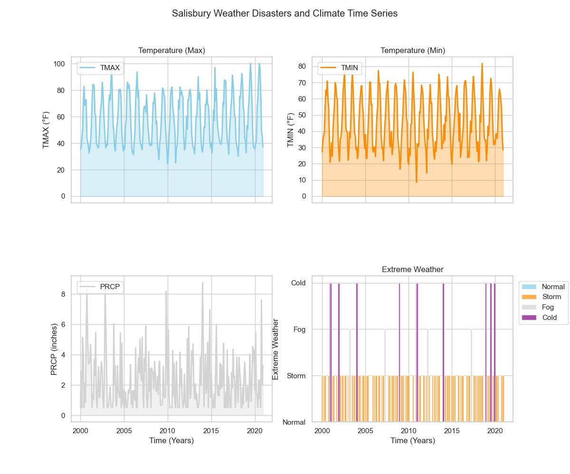
Figure 8: Salisbury Weather Disasters and Climate Time Series
Next, we further assess the social value of Hurst Castle ^{[11]} in the following ways.
- Historical value: it represents an important part of Britain's defense in the 16th century against the invasions of France and the Holy Roman Empire in the 16th century. The castle also played an important role in the English Civil War. The history of its construction and alteration records the development of Britain's military defense and historical events. The history of its construction and alteration records the development of Britain's military defenses and historical events.
- Cultural value: Hurst Castle has significant cultural and heritage value as part of the English Heritage. Value. It represents Britain's historical and cultural heritage and the castle's architecture and military fortifications reflect the architectural techniques and styles of the time. The castle's architecture and military fortifications reflect the building techniques and styles of the time and are a symbol of community identity and status.
- Military value: As a fire fortress, Hurst Castle has significant military value. Its military construction and modernization of the fortifications demonstrate the development of British military strategy and technology over time. It is the first system of sea defenses since the Roman period. The construction and subsequent modernization extension of the castle reflect its strategic location.
- Economic value: As a tourism resource, it receives 40,000 tourists annually, which drives the local tourism industry and promotes economic development.
- Ecological value: the immediate vicinity of the castle has important salt, brackish, and freshwater habitats supporting a large number of wild birds.
- Government backing: The British government has invested heavily in the restoration and refurbishment of the castle on several occasions, which highlights the importance the British government places on the castle.
Demonstration of the Community Preservation Model
Based on the value of the castle, we determine the fuzzy comprehensive judgment matrix and the judgment matrix:
Table 6: Evaluation Matrix
 | Excellent | Good | Fair
History | 0.8 | 0.15 | 0.05
Culture | 0.75 | 0.2 | 0.05
Military | 0.9 | 0.07 | 0.03
Economy | 0.6 | 0.25 | 0.15
Government | 0.5 | 0.3 | 0.2
Ecology | 0.8 | 0.2 | 0

Sensitivity Analysis
The data is constructed by using a feature process before the model is built, but the time (year, month) and location (latitude and longitude) data are not normalized or normalized. Therefore, to conduct a sensitivity analysis of the model for this file, we analyze the local sensitivity of regional differences and period variations (which should be accurate) and attempt to compare one feature with another (which should be inaccurate). At last, we find that the model predictions are in line with the expectations, as shown in the following analysis:
- Choose the local sensitivity of the same characteristic data from 2012 to 2018 in the Miami area.
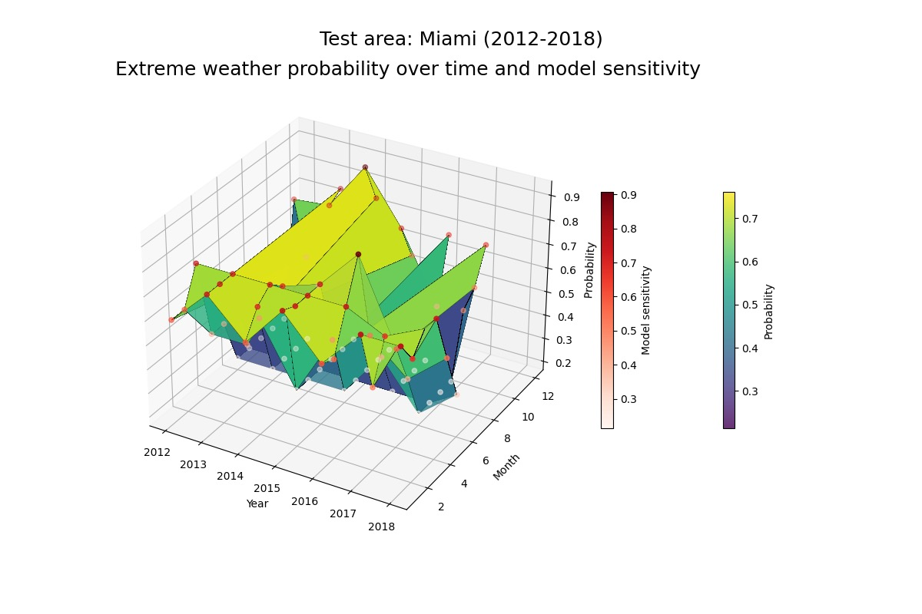
Figure 9: Sensitivity Analysis (Miami)
This site selected is to show whether the generalization ability of the model is strong enough. In the end, the results of the model are consistent with the actual meteorological disaster situation in the Miami area. Only a small number of predictions are biased.
- Choose the local sensitivity of the same characteristic data from 2020 to 2023 in the Norman area.
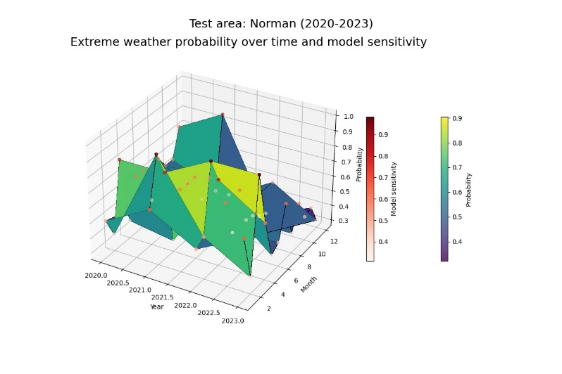
Figure 10: Sensitivity Analysis (Norman)
We sample the most recent four years of data for the local region, which is a sign of the robustness of the model's predictions for the future, and it is clear that the model predicts even better than the validated data.
- Choose the highest temperature (TMAX) in the Boulder region for comparison of replacement data.
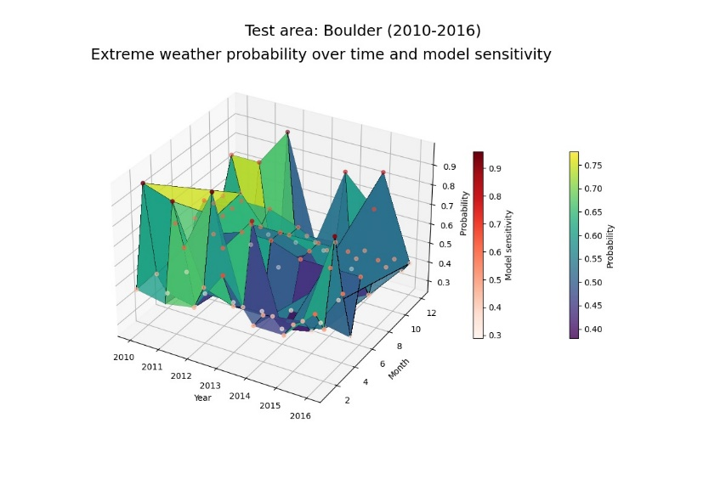
Figure 11: Sensitivity Analysis (Boulder)
To consider the overfitting of the model and the basic assumptions, we filter the climate data in the Boulder area, replace the maximum temperature (TMAX) in the climate indicator with the altitude data, carry out the same feature engineering, and apply it to the model, and find that the accuracy of the final prediction result is only 0.53, and the probability of predicting extreme weather doesn’t seem to be consistent with the trend of the time series. Therefore, the model has no overfitting phenomenon and has excellent robustness. Through the above three different analyses, we can be sure that the overall construction based on the model is realistic and in line with the basic assumptions, which plays an important role in the whole process.

Strengths and Further Discussion

Strengths
- Quantitative meteorological hazard risk assessment indicators
The model can further calculate the probability of meteorological disasters by quantitatively predicting different types of extreme weather. This approach not only makes forecasting more specific and actionable, but also provides strong support for the combination of insurance and risk sharing. The final quantitative assessment of insurance can more accurately predict insurance risks under different conditions, including region, time, and climate, to provide reliable decision-making recommendations for insurance companies.
- A holistic model with explainability.
Whether it is based on the prediction of different extreme climate types based on XGBoost or the optimization strategy based on the idea of compensating for weighted parameters, the total meteorological disaster probability prediction model of the improved algorithm shows strong interpretability. This allows the model's predictions to be clearly interpreted and understood, providing decision-makers with more intuitive information. At the same time, it also enhances the generalization ability of the model in actual climate conditions, so that it can be effectively applied in different scenarios.
- Insurance appraisals are realistic
When assessing insurance risks, several key factors are taken into account to truly meet the actual needs of the insurance industry. Enabling decision-makers to better respond to a variety of meteorological disaster scenarios and better meet the real-world challenges of the insurance industry
- Combination of economic benefits and social values
In the process of building the model, we not only help the insurance industry achieve sustainable economic benefits through extreme weather prediction, but also pay attention to community development in the context of extreme weather and establish a community preservation model.

Further Discussion
- Complexity of the natural environment
The diversity of the natural environment, which includes a variety of meteorological, topographical, and other geographical factors, so it makes the complexity of assessing insurance risk inevitable. While we have succeeded in distilling this complexity into a few key indicators and types of hazards, which have been validated by the science of physical geography, it is still difficult to fully cover all variables of the natural environment. This may lead to an incomplete assessment of meteorological hazards in some cases.
- Assessment Limitations for Special Insurance Types
Due to the broad coverage of insurance types, models may not adequately assess the specific insurance needs of individual industries. While we have collected statistics on the insurance landscape across regions, while providing a quantifiable basis for building models, they may not accurately reflect the risks and needs of certain specific types of insurance (e.g., manufacturing, which may be more vulnerable to natural disasters or supply chain disruptions). In this regard, the applicability of the model may be limited.
- The uncertainty of the damage to the insurance industry itself
Models may be uncertain in their assessment of the damage caused by extreme weather conditions to the insurance industry itself. Due to the complexity and randomness of extreme weather events, it is difficult to accurately predict the actual economic losses they will cause to the insurance industry. This uncertainty may affect the accuracy and reliability of the model in some scenarios.aa

Our Letter
Dear Ladies and Gentlemen:
It is an honor to write this letter. With the frequent occurrence of extreme weather, Hurst Castle is facing great challenges. Therefore, I will provide preservation advice and recommend future plans for this precious landmark.
Protection recommendations：
- We can establish a partnership with a local insurance company to develop an insurance program that is appropriate for our landmark buildings.
- Repairing deteriorated, broken or damaged portions in a timely manner reduces the cost of future repairs and avoids future situations that would require greater costs to repair.
- Strengthen cooperation with the government to obtain financial support from the government.
- Encourage local residents to obtain financial support through fundraising and charity events.
Future Plans for Precious Landmarks:
- Increase funding and adopt disaster-resistant building designs.
- Develop a plan to protect the surrounding ecological environment, effective management of the environment, to a certain extent, can reduce the impact of natural disasters on the landmark.
- Find a reliable insurance company, establish a long-term and effective relationship with them.
I sincerely hope that my suggestions and plans will work. Thank you for your valuable time.
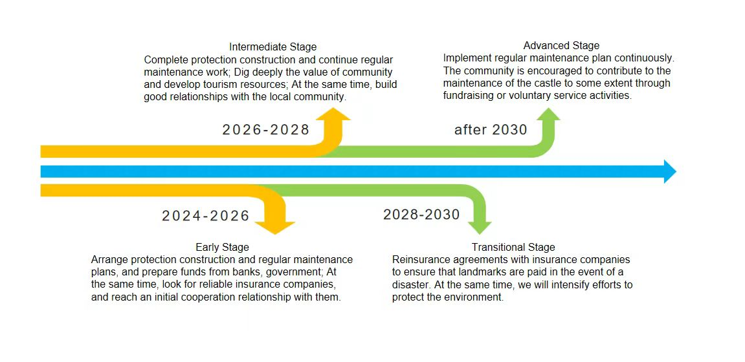
Sincerely.
Team #2426183

References
[1] https://www.munichre.com/en/company/media- relations/media-information-and-corporatenews/media-information/2022/natural-disaster-losses- 2021.html
[2] National Oceanic and Atmospheric Administration, United States (noaa.gov)
[3]https://www.worldweatheronline.com/london-15day-weather-chart/city-of-london-greater-london/gb.aspx
[4] https://tianqi.2345.com/inter_history/europe/london.htm
[5] Li Xiangling, Chen Xianxian, Chen Xijuan. Prediction of atrazine degradation in soil based on XGBoost model [J/OL] Chinese Journal of AppliedEcology:1-10[2024-02-05].https://doi.org/10.13287/j.1001-9332.202403.016.
[6] Risks - MBA Think Tank Encyclopedia (mbalib.com)
[7] https://tianqi.2345.com/wea_history/53898.htm
[8] Wu Ting, Zhang Ying. Based on AHP- Research on the evaluation of the efficiency of public service facilities based on fuzzy comprehensive evaluation method——Take Xiaojiafang Town as an example [J]. Architecture & Culture,2023(11):80-82.DOI:10.19875/j.cnki.jzywh.2023.11.026.
[9] Chunan A ,Feidong F . A Supplement to Saaty's Consistency Theory of Judgment Matrix in the Analytic Hierarchy Process[C]//Taiwan University,University of Malaya,Huazhong University of Science and Technology.Conference Proceedings of 2017 3rd IEEE International Conference on Control Science and Systems Engineering (ICCSSE).IEEE Press,2017:5
[10] https://www.archiposition.com/items/024d39a3f4
[11] https://www.english-heritage.org.uk/visit/places/hurst-castle/history/significance/

