**Design Documentation**

**Code Changes Over Time**

These Line Graphs depict the activity of a given repository over time according to the number of commits it sees. The user can select between a yearly overview and a weekly breakdown.

**Yearly:**

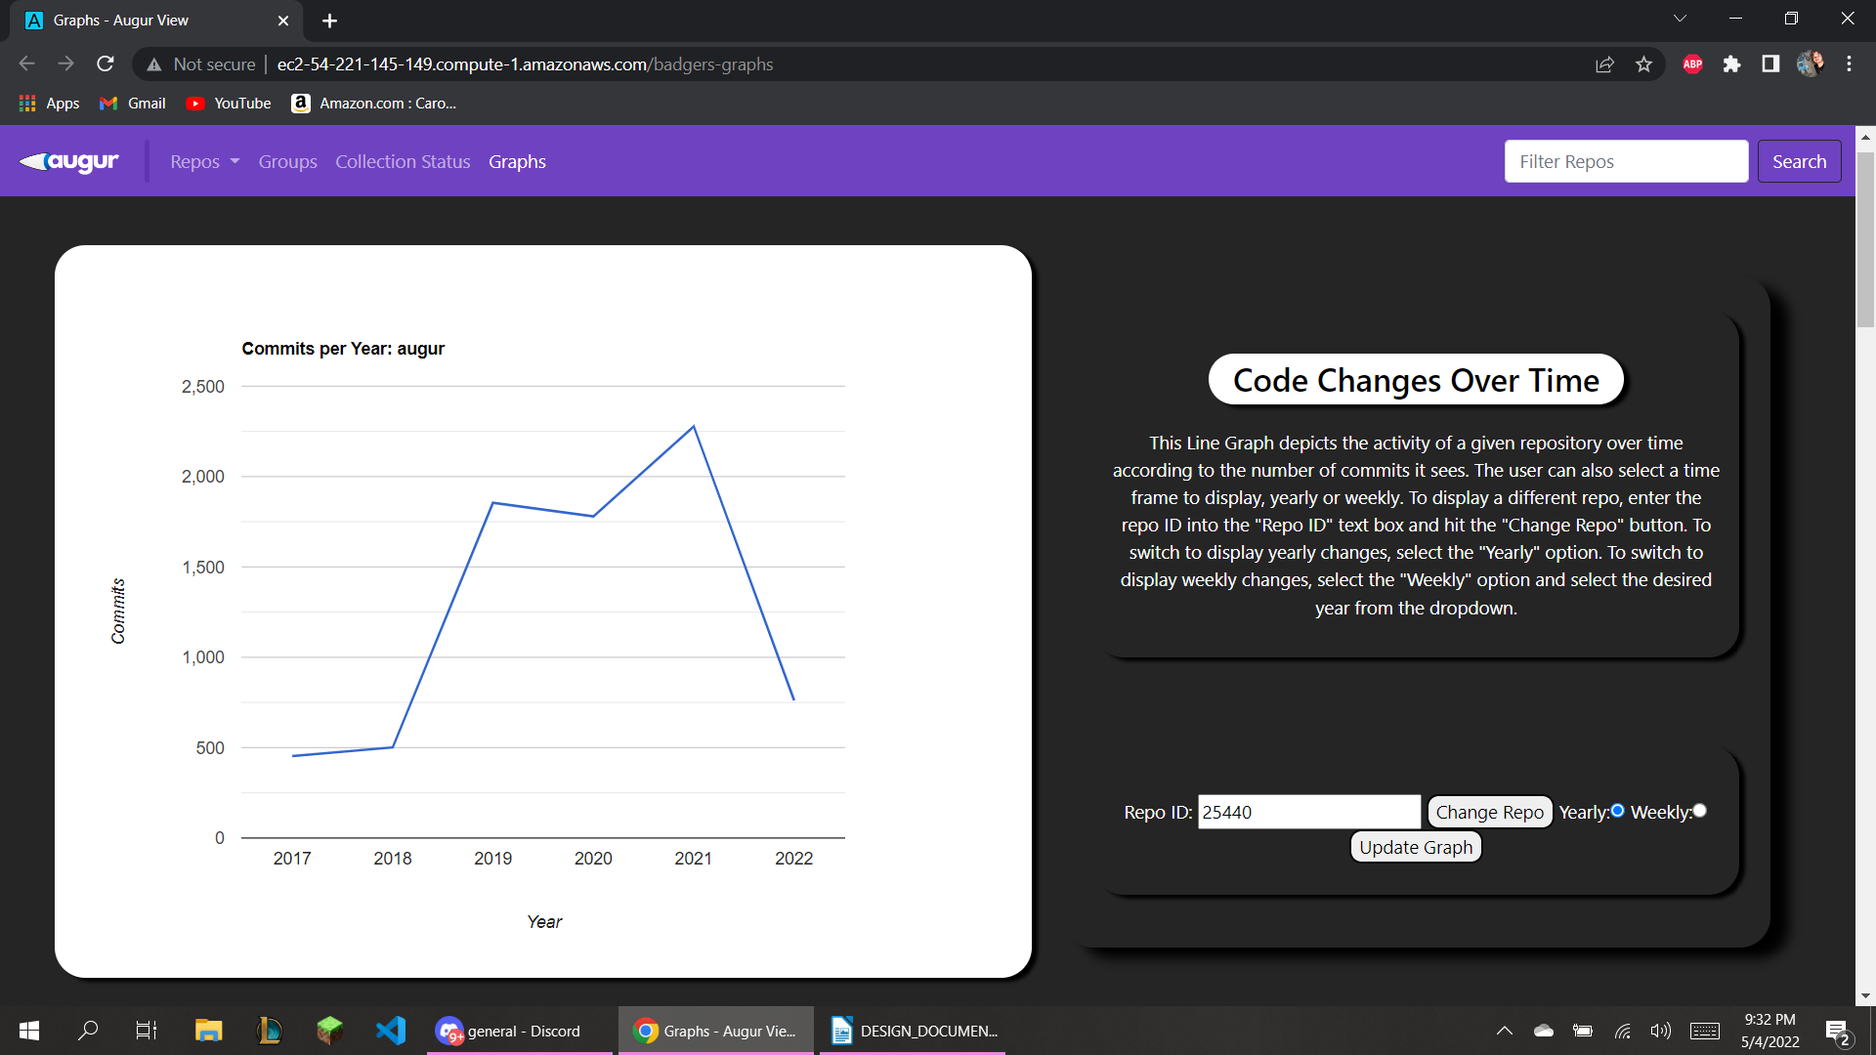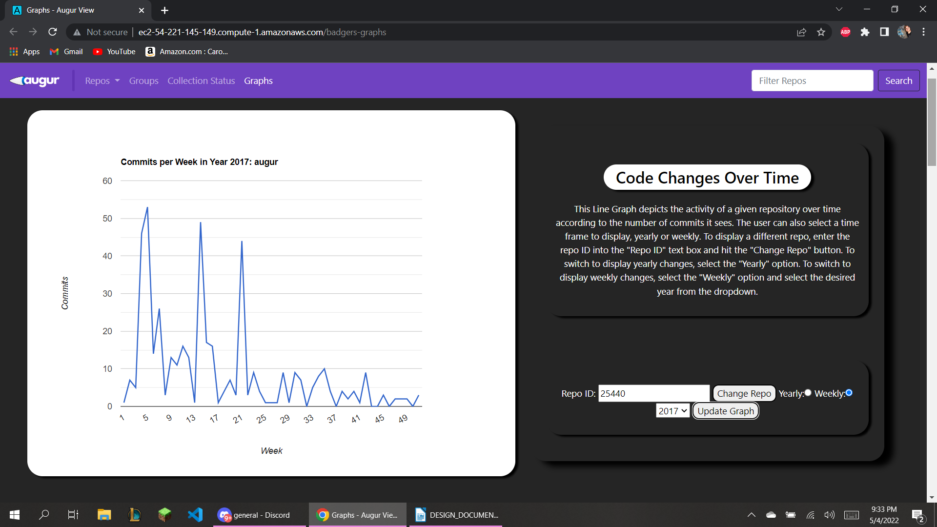 **Weekly:**

**Commits by Repository Group**

This Bar Graph separates the repositories of a repository group into columns showing how may commits each one has received. The user can view the repo group using its corresponding ID

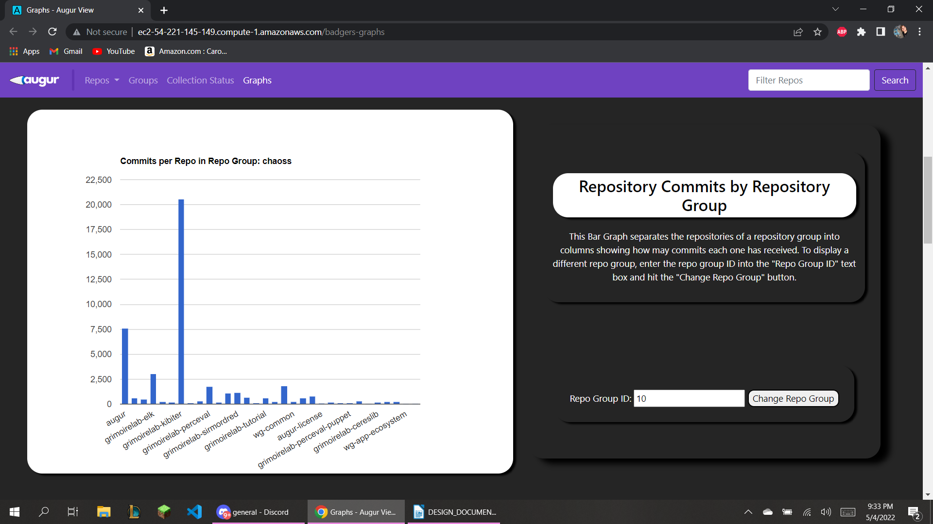

**User Contribution Chart**

This Pie Chart shows what percentage of contributions, each user within the repository has participated in. These contributions include commits, comments, issues, and pull requests. The user can select which repo they wish to view.

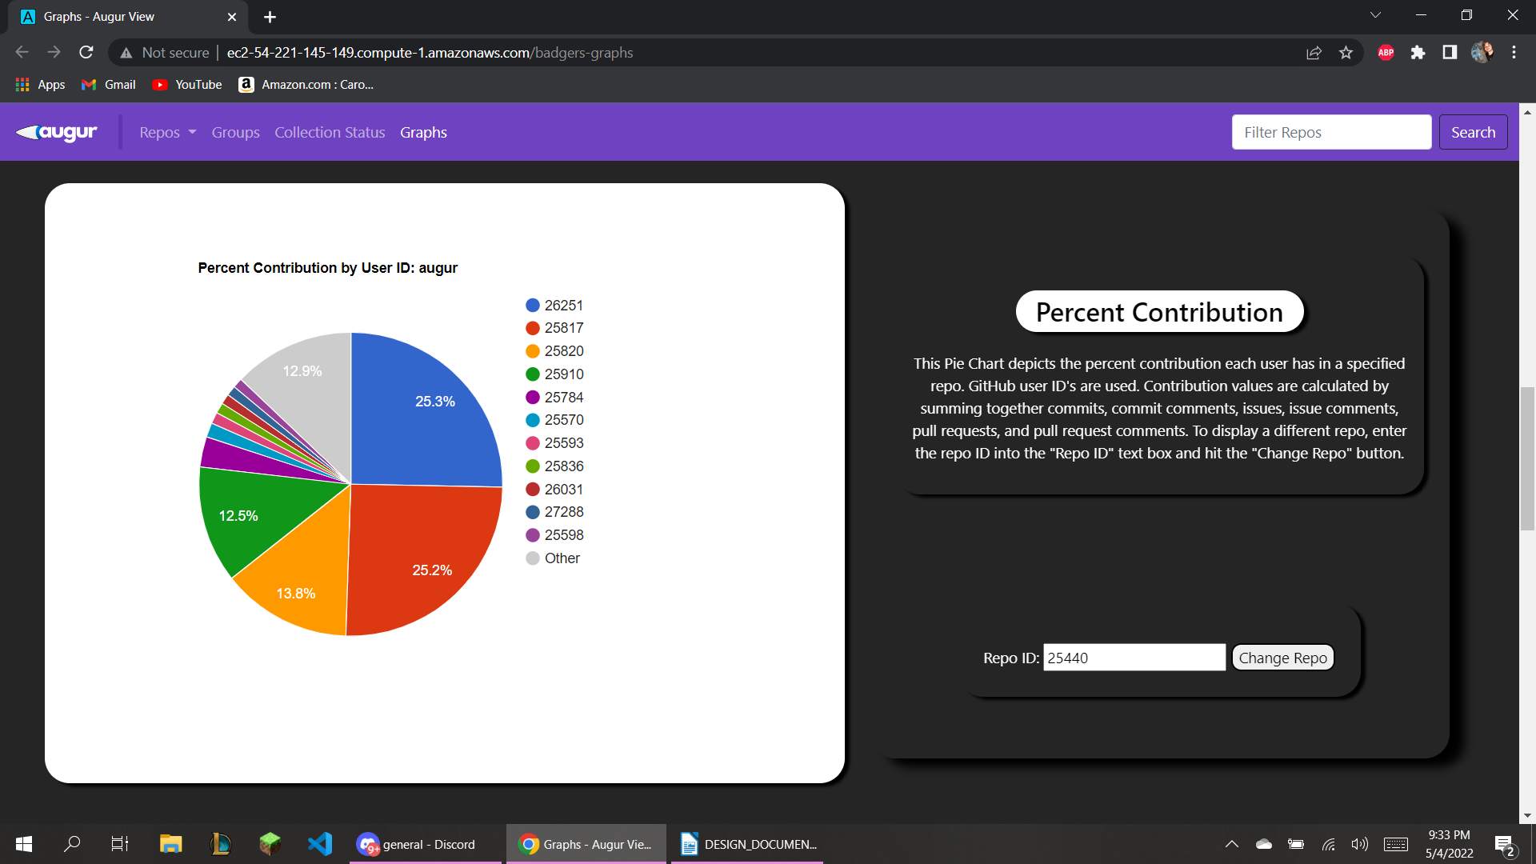

**Activity over Time**

This Line Graph shows the activity of each select repository within a repository group over time according to the number of commits it sees. This allows the user to see which repo of a repo group is worked on more as time progresses. The user can select between a yearly overview and a weekly breakdown.

**Yearly:**

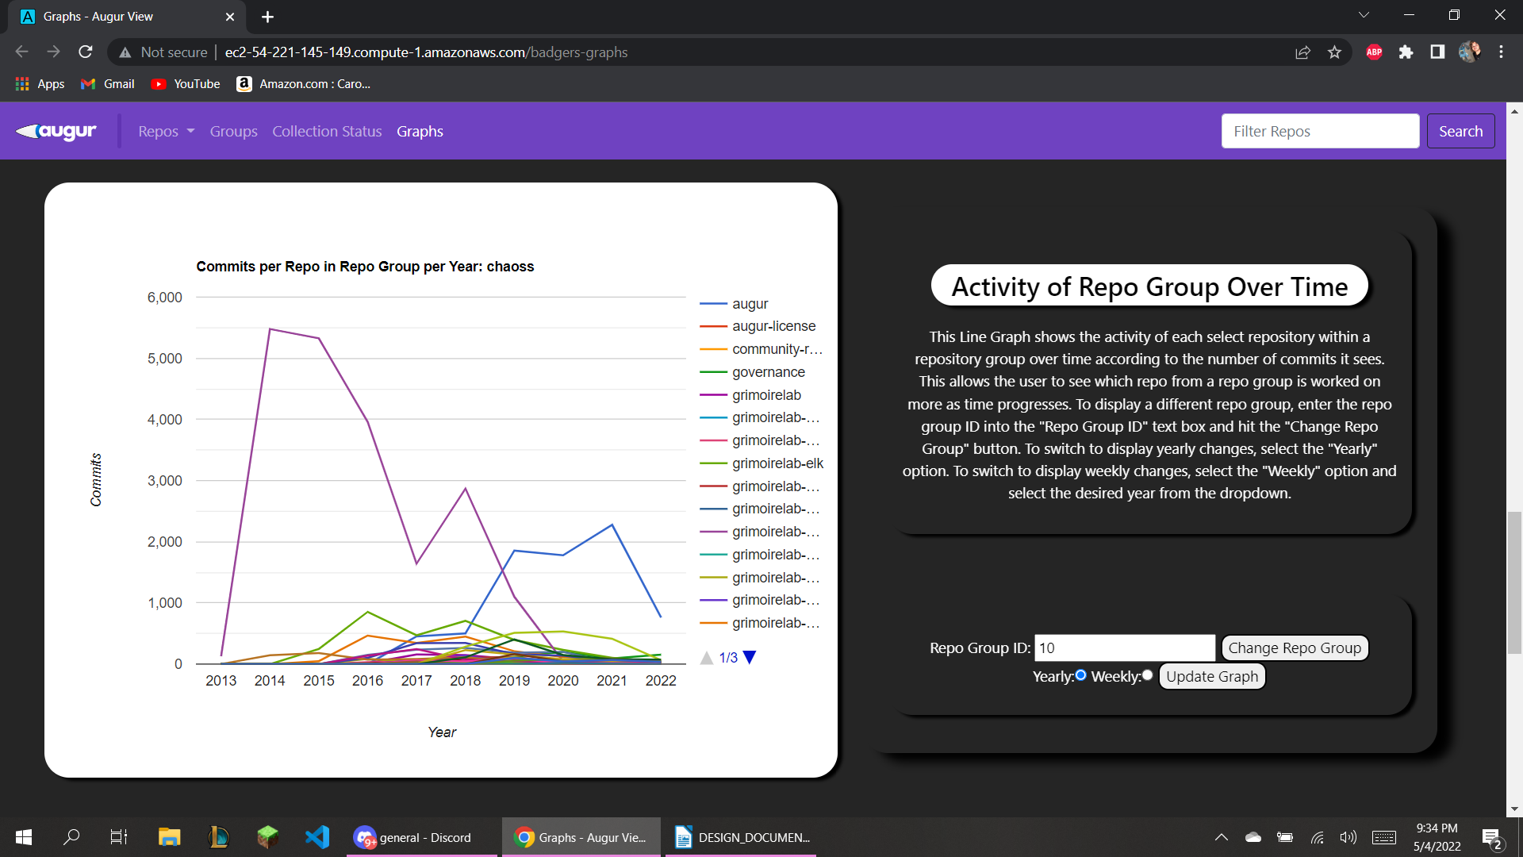 **Weekly:**

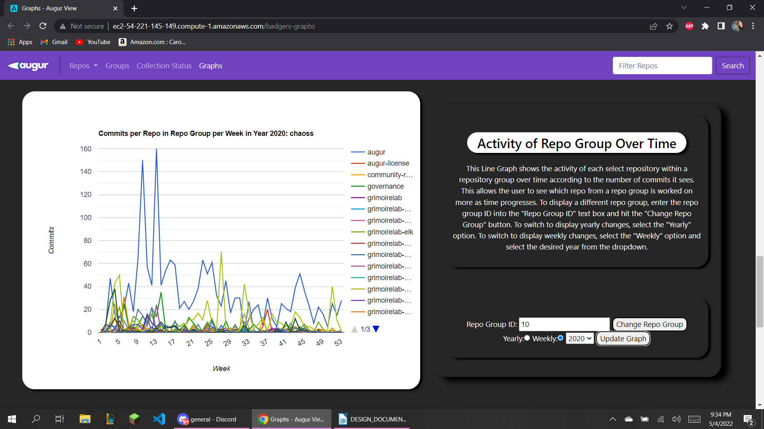

**Open and Resolved Issues**

This bar graph compares how many open and closed issues there are within select repositories of a repository group, so that a user may compare how much work is done, or which repository might need more help. The user can select between repo groups.

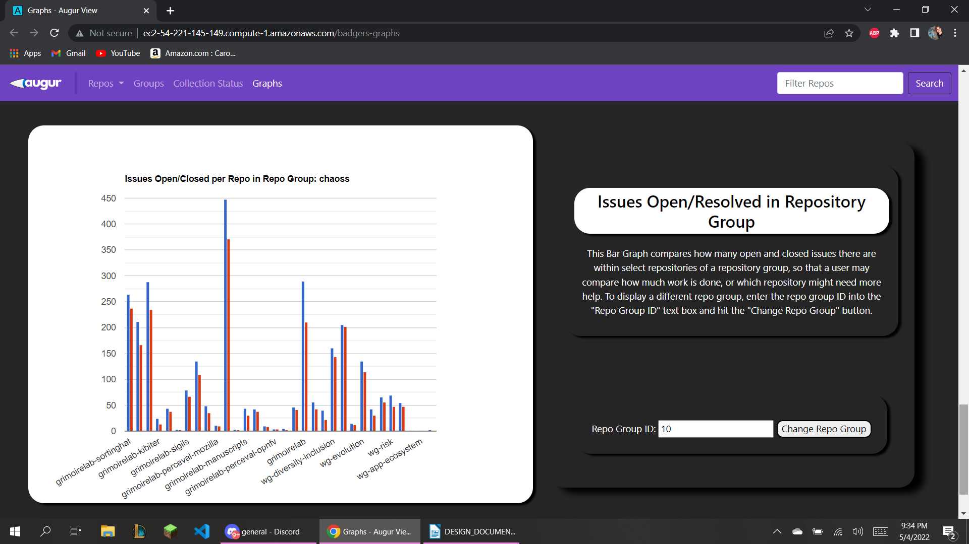These are the standing designs for our proposed graphs on the Augur frontend.