Palpath

Inventory and Builder UX Integrity

STATUS IMPLEMENTED |  | OWNER PALPATH MAINTAINERS |  | LAST UPDATED JULY 26, 2026

Authors | Palpath maintainers
Reviewers | Product and engineering
Related docs | docs/inventory-architecture.md · docs/data-contract.md · docs/architecture.md
Scope | Passive semantics, inventory stats, page scrolling, copy, motion, and regression gates.

1. Abstract
Palpath is a browser-first Palworld 1.0 inventory and breeding planner. Raw saves are decoded locally, normalized Pals are stored behind an inventory gateway, and breeding work runs client-side against versioned static data. This design tightens the product contract around passive selection, inventory stat readability, and scroll ownership.
An empty passive selection means no passive preference. Selected passives are required, but other passive slots are unconstrained. Inventory cards prioritize calculated HP, attack, and defense while keeping all four imported hidden scores visible. The document is the only main-page scroll owner.

2. Goals and Non-Goals
Goals | Non-goals
One passive rule: empty is unrestricted; selected passives are required. | Exact passive-set matching or a user-controlled extra-passive limit.
Show core HP, attack, defense, and all four 0–100 hidden scores clearly. | Simulating every condenser, enhancement, trust, passive, or temporary battle modifier.
Eliminate nested page scrolling, clipping, notch leakage, and ornamental shell shadows. | Replacing the finite carrier solver with a full breeding-DAG optimizer.
Keep motion restrained, accessible, testable, and reversible. | Introducing server rendering or uploading raw Palworld save bytes.

3. Background and Problem Statement
The previous Builder exposed two controls for the absence of a passive requirement: an “Any” pseudo-option and an extra-passive limit. Those controls encoded solver vocabulary rather than user intent. CSS aimed at the outer passive fieldset also matched MUI’s internal notch legend, which could place a white bar over selected chips. Inventory used a viewport-locked root plus an independently scrolling collection with a hidden scrollbar, making wheel, trackpad, footer, and sticky-header behavior feel broken.
The browser owns save decoding, local persistence, generated-data lookups, derived stat calculation, and breeding search. Supabase is optional and receives normalized records only. The key design invariant is that product intent is represented once: no passive selection is unrestricted, selected IDs are required, and remaining slots never disqualify a route.

4. Proposed Architecture

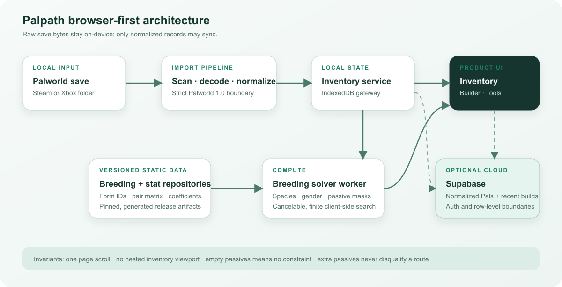
Figure 1. Palpath browser-first architecture and data boundaries.

Core components

Component | Responsibility | Primary storage | Failure behavior
Save import pipeline | Scan Steam/Xbox folders, decode supported 1.0 saves, and normalize immutable records. | Read-only user-selected files; transient WASM memory. | Fail explicitly; never persist a partial profile or mutate save bytes.
Inventory service + gateways | Own profile selection, replacement, filtering inputs, and sync boundaries. | IndexedDB locally; normalized Supabase rows when signed in. | Keep the local snapshot usable; surface feature-local sync or import errors.
Versioned data repositories | Resolve stable form IDs, breeding pairs, passives, and combat coefficients. | Generated JSON shipped with the static build. | Generation or build fails when coverage or identity validation fails.
Builder worker | Search the finite species, gender, and passive-carrier state space. | Immutable in-memory inputs and worker state. | Cancel cleanly; return a terminal route, gap, no-route, or error result.
React UI shell | Present one scroll surface, route-backed controls, stats, states, and accessible motion. | URL search state plus inventory snapshots. | Preserve navigation; show concise empty/error states without hidden interaction traps.

5. Request Lifecycle
- 1. The user selects a Steam or Xbox save folder.
- 2. The platform adapter scans supported Palworld 1.0 files; unsupported formats fail explicitly.
- 3. WASM decode and normalization produce OwnedPal records; raw bytes are discarded.
- 4. InventoryService replaces the imported profile through its gateway and exposes a snapshot.
- 5. Inventory combines form coefficients, level, and hidden scores to derive core combat values.
- 6. Builder converts the passive selection to unrestricted or required IDs with open remaining slots.
- 7. The worker returns a route, acquisition gap, cancellation, no-route result, or terminal error.

6. API and Data Contracts

Primary data contract

Field | Type | Required | Description
OwnedPal.speciesId | PalId | Yes | Stable exact-form identity; dex number is display metadata only.
OwnedPal.level | number | No | Imported current level used by core stat calculation.
OwnedPal.abilityScores | object | No | HP, melee, ranged, and defense hidden scores, each clamped to 0–100.
OwnedPal.passiveIds | PassiveId[] | Yes | Normalized passive IDs used by cards and solver inputs.
PassiveGoal.kind | any | specific | Yes | any only when no passive is selected; otherwise specific.
PassiveGoal.requiredIds | PassiveId[] | Conditional | The selected passives; unique and limited to four.
PassiveGoal.allowedExtras | number | Derived | Four minus required count; never controlled by the user.

Contract guarantees

- Generation validates that every runtime form has breeding identity and combat coefficients before release.
- Profile replacement is keyed by owner and imported world identity; repeated imports update rather than duplicate.
- Generated artifacts record game version and a pinned source commit for reproducibility.
- Core combat values are derived display data, not a complete battle-state source of truth; passive and enhancement bonuses are excluded.
Schemas and implementation notes:
docs/data-contract.md and docs/inventory-architecture.md.

7. Consistency, Idempotency, and Replay

Inventory writes are profile-level replacements serialized by InventoryService. Solver requests are pure and cancelable; they do not write inventory. Builder history canonicalizes target and passive IDs so setting variants deduplicate. URL parsing is backward compatible but always emits the current contract.
Scenario | Expected behavior | Reasoning
The same world is imported again | Replace the matching profile and preserve one active world record. | Refresh is idempotent from the user’s perspective and avoids duplicated Pals.
A runtime form lacks stat coefficients | Fail generation or build; do not publish a partially covered release. | Missing values would make cards silently misleading.
The worker is canceled or errors | Stop the request, keep inventory unchanged, and expose a terminal UI state. | Solver work is side-effect free and cancellation cannot corrupt persisted data.
A legacy URL contains any or extras | Normalize to the current empty/unrestricted contract and drop extras. | Old links remain usable without reviving removed controls.

8. Security and Privacy Considerations

- Authentication is optional. Account inventory and history are isolated by Supabase row-level policies.
- Raw save bytes remain local, read-only, and excluded from sync, logs, and analytics.
- Browser configuration may contain publishable keys only; service-role and OAuth secrets stay server-side.
- Administrative, migration, and debugging paths default to no raw-save retention and no cross-owner access.
- Users can remove local worlds, clear recent builds, sign out, and request server-side deletion through the published contact.

9. Operational Readiness
Signal | SLO or alert | Owner | Launch gate
Build correctness | Build, typecheck, and lint complete with zero errors. | Engineering | Required
Generated stat coverage | 100% of runtime form IDs resolve to coefficients. | Data maintainer | Required
Automated regression suite | All unit tests pass; passive and formula cases included. | Engineering | Required
Visual integrity | Desktop/mobile review: no nested scroll, chip overlay, or horizontal overflow. | Product + engineering | Required
Privacy boundary | No raw-save network request; only normalized sync payloads. | Engineering | Required
Rollout constraint: ship the semantic, data, and layout changes together; rollback the static release if any required gate fails.

10. Alternatives Considered

Alternative | Why it was considered | Why it was not selected
Keep Any; hide extras conditionally | Smallest surface-only change. | Preserves redundant state and still asks users to understand solver vocabulary.
Exact passive matching by default | Simple exact-set model. | Extra passives are not a user failure condition and should not reject useful routes.
Fetch stats from a live API | Avoids a generated artifact. | Adds availability, latency, privacy, and version-drift risk to a static product.
Expose the nested inventory scrollbar | Minimal CSS change. | Document navigation, sticky header behavior, and footer access remain worse.

11. Open Questions
- 1. Should future imports include condenser, enhancement, and trust ranks so cards can show fully modified displayed stats?
- 2. Should the legacy melee hidden score remain visible if later game versions continue not to use it for primary attack?
- 3. At what imported-Pal count would list virtualization become necessary without reintroducing a nested viewport?
- 4. Who owns coefficient refresh and formula validation for each supported Palworld release?

12. Decision and Next Steps
Adopt the simplified passive contract, natural page scroll, compact stat hierarchy, scoped selectors, and restrained motion rules as the product standard. Release only after generated coverage, automated tests, desktop/mobile visual checks, and the selected-chip regression check pass.
Milestone | Deliverable | Exit criteria
M1 | Passive contract and URL/history compatibility. | Empty, selected, and legacy URL cases pass.
M2 | Versioned coefficients, formula tests, and inventory stat hierarchy. | All forms covered; desktop and mobile cards remain legible.
M3 | Natural scroll, scoped notch CSS, copy audit, and restrained motion. | No nested viewport, overlay artifact, or low-value workflow copy.
M4 | Release candidate validation. | Build, lint, 65 tests, and visual gates pass; rollback remains available.

Use footnotes for definitions, assumptions, or terms that need precision without interrupting the main narrative.

