Ethan J. Nephew

Due: 11/18/2021

Deployment

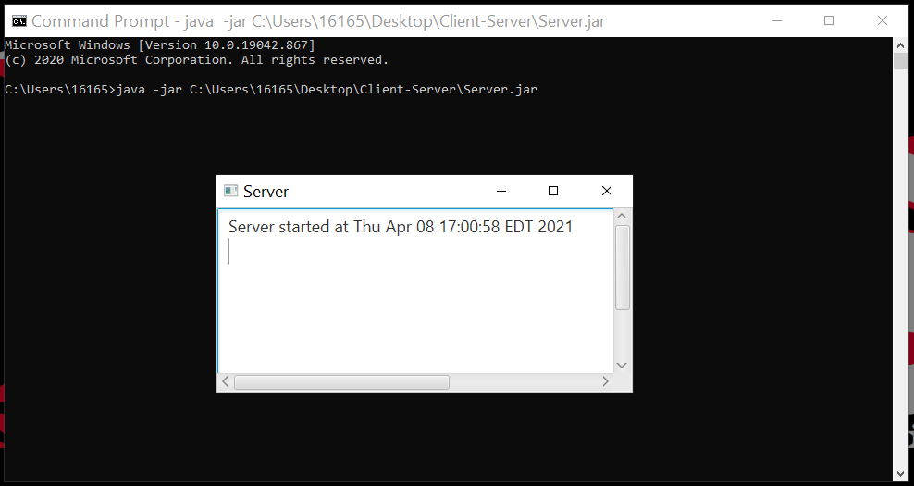

Figure Begin by running the Server.jar.

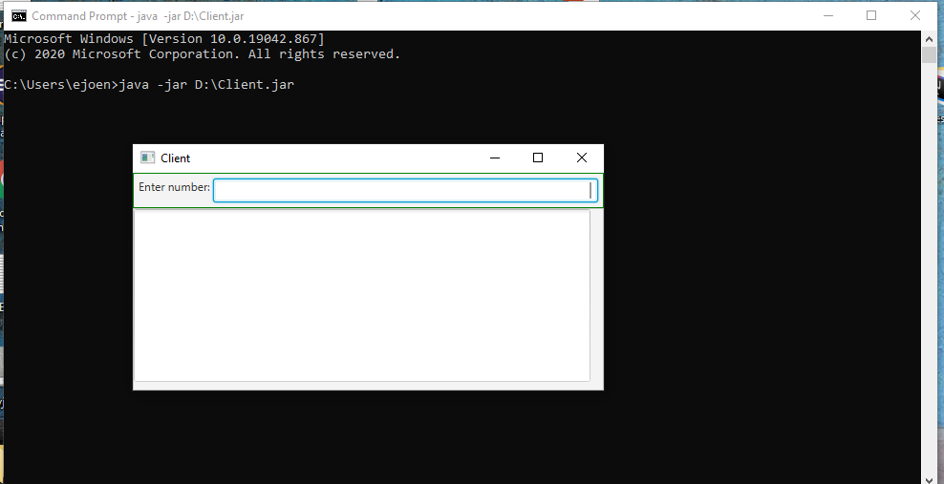

Figure Run the Client.jar. This requires the Server to be up and running.

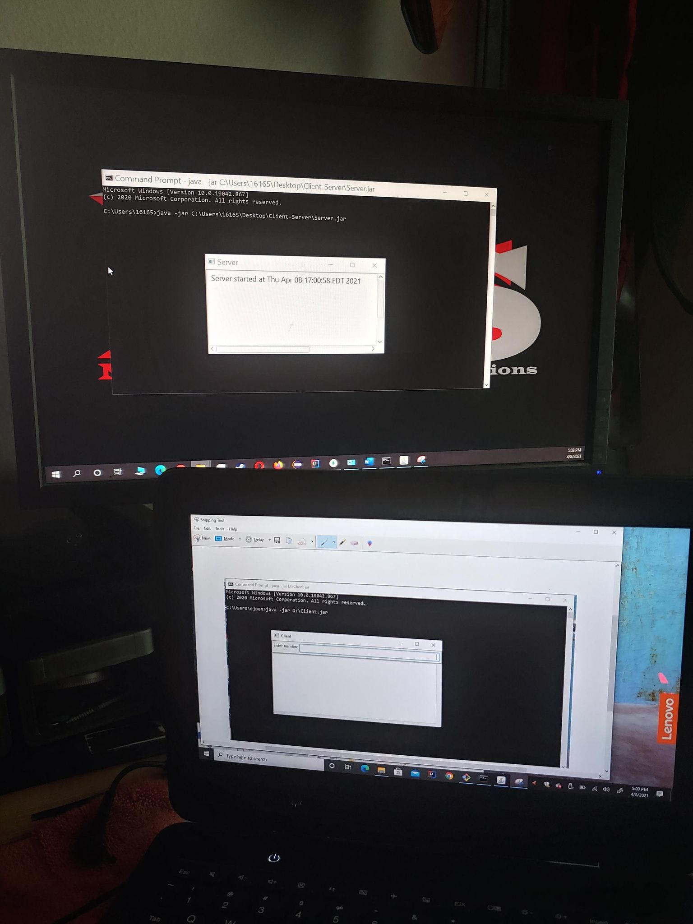

Figure This is a photo I took with my cellphone to show how it looks. Note: On the client side I had the snipping tool running in the background (that is what the white window, behind is).

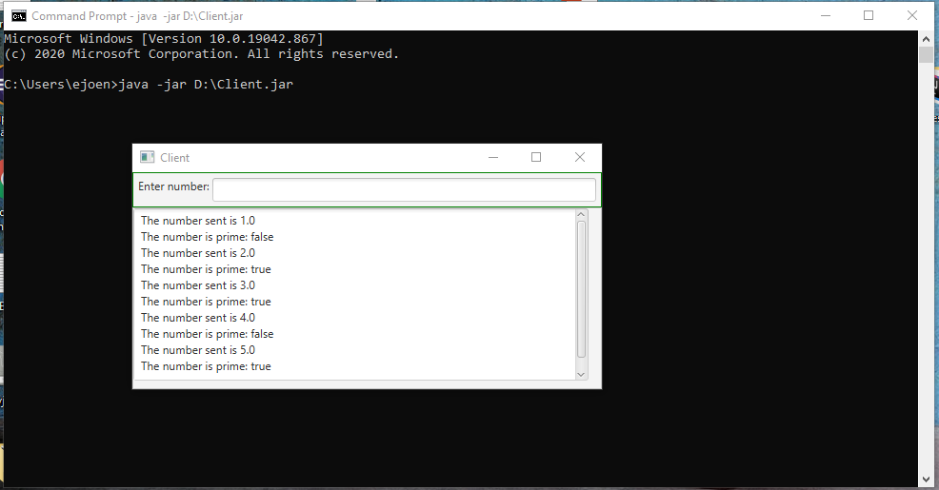

Figure Next, on the Client, type in numbers. The numbers will be sent to the Server where the Server will determine if they are prime or not.

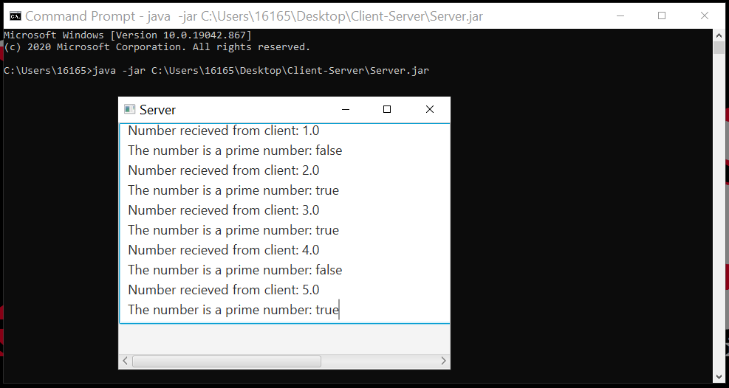

Figure This is what it looks like on the Server side.

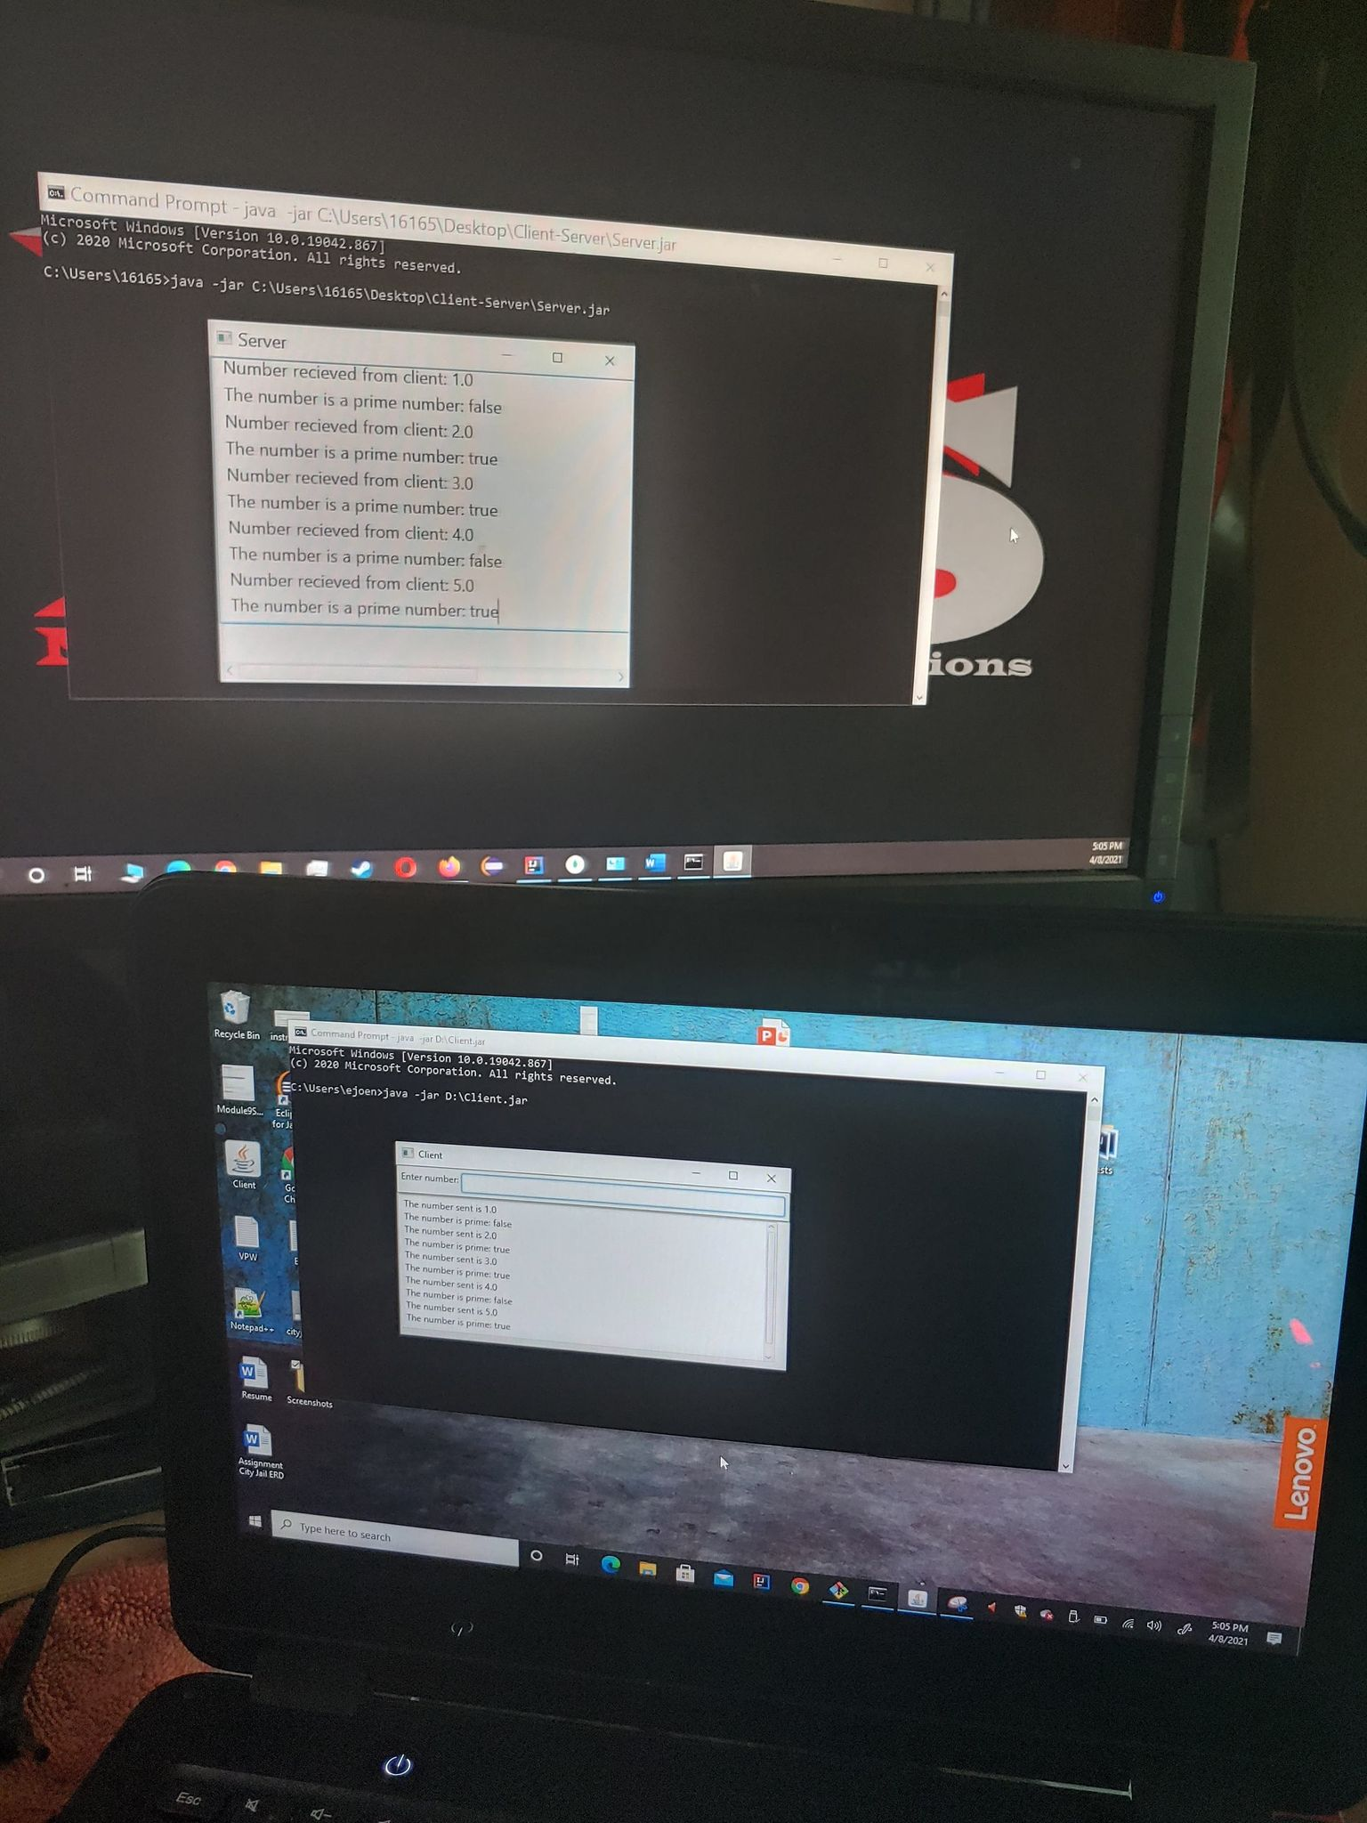

Figure This is what it looks like to have the Server and Client running on separate systems.