MINISTRY OF EDUCATION & TRAINING
HO CHI MINH CITY UNIVERSITY OF ECONOMICS AND FINANCE


FINAL REPORT
MOBILE DEVICE PROGRAMMING

FINAL REPORT
TOPIC: DRPLANT - ANDROID APPLICATION
FOR PLANT LEAF DIAGNOSIS SUPPORT

Ho Chi Minh City – 2026
MINISTRY OF EDUCATION & TRAINING
HO CHI MINH CITY UNIVERSITY OF ECONOMICS AND FINANCE

PROGRESS REPORT
TOPIC: DRPLANT - ANDROID APPLICATION
FOR PLANT LEAF DIAGNOSIS SUPPORT

Member:
Nguyễn Việt Anh - 235050236
Nguyễn Thế Anh - 235053028
Nguyễn Bảo Linh Nhi - 235057326
Phan Thị Ngọc Duyên - 235052977
Nguyễn Ngọc Phương Nghi - 235051516

SUPERVISOR(S): Tran Thi Huong.

Ho Chi Minh City – 2026

ACKNOWLEDGEMENT
We thank the lecturer of Mobile Device Programming for the feedback during the lab sessions. The comments that helped most were about keeping activities thin, asking for camera permission before opening the preview, and not blocking the UI thread when an image is processed.
The layouts follow Material components already available in the Android project template. Icons and strings are kept in the resource folders so the screens stay readable when the device language or density changes.

LETTER OF GUARANTEE
We, Nguyễn Việt Anh (student ID 235050236), Nguyễn Thế Anh (student ID 235053028), Nguyễn Bảo Linh Nhi (student ID 235057326), Phan Thị Ngọc Duyên (student ID 235052977), and Nguyễn Ngọc Phương Nghi (student ID 235051516), confirm that this progress report and the DrPlant Android source it describes are our own work for the Mobile Device Programming course. The code in the DrPlant module was written and tested by the group on Android Studio.
Where the project uses a published library (CameraX, Material, Gson, Firebase Authentication, ONNX Runtime Android), the name is given in the report and the dependency line sits in the Gradle files. We did not submit another student's application as our own.
Ho Chi Minh City, October 2026
Nguyễn Việt Anh Student ID: 235050236
Nguyễn Thế Anh Student ID: 235053028
Nguyễn Bảo Linh Nhi Student ID: 235057326
Phan Thị Ngọc Duyên Student ID: 235052977
Nguyễn Ngọc Phương Nghi Student ID: 235051516

TABLE OF CONTENTS
LIST OF ASSIGNMENTS 5
LIST OF ABBREVIATIONS 6
LIST OF TABLES 7
LIST OF FIGURES 8
INTRODUCTION 9
1.1. Background and Problem Statement 9
1.2. Objectives 9
1.2.1. General Objective 9
1.2.2. Detailed Objectives 9
1.3. Scope and Limitations 10
1.3.1. Project Scope 10
1.3.2. Project Limitations 10
LITERATURE REVIEW & REQUIREMENTS 11
2.1. Technologies 11
2.2. Requirement Analysis 11
2.2.1. Functional Requirements 11
2.2.2. Non-Functional Requirements 12
SYSTEM DESIGN 13
3.1. Local Data Design 13
3.2. UI Design 14
3.2.1. Design Principles 14
3.2.2. Main Screens 14
3.3. Use Cases 15
3.4. Application Architecture 15
3.4.1. Layered Structure 15
3.4.2. Project Folder Structure 16
IMPLEMENTATION & RESULTS 17
4.1. What Was Built 17
4.2. Authentication Screens 23
4.3. Camera and Gallery 24
4.4. Diagnosis Result Screen 24
4.5. History Screen 24
4.6. Statistics Screen (UI) 25
4.7. Progress against the Plan 25
CONCLUSIONS 26
REFERENCES 27

LIST OF ASSIGNMENTS
Table 1 lists the split used for this progress milestone. Weights are approximate and will be adjusted when the remaining modules land.
Member | Student ID | Main assignments (this milestone)
Nguyễn Việt Anh | 235050236 | CameraActivity, gallery flow, diagnosis result screen, history helper, Gradle / Firebase setup
Nguyễn Thế Anh | 235053028 | Requirement notes, use-case wording, StatisticalActivity UI, navigation, string/drawable resources
Nguyễn Bảo Linh Nhi | 235057326 | UI review and testing on device, history filter flows, screenshot capture for report figures
Phan Thị Ngọc Duyên | 235052977 | Login / Register activities and layouts, table content check, non-functional requirement draft
Nguyễn Ngọc Phương Nghi | 235051516 | Permission / CameraX checklist, local storage notes, progress tracking against the module plan
Table 1. List of assignments for the progress milestone

LIST OF ABBREVIATIONS
Num. | Abbreviation | Explanation
1 | API | Application Programming Interface
2 | APK | Android Package
3 | JSON | JavaScript Object Notation
4 | UI | User Interface
5 | UX | User Experience
6 | SDK | Software Development Kit
7 | SHA | Secure Hash Algorithm (signing certificate)
8 | XML | Extensible Markup Language
Table 2. List of abbreviations

LIST OF TABLES
Table 1 . List of assignments for the progress milestone 5
Table 2 . List of abbreviations 6
Table 3 . Main functional requirements 11
Table 4 . Screens implemented in this build 16
Table 5 . Progress against planned modules 24

LIST OF FIGURES
Figure 3.1 . Data flow from image capture to result and local history 13
Figure 3.2 . Navigation flow between the main DrPlant screens 14
Figure 3.3 . Use case diagram for the progress build 15
Figure 3.4 . Layered architecture of the DrPlant Android application 16
Figure 4.1 . Login screen of DrPlant 18
Figure 4.2 . Register screen of DrPlant 19
Figure 4.3 . Camera home screen of DrPlant 20
Figure 4.4 . Diagnosis result screen of DrPlant 21
Figure 4.5 . History screen of DrPlant 22
Figure 4.6 . Statistics screen of DrPlant 23

INTRODUCTION

1.1. Background and Problem Statement
Coffee and durian gardens still rely a lot on looking at leaves by eye. When a grower is already in the field, opening a laptop is awkward. A phone application that can open the camera, keep a short history, and show a clear result screen fits that situation better than a desktop tool.
For the Mobile Device Programming course the group builds DrPlant, an Android application. The course focus is the mobile side: activities, layouts, permissions, camera preview, local storage, and an online login. The leaf-check step is treated as one feature of the app, not as a separate research product in this report.
At the start of the term there was no shared Android project for the group. Screens were sketched one by one, then wired through intents. Several parts that need a server or a shared database are still open; those gaps are listed in Chapter 4 and in the conclusion.

1.2. Objectives

1.2.1. General Objective
Build a usable Android application that lets a signed-in user capture or pick a leaf image, view a diagnosis screen, keep a local history, and open a statistics page that will later read real farm data.

1.2.2. Detailed Objectives
• Register and log in with email and password through Firebase Authentication.
• Request camera and media permissions in a way that works on current Android versions.
• Show a CameraX preview, take a photo, or pick an image from the gallery.
• Open a result activity with plant type, status, and suggested care notes.
• Store recent diagnoses on the device and let the user filter or delete them.
• Prepare a statistics activity and bottom navigation so later data can plug in.

1.3. Scope and Limitations

1.3.1. Project Scope
This progress build covers the DrPlant Android module only. Target platform is Android phone, minSdk 24, written mainly in Java. Package name is com.nckh.drplant. The user flow starts at LoginActivity, moves to CameraActivity after a successful sign-in, then branches to diagnosis, history, or statistics.

1.3.2. Project Limitations
There is no remote database for plants, areas, or disease counts yet. The statistics screen shows empty placeholders on purpose. History is kept in SharedPreferences on the phone, so it does not follow the user to another device. iOS is out of scope. Push notifications and map views are not in this milestone.

LITERATURE REVIEW & REQUIREMENTS

2.1. Technologies
Android Studio and the Android Gradle Plugin drive the build. The app module uses Java 11, AppCompat, Material, ConstraintLayout, and Activity Result APIs for permissions and the gallery picker.
CameraX (camera-core, camera2, lifecycle, view) handles the preview and still capture. Lifecycle binding keeps the camera tied to CameraActivity, which avoids a common leak when the user rotates the phone or leaves the screen. Gallery images go through GetContent and are copied into app storage before the next step.
Firebase Authentication covers email sign-up, sign-in, password reset, and sign-out. The google-services.json file is placed under the app folder and is not committed to the public repository. Gson serialises history items. SharedPreferences holds the history JSON string with a hard cap of 100 entries so the preference file does not grow without limit.
For the leaf check itself the project loads an on-device model through ONNX Runtime Android. In this course report that step is only the bridge from a captured file to the DiagnosisActivity extras. Training details belong to another document and are not expanded here.

2.2. Requirement Analysis

2.2.1. Functional Requirements
Table 3 lists the functions planned for the mobile app. Status reflects the code at the time of this progress report.
ID | Requirement | Status
FR01 | Register with email and password | Done
FR02 | Log in / log out / reset password | Done
FR03 | Camera preview, capture, flash, flip | Done
FR04 | Pick image from gallery | Done
FR05 | Show diagnosis result screen | Done
FR06 | Save and browse diagnosis history | Done
FR07 | Statistics by area / plant / disease | UI only
FR08 | Sync user farm data with a server | Not started
Table 3. Main functional requirements

2.2.2. Non-Functional Requirements
The UI must stay responsive while an image is prepared. Long work runs off the main thread; a simple overlay tells the user that the app is busy. Permission denials show a short Toast instead of crashing. Debug builds use the standard Android debug keystore; the SHA-1 of that keystore is registered in the Firebase console so Authentication can run on the student devices.
Layouts target phones first. Text and icons come from resources. The application requests only the permissions it needs: CAMERA, internet for Firebase, and the media-read permissions required by the gallery path on Android 13 and newer.

SYSTEM DESIGN

3.1. Local Data Design
This milestone does not open a Room database or a remote SQL store. History items are plain Java objects (DiagnosisHistoryItem) turned into JSON by Gson and written under the preference name diagnosis_history_prefs. Each item keeps an id, timestamps, image path, plant type, health flag, and the fields needed to rebuild the result screen when the user opens an old row.
Firebase only stores the authentication account. Plant areas, tree lists, and disease counters for the statistics page still need a later schema (local Room, Firestore, or a custom API). The StatisticalActivity already exposes updateStatistics(...); nothing calls it with live numbers yet.
The capture-to-result path stays on the device. A new diagnosis may also be appended to SharedPreferences through DiagnosisHistoryManager.
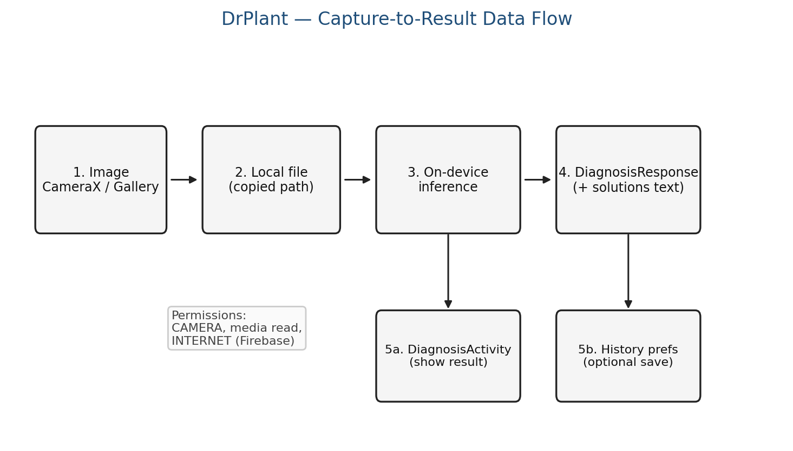
Figure 3.1. Data flow from image capture to result and local history

3.2. UI Design

3.2.1. Design Principles
The camera screen stays dark and uncluttered so the preview remains the main object. Controls sit at the edges: history, statistics, and logout on the left; flash, flip, and gallery on the right; capture at the bottom. Login and register use outlined text fields and a single primary button, which matches common Material patterns and is easy to tap outdoors.

3.2.2. Main Screens
activity_login and activity_register are scrollable forms. activity_camera hosts PreviewView. activity_diagnosis shows the photo, status, and care blocks. activity_history is a list with plant filters and date filters. activity_statistical is a dashboard layout with cards, empty chart frames, and a bottom text navigation bar.
The navigation map shows how the user moves from authentication to the camera home screen and then to diagnosis, history, or the statistics shell.
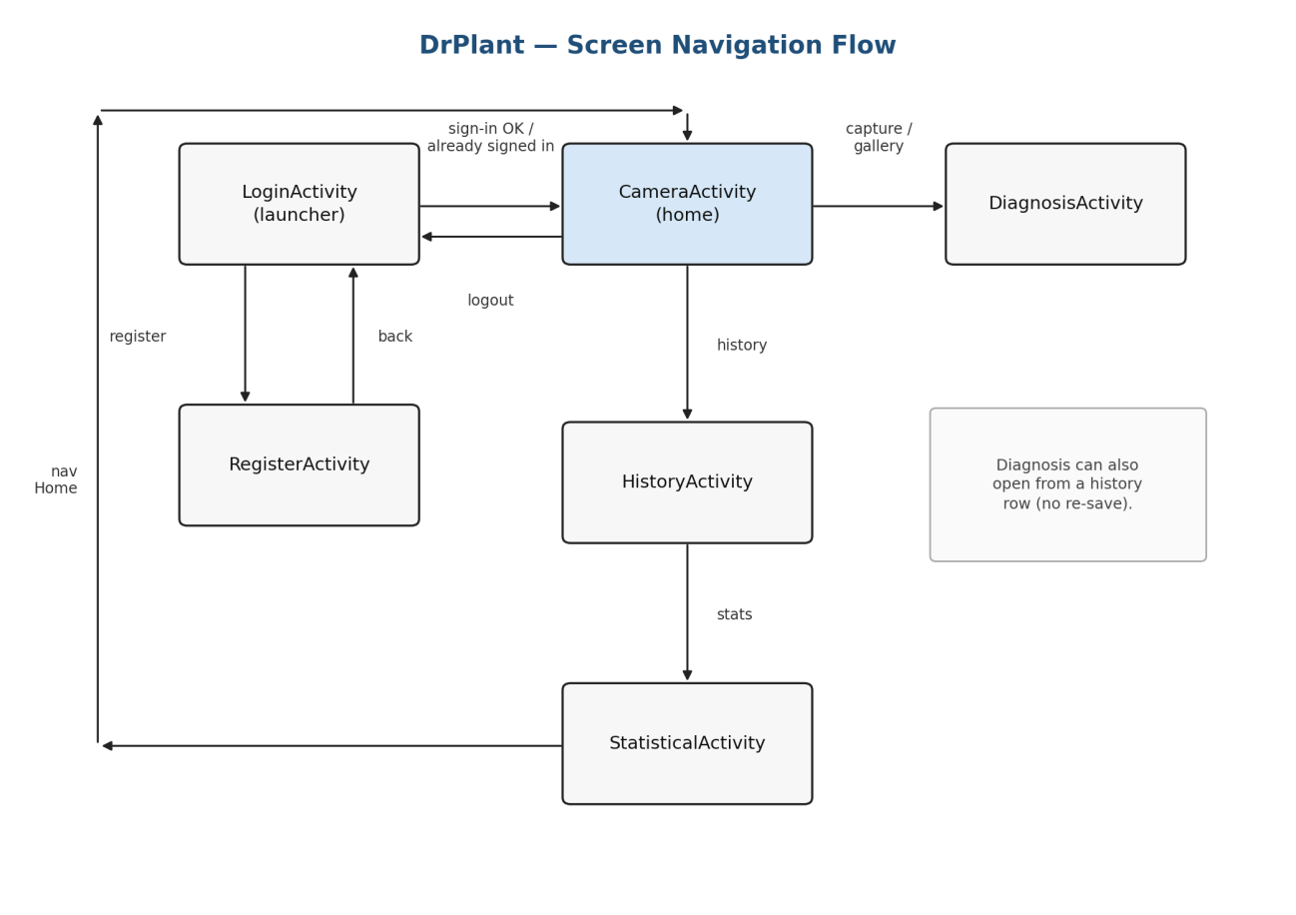
Figure 3.2. Navigation flow between the main DrPlant screens

3.3. Use Cases
Primary actor: garden user with an account. Main use cases already wired: register, log in, reset password, open camera, capture leaf, pick from gallery, view diagnosis, save to history, filter history, delete history rows, open statistics page, log out. Use cases waiting on data: choose farm area, manage plant records, view real disease charts.
The actor is a garden user with an account. Solid links mark use cases already wired in the APK; area and plant management remain for later work.
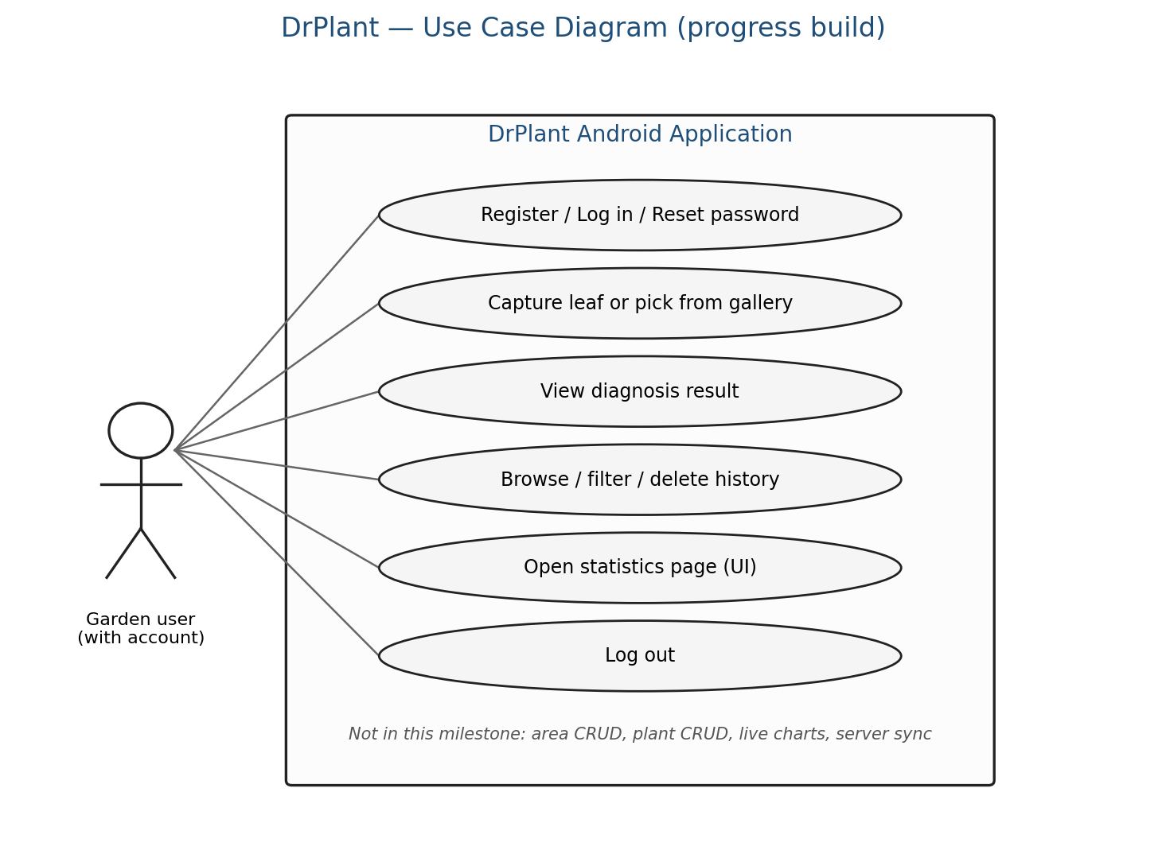
Figure 3.3. Use case diagram for the progress build

3.4. Application Architecture

3.4.1. Layered Structure
The app is a classic multi-activity Android project, not a single-Activity Compose app. Activities own the screens. Helper classes under Utils prepare intents and history I/O. Model classes hold serialisable payloads for DiagnosisActivity. The AiUtils package isolates image prep and the on-device engine so CameraActivity does not grow into one large file.
Figure below summarises the three layers used in this progress build: activities and layouts on top, helper classes in the middle, and Firebase, CameraX, and the on-device engine at the bottom.
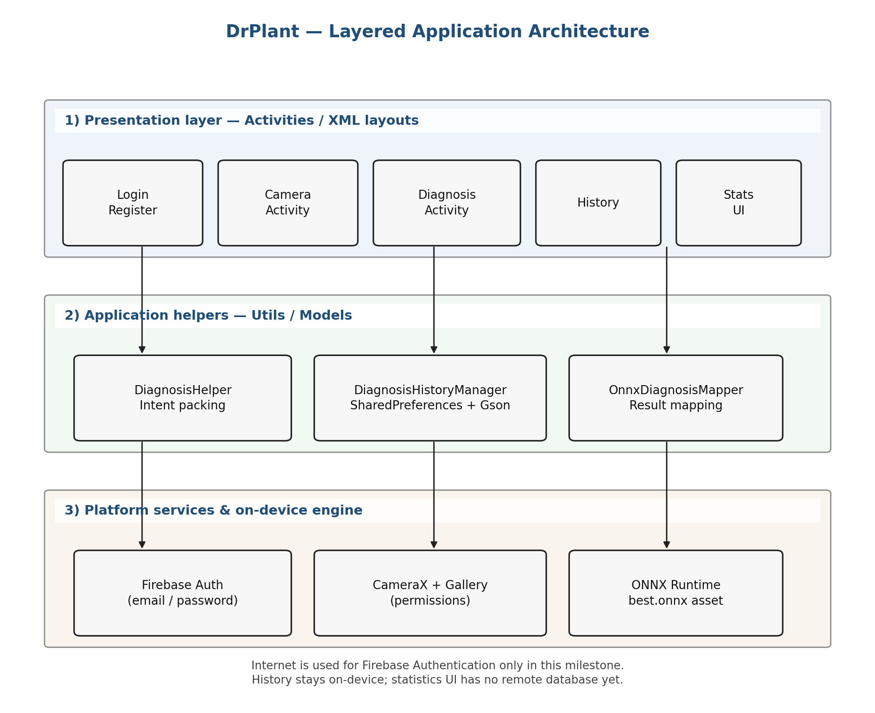
Figure 3.4. Layered architecture of the DrPlant Android application

3.4.2. Project Folder Structure
Under DrPlant/app/src/main the important paths are java/com/nckh/drplant (activities), Models, Utils, AiUtils, res/layout, res/values, res/drawable, and assets for the packaged model file. Gradle files sit at the module root. google-services.json stays in the app directory on each developer machine.

IMPLEMENTATION & RESULTS

4.1. What Was Built
The progress APK opens on LoginActivity. After Firebase accepts the credentials, CameraActivity becomes the home screen. From there the user can capture, pick a gallery image, open history, open the statistics shell, or sign out. Table 4 summarises the activities that exist in the manifest.
Activity | Role | Notes
LoginActivity | Launcher | Email / password, reset link
RegisterActivity | Sign-up | Confirms password length >= 6
CameraActivity | Home after login | CameraX + gallery + logout
DiagnosisActivity | Result | Reads Intent extras
HistoryActivity | Local history | Filter by plant / date
StatisticalActivity | Dashboard UI | No live data yet
Table 4. Screens implemented in this build
The following figures were captured from the running DrPlant debug build on an Android emulator (Medium Phone). They show the main screens of the progress milestone.
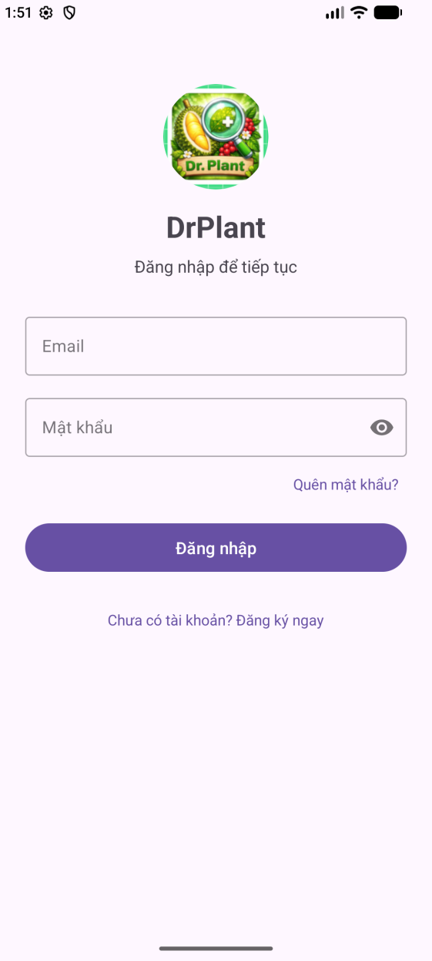
Figure 4.1. Login screen of DrPlant
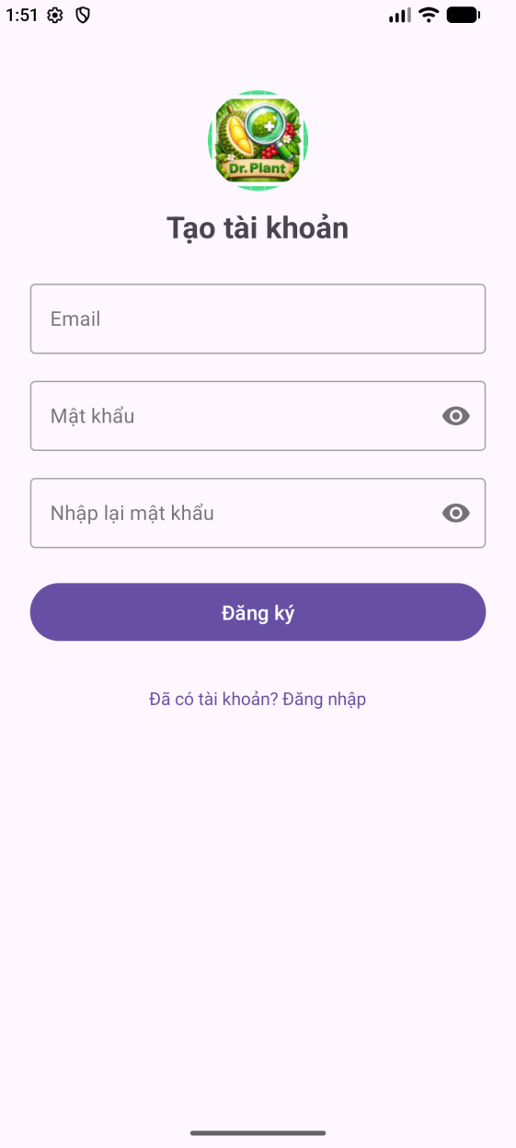
Figure 4.2. Register screen of DrPlant
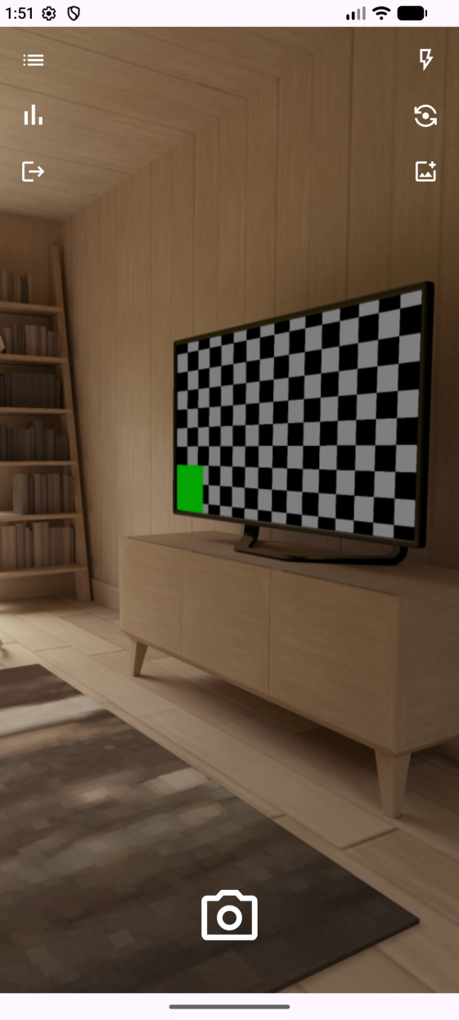
Figure 4.3. Camera home screen of DrPlant
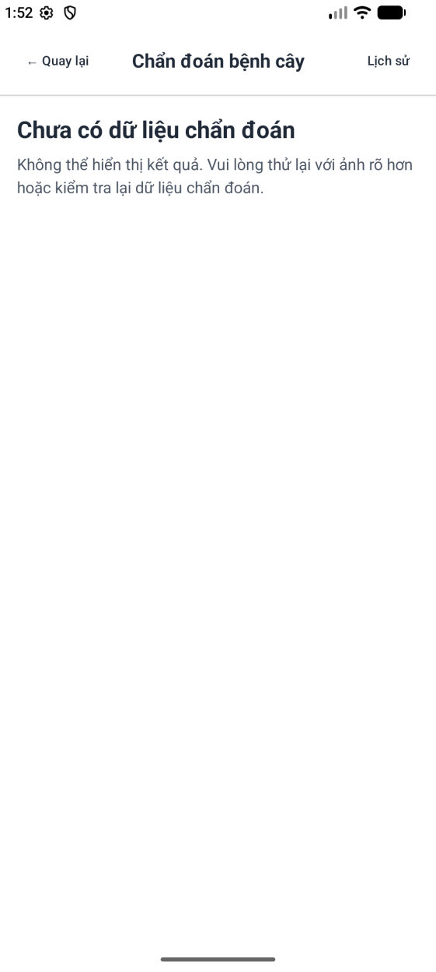
Figure 4.4. Diagnosis result screen of DrPlant
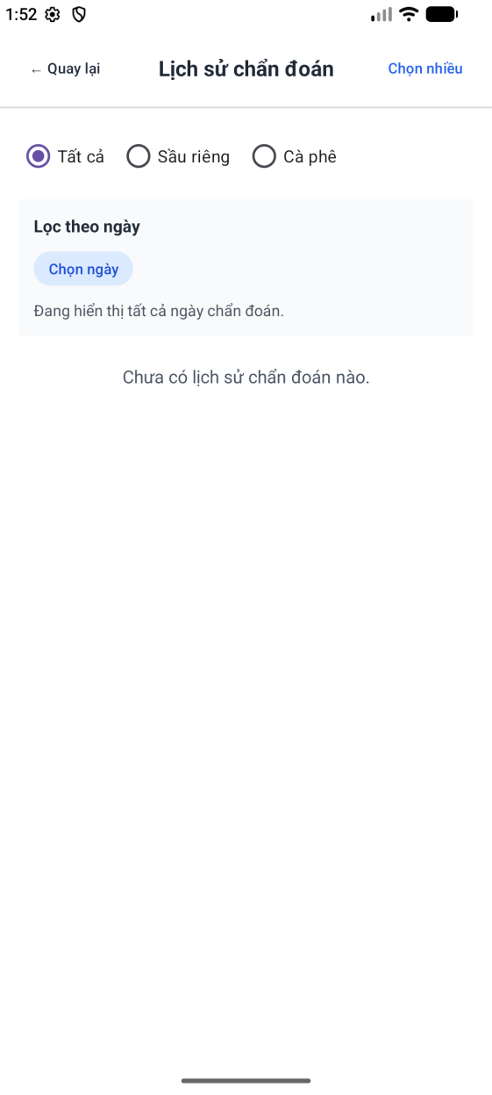
Figure 4.5. History screen of DrPlant
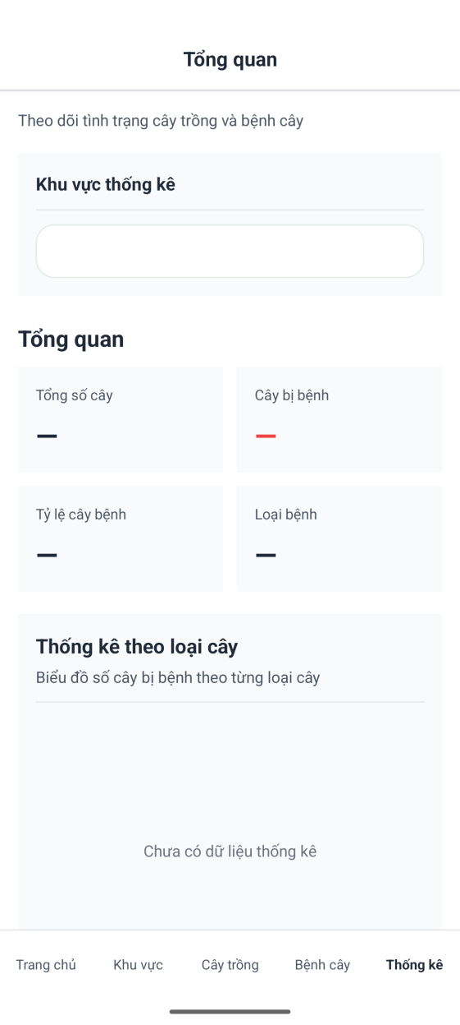
Figure 4.6. Statistics screen of DrPlant

4.2. Authentication Screens
LoginActivity validates the email pattern before calling signInWithEmailAndPassword. A ProgressBar blocks double taps while the request runs. If FirebaseUser is already present in onStart, the activity skips straight to the camera. RegisterActivity creates the account and then clears the back stack so the user does not return to the form with the Back key. CameraActivity asks for confirmation before signOut and returns to login with NEW_TASK | CLEAR_TASK.
Early in the milestone the Java classes for login existed before the XML layouts were merged, which broke resource linking. That gap is closed in the current tree. Building without google-services.json only prints a Gradle warning; once the file is present, processDebugGoogleServices runs as usual.

4.3. Camera and Gallery
Camera permission is requested through ActivityResultContracts.RequestPermission. startCamera binds Preview and ImageCapture to the activity lifecycle. Flash toggles the torch when the device supports it. Flip switches between back and front selectors. Captured files can also be copied into the public Pictures/DrPlant album on older storage rules, with a separate permission path when the system requires it.
Gallery picks use GetContent with image/*. The URI is copied to a local file so the later diagnosis step always receives a File path. While work runs, uploadLoadingOverlay covers the preview and ignores extra taps. That behaviour matters on slower phones where a second capture would otherwise queue confusing results.

4.4. Diagnosis Result Screen
DiagnosisHelper packs a DiagnosisResponse and an optional image path into the Intent. DiagnosisActivity renders plant name, status text, severity colour, and the solution blocks. If the payload is missing, an empty-state layout appears instead of a blank card. When the screen is opened from a new capture, the helper can ask DiagnosisHistoryManager to append a row.
From a mobile-course view the important part is the Intent contract and the separation between capture UI and result UI. The mapping from model output to Vietnamese care text lives in OnnxDiagnosisMapper and can change without rewriting the camera screen.

4.5. History Screen
HistoryActivity loads the preference list, shows thumbnails when the image file still exists, and supports plant filters (all / coffee / durian) plus a date range. Multi-delete asks for confirmation through AlertDialog. Opening a row rebuilds DiagnosisResponse from the stored fields and launches the result activity without writing a duplicate history entry.

4.6. Statistics Screen (UI)
StatisticalActivity inflates the dashboard layout, disables the area spinner when no areas exist, and fills metric TextViews with a placeholder string. Chart FrameLayouts stay empty; empty labels remain visible. Bottom navigation returns to CameraActivity on Home. Area, Plants, and Disease items only show a Toast that the feature is under construction. This is enough to review spacing and navigation, but it is not a finished analytics module.

4.7. Progress against the Plan
Module | Planned | Progress
Auth (Firebase) | Login, register, logout | Complete in this build
Camera / gallery | Capture and pick image | Complete
Diagnosis UI | Result activity | Complete
History | Local list + filters | Complete
Statistics | Charts from farm data | Layout + stubs only
Server / shared DB | User data sync | Not started
Area / plant CRUD | Manage garden objects | Not started
Table 5. Progress against planned modules
Rough completion for the mobile milestone is about two thirds of the screens and flows in the original sketch. Authentication, camera, result, and history are in a state that can be demonstrated on a device. Statistics and anything that needs a shared database remain for the next phase.

CONCLUSIONS
This progress build gives DrPlant a real Android shell: account entry, camera home, diagnosis page, and local history. Permissions, Activity Result contracts, and CameraX lifecycle binding were the parts that took the most debugging time, which matches the focus of the Mobile Device Programming course.
The statistics page is intentionally unfinished. Without area and plant records there is nothing honest to chart, so the group stopped at layout and navigation rather than inventing fake numbers. The same is true for server sync: the Internet permission and Firebase Auth are in place, but no REST client has been added yet.
Next work, in order: decide the data store for areas and plants, feed StatisticalActivity from that store, optionally upload history when the user is online, then polish the UI with device screenshots for the final report. Demo accounts should be created in the group's Firebase project; they are classroom credentials only.

REFERENCES
[1] Android Developers, "CameraX overview," Android Developers Documentation. Available: https://developer.android.com/media/camera/camerax
[2] Android Developers, "Request runtime permissions," Android Developers Documentation. Available: https://developer.android.com/training/permissions/requesting
[3] Android Developers, "Get a result from an activity," Android Developers Documentation. Available: https://developer.android.com/training/basics/intents/result
[4] Google, "Get Started with Firebase Authentication on Android," Firebase Documentation. Available: https://firebase.google.com/docs/auth/android/start
[5] Android Developers, "Save simple data with SharedPreferences," Android Developers Documentation. Available: https://developer.android.com/training/data-storage/shared-preferences
[6] Android Developers, "Material Design for Android," Android Developers Documentation. Available: https://developer.android.com/develop/ui/views/theming/look-and-feel
[7] Android Developers, "Guide to app architecture," Android Developers Documentation. Available: https://developer.android.com/topic/architecture
[8] Microsoft, "Install ONNX Runtime," ONNX Runtime Documentation. Available: https://onnxruntime.ai/docs/install/

