1. (10) Given the grammar below, identify which sentences are in the language (which are valid sentence).
   1. baab
   2. bbbab
   3. bbaaaaaa
   4. bbaab

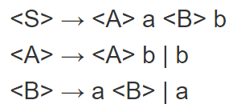

Choose A, baab (AaBb , <A>-b and <B>-b)

1. (10) Identify all of the tokens (categories of lexemes) in the grammar below, and which lexemes they categorize. Put them in a table.

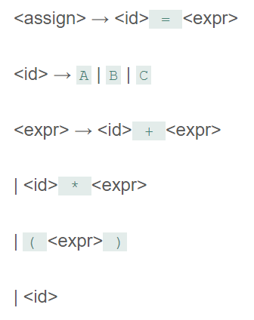

|  |  |
| --- | --- |
| lexeme |  |
| A,B,C | Identifier |
| = | Assign_op |
| * | Mul op |
| + | Add op |
| （ | Opening parentheses |
| ) | parentheses |
|  |  |

1. (10) Given the grammar from question 2, show a left-most derivation and draw the parse tree for the following statement.
   1. B = B + (C + (A * A) )

<id> = <expr>

B = <expr>

B= <id> + <expr>

B= B + <expr>

B= B + (<expr>)

B =B + (<id> + <expr>)

B = B+ (C + <expr>)

B = B + (C + (<expr>))

B = B + (C + (<id> * <expr>))

B = B + (C + (A * <expr>))

B = B + (C + (A*A))

Parse tree

<assign>

<id> = <expr>

<id> +<expr>

(<expr>)

<id> + <expr>

（<expr>）

<id>*<expr>

B = B + (C + (A*A))

1. (10) Remove all of the recursion from the following grammar:

S -> Aa | Bb

A -> Aa | AbC | C

B -> S | bb

C -> c

S -> Aa | Bb

A -> CA’

A’ -> aA’|bCA’|epsilon

B -> AaB’|bbB’

B’ -> bB’|epsilon

C -> c

1. (10) Use left factoring to resolve the pairwise disjointness problems in the following grammar:

A -> aBc | ac | a

B -> b | aB

A ->a<new>

<new> ->BC|C|epsilon

B -> b|aB

1. (20 pts) Create an LR(0) parse table for the following grammar. Show all steps (creating closures, the DFA, the transition table, and finally the parse table):

E -> E + T | E * T | T

T -> ( E ) | id

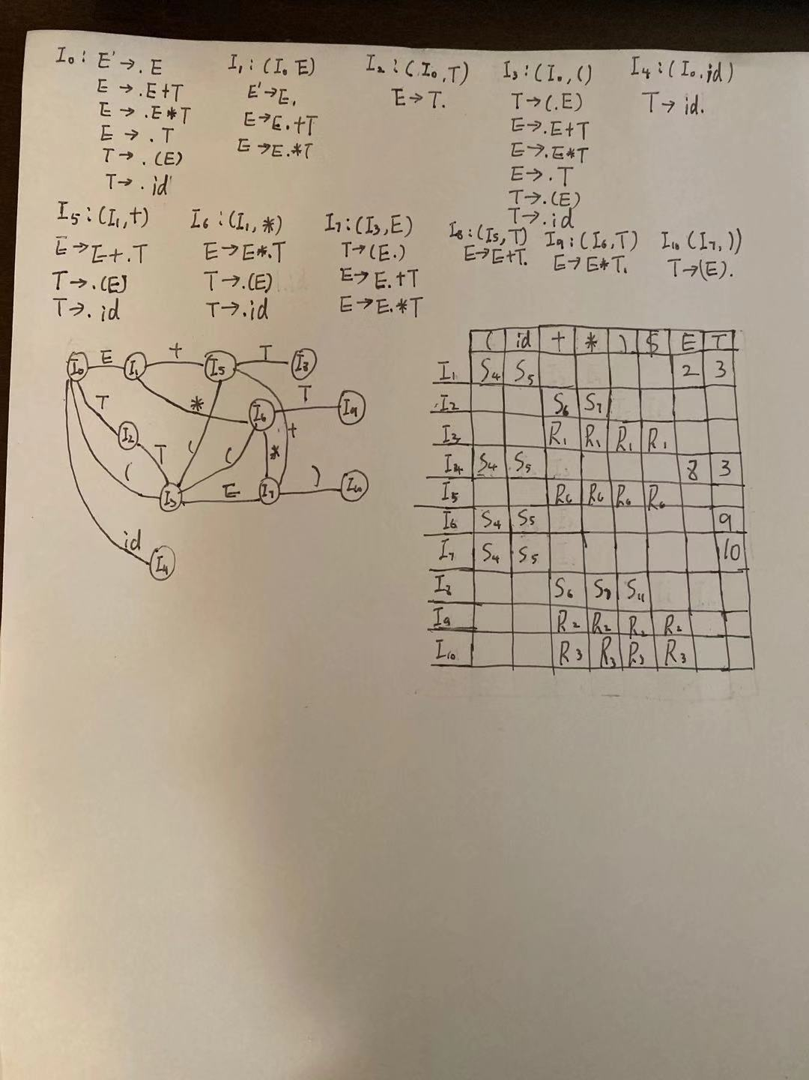

1. (20 pts) Show a complete bottom-up parse, including the parse stack contents, input string, and action for the string below using the parse table you created in step 6. Think about how I went through this in class.

(id + id) * id

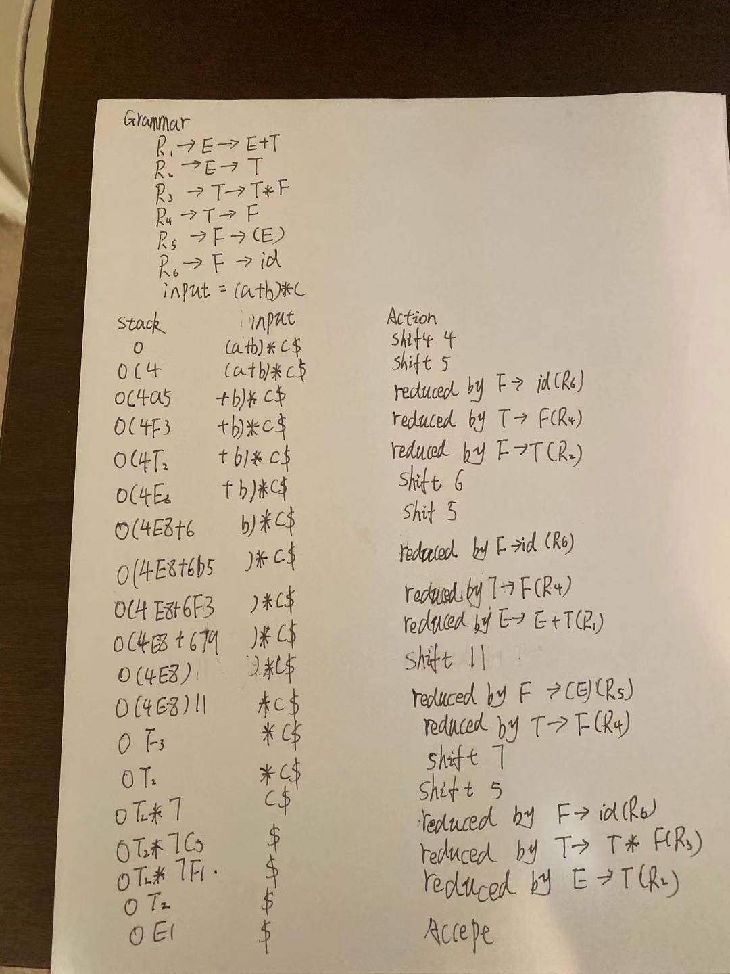

1. (10 pts) Show a rightmost derivation for the string above, and show how the bottom-up parse you completed in step 7 correctly finds all of the handles for the input string above.

