Decentralized MRP II System — Design Diagrams
DFD, Use Case, and Activity diagrams derived from the system architecture.

4.1 Data Flow Diagram — Level 0
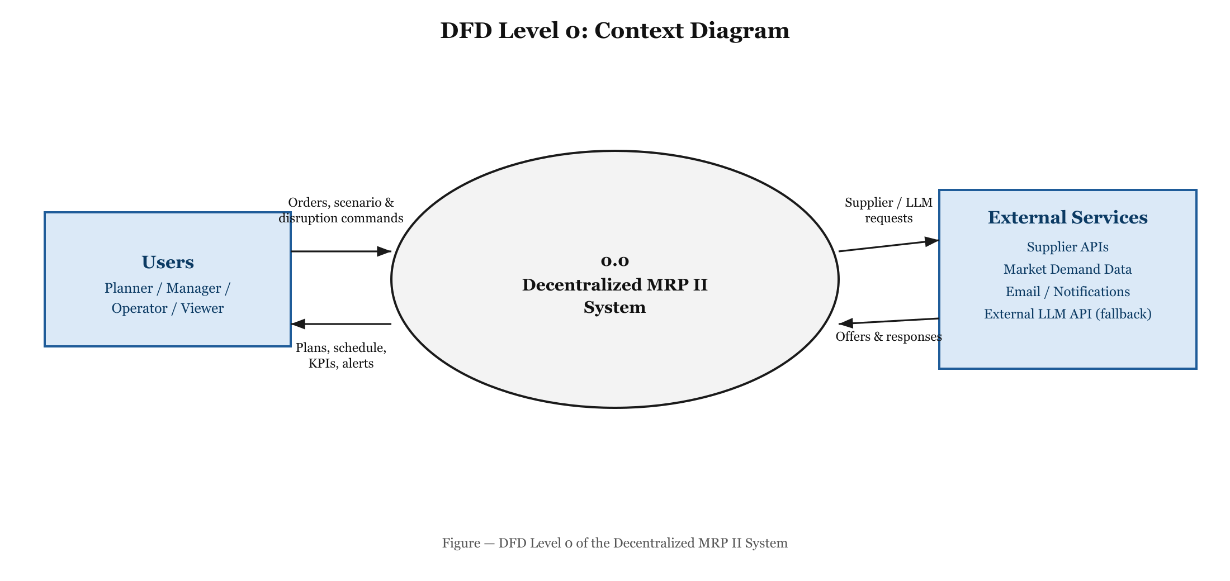
Figure 4.1: DFD Level 0 (Context Diagram) of the Decentralized MRP II System

4.2 Data Flow Diagram — Level 1
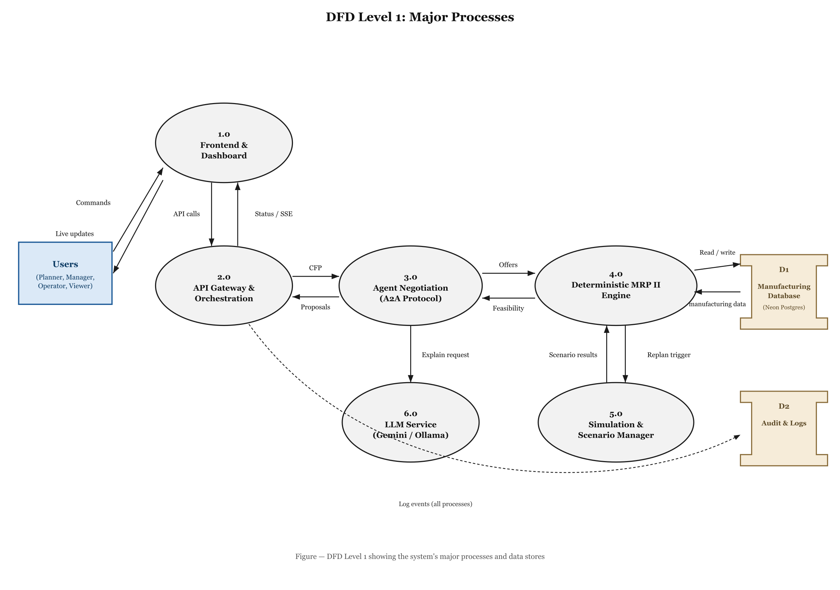
Figure 4.2: DFD Level 1 showing the system's major processes and data stores

4.3 Use Case Diagram
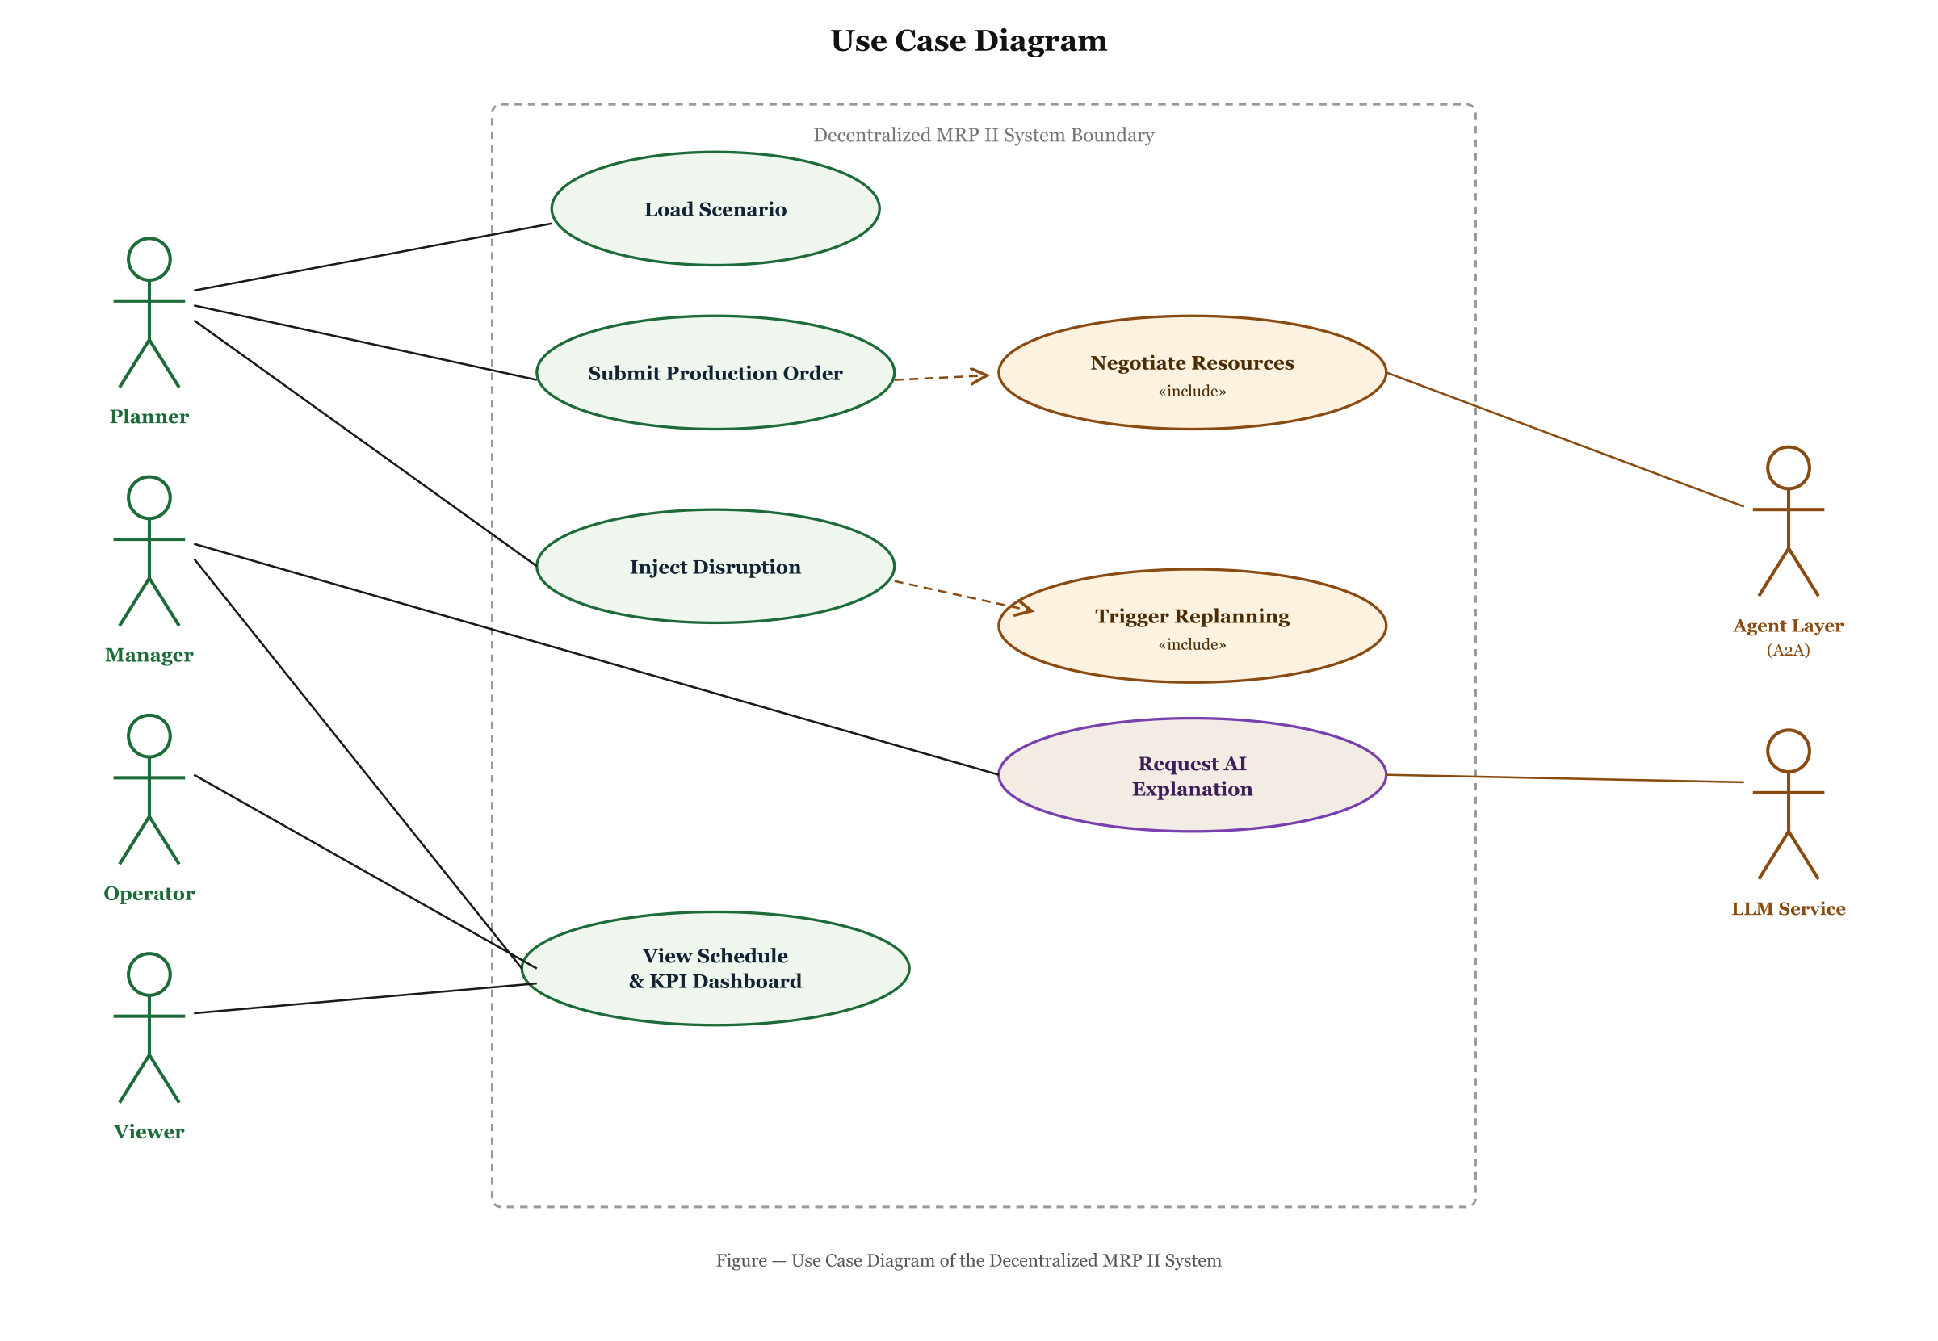
Figure 4.3: Use Case Diagram of the Decentralized MRP II System

4.4 Activity Diagram
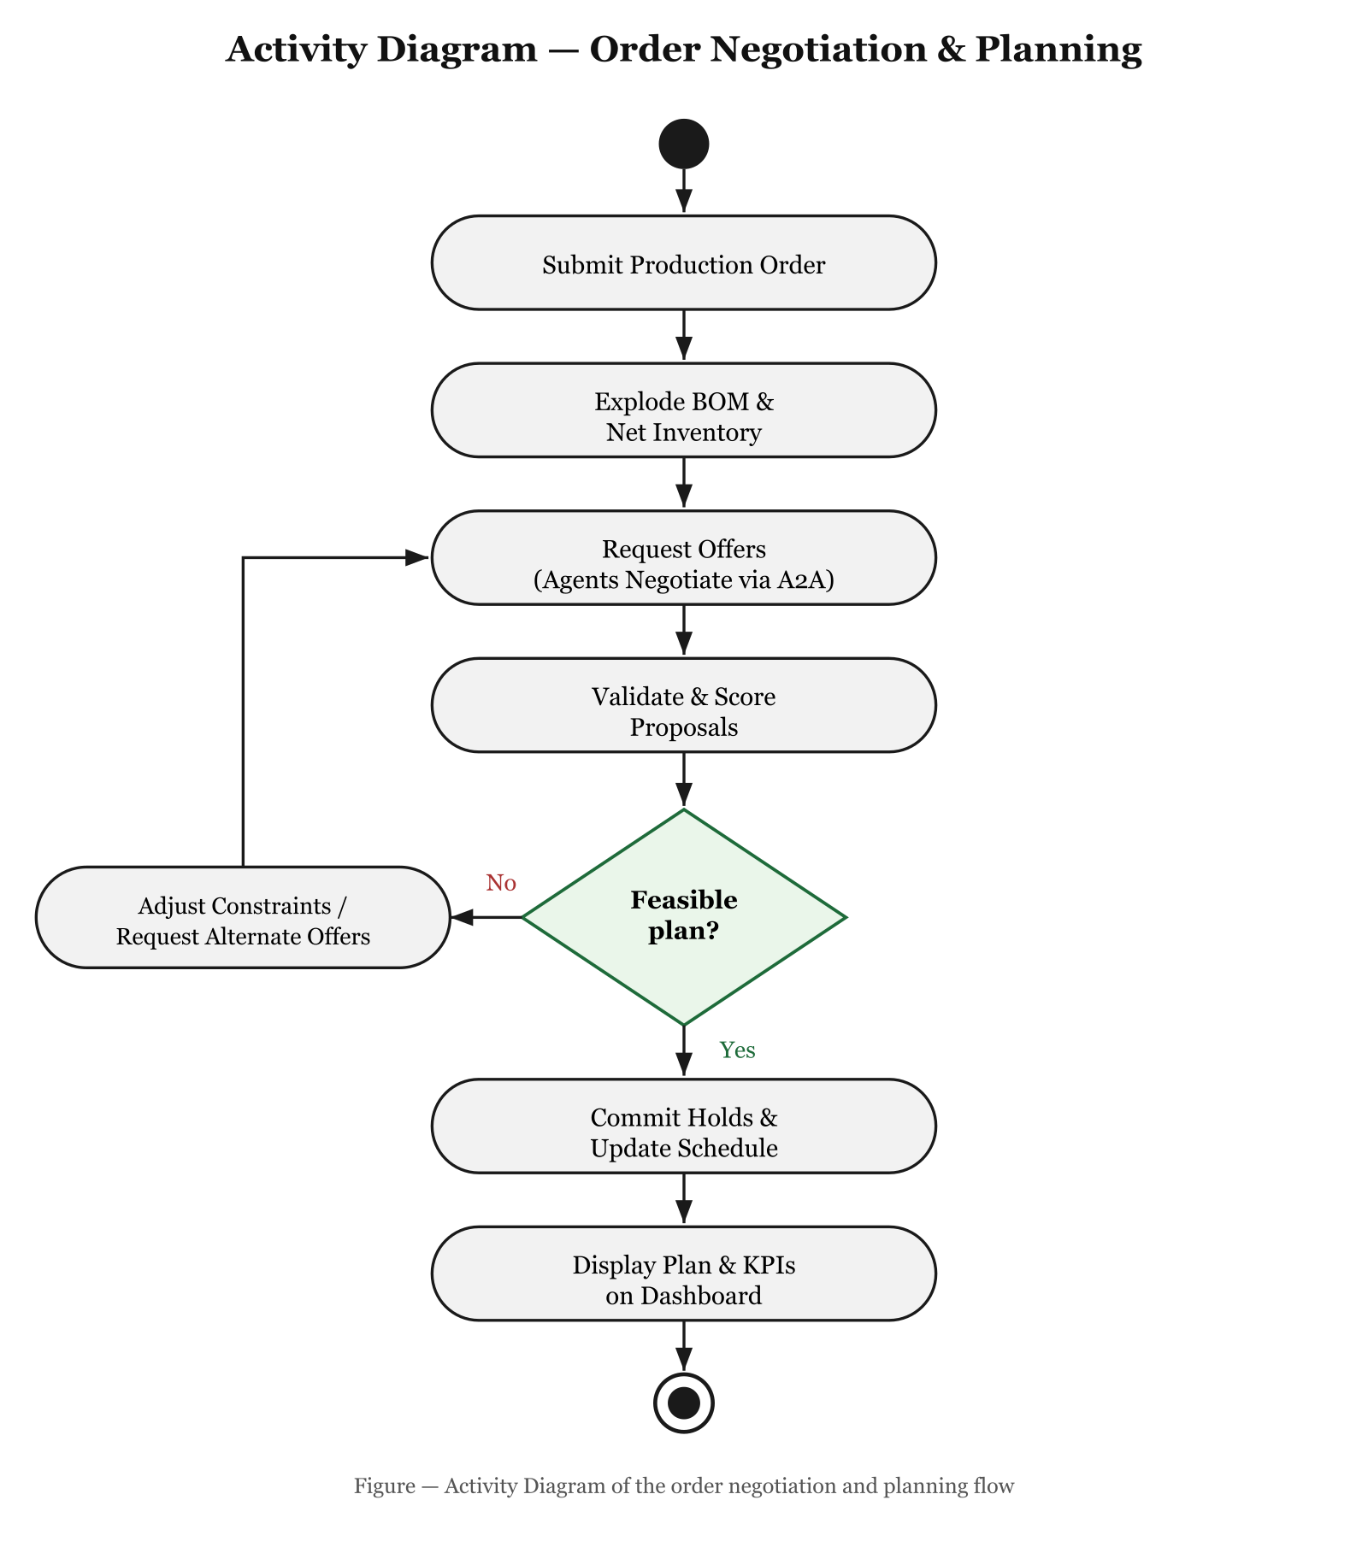
Figure 4.4: Activity Diagram of the order negotiation and planning flow

