2022

[Coding Complexities]

Contents
Customised Exception 3
Global Variables 4
Click Events 5
Usage of Regex 7
Email Validation 8
Postcode Validation 9
Confirmation Form Receiving and Displaying Data 10
Automatic Archiving of Historic Bookings and Deletion of Future Bookings from Deleted Customers 11
Selecting a Booking from Clicking on The DataGridView 12

Customised Exception
In my system I have made use of a customised exception to display a specialised error message. I have used this to display an error message in the case of a booking overlapping with another pre-existing booking
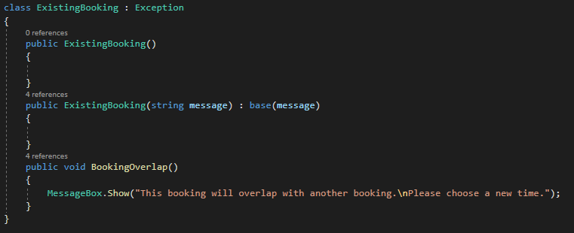
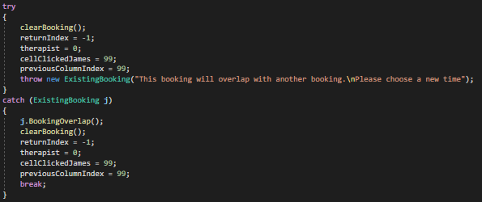

Global Variables
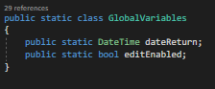
In my code I have made use of something I call “Global Variables”. Just by putting variables into a class they can be accessed and used throughout the entire project, not bound by form. This has been used to keep track of the last date booked and if edit is enabled.

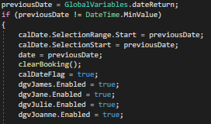

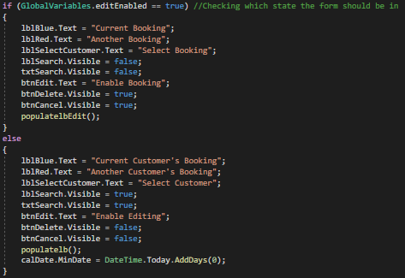

Click Events
In my code the click events handle almost all of the validation for bookings. The screenshots show a single click event whilst in the code there is 4. Only 1 has been shown to not clutter the document. The difference between the 4 events is very minor, only varying for the schedule or name of each therapist.
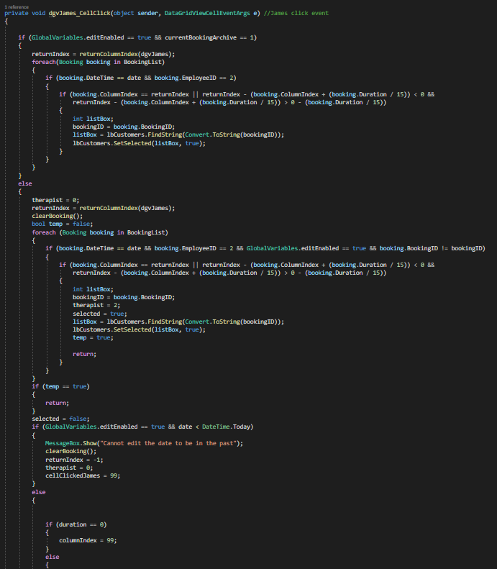

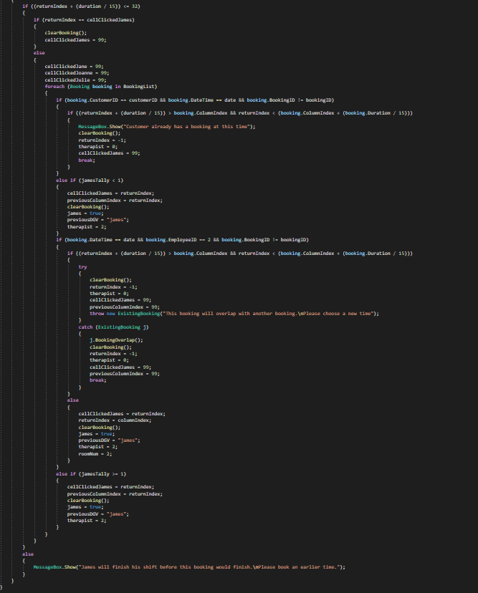

Usage of Regex
The usage of regex throughout my code has allowed me to make my code more versatile. Primarily it has been utilised in getting numbers from strings of characters. Without regex many aspects of my code would be significantly more complicated.
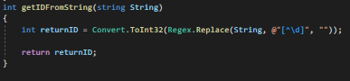
These get the first digits encountered in a string

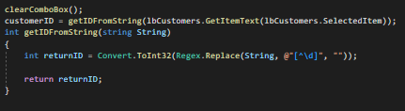

This capitalises the first character of each word in a string

Email Validation
The email validation is used to confirm that an email contains both an “@” and a “.com” or “.co.uk” and will not allow a user to save a customer without an email with these validations.
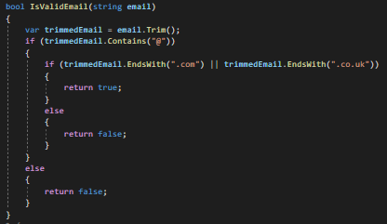

Postcode Validation
The postcode validation will only allow a user to enter a valid postcode. Beginning with 2 letters, then a number or 2 and confirming it has a length of 5-7 characters.

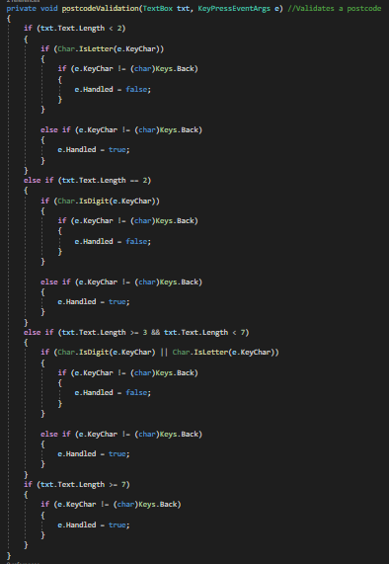

Confirmation Form Receiving and Displaying Data
The confirmation form is a nice section of the system. It clearly displays summary data of the current booking before it is saved. The form itself, however, must receive all the necessary data from the booking form. This is a small bit of complexity that is quite effective.
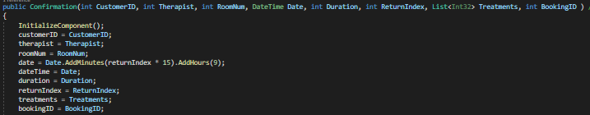
And the code to display the information.
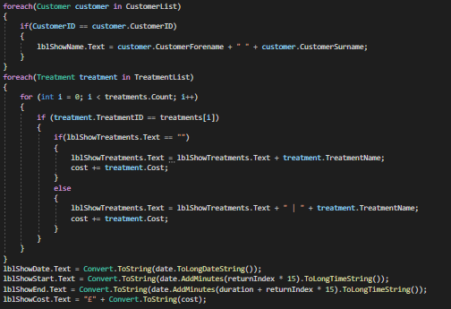

Automatic Archiving of Historic Bookings and Deletion of Future Bookings from Deleted Customers
My code will automatically archive historic bookings and delete any future bookings that still exist from a previously deleted customer. This is good as it minimises error while editing and to stop the therapists from attempting to serve a customer that may no longer exist.
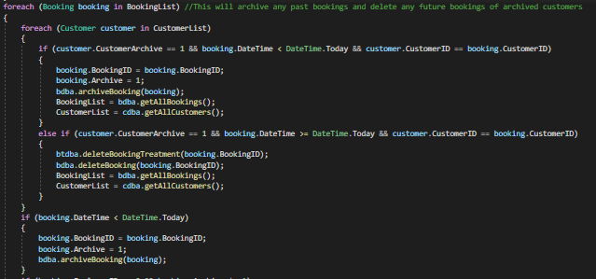

Selecting a Booking from Clicking on The DataGridView
When editing is enabled, the user can click on a booking. This will automatically select the booking and display the details. When considering this it also had to be considered that the system may assume the user is trying to place a booking at that position. However, the code has been designed to handle this kind of input and as such is a good complexity. It is identical in each of the 4 click events.
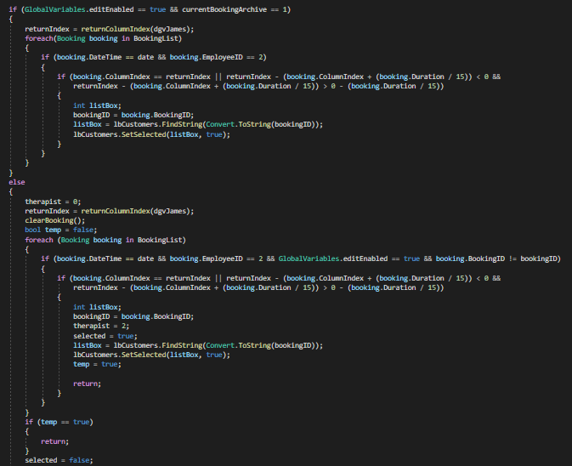

CheckBox Checked Event
This event is checked constantly using timers in my code. It will automatically update the DataGridView with new durations of bookings. It will also check for validations. This method also makes use of tuple to return multiple data types.
