Memory Manager for Mac
Complete Installation & Setup Guide

IMPORTANT: About Terminal Windows
This app uses Terminal windows as part of its normal operation. You will see Terminal windows appear when:
• Running the setup (first time only)
• Opening Memory Manager
This is completely normal and not a cause for concern. The Terminal windows are how Mac runs Python programs. Although it may seem convoluted, this is the easiest way to get the program working on Mac without a paid Apple Developer certificate.

What is Memory Manager?
Memory Manager is a desktop application that helps you download and organize all your Snapchat memories from your data export. Instead of manually downloading hundreds or thousands of photos and videos one by one, this tool automates the entire process.

Key Features:
- Downloads all your Snapchat memories automatically and securely
- Organizes files by date and time
- Handles both photos and videos
- Merges overlays (text, stickers, filters) with your media
- Shows real-time progress with pause/resume capability
- Retries failed downloads automatically
- Works on Windows and Mac

Privacy & Security
Memory Manager is designed with your privacy as the top priority. Here's what you need to know:
Everything Stays Local: The app runs entirely on your computer. Your photos, videos, and data never leave your device except when downloading directly from Snapchat's servers.
No Data Collection: We don't collect, store, or transmit any of your personal information, photos, or videos. There are no analytics, tracking, or data harvesting of any kind.
Direct Downloads Only: When downloading your memories, the app connects directly to Snapchat's official servers using the URLs from your data export. We never act as a middleman.
No Account Required: You don't need to create an account or provide any login credentials to use Memory Manager. You only need the data export file that Snapchat provides to you.
No Internet Except for Downloads: The app only uses your internet connection to download files from Snapchat. It doesn't communicate with any other servers or services.
Open Source Approach: The code is straightforward and readable. If you're technically inclined, you can review exactly what the app does before running it.

How Memory Manager Works
Understanding what happens behind the scenes:
Reading Your Data: The app reads your memories_history.html file to find all your photos and videos
Downloading Media: It downloads each file from Snapchat's servers using the URLs in your data
Handling Overlays: For memories with text, stickers, or filters, it downloads both the original media and the overlay, then merges them together
Organizing Files: Files are saved with their date and time as the filename (e.g., "2024-01-15_14-30-45.jpg")
Error Handling: If a download fails, it's tracked so you can retry just that file later

File Naming Convention:
Your files will be named using the format: YYYY-MM-DD_HH-MM-SS.extension
Examples:
• 2024-03-15_14-30-45.jpg = March 15, 2024 at 2:30:45 PM
• 2023-12-25_09-15-00.mp4 = December 25, 2023 at 9:15:00 AM

Running the Program

Requirements
• Python 3.10 or newer
• macOS 10.13 or newer
• Internet connection (for one-time library installation)

Step 1: Install Python
If you already have Python 3.10 or newer installed, skip to Step 2.

Download Python:
Go to https://www.python.org/downloads/
- Click the yellow "Download Python" button (it will show the latest version)
- The installer file will download (usually to your Downloads folder)

Install Python:
- Open the downloaded .pkg file
- Follow the installation wizard
- Click "Continue" through the prompts
- Click "Install" when prompted
- Enter your Mac password if requested
- Wait for installation to complete
- Click "Close" when finished

Step 2: Download & Extract Memory Manager
- Download the Memory_Manager_Mac.zip file
- The file will download to your Downloads folder
- Double-click the ZIP file to extract it
- A folder called "Memory Manager" will appear
- Move this folder to a location you can easily find (Desktop or Documents recommended)

Step 3: Get Your Snapchat Data
Before using Memory Manager, you need to download your data from Snapchat.

Request Your Data:
- Open the Snapchat app on your phone
- Tap your profile icon (top left)
- Tap the settings gear icon (top right)
- Scroll down to "My Privacy & Data"→ "My Data"
- Tap "Export Your Memories"
- Tap "Request Only Memories"
- Select "All Time" from the date options
- Enter your email then tap "Submit" at the bottom

Download Your Data:
- Wait for Snapchat to email you (usually 24-48 hours)
- Check your email for a message from Snapchat
- Click the download link in the email
- Download the ZIP file
- Extract the ZIP file to a folder on your Mac
- Look for a folder called "mydata" - this is what you'll select in Memory Manager
Important: Download links expire in 24-72 hours. Download your data as soon as you receive the email!

Step 4: Bypass Mac Security (First Time Only)
Mac will block the app because it's from an "unidentified developer." You need to allow both files to run. This is a one-time process - after this, the app will open normally.

Part A: Allow "1 - Run Setup (First Time Only)"
- Open the "Memory Manager" folder
- Double-click "1 - Run Setup (First Time Only)"
- Mac will show a warning: "Apple could not verify... free of malware"
- Click "Done" (do not click "Move to Trash") (See “Photo 1”)

- Open System Settings (Apple menu → System Settings)
- Click "Privacy & Security" in the left sidebar
- Scroll down to the "Security" section (See “Photo 2”)
- You'll see: "1 - Run Se...y).command was blocked to protect your Mac."
- Click the "Open Anyway" button next to this message (See “Photo 3”)
- A new dialog will appear - click "Open" again
- Enter your Mac password if prompted
- The Setup wizard will now run in Terminal

Note: See screenshot "Photo 1" for the first security warning.
Note: See screenshot "Photo 2" for the Security section in System Settings.
Note: See screenshot "Photo 3" for the security warning dialog.

Part B: Allow "2 - Memory Manager"
- After Setup completes, go back to the "Memory Manager" folder
- Double-click "2 - Memory Manager"
- Mac will show the same security warning
- Click "Done"

- Go back to System Settings → Privacy & Security → Security
- You'll see: "2 - Memory Manager.command was blocked to protect your Mac."
- Click "Open Anyway"
- Click "Open" in the confirmation dialog
- Enter your Mac password if prompted
- Memory Manager will now open!
Note: See screenshot "Photo 1" for the first security warning.
✓ Success! After completing these steps once, you can simply double-click "2 - Memory Manager" to open the app. No more security warnings!

Step 5: Understanding Terminal Windows
When you run Memory Manager, you'll see Terminal windows. This is normal and expected.
What happens:
- When you run "1 - Run Setup": Terminal opens, shows installation progress, then closes automatically
- When you run "2 - Memory Manager": Terminal appears briefly, then minimizes to your Dock
- The Memory Manager window opens and works normally
- Terminal stays minimized in the Dock while you use the app
- When you close Memory Manager, press Cmd+Q on the Terminal icon in the Dock to fully close it
Don't be alarmed by Terminal windows - they are simply the way Mac runs Python programs. Your data remains private and secure on your computer.

Step 6: Run Setup (First Time Only)
- Double-click "1 - Run Setup (First Time Only)"
- Terminal will open with the Setup wizard
- Press Enter to begin
- Wait for Python libraries to install (2-3 minutes)
- Terminal will close automatically when complete
This only needs to be done once.

Step 7: Use Memory Manager
Now you're ready to download your memories!
- Double-click "2 - Memory Manager"
- Terminal will appear briefly and minimize to the Dock
- The Memory Manager window opens
- Click the orange "Browse Folder" button
- Navigate to and select your "mydata" folder (from Step 3)
- Select the location your memories will be saved to: they will save in a folder named “snap_memories”
- Memory Manager will scan your memories and show you the count
- Click the green "Start Download" button
- Wait for downloads to complete (you can pause/resume if needed)
- Once complete you can select “Retry Failed” if you had and items that failed to download
- When finished, close the app and press Cmd+Q on Terminal in the Dock

Troubleshooting

Problem: "Python not found" error
Solution: Install Python from python.org and run Setup again.

Problem: "Libraries not installed" error
Solution: Open Terminal and run: python3 -m pip install --user requests beautifulsoup4 Pillow opencv-python numpy

Problem: Can't find "Open Anyway" button
Solution: Make sure you clicked "Done" on the security warning first (not "Move to Trash"). Then immediately check System Settings → Privacy & Security → Security section.

Problem: Terminal won't close
Solution: Click the Terminal icon in the Dock, then press Cmd+Q to quit.

Problem: App won't open after security bypass
Solution: Try restarting your Mac, then double-click the file again.

Problem: Downloads are failing
Solution: Check your internet connection. If some downloads fail, use the "Retry Failed" button after the initial download completes.

Tips & Best Practices
- Downloads are processed 5 at a time for speed - this is normal!
- The download may take a while depending on how many memories you have
- You can pause and resume downloads at any time
- All processing happens on your computer - your data stays private
- Downloaded files are automatically organized by date and time
- Snapchat overlays (date/time stamps) are merged with your photos and videos
- Terminal windows are normal - don't be concerned when you see them
- Keep the Terminal window open while using the app (it will be minimized in the Dock)
Memory Manager - Download and organize all your Snapchat memories

Photo 1

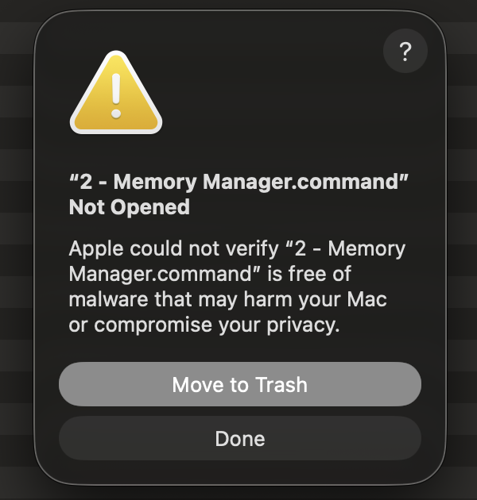

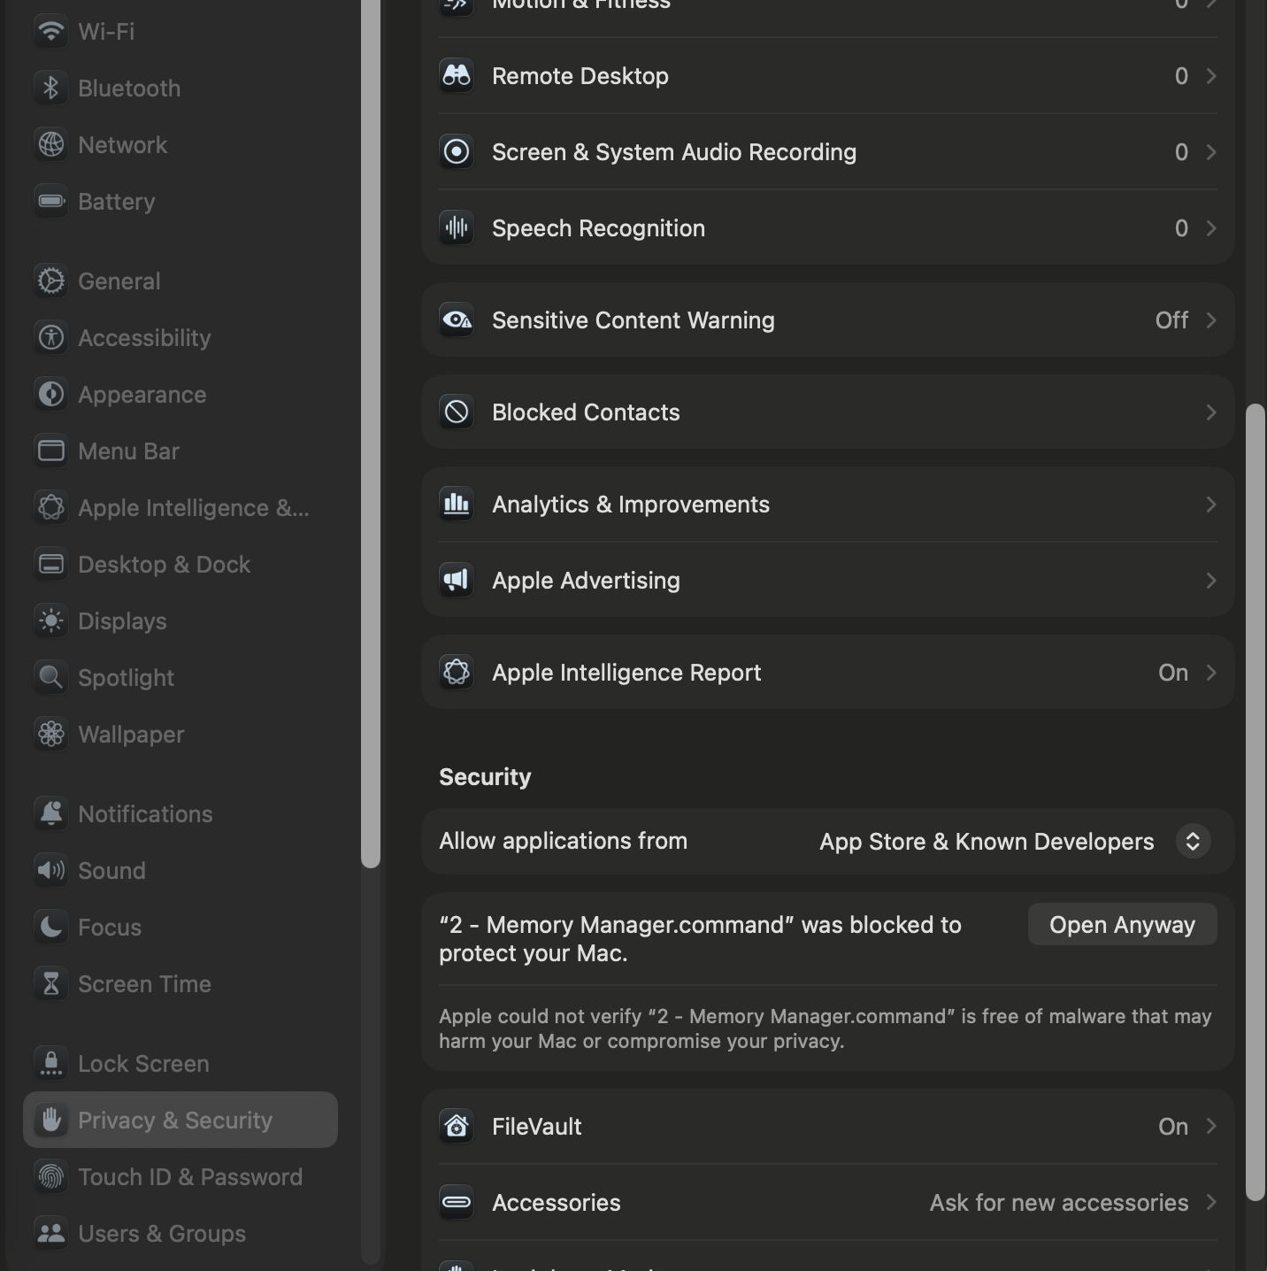

Photo 2

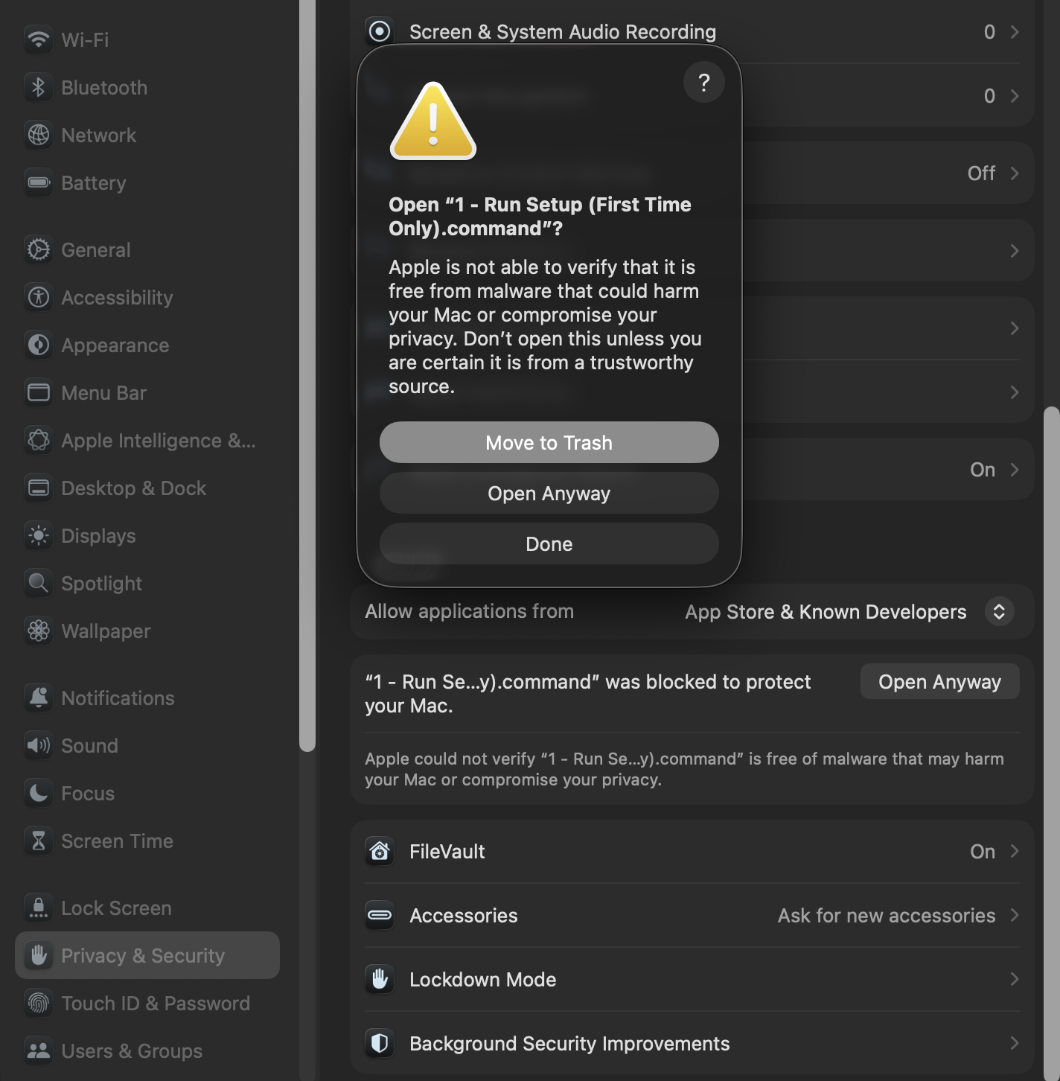
Photo 3

