Application: La Canada Engineering Club

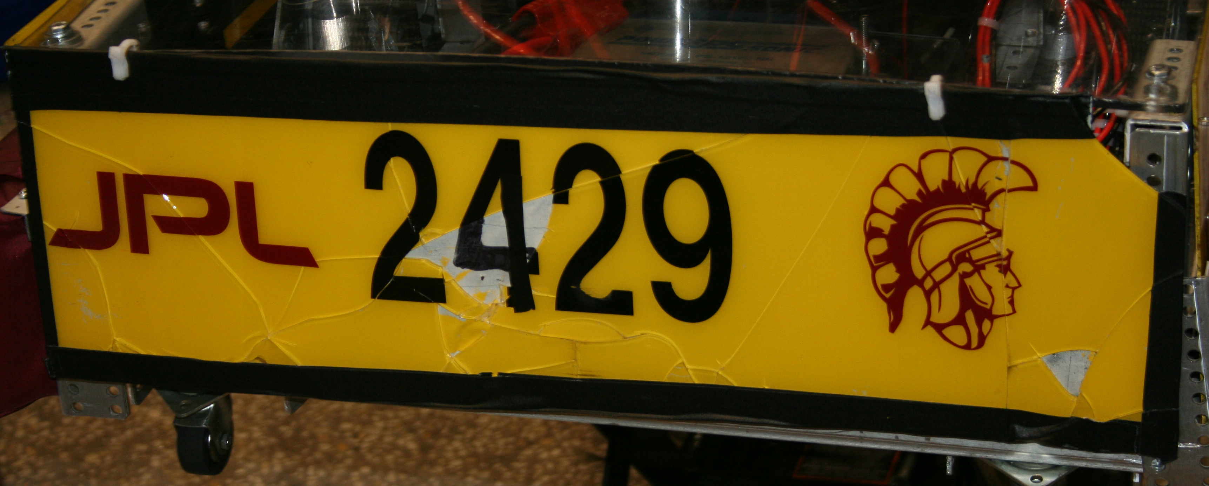

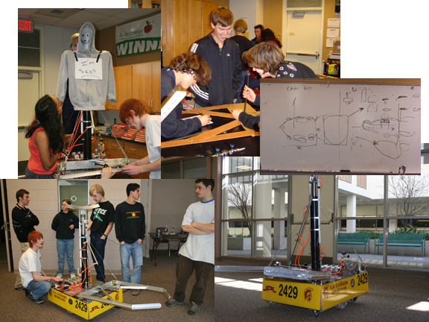

 TEAM 2429

La Canada High School - JPL
Membership in the La Canada Engineering Club

All students (both new and returning) will proceed though the application process with the exception of the Application Committee. The Application Committee will consist of the Leadership Team (President, Vice-President, Secretary, Treasurer) and one “at large” member selected by the Leadership Team upon petition and the team Coach. The Application Committee will conduct the application process.

All returning students shall apply for membership in the La Canada Engineering Club in the spring of the proceeding year. New students may apply in the spring or fall recruiting period. From the club membership, the Robotics Team shall be chosen. The primary determinate for team membership is “devotion to duty”. Once a member has dropped below 80% participation in after-school work time, the member is on probation and has two weeks to make up any deficiency. If after the probation period has passed and the time is not made up, the member drops to club membership and may reapply for team membership in the following year.

The application process will consist of the following:

- A letter of interest: typed and conforming to the proper standards of writing for business letters.
- Student Data Sheet
- Complete General Essay Questions
- Complete Specific Multiple Choice Quiz on First Overdrive Game: Online
- Complete OSHA 10 Hour Training: Online
- Signed Club Contract and Media Permission

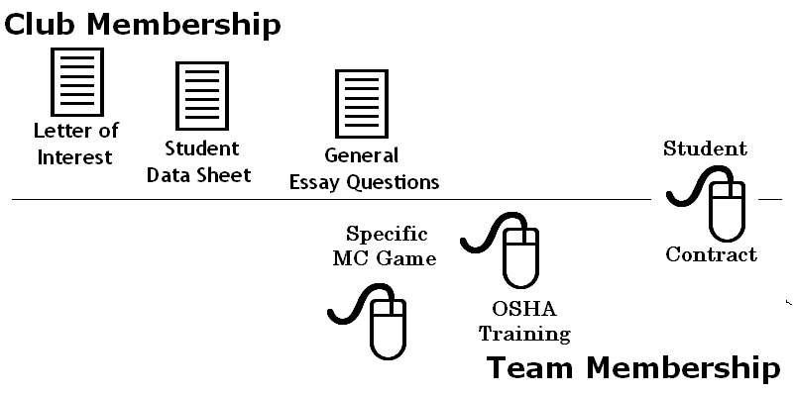

 | Student  Data  Sheet

Name: __________________________________________

Address: ________________________________________

Phone: ____________________

Email: _____________________

Parent/Guardian: __________________________________

Parent/Guardian: __________________________________

How did you first hear of LC Engineering?
? Friend ? Teacher/Guidance Counselor
? Announcements ? Other
? Team Member

Do have any experience with: (check all that apply).
? AutoCAD ? Pneumatics ? 3-D Studio Max
? Electronics ? Computer Animation Software ?Carpentry
? Machine Tools ?R/C (radio controlled) hobbies ? Computer Programming
Robotics ? Welding ?Budget/Finance
? Web page design ?Video production ? Graphic design
? Journalism ?Fundraising ? Leadership positions
(specify positions)
Schedule:
- _______________ 2 _______________ 3 _______________
- _______________ 5 _______________ 6 _______________
After School _______________ Weekend _______________

General

Essay

Questions

  - What do you see as you top three personal strengths, give an example of how you have used each.

  - What do you see as your personal weakness, give an example.

  - What does Gracious Professionalism mean to you?

  - Have you ever helped someone learn something new? Give an example.

  - Give an example of how you have specifically set an example for another peer or team member.

  - Please include anything else that might be valuable in getting to know you.

~~~ returning members complete 7 and 8 ~~~

  - List five Attainable New Ideas on how to promote FIRST in our community.

  - List five Attainable New Ideas on how to increase our fundraising.

La Canada Engineering Club Student Contract

- During the robot build phase (January to February), engineers are expected to attend SSR/STEP. If STEP, that would be enrolling for the second and third quarters, Monday through Friday. Engineers are responsible for signing onto the computer for recording work hours.
- During the robot build phase, Engineers are also expected to attend significant periods of after school and weekend work sessions, flexibility in the student’s schedule is required. Engineers falling below 80% participation will have two weeks to “catch up” otherwise the engineer will be dropped from Team membership and may reapply the following year.
- It is mandatory that Engineers be available for the Kick-Off presentation which will happen somewhere around the 1st of January (TBA), so please plan your holiday vacation accordingly.
- After the build phase, we will move to the competition phase. Engineers are expected to attend additional practices.
- Engineers will miss school on the competition days. This is an official school field trip and the absences will be excused. However engineers are responsible for completing their homework.

Documentation of attendance
- Engineers are responsible for signing onto the computer during any club or team function. Absences for school events, with note signed by teacher, are approved. Absences for religious holidays are also approved.

Parent Meeting
- Parents, please attend our fall parent meeting for the club. We look forward to meeting you and sharing what we have planned. Please consider volunteering to help the Team.

Please return with this application to Mr. Zimmerman (rm 322):
I have read the above guidelines and agree to the expectations of the La Canada Engineering Club
____________________________________ __________________________________
Student Name (print) Student Signature Date

____________________________________ __________________________________
Parent/Guardian Name (print) Parent/Guardian Signature Date

MEDIA PERMISSION
for
La Canada Engineering Club

____ I GIVE permission for my student to participate in the following activities when representatives of the media have been permitted by the principal to be on campus or at any First event:
___observe ___interview ___photograph ___film

_____ I GIVE permission for my student’s picture and name to be used in any electronic or printed material associated with La Canada Engineering, the only identifying information will be the student’s first name and year in school.

____ I DO NOT want my student to participate in any media events.

____ I DO NOT want my student’s picture to be used in any way.

______________________________ and/or ______________________________
SIGNED (father/male guardian) DATE SIGNED (mother/female guardian) DATE

How to Write a Business Letter

Business letters are used as ways of communicating between companies. They may be used to request information, send information, sell products or for dozens of other reasons. Either way, business letters must look professional. A letter from your company is often the first impression that a potential client or buyer receives about your business. You want that first impression to be a good one and the way to do that is to format your business letters correctly and professionally.

Each basic part of a business letter is listed below with a complete explanation of its purpose. An example letter is provided as a reference at the end of this article.

Heading
The heading of a letter is the address of the sender. Most businesses have a letterhead with this information already imprinted. If you do not have a pre-printed letterhead, you can create one on your computer that looks very professional. You should include the name of the company, the address, phone and fax numbers and e-mail address. You may also choose to include your company's logo. If you are not using a letterhead, you should enclose a return address, this is simply the address of the letter's sender.

Date Line
The date line is just what it implies, the date. The month should be written out in full, followed by the date and the year, also written out in full. Example: January 1, 2000. If you are using a company letterhead, the date line should be typed three lines below the heading. If you are using a return address, type the date line directly below the return address, leaving no spaces.

Inside Address
The inside address is the name and address of the person or business that you are sending the letter to. The person the letter is addressed to is also called the addressee. Type the inside address five lines under the date line. The inside address should contain the same information that will be used on the envelope.

Salutations
The salutation is the letter's greeting. It should be typed two lines underneath the inside address. Include the addressee's name and courtesy title along with the greeting. Example: Dear Mrs. Pipes

Body of Letter
The body of the letter is where you discuss the purpose of the letter. The body begins two lines below the salutation. Usually the body paragraphs should be single spaced with two spaces between each paragraph. If the letter is very short, you may use double spaces between the sentences to give a balanced look to the letter.

Complimentary Close
The complimentary close is a courtesy signal at the end of each letter. It should be typed two lines below the body of the letter. Keep your complimentary close professional. Never close a business letter with Love, Your Friend or any other personal notation. Some good, professional choices are Sincerely, Cordially, Regards, and Respectfully.

Writer's name and title
The writer's name should be typed on the fourth line following the complimentary close. The writer's title should be on the line directly below the name. The space in between the complimentary close and the typed name, is to be used for the writer's signature.

Example: Jeremy Christopher
Vice President

There are two basic styles in which to write a business letters. They are the block format and the modified block format with indented paragraphs. In the block format, all parts of the letter are started at the left margin. The body of the letter is single spaced, with one line left between each paragraph. The paragraphs are not indented. The modified block with indented paragraphs is very similar to the block format. The difference is that each paragraph is indented five spaces.

