Magpie CMS API Developer Documentation

PHP Version (Continued from W17 team)

Date Last Modified: 27. May. 2018

API code: https://github.com/rkwitz/magpie-php
Frontend code: https://github.com/EthanTuning/Magpie-CMS-Website

API user documentation: https://documenter.getpostman.com/view/4418001/RW87rVjU

Table of Contents
Introduction 2
Frameworks and Tools: 2
Constraints: 3
Data Models 4
Hunt 4
Hunt Status 5
Badge 6
Award 6
Notes 7
API Overview 8
Routing 8
Endpoints 9
UML Diagram 10
Database 11
References 12

Introduction
This is documentation for developers working on the Magpie API codebase. For the API user documentation, see the link at the bottom of the document.

Magpie is a geocaching application for phones. For information about geocaching, see https://en.wikipedia.org/wiki/Geocaching. The web-based Application Programming Interface (API) is used to serve both the phone application (currently for Android systems) and the Content Management System (CMS). The CMS was created to allow users to create and manage their data.

The API attempts to adhere to an architectural style known as “Representational State Transfer.” This style applies object-orientated paradigms to web-enabled resources. Traditional web APIs emulated Remote Procedure Calls (RPC). The RESTful API aims for more flexibility and does not distinguish between client types. The Android application and browser-based CMS utilize the same API endpoints. A list of resources on the topic of RESTful API design can be found at the end of this document.

Frameworks and Tools:
- PHP v7
  - Composer
    - to manage dependencies and 3rd party PHP libraries
  - Slim v3
    - A very useful mini-framework for mapping URL endpoints to Controllers written in php
    - Also, Slim Middleware is used to ensure authentication when users connect to the API
  - Kreait’s firebase-php library
    - Google does not provide php libraries for their Firebase project (probably to force everyone to use Go or Python), this 3rd party library used instead.
  - PhpMailer
    - Used to send emails to users. Note: Currently disabled, however it did work, just not reliably enough to push live.
  - phpMyAdmin
    - To manage the MySQL easier
- Google Firebase
  - Google OAuth2 tokens provided by Firebase Authentication
- MySQL
  - Opensource relational database used for data storage
  - MariaDB could probably be used with zero configuration changes
- SSL/TLS
  - Since the API uses a Bearer token to authenticate, SSL is an absolute must to prevent session hijacking and credential leakage

Constraints:

- API and CMS website must deploy to Bluehost shared hosting site already owned by client
- CMS website must allow a single user both admin and regular user functionality

Data Models

The API exists to store and retrieve data. The first step is defining what kinds of data we need to store and their relationship with each other. Each data structure is tied to it’s own table in the database. The data fields of an object are stored in the database. However, it’s representation is converted to JavaScript Object Notation (JSON) by the API before being returned to the client.

Illustration 1: Hunt Abstraction

Hunt
The core unit of this entire project is a Hunt. A Hunt is the parent object in Magpie. It contains all other objects, usually referred to as “sub-resources” or “children.” Currently there are only two types of sub-resources, Badges and Awards.

{
"class": "hunt",
"data": {
"hunt_id": "671",
"abbreviation": "string",
"approval_status": "non-approved",
"audience": "string",
"date_end": "1902-01-10",
"date_start": "2120-12-25",
"name": "string",
"ordered": "0",
"summary": "string",
"sponsor": "string",
"super_badge": "string",
"uid": "jaksEPf7HjPI2uRA1gnQ0yhYJyy1",
"city": "City",
"state": "WA",
"zipcode": "99227"
},
"href": "https://magpiehunt.com/api/v1/hunts/671",
"subresources": [
{
"class": "badges",
"href": "https://magpiehunt.com/api/v1/hunts/671/badges",
"type": "json"
},
{
"class": "awards",
"href": "https://magpiehunt.com/api/v1/hunts/671/awards",
"type": "json"
}
]
}

The “class” attribute contains the name of the object (in this case a Hunt). The “data” attribute contains the actual data about a Hunt. Name, location, dates, etc are in here. The “href” is a self-referencing link. The “subresources” is a list of sub-resources.

The ‘subresources’ list doesn’t contain a list of actual resource objects, it contains links to them. This is a “recommended” way to handle sub-resources according to the REST style, but there is no hard rule saying you have to do this. This did save on some complexity though, by enforcing modularity.

Hunt Status
To ensure that users don’t create Hunts that could lead people to their doom, all Hunts must be reviewed by an Administrator before they can be published for public consumption. There is a field in the Hunt called “approval_status” that keeps track of this. Below is a state diagram that covers the different states:
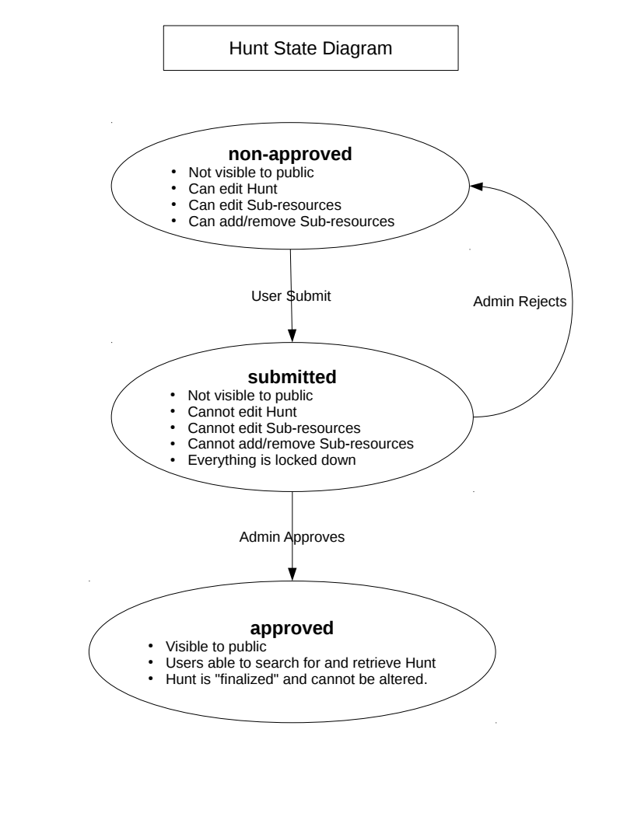

Badge
A Badge is a location in the real world. It contains the geographic coordinates of the location, as well as other data about the location.

{
"class": "badge",
"data": {
"badge_id": "7",
"description": "string",
"icon": {
"href": "https://magpiehunt.com/api/v1/uploads/f01d5bb02739777c.jpg"
},
"image": {
"href": "http://www.customURL.com/image.jpg"
},
"landmark_name": "string",
"lat": "4.54",
"lon": "-30.43",
"name": "string",
"qr_code": "qr_code string",
"hunt_id": "678"
},
"href": "https://magpiehunt.com/api/v1/hunts/678/badges/7"
}

This object has the same style as a Hunt. It has a “class”, “data”, and “href” as top-level attributes. There is no list of subresources, as the API currently can only handle one level of sub-resources. Notice how images contain an {“href” : URL} pair. This is to aid in parsing the Badge on the client side. While iterating through the attributes, if “attribute.href” exists, then it is a link.

Award
An Award is an achievement for completing a Hunt. It is structurally similar to a Badge, and on the backend, it is treated the same as a Badge. It has it’s own table in the database.

{
"class": "award",
"data": {
"award_id": "1",
"address": "string",
"description": "string",
"lat": "45.435435435",
"lon": "-39.54543",
"name": "string",
"redeem_code": "string",
"award_value": "string",
"hunt_id": "671"
},
"href": "https://magpiehunt.com/api/v1/hunts/671/award/1"
}

Notes
Images are currently referred to by URL in objects. When images are uploaded, a PHP controller saves the image to disk with a pseudo-random filename in the uploads/ directory. The saved filepath is converted to a URL and stored in the appropriate column in the database. This is not ideal.

The last team used a separate database table to store image data. This table could store the owner of the image, the name, the type, and any other data associated with it. The image would still be saved on the local filesystem, but the database would hold additional information. This is probably a better way to handle image files. We started getting crunched for time, hence our current approach of throwing all files into the uploads/ folder and having absolutely no storage structure.

API Overview

There’s three main parts to the API:

- The Slim application
- The Controllers
- The Mapper class

Routing

The Slim application is responsible for taking a HTTP request, routing it to the correct Controller, and returning a response. Added on to the Slim application are Middleware layers that handle Authenticating the client with Firebase, making sure the client exists in the database, and checking if the client is an administrator. There is also a middleware layer that handles CORS compatibility, which is a massive pain.

Once the request is routed to the appropriate Controller class, the controller creates an instance of a Mapper, and uses the Mapper to interface with the database. In some cases the controller performs SQL queries directly (The AdminController does this). The controller also has to send client input to the Mapper by using an object such as Hunt, Badge, or Award. These objects implement an IMapperable interface for use by the Mapper. They also only allow certain fields to be entered, and will ignore any data not allowed (see comments in source code).

Once the IMapperable object reaches the Mapper, a series of checks are performed to determine whether or not the object can be placed in the database, or if data can be returned. The Mapper then returns data in an associate array (or an array of associative arrays depending on the function performed).

This data is then JSON encoded by the Controller, and sent back to the client.

Endpoints
In general a URL specifies a resource, so “magpiehunt.com/api/v1/hunts” references the Hunts resource. The HTTP verbs like GET, POST, and DELETE are actions to perform on that resource. A POST sent to /hunts means that a client wants to create a Hunt.
If there’s a number following the resource, it’s referring to that specific resource, ex: “magpiehunt.com/api/v1/hunts/2322”. A GET send to that URL indicates someone wants to retrieve that resource.
Sub-resources are tacked on to their parent resource IDs. A badge for example is “magpiehunt.com/api/v1/hunts/2322/badges/3”.
This is a pdf file in the documentation/ folder. This flowchart depicts the endpoints of the API that a client would use. The ‘approved’ endpoint was never completed.
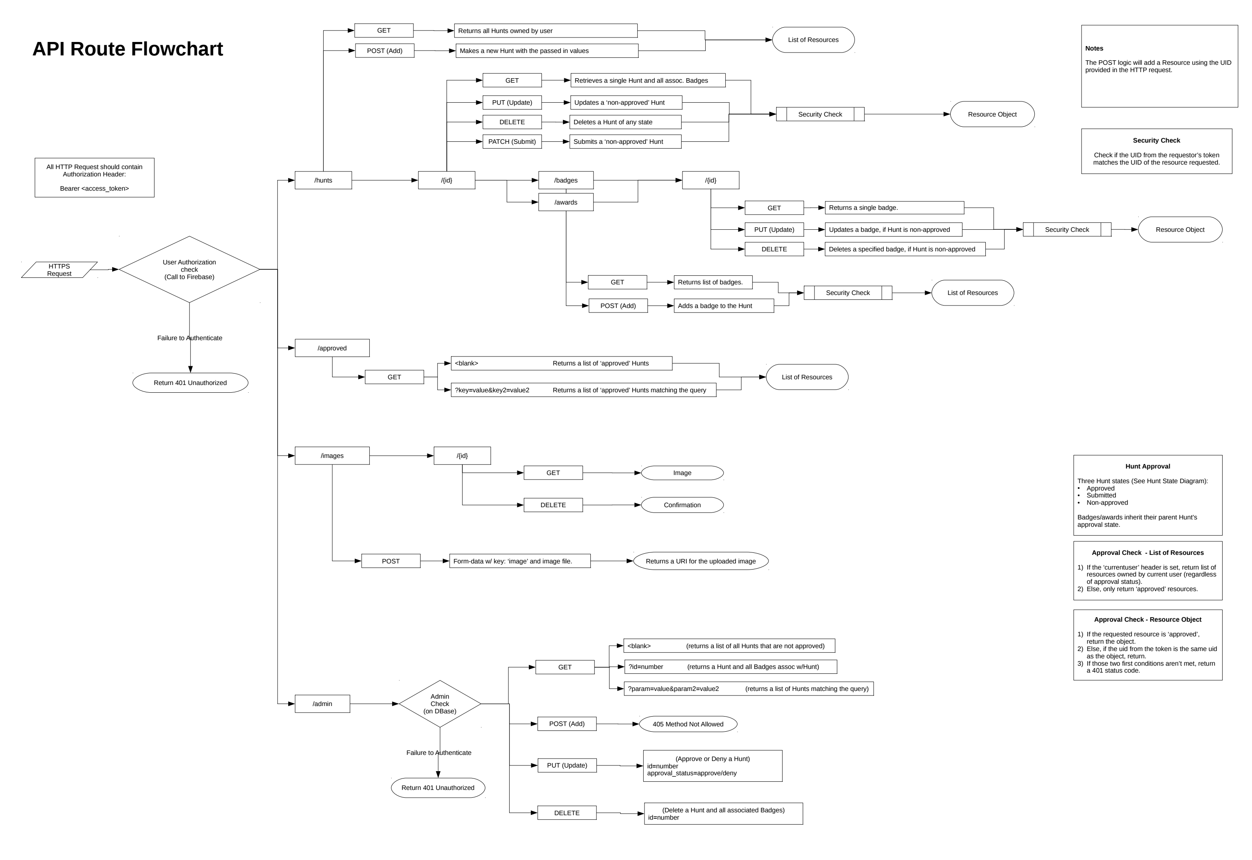

UML Diagram
This is a pdf export of the “documentation/UML_overview.uxf”, which is editable by UMLet. UMLet is a really neat UML creator.
To save on clutter I didn’t mention the namespaces of the classes. Namespaces are the PHP equivalent of Java packages.
For more information on the classes, see the comments at the top of the PHP file for each class.

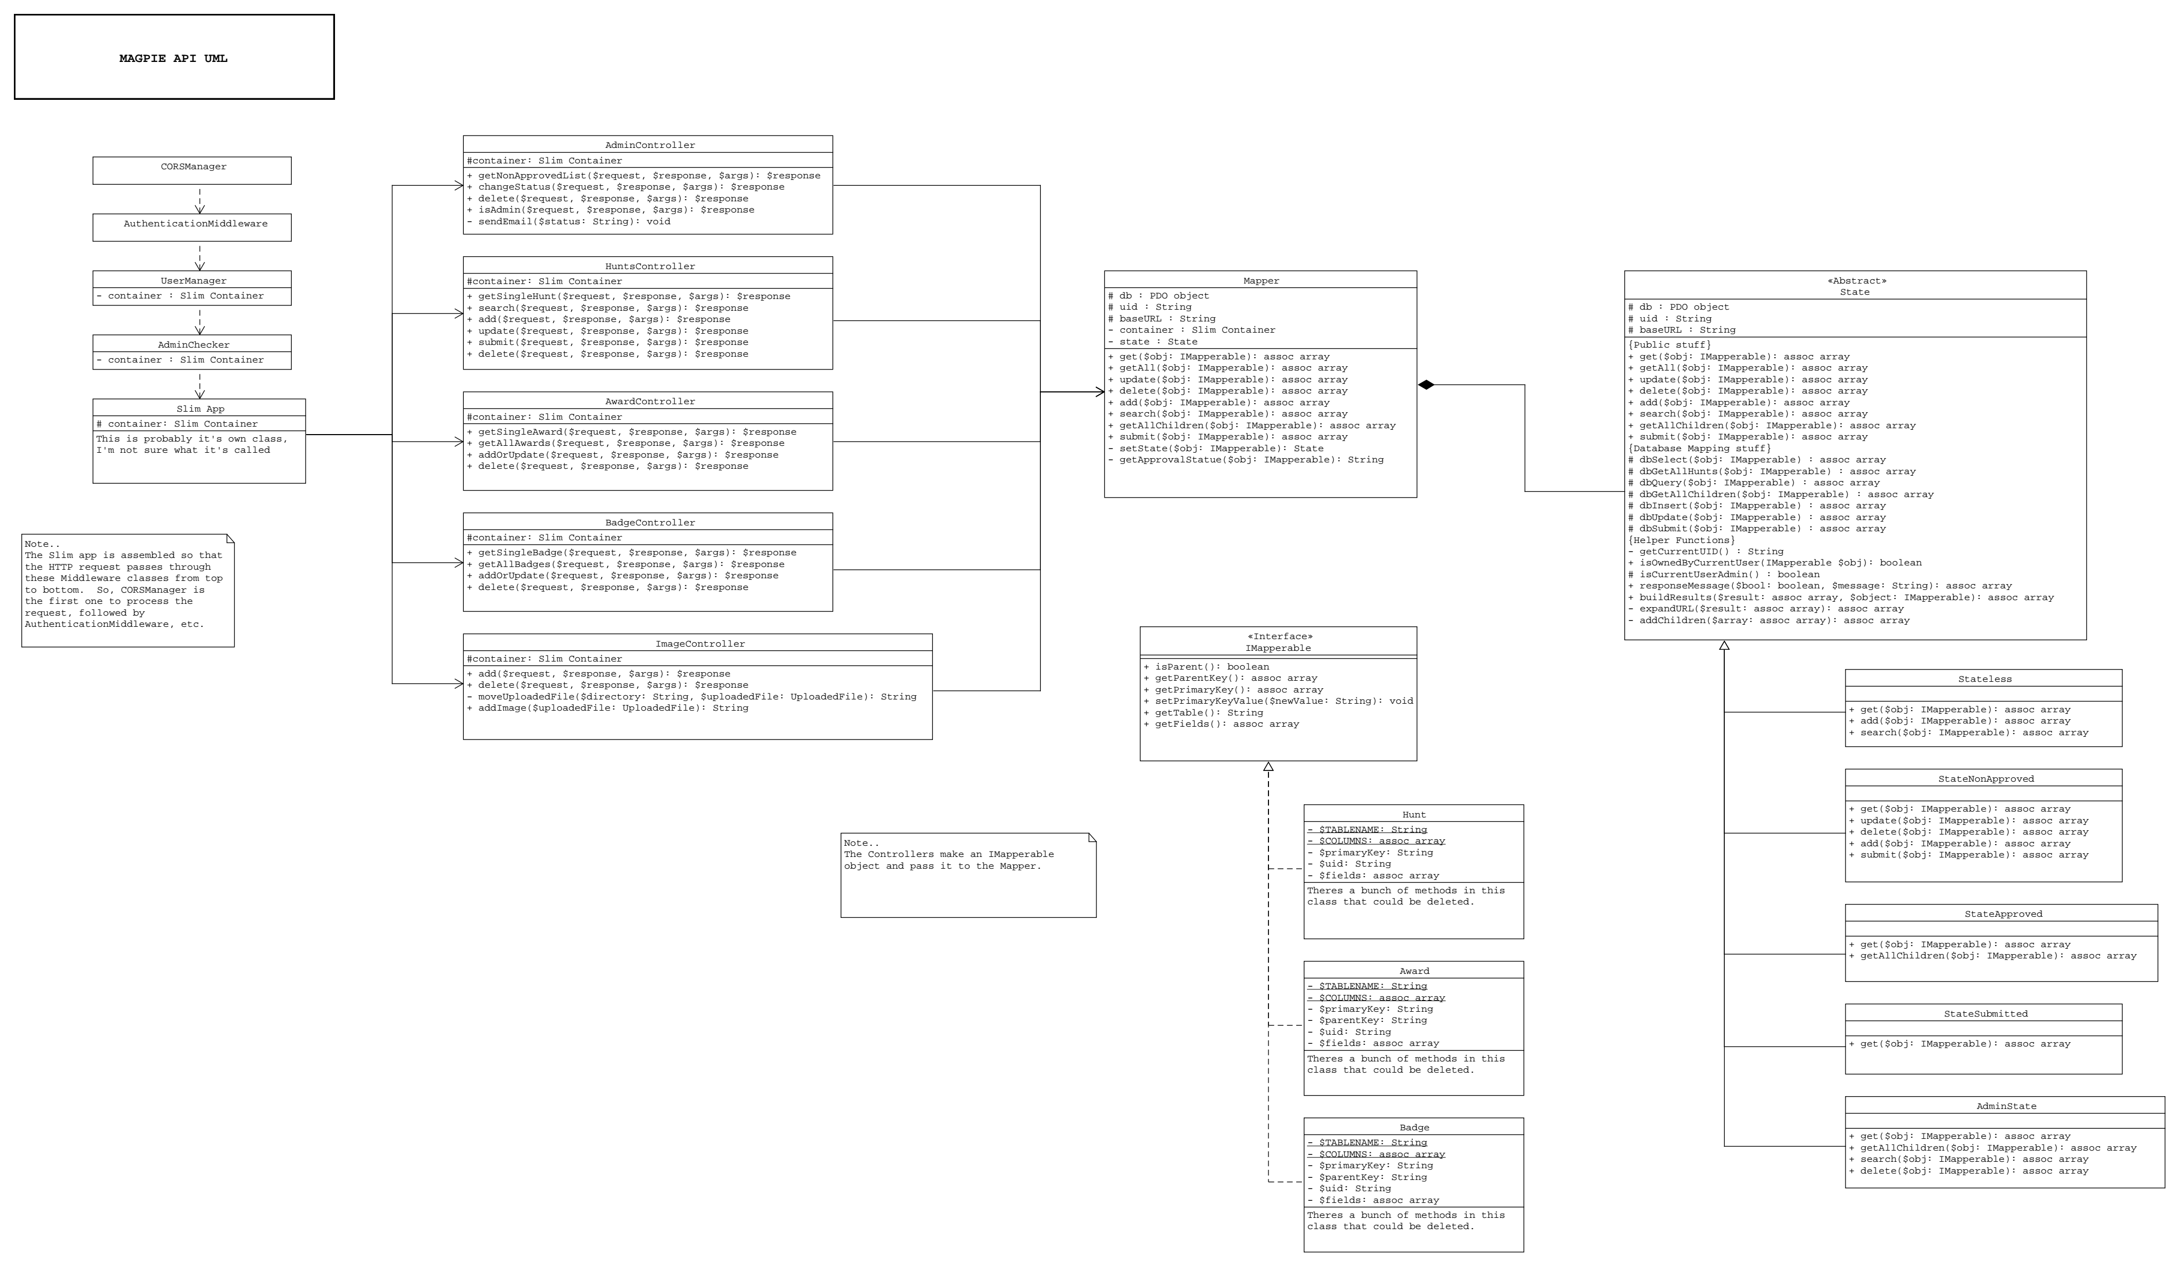

Database

The file “database/MagpieDB.sql” is a SQL script to create the database. It will also create a user (with password) for the PDO container in Slim to use to access the database. The file “database/old-MagpieDBv1.sql” is an older version of the database that I ended up using quite a bit for reference, so I’ve included it for future reference.
I recommend using phpMyAdmin to manage the database and import the SQL script.
Below is a diagram of the database:

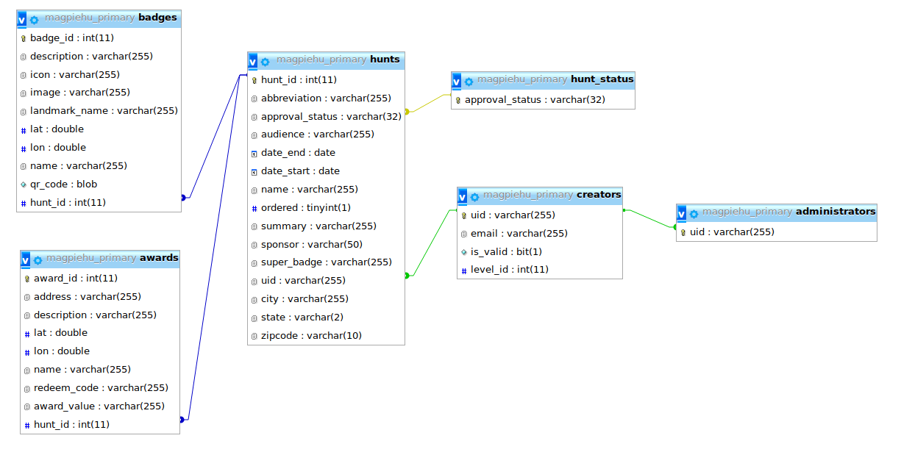

References

List of References by topic:

PHP
- Documentation: http://php.net/manual/en/
- W3 Schools Tutorial: https://www.w3schools.com/php/default.asp
- Other: http://www.phptherightway.com/
- Autoloading: https://phpenthusiast.com/blog/how-to-autoload-with-composer
PDO
- Intro: https://phpdelusions.net/pdo
- Slim also has a good PDO snippet
Slim:
- Documentation: https://www.slimframework.com/docs/
- IBM Tutorial: https://www.ibm.com/developerworks/library/x-slim-rest/
- Another tutorial: https://scotch.io/tutorials/getting-started-with-slim-3-a-php-microframework
- Passing Variables from Middleware: http://help.slimframework.com/discussions/questions/8833-slim-3-pass-variables-from-middleware
Firebase
- Authentication: https://firebase.google.com/docs/auth/
- Google sign-in: https://firebase.google.com/docs/auth/web/google-signin
- Verify ID Tokens: https://firebase.google.com/docs/auth/admin/verify-id-tokens
- Verify ID Tokens w/3rd party: http://firebase-php.readthedocs.io/en/latest/authentication.html#verify-a-firebase-id-token
- Firebase on the server: https://firebase.google.com/docs/admin/setup
- Firebase on the server 2: https://github.com/kreait/firebase-php/blob/master/docs/authentication.rst
- Not sure how userful but here ya go: https://stackoverflow.com/questions/42098150/how-to-verify-firebase-id-token-with-phpjwt
Postman
- Authorization in Postman: https://www.getpostman.com/docs/v6/postman/sending_api_requests/authorization
REST API
- The actual Dissertation: https://www.ics.uci.edu/~fielding/pubs/dissertation/rest_arch_style.htm
- Rest and PHP: http://coreymaynard.com/blog/creating-a-restful-api-with-php/
- Linking: https://stormpath.com/blog/linking-and-resource-expansion-rest-api-tips
Basic Create, Read, Update, Delete (CRUD) stuff
- Tutorial: https://www.taniarascia.com/create-a-simple-database-app-connecting-to-mysql-with-php/
Other
- Force SSL: https://my.bluehost.com/hosting/help/599
- JSON: https://www.json.org/
- JSON Viewer: http://jsonviewer.stack.hu/
- JSON Web Tokens: www.jwt.io
- UML: http://www.cs.bsu.edu/~pvg/misc/uml/ and http://pages.cs.wisc.edu/~hasti/cs302/examples/UMLdiagram.html

