**CPE 233 SW 6**

Wyatt Tack and Ethan Vosburg

1. Flowcharts :

Part 1 :

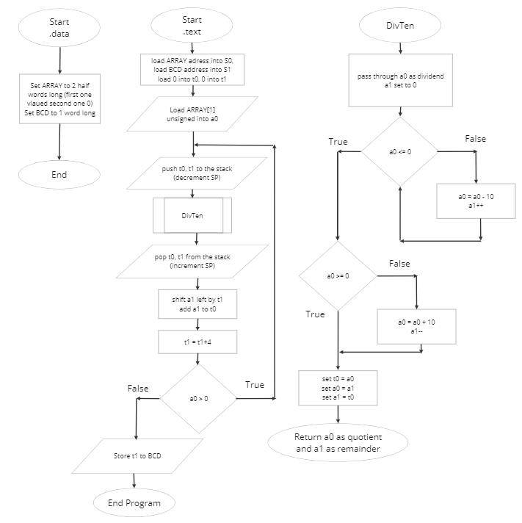

Part 2 :

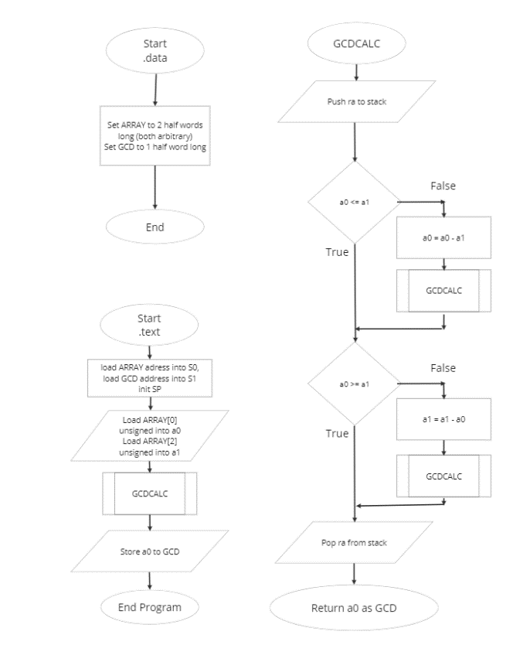

1. Table 1: Verification Part 1:

|  |  |  |  |
| --- | --- | --- | --- |
| **ARRAY[1]** |  | **BCD CODED** | **Reasoning** |
| **65535**  **0xffff** |  | **0x00065535** | Tests high end of half word values |
| **4**  **0x0004** |  | **0x00000004** | Tests numbers below 16 (0x10) |
| **0**  **0x0000** |  | **0x00000000** | Tests 0 |
| **12345**  **0x3039** |  | **0x00012345** | Standard test for middle of spectrum |
| **70000**  **0x1_1170**  **(turned into**  **0x1170 = 4464)** |  | **0x00004464** | Tests overflow in .data (assembler automatically truncates data past 2nd byte) |

Table 2: Verification Part 2:

|  |  |  |  |
| --- | --- | --- | --- |
| **CONDITION:**  **a0/a1 < 10238 && a1/a0 < 10238** | | | |
| **ARRAY** |  | **GCD** | **Reasoning** |
| **a0:60000**  **0x3a60**  **a1:3005**  **0x0bbd** |  | **5**  **0x0005** | **Tests standard operation**  **with a0 > a1** |
| **a0: 65535**  **0xffff**  **a1: 0**  **0x0000** |  | **Stack overflow error** | **Tests stack overflow and divide by 0** |
| **a0:3920**  **0x0f50**  **a1:5920**  **0x1720** |  | **80**  **0x0050** | **Tests standard operation**  **with a0 < a1** |
| **a0:65320**  **0xff50**  **a1:63264**  **0xf720** |  | **8**  **0x0008** | **Tests standard operation with high numbers** |

1. Figure 1: Assembly Code Part 1:

.data

ARRAY: .half 256 #number you want to be BCD coded

BCD: .word 0

.text

la s0, ARRAY #load mem addresses

la, s1, BCD

li sp, 0x10000 #Stack Pointer

li t0, 0 #set BCD total to 0

li t1, 0 #start shift value to 0

lhu a0, (s0) #load array into a0

BCODED:

addi sp, sp, -8 #push t0 and t1 to stack

sw t0, (sp)

sw t1, 4(sp)

call DIVTEN #divide a0 by 10, return a0 quotient, a1 remainder

lw t0, (sp) #pop t0 and t1 from stack

lw t1, 4(sp)

addi sp, sp, 8

sll a1, a1, t1 #shift a1 by nibble count

add t0, a1, t0 #add a1 to t0 --> add to BCD val

addi t1, t1, 4 #increment nibble count

bgt a0, x0 BCODED #loop until whole number is coded

sw t0, (s1) #set BCD coded number into bcd

END: j END

#DIVTEN Function (a0/10 = a0, a1 remainder)

DIVTEN: addi a1, x0, 0 #set a1 to 0

SUB: ble a0, x0 DIVBY #count how many times

addi a0, a0, -10 #a0 can be subtracted by 10

addi a1, a1, 1

j SUB

DIVBY: bge a0, x0 QTNT #if remainder, remove 1 from sub

addi a0, a0, 10 #count and send to remainder

addi a1, a1, -1

QTNT: addi t0, a0, 0 #swap a1 and a0 so

addi a0, a1, 0 #quotient can be a0

addi a1, t0, 0

ret

Figure 2: Assembly Code Part 2:

.data

ARRAY: .half 4 #const 1

.half 16 #const 2

GCD: .half

#GCDCALC can only run 10238 iterations, a0/a1 < 10238 && a1/a0 < 10238

.text

la s0, ARRAY #load mem addresses

la, s1, GCD

li sp, 0x10000 #Stack Pointer

lhu a0, (s0) #load ARRAY into a0 and a1

lhu a1, 2(s0)

call GCDCALC #calculate GCD of a0 and a1, return to a0

sw a0, (s1) #store GCD to GCD array

END: j END #terminate program

#GCD Function: a0 = GCD(a0, a1)

GCDCALC:

addi sp, sp, -4 #push ra to stack

sw ra, (sp)

ble a0, a1, LT #if a0 > a1,

sub a0, a0, a1 #a0 = a0-a1 and loop

call GCDCALC

LT: bge a0, a1, GE #if a0 < a1,

sub a1, a1, a0 #a1 = a1-a0 and loop

call GCDCALC

GE: lw ra, (sp) #pop ra from stack

addi sp, sp, 4

ret