**CPE 233 SW 7**

Wyatt Tack and Ethan Vosburg

1. Flowcharts :

Part 1 :

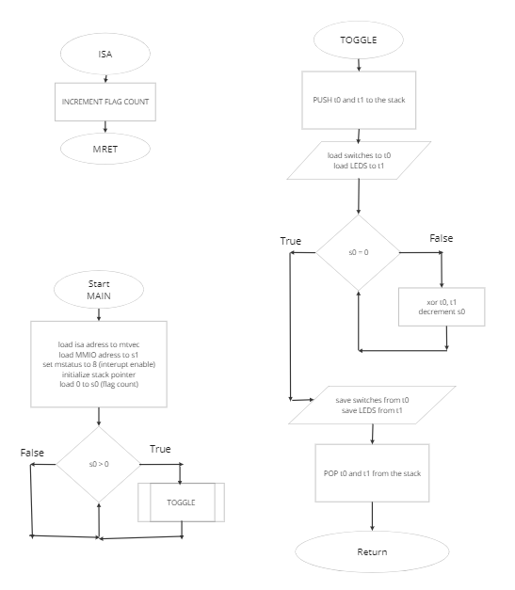

Part 2 :

1. Table 1: Verification Part 1:

|  |  |  |  |  |
| --- | --- | --- | --- | --- |
| **LEDS (0x20)** | **SWITCHES** | **INTERUPT** | **LEDS** | **Reasoning** |
| **0x0000_0000** | **0x0000_0000** | **0** | **0x0000_0000** | Tests if nothing happens |
| **0x0000_0000** | **0x1010_0101** | **1** | **0x1010_0101** | Tests standard toggle |
| **0x1010_0101** | **0x1111_1111** | **0** | **0x1010_0101** | Tests for no toggle if no interrupt |
| **0x1010_0101** | **0x1111_1111** | **1** | **0x0101_0101** | Tests toggle for both on and off |
| **0x0101_0101** | **0xffff_ffff** | **1** | **0xfefe_fefe** | Tests toggle for all switches |
| **0xfefe_fefe** | **0xfefe_fefe** | **1** | **0x0000_0000** | Tests clear (toggle=leds) |
| **0x0000_0000** | **0xffff_ffff** | **1** | **0xffff_ffff** | Tests toggle high for all switches |

Table 2: Verification Part 2:

|  |  |  |  |  |  |
| --- | --- | --- | --- | --- | --- |
| **LEDS (0x20)** | **SWITCHES** | **INTERUPT** | **BUTTON 0** | **LEDS** | **Reasoning** |
|  |  |  |  |  |  |

1. Figure 1: Assembly Code Part 1:

SETUP: la t0, ISA

csrrw x0, mtvec, t0 #set ISA prog add

li s1, 0x11000000 #set mmio

li t0, 8

csrrw x0, mstatus, t0 #enable interupts

li s0, 0 #set up flag count

li sp, 0x10000 #initialize the stacker

LOOP:

beqz s0, NOFLAG #check for flag count

call TOGGLE

NOFLAG:

j LOOP

TOGGLE:

addi sp, sp, -8 #push t0, t1 to stack

sw t0, (sp)

sw t1, 4(sp)

lw t0, (s1) #load switches

lw t1, 0x20(s1) #load leds

FLAGLOOP:

xor t0, t0, t1 #toggle leds

addi s0, s0, -1 #decrement flag count

bnez s0, FLAGLOOP #loop for all flag count

sw t0, 0x20(s1) #store toggled leds

lw t0, (sp) #pop t0, t1 from stack

lw t1, 4(sp)

addi sp, sp, 8

ret

ISA: addi s0, s0, 1 #increment flag count

mret

Figure 2: Assembly Code Part 2: