Citation_Analysis

Manikandan

18/07/2020

library(bibliometrix)

## Warning: package 'bibliometrix' was built under R version 3.6.3

## To cite bibliometrix in publications, please use:  
##   
## Aria, M. & Cuccurullo, C. (2017) bibliometrix: An R-tool for comprehensive science mapping analysis, Journal of Informetrics, 11(4), pp 959-975, Elsevier.  
##   
##   
## http:\\www.bibliometrix.org  
##   
##   
## To start with the shiny web-interface, please digit:  
## biblioshiny()

file <- "../masterbib.bib"  
  
M <- convert2df(file = file, dbsource = "isi", format = "bibtex")

##   
## Converting your isi collection into a bibliographic dataframe  
##   
## Done!  
##   
##   
## Generating affiliation field tag AU_UN from C1: Done!

results <- biblioAnalysis(M, sep = ";")

options(width=100)  
S <- summary(object = results, k = 10, pause = FALSE)

##   
##   
## MAIN INFORMATION ABOUT DATA  
##   
## Timespan 1977 : 2020   
## Sources (Journals, Books, etc) 1159   
## Documents 2324   
## Average years from publication 6.15   
## Average citations per documents 7.614   
## Average citations per year per doc 1.013   
## References 46630   
##   
## DOCUMENT TYPES   
## article 707   
## article; book chapter 1   
## article; early access 11   
## article; proceedings paper 134   
## book review 15   
## correction 1   
## editorial material 19   
## letter 2   
## proceedings paper 1410   
## reprint 1   
## review 22   
## review; early access 1   
##   
## DOCUMENT CONTENTS  
## Keywords Plus (ID) 823   
## Author's Keywords (DE) 4096   
##   
## AUTHORS  
## Authors 5366   
## Author Appearances 8522   
## Authors of single-authored documents 222   
## Authors of multi-authored documents 5144   
##   
## AUTHORS COLLABORATION  
## Single-authored documents 247   
## Documents per Author 0.433   
## Authors per Document 2.31   
## Co-Authors per Documents 3.67   
## Collaboration Index 2.48   
##   
##   
## Annual Scientific Production  
##   
## Year Articles  
## 1977 1  
## 1980 3  
## 1987 1  
## 1990 2  
## 1991 2  
## 1992 5  
## 1994 5  
## 1996 3  
## 1997 1  
## 1998 1  
## 2000 5  
## 2001 4  
## 2002 6  
## 2003 8  
## 2004 17  
## 2005 31  
## 2006 61  
## 2007 50  
## 2008 100  
## 2009 103  
## 2010 112  
## 2011 102  
## 2012 124  
## 2013 130  
## 2014 149  
## 2015 257  
## 2016 230  
## 2017 232  
## 2018 278  
## 2019 229  
## 2020 60  
##   
## Annual Percentage Growth Rate 9.989785   
##   
##   
## Most Productive Authors  
##   
## Authors Articles Authors Articles Fractionalized  
## 1 MOREAU L 50 MOREAU L 16.94  
## 2 MATTOSO M 39 GROTH P 10.23  
## 3 DE OLIVEIRA D 32 PLALE B 10.08  
## 4 GROTH P 32 MISSIER P 9.51  
## 5 MISSIER P 31 MILES S 9.01  
## 6 PLALE B 30 BERTINO E 8.74  
## 7 MILES S 28 MATTOSO M 8.40  
## 8 BERTINO E 26 DEUTCH D 7.48  
## 9 FREIRE J 24 DE OLIVEIRA D 7.47  
## 10 DEUTCH D 23 CHENEY J 7.42  
##   
##   
## Top manuscripts per citations  
##   
## Paper TC  
## 1 SIMMHAN YL, 2005, SIGMOD REC 477  
## 2 FINLAY L, 2002, QUAL HEALTH RES 394  
## 3 KLEIN G, 2009, SOSP'09: PROCEEDINGS OF THE TWENTY-SECOND ACM SIGOPS SYMPOSIUM ON OPERATING SYSTEMS PRINCIPLES 355  
## 4 BUNEMAN P, 2001, DATABASE THEORY - ICDT 2001, PROCEEDINGS 314  
## 5 ARTZ D, 2007, J WEB SEMANT 274  
## 6 MOREAU L, 2011, FUTUR GENER COMP SYST 243  
## 7 DEELMAN E, 2015, FUTUR GENER COMP SYST 205  
## 8 FOSTER I, 2002, 14TH INTERNATIONAL CONFERENCE ON SCIENTIFIC AND STATISTICAL DATABASE MANAGEMENT, PROCEEDINGS 180  
## 9 PETERSEN L, 2005, CHEMOMETRICS INTELL LAB SYST 156  
## 10 SCHMACHTENBERG M, 2014, SEMANTIC WEB - ISWC 2014, PT I 155  
## TCperYear  
## 1 29.81  
## 2 20.74  
## 3 29.58  
## 4 15.70  
## 5 19.57  
## 6 24.30  
## 7 34.17  
## 8 9.47  
## 9 9.75  
## 10 22.14  
##   
##   
## Corresponding Author's Countries  
##   
## Country Articles Freq SCP MCP MCP_Ratio  
## 1 USA 809 0.3553 714 95 0.117  
## 2 UNITED KINGDOM 308 0.1353 241 67 0.218  
## 3 CHINA 155 0.0681 90 65 0.419  
## 4 GERMANY 148 0.0650 115 33 0.223  
## 5 BRAZIL 125 0.0549 95 30 0.240  
## 6 AUSTRALIA 68 0.0299 55 13 0.191  
## 7 ITALY 64 0.0281 50 14 0.219  
## 8 FRANCE 60 0.0264 25 35 0.583  
## 9 INDIA 46 0.0202 41 5 0.109  
## 10 SPAIN 44 0.0193 26 18 0.409  
##   
##   
## SCP: Single Country Publications  
##   
## MCP: Multiple Country Publications  
##   
##   
## Total Citations per Country  
##   
## Country Total Citations Average Article Citations  
## 1 USA 8043 9.942  
## 2 UNITED KINGDOM 3074 9.981  
## 3 GERMANY 1148 7.757  
## 4 CHINA 866 5.587  
## 5 BRAZIL 569 4.552  
## 6 AUSTRALIA 429 6.309  
## 7 FRANCE 336 5.600  
## 8 ITALY 272 4.250  
## 9 NETHERLANDS 234 5.707  
## 10 SPAIN 182 4.136  
##   
##   
## Most Relevant Sources  
##   
## Sources Articles  
## 1 PROVENANCE AND ANNOTATION OF DATA AND PROCESSES 66  
## 2 FUTURE GENERATION COMPUTER SYSTEMS-THE INTERNATIONAL JOURNAL OF ESCIENCE 59  
## 3 CONCURRENCY AND COMPUTATION-PRACTICE \\& EXPERIENCE 41  
## 4 PROVENANCE AND ANNOTATION OF DATA AND PROCESSES (IPAW 2014) 38  
## 5 PROVENANCE AND ANNOTATION OF DATA AND PROCESSES IPAW 2018 33  
## 6 PROCEEDINGS OF THE VLDB ENDOWMENT 29  
## 7 PROVENANCE AND ANNOTATION OF DATA AND PROCESSES IPAW 2012 29  
## 8 JOURNAL OF WEB SEMANTICS 28  
## 9 PROVENANCE AND ANNOTATION OF DATA AND PROCESSES IPAW 2016 28  
## 10 IEEE TRANSACTIONS ON VISUALIZATION AND COMPUTER GRAPHICS 26  
##   
##   
## Most Relevant Keywords  
##   
## Author Keywords (DE) Articles Keywords-Plus (ID) Articles  
## 1 PROVENANCE 534 PROVENANCE 150  
## 2 DATA PROVENANCE 150 MODEL 68  
## 3 SECURITY 69 MANAGEMENT 38  
## 4 BLOCKCHAIN 68 FRAMEWORK 37  
## 5 SEMANTIC WEB 68 SYSTEM 35  
## 6 CLOUD COMPUTING 66 WEB 35  
## 7 LINKED DATA 65 DESIGN 31  
## 8 SCIENTIFIC WORKFLOWS 53 VISUALIZATION 31  
## 9 DATA 52 LINEAGE 29  
## 10 METADATA 50 SCIENCE 27

plot(x = results, k = 10, pause = FALSE)

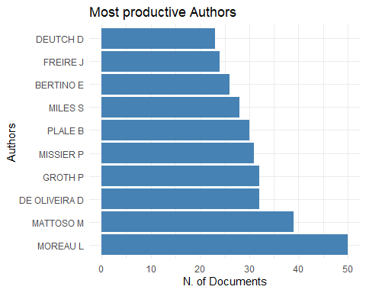

## Warning: Use of `xx$Country` is discouraged. Use `Country` instead.

## Warning: Use of `xx$Freq` is discouraged. Use `Freq` instead.

## Warning: Use of `xx$Collaboration` is discouraged. Use `Collaboration` instead.

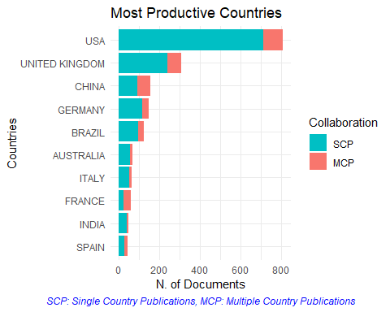

## Warning: Use of `Y$Year` is discouraged. Use `Year` instead.

## Warning: Use of `Y$Freq` is discouraged. Use `Freq` instead.

## Warning: Use of `Y$Year` is discouraged. Use `Year` instead.

## Warning: Use of `Y$Freq` is discouraged. Use `Freq` instead.

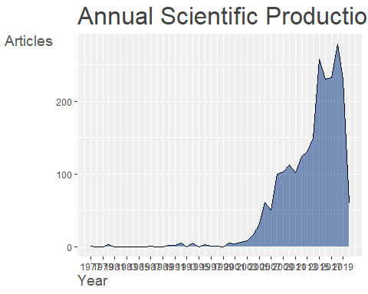

## Warning: Use of `Table2$Year` is discouraged. Use `Year` instead.

## Warning: Use of `Table2$MeanTCperYear` is discouraged. Use `MeanTCperYear` instead.

## Warning: Use of `Table2$Year` is discouraged. Use `Year` instead.

## Warning: Use of `Table2$MeanTCperYear` is discouraged. Use `MeanTCperYear` instead.

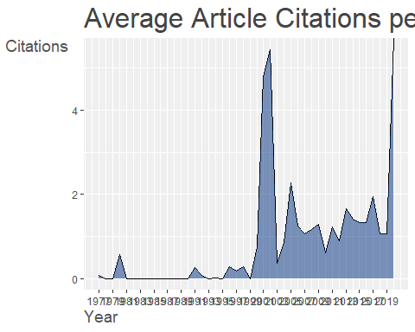

## Warning: Use of `Table2$Year` is discouraged. Use `Year` instead.

## Warning: Use of `Table2$MeanTCperArt` is discouraged. Use `MeanTCperArt` instead.

## Warning: Use of `Table2$Year` is discouraged. Use `Year` instead.

## Warning: Use of `Table2$MeanTCperArt` is discouraged. Use `MeanTCperArt` instead.

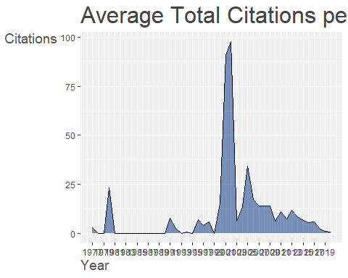

CR <- citations(M, field = "article", sep = ";")  
cbind(CR$Cited[1:10])

## [,1]  
## SIMMHAN YL, 2005, SIGMOD REC, V34, P31, DOI 10.1145/1084805.1084812 295  
## BUNEMAN P, 2001, LECT NOTES COMPUT SC, V1973, P316 167  
## MOREAU L, 2011, FUTURE GENER COMP SY, V27, P743, DOI 10.1016/J.FUTURE.2010.07.005 163  
## FREIRE J, 2008, COMPUT SCI ENG, V10, P11, DOI 10.1109/MCSE.2008.79 128  
## CHENEY J, 2007, FOUND TRENDS DATABAS, V1, P379, DOI 10.1561/1900000006 97  
## DAVIDSON SUSAN B., 2008, P 2008 ACM SIGMOD IN, P1345, DOI [DOI 10.1145/1376616.1376772, 10.1145/1376616.1376772] 94  
## MUNISWAMY-REDDY KK, 2006, USENIX ASSOCIATION PROCEEDINGS OF THE 2006 USENIX ANNUAL TECHNICAL CONFERENCE, P43 93  
## LUDASCHER B, 2006, CONCURR COMP-PRACT E, V18, P1039, DOI 10.1002/CPE.994 87  
## GREEN TODD J., 2007, PODS, P31, DOI [DOI 10.1145/1265530.1265535, 10.1145/1265530.1265535] 85  
## BOSE R, 2005, ACM COMPUT SURV, V37, P1, DOI 10.1145/1057977.1057978 81

CR <- citations(M, field = "author", sep = ";")  
cbind(CR$Cited[1:10])

## [,1]  
## ANONYMOUS 673  
## MOREAU L 665  
## BUNEMAN P 548  
## SIMMHAN YL 468  
## GROTH P 302  
## CHENEY J 255  
## FREIRE J 248  
## FOSTER I 213  
## MISSIER P 211  
## ZHAO J 202

DF <- dominance(results, k = 15)  
DF

## Author Dominance Factor Tot Articles Single-Authored Multi-Authored First-Authored Rank by Articles  
## 1 DEUTCH D 0.65217391 23 0 23 15 9  
## 2 ZHANG J 0.47058824 17 0 17 8 13  
## 3 MISSIER P 0.41935484 31 0 31 13 5  
## 4 BOWERS S 0.35294118 17 0 17 6 13  
## 5 CHEN J 0.35294118 17 0 17 6 13  
## 6 BERTINO E 0.30769231 26 0 26 8 7  
## 7 GROTH P 0.23333333 32 2 30 7 3  
## 8 CHENEY J 0.22222222 19 1 18 4 11  
## 9 MILES S 0.20000000 28 3 25 5 6  
## 10 EDWARDS P 0.13043478 23 0 23 3 9  
## 11 MOREAU L 0.10638298 50 3 47 5 1  
## 12 DE OLIVEIRA D 0.09375000 32 0 32 3 3  
## 13 MCGUINNESS DL 0.05555556 18 0 18 1 12  
## 14 FREIRE J 0.04347826 24 1 23 1 8  
## 15 MATTOSO M 0.02564103 39 0 39 1 2  
## Rank by DF  
## 1 1  
## 2 2  
## 3 3  
## 4 4  
## 5 4  
## 6 6  
## 7 7  
## 8 8  
## 9 9  
## 10 10  
## 11 11  
## 12 12  
## 13 13  
## 14 14  
## 15 15

topAU <- authorProdOverTime(M, k = 10, graph = TRUE)

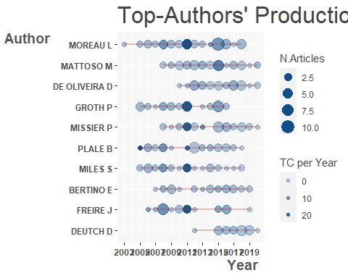

CS <- conceptualStructure(M,field="ID", method="CA", minDegree=4, clust=8, stemming=FALSE, labelsize=10, documents=10)

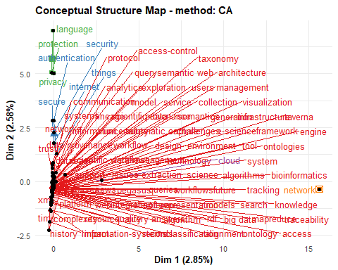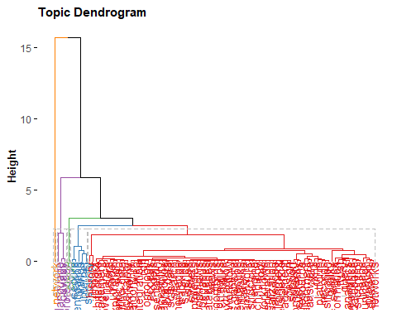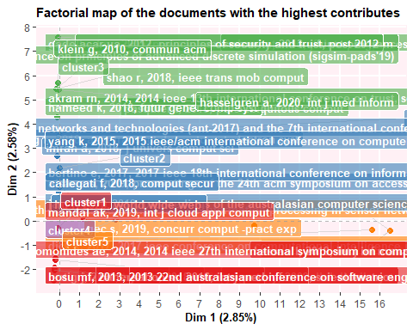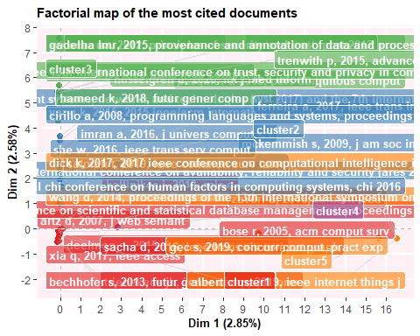

options(width=130)  
histResults <- histNetwork(M, min.citations = 1, sep = ";", network = TRUE, verbose = TRUE)

##   
## WOS DB:  
## Searching local citations (LCS) by reference items (SR) and DOIs...  
##   
## Analyzing 64226 reference items...  
##   
## Found 200 documents with no empty Local Citations (LCS)

# Plot a historical co-citation network  
net <- histPlot(histResults, n=15, size = 10, labelsize=5)

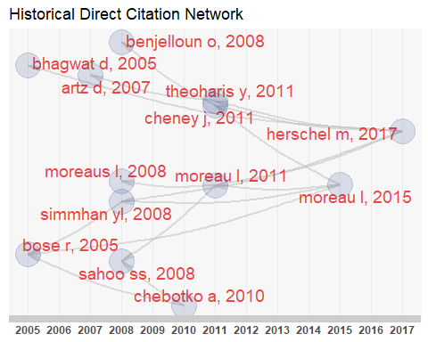

##   
## Legend  
##   
## Label Year LCS GCS  
## 1 BHAGWAT D, 2005, VLDB J DOI 10.1007/S00778-005-0156-6 2005 23 44  
## 2 BOSE R, 2005, ACM COMPUT SURV DOI 10.1145/1057977.1057978 2005 81 152  
## 3 ARTZ D, 2007, J WEB SEMANT DOI 10.1016/J.WEBSEM.2007.03.002 2007 15 274  
## 4 SAHOO SS, 2008, IEEE INTERNET COMPUT DOI 10.1109/MIC.2008.86 2008 23 44  
## 5 SIMMHAN YL, 2008, INT J WEB SERV RES DOI 10.4018/JWSR.2008040101 2008 37 61  
## 6 BENJELLOUN O, 2008, VLDB J DOI 10.1007/S00778-007-0080-Z 2008 20 67  
## 7 MOREAUS L, 2008, COMMUN ACM DOI 10.1145/1330311.1330323 2008 38 71  
## 8 CHEBOTKO A, 2010, DATA KNOWL ENG DOI 10.1016/J.DATAK.2010.03.005 2010 18 23  
## 9 MOREAU L, 2011, J WEB SEMANT DOI 10.1016/J.WEBSEM.2011.03.001 2011 14 16  
## 10 CHENEY J, 2011, 2011 IEEE 24TH COMPUTER SECURITY FOUNDATIONS SYMPOSIUM (CSF) DOI 10.1109/CSF.2011.26 2011 12 14  
## 11 THEOHARIS Y, 2011, IEEE INTERNET COMPUT DOI 10.1109/MIC.2010.127 2011 16 18  
## 12 MOREAU L, 2015, J WEB SEMANT DOI 10.1016/J.WEBSEM.2015.04.001 2015 20 28  
## 13 HERSCHEL M, 2017, VLDB J DOI 10.1007/S00778-017-0486-1 2017 18 28