Tianqi Zhang (001056916)

**Program Structures & Algorithms**

**Spring 2021**

**Union-Find alternatives**

* **Task**

We mentioned two alternatives for implementing Union-Find:

For weighted quick union, store the depth rather than the size;

For weighted quick union with path compression, do two loops, so that all intermediate nodes point to the root, not just the alternates.

For both of these, code the alternative and benchmark it against the implementation in the repository. You have all of that available from a previous assignment.

If you can explain why alternative #1 is unnecessary to be benchmarked, you may skip benchmarking that one.

* **Output**

Output1(WQU):

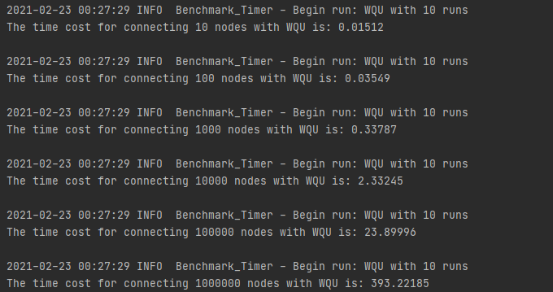

Output2(WQU which stores depth instead of size):

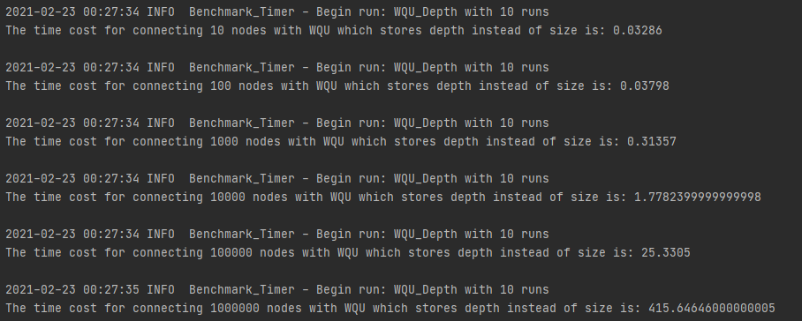

Output3(WQUPC):

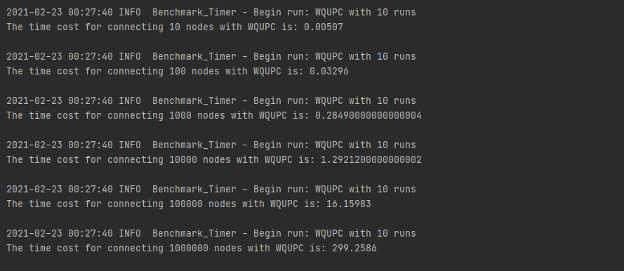

* **Relationship Conclusion:**

WQU cost nearly the same time whether it stores depth or size. But WQUPC cost obviously less time than the former 2 ways.

**Evidence to support the conclusion:**

* **Graphical representation:**

