Waterfall: Linear, step-by-step (Good for stable requirements).
V-Model: Extension of Waterfall, pairs development with testing (Good for safety-critical systems).
Spiral: Iterative loops with a focus on Risk (Good for complex/expensive projects).
Agile: Iterative, flexible, customer-focused (Good for changing requirements).
DevOps: Culture of automation to speed up Releases (Good for continuous delivery)
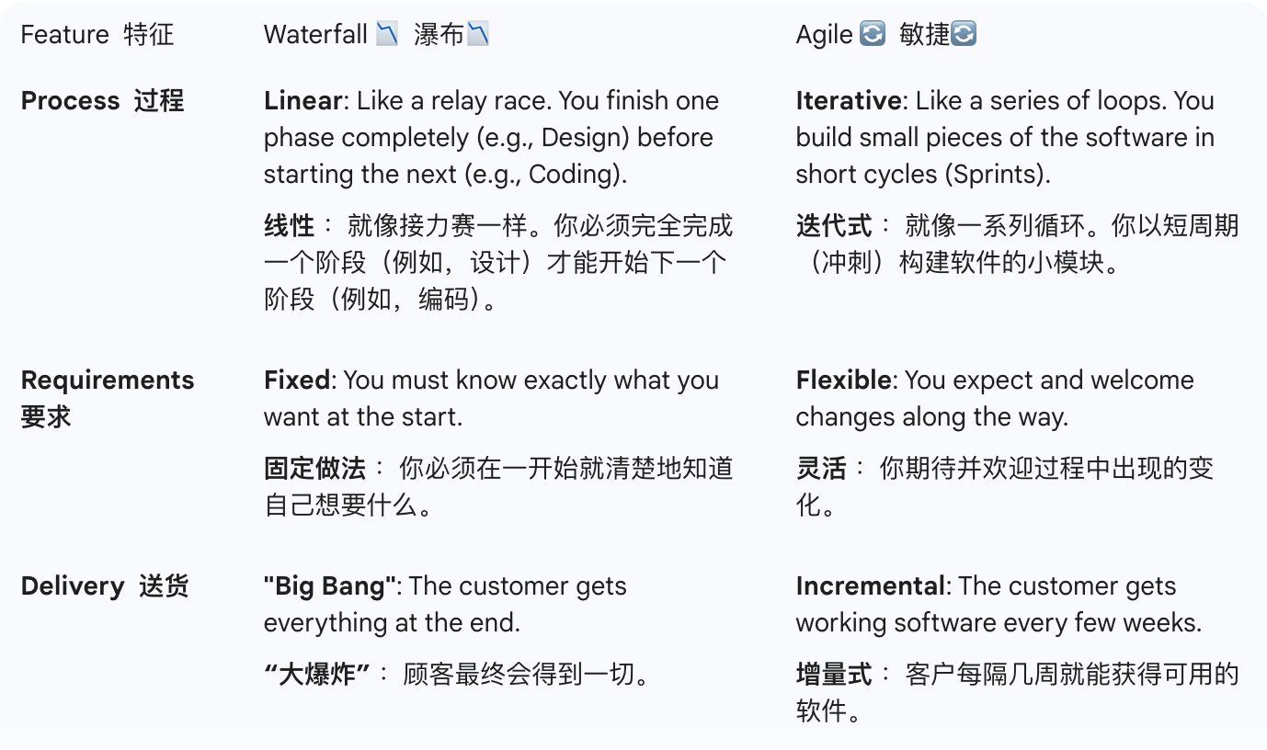
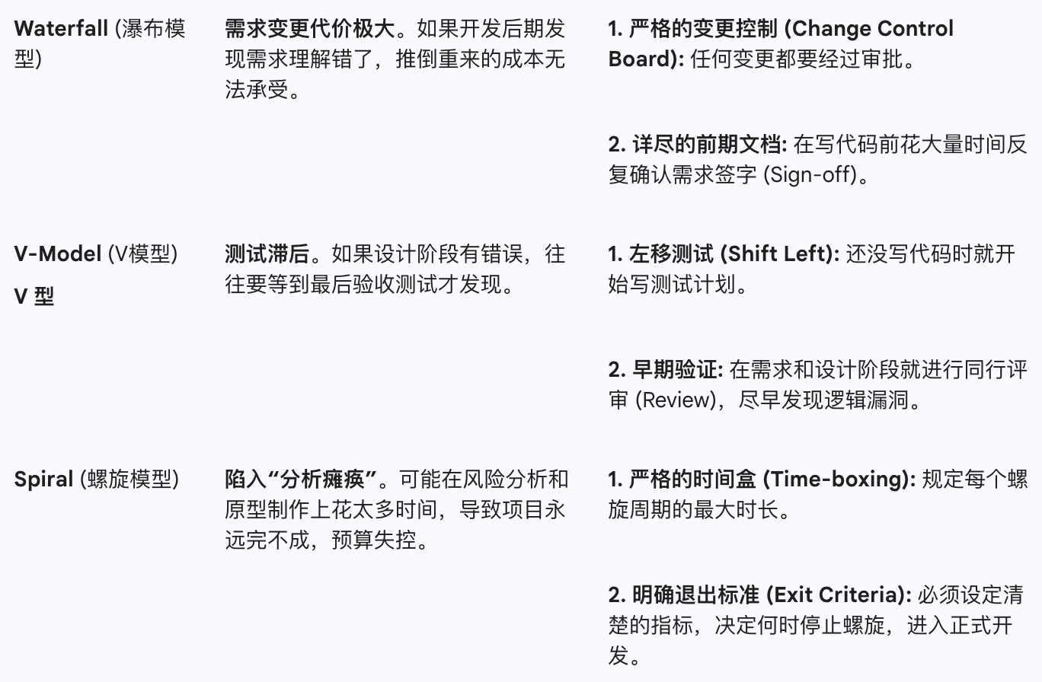
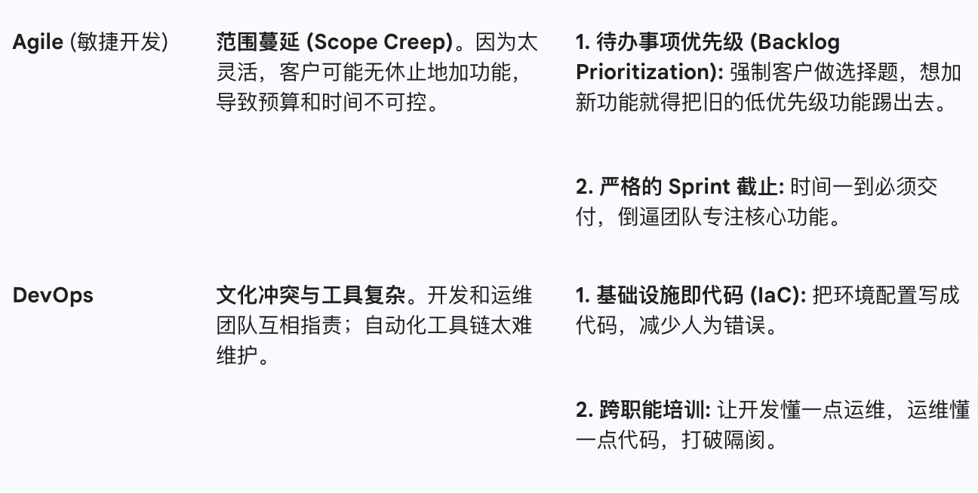
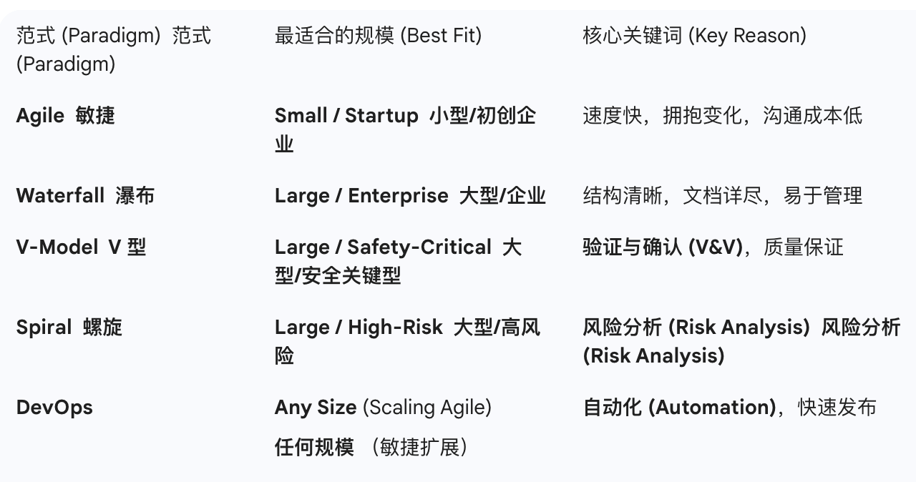
The role of refactoring in Agile development?
Reducing Technical Debt
t cleans up “messy” code caused by rapid iteration, ensuring the software remains stable.
Maintaining Speed
By keeping the code clean and readable, developers can add new features quickly in future sprints without being slowed down by bad code.
Improving Maintainability
It ensures the codebase is easy for the entire team to understand and modify.
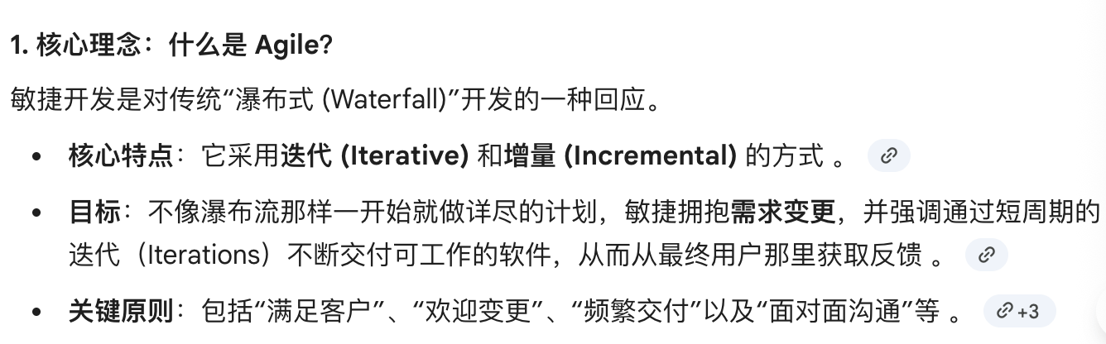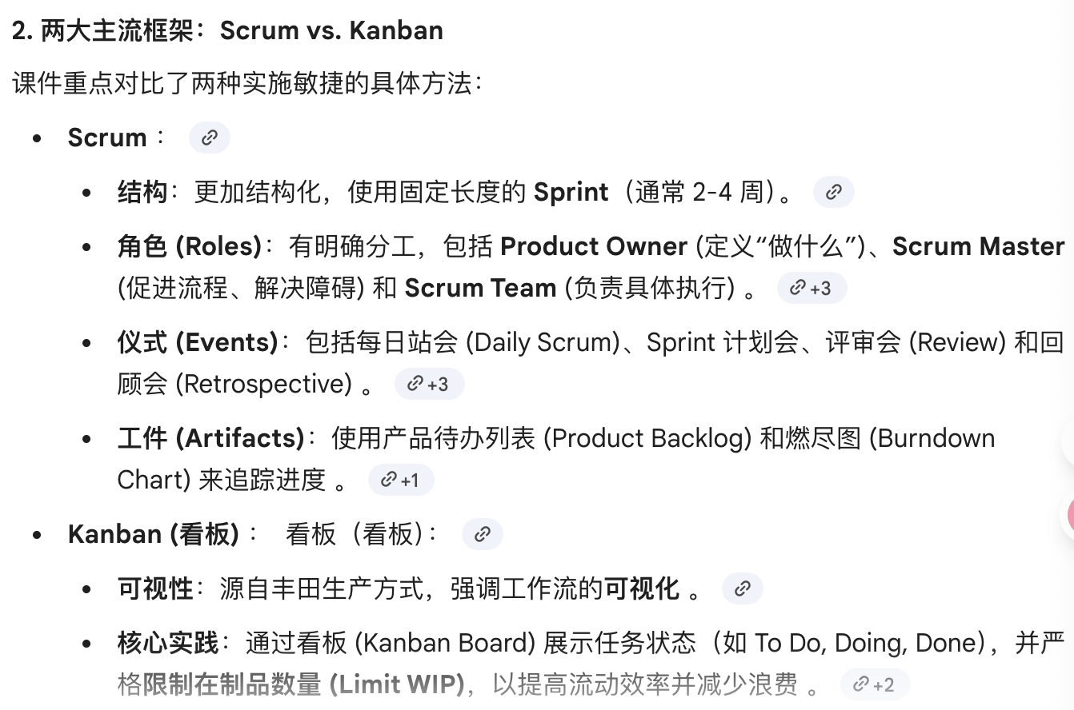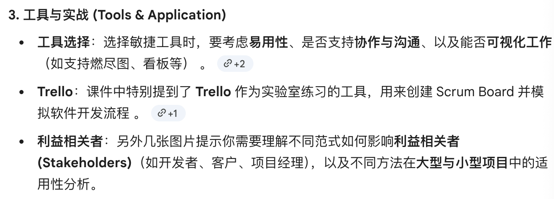

对于经常有紧急任务插队的团队
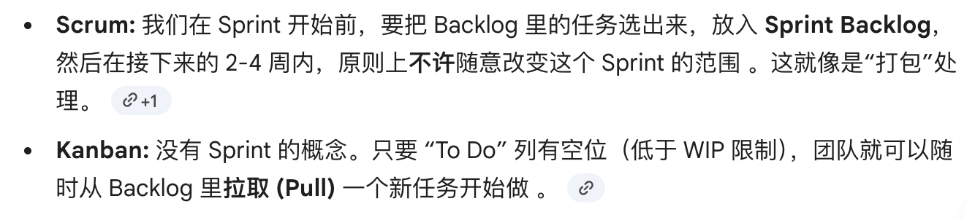
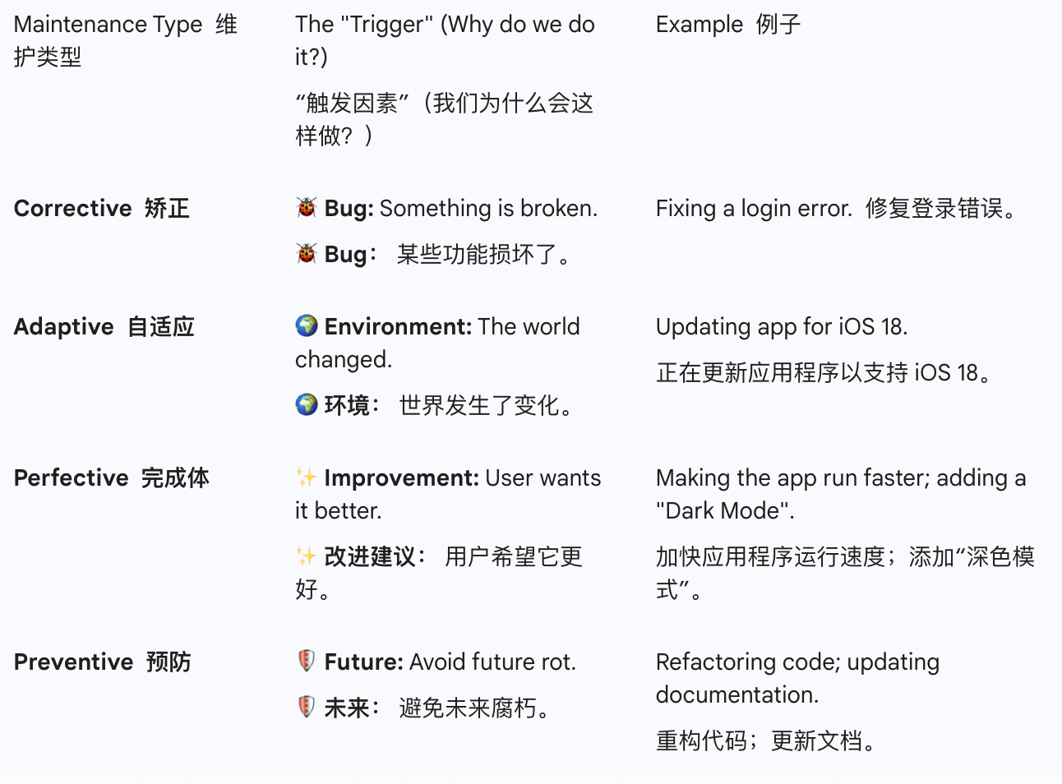
需求工程的方法