软件开发生命周期（SDLC）

Initiating 启动

Develop project Charter（3W） // Business Case（ROI & Risk management plan）

Identify stakeholders（3W）
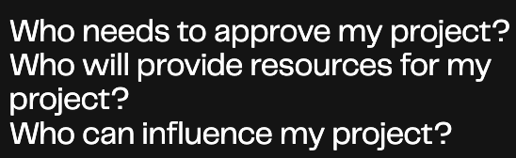
Steps to conduct stakeholders analysis:
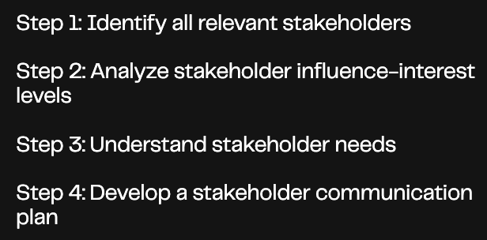

Run a feasibility可行性 study
Does my team have the required resources to complete this project?
Will there be enough return on investment(ROI) to make this project worth pursuing?
When to use a Feasibility Study?
large projects
When you can skip it?
The project is small and has little long-term impact.
You have managed a similar project in the past.
You competitors are already successful with a similar idea.
You have already done a similar study in the last three years.

Assemble your team and tools

Planning 计划
project schedule
scope
due dates
deliverables for all phases of the project lifecycle

How to create project planning?
- Define your goals and objectives
- Set success metrics
- Clarify stakeholders and roles
- Set your budget
- Align对齐 on milestones, deliverables and project dependencies
- Outline you timeline and schedule
- Share your communication plan

Executing 执行

Monitoring 监控

Controlling 控制

Closing 收尾

