What is Project Rescue？
How to save a project that is failing or “bleeding to death”. Even well-planned projects can fail due to unexpected challenges, bed management, or budget problems.

The 7 Steps to Rescue a Project
Assess the Impact :
- Pause the project to check what is wrong before making decisions.
- Ask critical questions about the budget, time, and solution.
- Talk to the key people involved.
Analyze the Cause :
- Find out why the project is failing. Don’t just guess.
- Review documents like risk logs and plans.
- Use the Fishbone Diagram to find the “root cause” of the problems.
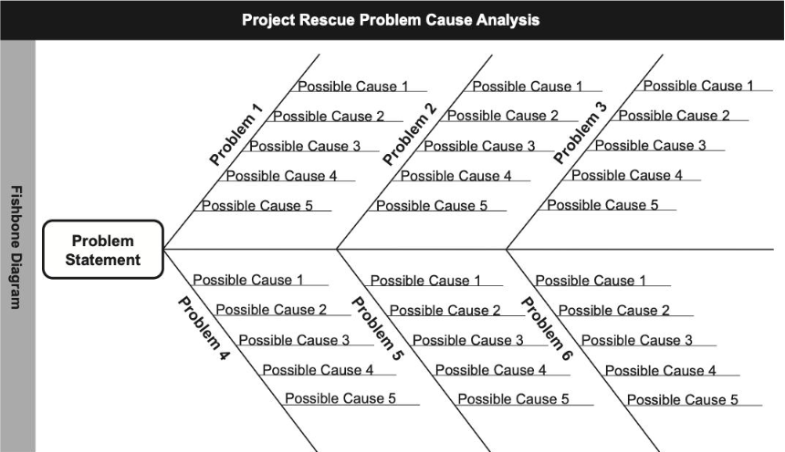
Define a Strategy :
- Decide on a solution. You might continue the project, change it significantly, or cancel it entirely.
- Check how you solution affects time, cost, and quality.
Make a Plan :
- Create a Stabilization Plan to get immediate control.
- Create a Delivery Assurance Plan for the long term to ensure the project gets finished.
Update the Project Plan :
- Change the timeline to be realistic.
- Find “quick wins” to help the team feel confident again.
Implement the Solution :
- Start using new processes.
- Make sure you have enough resources.
Restart the Project :
- Relaunch with clear communication to get everyone on the same page.
- Focus on improving team moral and keep meetings short and useful.

Key Takeaways
Don’t Blame : Focus on fixing the problem and working together, not blaming individuals.
Be Structured : Use a step-by-step process rather than trying to fix everything at once.
Communicate : Strong leadership and open communication are necessary to turn a project around.

